Attachment C - Mandatory Pre-Bid Conference Location

RFx #3000026671 Title: *Mand.Prebid* Herbicide Treatment
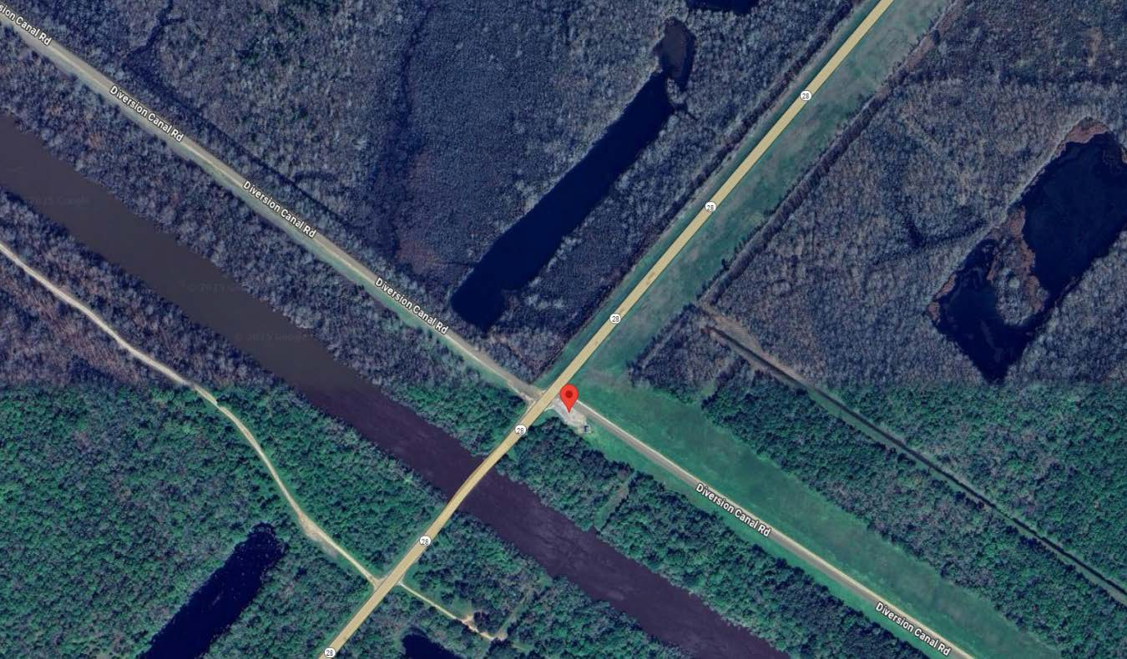
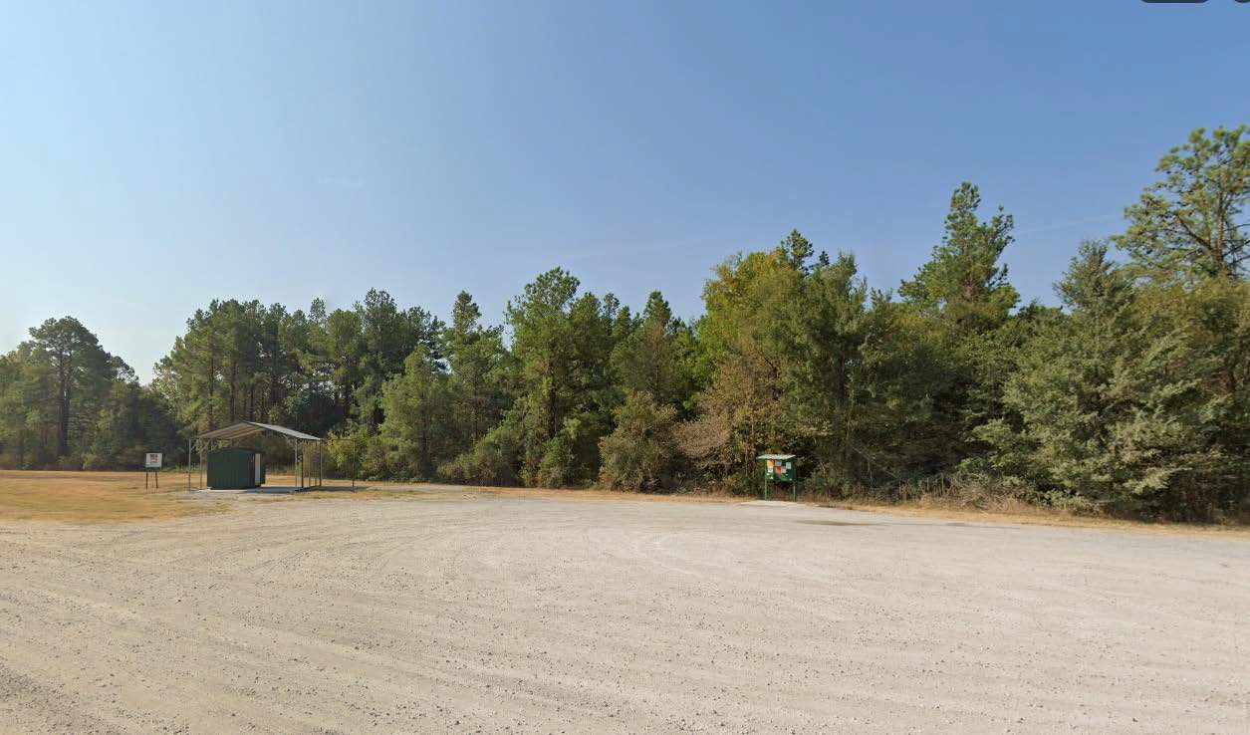

Page 1

