Scope of Work:
The Contractor shall furnish all labor, materials, equipment, tools, supervision, and services necessary to remove and install valley gutters on two open air steel buildings for the Department of Military Affairs (DMA).

Location:
Regional Staging Area
62387 Holloway Rd.
Roseland, Louisiana 70456

DMA Contact:
Von Fish (504) 559-6784, von.fish@la.gov
David Teague (504) 258-2814, david.teague@la.gov

Specification:
The Contractor shall perform the following:

- Replace 150 feet of 8” x 22.5” gutter on the open-air Shipping and Receiving Steel Building #201 (see Figure 1 & 2) and two 284 foot 8” x 8.5” gutters on the open-air Chow/ Maintenance Steel Building #202(See Figures 1,3, & 4).

- Remove and retain all gutter fasteners for disposal.

- Remove gutters from buildings as necessary.

- Install new gutters and fasten to existing eave purling’s with self drilling metal fasteners.

- Install metal straps every 5-6 feet to secure, support and maximize the load capacity of gutters.

- All metal seams must be reinforced with fasteners (rivets/screws) at intervals as necessary to maintain the integrity of the joint. All joints and seams must be watertight. Specialized sealant (a "glue" or high-performance, flexible sealant) is required both inside and outside the connection to prevent leaks.

- Remove and dispose of all removed materials from jobsite.

Terms and Conditions:
- The Contractor shall supply all labor, equipment, tools, materials, and personnel necessary to complete all the work outlined in a timely and professional manner.

- The Contractor and all employees shall obey all traffic laws, speed limits, and signage at the Regional Staging Area.

- All work shall be done during normal RSA operating hours as per Facility Managers.

- The Contractor and sub- contractors are solely responsible for complying with all Federal, State, and Local Safety requirements.

- The Contractor shall ensure no alcohol or illegal drugs are brought onto Regional Staging Area by any employees.

- The Contractor shall obey directions given by Regional Staging Area Facility Managers at all times.

- The Contractor shall mitigate any materials or debris from spreading from job site as much as possible.

- The Contractor shall thoroughly cleanup project site at the end of each workday.

- The Contractor shall dispose of all materials and trash produced by job or workers away from jobsite.

- The Contractor shall provide detailed billing invoice for reimbursement.

- 1 year warranty shall be provided for work and materials.

- The inspection shall be completed by the State Contracting Office and RSA Facility Manager upon completion.

Figure 1: Aerial view of Buildings 201 & 202
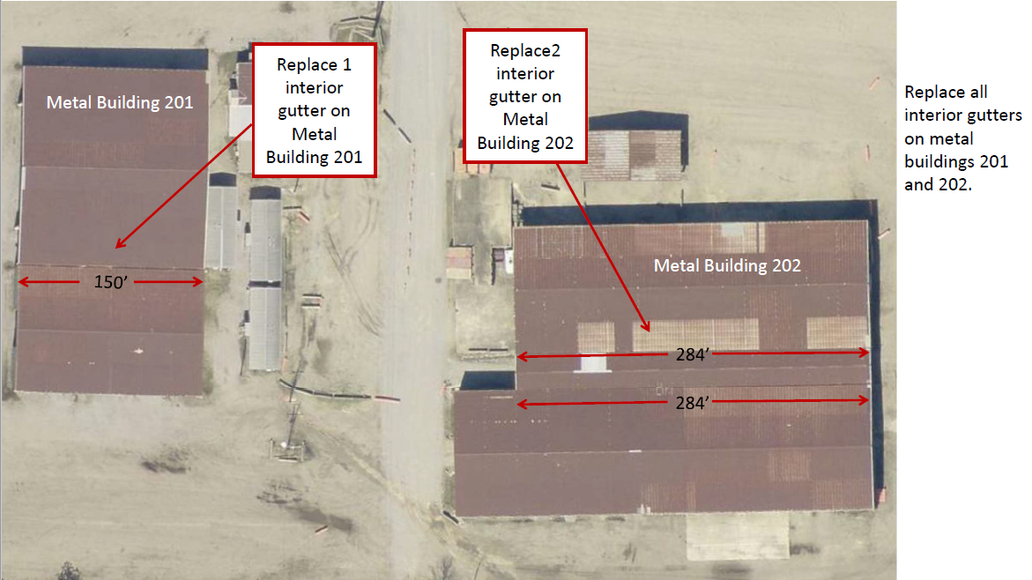

Figure 2: Metal Building 201 (Top and bottom view)
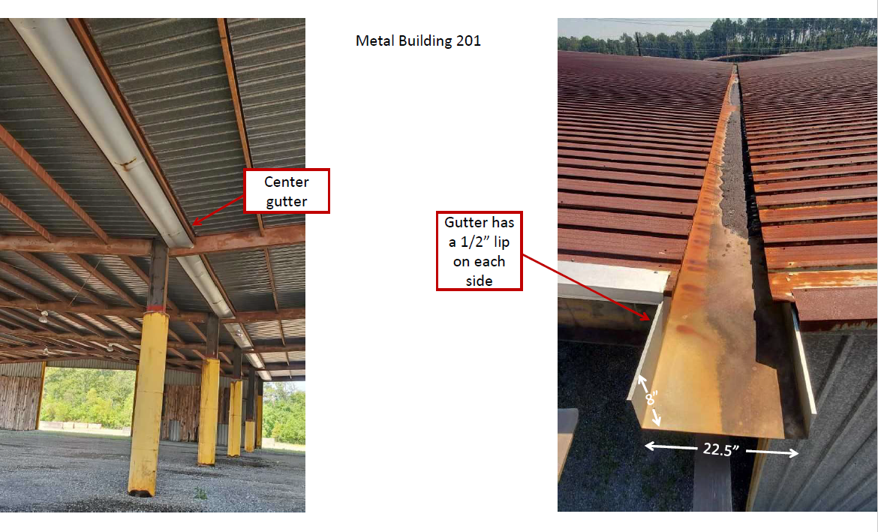
Figure 3: Metal Building 202 (View from ground, East side of building)
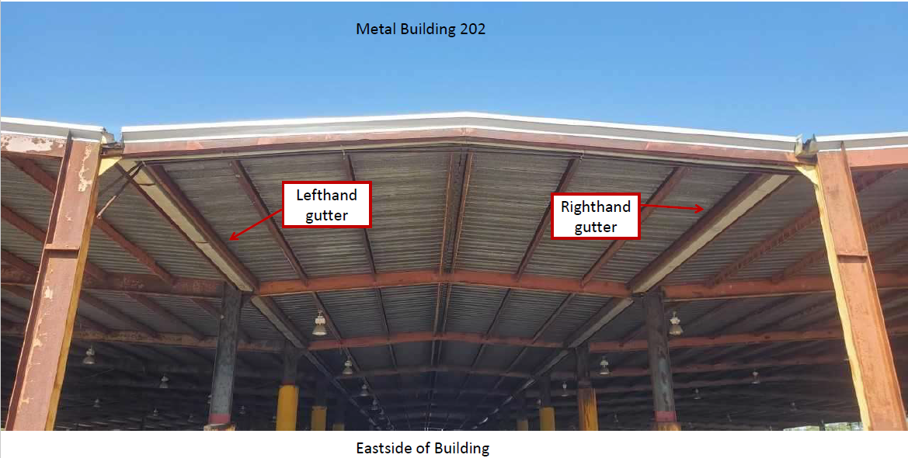

Figure 4: Metal Building 202 (View of ends of gutters)

