RFx 3000026173 Title: *Mand.SiteVisit* Shuttle Services - WLF

Attachment B
Specifications for Shuttle Operation at Elmer’s Island Wildlife Refuge

Summary: The shuttle operation will provide transportation to visitors and their gear from the parking area at Elmer’s Island Wildlife Refuge to the beach at Caminada Pass, a distance of approximately 2 miles. The shuttle will operate primarily during the summer season, when visitation is typically high, between May through the end of August or Labor Day. During the summer season, the shuttle will be expected to run daily from sunrise to sunset. Operators will be expected to maintain a distance from environmentally sensitive areas and protected wildlife on the Refuge, such as shorebird nests and sea turtle nests, and strictly adhere to Best Management Practices (BMPs).

Required Operating Times
The shuttle will operate from sunrise to sunset; all shuttles should be off of the refuge by sunset. These operating times are subject to change.

- January: no operations
- February: 1 shuttle from sunrise to sunset, Friday through Sunday
- March: 1 shuttle from sunrise to sunset, Friday through Sunday
- April: 2 shuttles from sunrise to sunset, Friday through Sunday
- May: 2 shuttles from sunrise to sunset on weekends, Friday through Sunday, until Memorial Day. 3 shuttles on Memorial Day and the remaining days in May after Memorial Day.
- June/July/August: 3 shuttles from sunrise to sunset, every day
- September: 2 shuttles from sunrise to sunset every day through Labor Day. After Labor Day, 2 shuttles from sunrise to sunset on weekends, Friday through Sunday
- October: 2 shuttles from sunrise to sunset, Friday through Sunday
- November: 2 shuttles from sunrise to sunset, Friday through Sunday
- December: no operations

All visitors will be responsible for following refuge regulations, including the opening and closing times as stated in the Louisiana Administrative Code - Title 76.

Type of Vehicles
- All-Terrain Vehicles, able to transport 5 passengers (6-person ATV) with trailer attachment, or
- Modified 4-wheel drive truck, able to transport 5 passengers, with optional trailer.
- No more than 4 vehicles shall be utilized at any one time.

Location and Storage
All facilities, storage, fueling and maintenance operations associated with the third-party contractor must be located off-site. The contractor is responsible for providing all equipment needed to fulfill this task (e.g., vehicles, etc.).

State Oversight
The Louisiana Department of Wildlife and Fisheries (LDWF) will continually monitor Elmer’s Island Refuge for nesting birds, sea turtle nests, and other protected resources and LDWF will inform the shuttle operators of any issues, so that they can adhere to the LDWF management plan and all state and federal laws. The LDWF enforcement division has agents monitoring Elmer’s Island Refuge, who have the ability to enforce state and federal laws if needed. In addition, LDWF reserves the right to suspend the shuttle service at any time for any reason, including unfavorable driving conditions. For example, LDWF can temporarily suspend shuttle operations during a high-water event, where the water is pushed against dune habitat. In this scenario, the shuttles will have to drive on the dunes, which is not allowed, due to high water. In this instance, the shuttle service will be suspended until appropriate driving conditions return. In addition, shuttle service could be suspended or altered due to other conditions as deemed appropriate by LDWF (e.g., minimizing impacts to wildlife, etc.).

Emergency Management/Insurance
The shuttle service will not be responsible for public safety measures at Elmer’s Island. Visitors to Elmer’s Island will be responsible for their own health and safety. Emergency services can be obtained through 911 phone calls. Likewise, the shuttle service will be halted due to unsafe environmental conditions (localized weather systems with lightning) or other emergency closures.

Reporting/Documentation
The contractor will be required to develop a Shuttle Management Plan prior to the start of service, which will outline the operations and logistics of the shuttle service. LDWF must approve the Shuttle Management Plan prior to work. In addition, status updates will be submitted to the LDWF Contract Manager on a weekly basis, which will provide daily GPS data of the tracks, daily log to include the following: 1) number of visitors and any down time due to weather, 2) mechanical issues, or other reasons and 3) wildlife interactions (strandings, nesting, coyotes, etc.), and 4) any concerns or issues that need to be resolved. For any strandings/nesting or urgent issues, LDWF must be notified the same day/as soon as possible. LDWF may require backup documentation on invoices, such as timesheets from the contractor. Any consultants/contractors/subcontractors paid under this awarded project shall maintain all books and records pertaining to this awarded project for a period of ten (10) years after the date of final payment under the prime contract and any contract/subcontract entered into under this project. Up to date reports are required for payment. If any invoices are submitted without the reporting documentation, payment will not occur until the reports are received and approved by the LDWF Contract Manager.

Best Management Practices (BMPs)
For the beach shuttle service, vehicles must abide by BMPs for beach driving, including weight and tire restrictions, speed limits, driving only on or adjacent to the wet sand area of the beach, and at no time disturbing nesting birds, sea turtles, or other wildlife.

- Controlled Operations/Path: Controlled driving could be allowed only in the area above the water’s edge or on or adjacent to the wet sand. Under this BMP, driving will be strictly prohibited near or on the dune habitat. This policy will minimize impacts to foraging, loafing, and nesting birds and other wildlife that use these areas. This policy also will protect dune vegetation and minimize impacts (e.g., increased erosion, reduced dune stability). Additionally, the shuttle service will have designated stops along the beach. This will provide further protections for birds and other wildlife by directing recreational use away from prime foraging and nesting area while still allowing recreational beach access. The designated shuttle stops will be integrated in the monitoring and adaptive management plan for the shuttle service. Through the monitoring and adaptive management of this project, shuttles will be outfitted with GPS units, so that tracks can be plotted along with stop (drop-off/pick-up) locations to better illustrate the shuttle service footprint and relative areas of utilization. This information will be included as part of the monitoring reports. Likewise, shuttle operators will be advised to minimize impacts by driving only on the wet sand and avoiding the wrack line when possible.

Adherence to these BMPs will be a requirement for any contractor operating the shuttle service, and the contract award/revocation will be contingent on these conditions. Depending on the time of year and the corresponding need for the service, the number of shuttles operating will vary, but no more than four vehicles will be used at any one time. When multiple shuttles are in service, efforts will be made to operate in caravans to minimize the frequency of shuttle service impacts to birds and other wildlife present. For the first year, the shuttle service will only operate to the east of the existing parking area. After the first year, operation of the shuttle service will be evaluated to determine if the shuttle will service the beachfront westward of the existing parking lot or remain operational only east of the existing parking area.

- Shuttle Vehicle Requirements: The shuttle service will only be allowed to use multi-passenger UTV/ATV style vehicles or four-wheel drive vehicles customized for carrying multiple passengers in an effort to reduce the number of shuttles and trips. Trailers will be allowed for carrying additional gear. Operational protocols will reflect the following BMPs, and other pertinent guidelines set forth during the planning stage and over time through adaptive management.

Additional restrictions on vehicles could include the following:
- Weight limitations.

- Tire restrictions/requirements - reducing tire pressure and using four-wheel drive reduces ruts on the sand, minimizing damage to intertidal species and to the beach.

- Limited operating hours - Elmer’s Island is open during daytime hours (closed at night); operating vehicles strictly during the day will reduce impacts to nocturnal wildlife that use the beach.

- Speed limits - driving slowly will allow the operator/driver to notice any animals within the vehicles line of travel.

- Personnel Training: All shuttle operators and employees will be trained in the BMPs as a condition of the contract. LDWF will continue to follow Elmer’s Island management plan to protect nesting shorebirds. Sea turtle nesting has not been documented on Elmer’s Island; some false crawls have been observed by LDWF biologists. All shuttle operators and employees will be required to meet with wildlife personnel to learn what sea turtle tracks/crawls look like and will be required to call the Louisiana Sea Turtle Strandings Coordinator and/or the LDWF Contract Manager if a sighting occurred. BMPs will be initiated if a turtle is sighted (e.g., all vehicles must stop until the nesting is completed and the turtle has returned to water). Contractors will be required to alert LDWF to any marine mammal or sea turtle stranding.

- Protected Species: Operators and their vehicles will remain outside of all posted areas of nesting shorebirds at all times. Operators shall report any stranded sea turtle or marine mammals and nesting sea turtles or tracks to LDWF. Absolutely no beach raking is allowed at any time.

Payment Terms
The contractor will be paid on regularly submitted invoices (quarterly or monthly), as agreed upon by Contractor and LDWF.

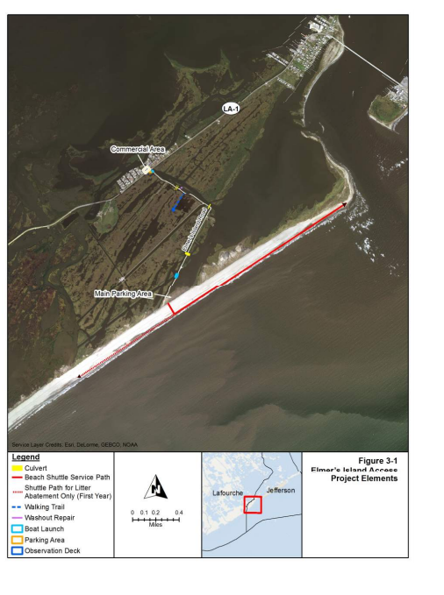

Daily Information

Date
Start time: |  | End time:

Actions
Action item |  | Status
Morning safety meeting (weather, tides, etc.) |  | ☐
Check GPS units, save tracks on each vehicle |  | ☐
Log number of visitors using the shuttle |  | ☐
Follow shuttle schedule |  | ☐
Report number of visitors (daily)

Report to LDWF (Weekly)
Action item | Status
Daily GPS tracks for each vehicle | ☐
Log of visitors (number per day) | ☐
Closures due to weather/mechanical issues | ☐
Problems affecting shuttle operations | ☐
Email LDWF, jlightner@wlf.la.gov | ☐

Emergency Reporting
Illegal materials, report to LDWF Enforcement ☐
1 (800) 422-2511
Marine mammals or sea turtles, report to LDWF ☐
Julia Lightner, (504) 913-7849
Other Emergency – 911 ☐

Concerns
Report large debris, hazardous materials, problems affecting operations, other.
Contact: Julia Lightner, jlightner@wlf.la.gov or (504) 286-4041

