State of Louisiana
Office of State Procurement

Jeff Landry
Governor
Taylor F. Barras
Commissioner of Administration


Division of Administration
1201 N. Third Street, Suite 2-160
Baton Rouge, Louisiana 70802-5243
Phone (225) 342-8010
Fax (225) 342-9756

April 7, 2026

Addendum No. 02

Your reference is directed to RFx Number 3000026092 for the Invitation to Bid (ITB) for the State of Louisiana - Tube Socks Unfinished - DOC-Prison Enterprises, which is currently scheduled to open at 2:00 PM CT on 04/14/2026.

______________________________________________________________________________
Questions from the Vendor and State’s Responses:

Vendor Question 1. Could you please clarify whether ‘unfinished’ refers to greige (undyed/unbleached) socks without chemical finishing, or if it refers to socks prior to final construction/finishing processes?

State’s Response: The meaning of “unfinished” is the toe must be surged closed.

Vendor Question 2. My question is about the "Open Toe." It would help us tremendously if you could provide a link to a picture of it, or if you have a photo detailing what the "Open Toe" looks like.

State’s Response: Please see the picture below of the unfinished sock.

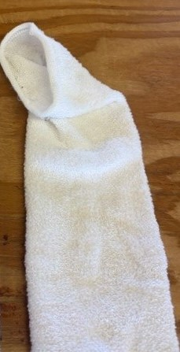

All else remains as on original Invitation to Bid.

This Addendum is hereby officially made a part of the referenced solicitation.

Acknowledgement: If you have already submitted your bid and this Addendum does not cause you to revise your bid, you should acknowledge receipt of this Addendum by identifying your business name and by signing where indicated. You may return this Acknowledgement by mail or delivery by hand or courier to: Office of State Procurement, 1201 N. 3rd Street, Ste. 2-160, Baton Rouge, LA 70802, or by fax to: (225) 342-9756. The State reserves the right to request a completed Acknowledgement at any time. Failure to execute an Acknowledgement shall not relieve the bidder from complying with the terms of its bid.

Addendum Acknowledged/No changes:

For: ________________________ By: __________________________

Revision: If you have already submitted your bid and this Addendum requires you to revise your bid, you must indicate any change(s) below, identify your business name and sign where shown. Revisions shall be delivered prior to bid opening by mail or delivery by hand or courier to: Office of State Procurement, 1201 N. 3rd Street, Ste. 2-160, Baton Rouge, LA 70802, or by fax to: (225) 342-9756, and indicate the RFx number and the bid opening date and time on the outside of the envelope for proper identification, or by fax to: (225) 342-9756. Electronic transmissions other than by fax are not being accepted at this time.

Revisions received after bid opening shall not be considered and you shall be held to your original bid.

Revision:

For: ________________________ By: __________________________

By: LaKeisha Bryant
Office of State Procurement
Telephone No. 225-342-4824
Email: LaKeisha.Bryant2@la.gov

