Attachment B – Specifications

RFx number: 3000025950 Contract Title: Campaign Hats – DPS

Line 1 - Campaign Style Straw Hats:

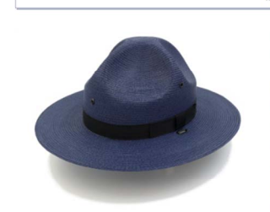

Campaign Style Straw hat comes with a traditional four dent style crown and a 3’ brim. A single, centered badge hole comes standard.
Please list your delivery time frame for an order of approximately 165 hats. (These hats are the only large order items)
Estimated delivery time frame: ____________________
Manufactured in the USA.
- Colors: Royal Blue
- Shape: Long Oval
- Badge Holes: Standard single badge hole
- Brim: Double brim
- Ribbon Color: Blue
- Available sizes:
Regular: 6.5, 6.63, 6.75, 6.88,7, 7.13, 7.25, 7.38, 7.5, 7.63, 7.75, 7.88
Long Oval: 6.5, 6.63, 6.75, 6.88,7, 7.13, 7.25, 7.38, 7.75, 7.63, 7.75, 7.88

Line 2 - Campaign Style Felt Hats:

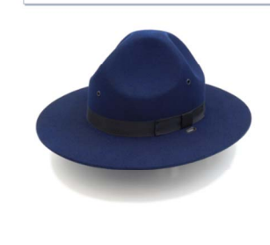

Campaign Style Felt Hat comes with a traditional four dent style. Pressured dye is used and capable of withstanding 100 hours of Fade-O-Meter testing. The extra stiff brim comes in 3” width. Single vent eyelet located on sides and back. Campaign Style Felt Hat is reserved for our Honor Guard. This will result in smaller and less frequent orders of this item.
- Colors: Royal Blue
- Shape: Long Oval
- Badge Holes: Standard single badge hole
- Ribbon Color: Blue
- Available sizes:
Regular: 6.5, 6.63, 6.75, 6.88,7, 7.13, 7.25, 7.38, 7.5, 7.63, 7.75, 7.88
Long Oval: 6.5, 6.63, 6.75, 6.88,7, 7.13, 7.25, 7.38, 7.75, 7.63, 7.75, 7.88

Lines 3 and 4 - 3-Piece Leather Strap:
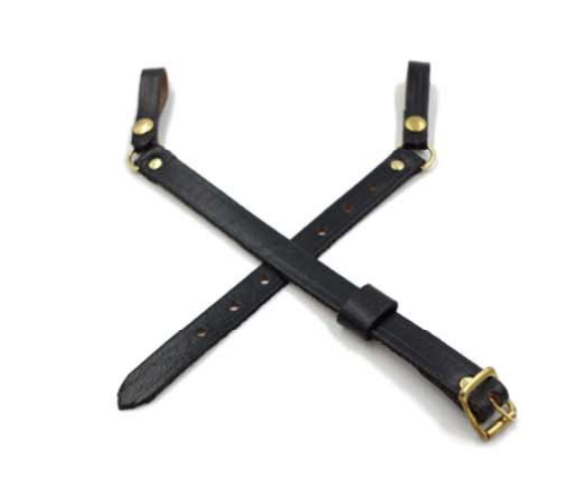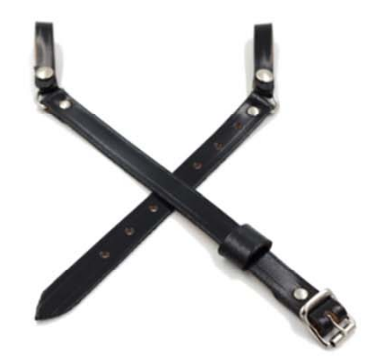
The 3 Piece Leather Strap needs to be come in Black with Brass Buckles and Black with Silver Buckles. There are two straps that are ½” wide. The ends are 3/8” wide with a snap-type swivel and closure. One of these straps comes with a leather keeper which together make three pieces. These straps need to be manufactured in the USA and available for immediate delivery.

Lines 5 and 6 - Cords:
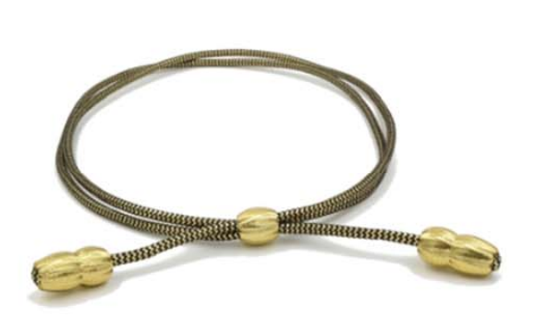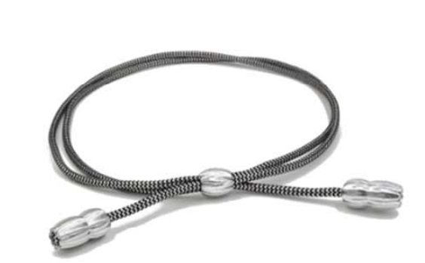

The cords are worn on top of the brim at the bottom of the crown and held to the hat with a three-piece leather strap. These need to be available in Gold/black with gold acorns, Silver/black with silver acorns.

