Product ID 10037, 50292, & 50290 DOTD Spec. 190-002
Rev. 9/23/2022
Attachment D
RFx number: 3000026031 Contract Title: Emergency Safety and Traffic Supplies

Louisiana Department of Transportation and Development
Specifications
Safety Product
Traffic Cones
Type II and Looper Style
Description:
This specification sets forth the requirements for two types of traffic cones, 28” Type II Traffic Cones and Looper Traffic Cones to be used by DOTD personnel for traffic channelizing during various roadway maintenance.
28” Type II Traffic Cone
Product ID 10037 – Type II Traffic Cone, 28”
Materials and Design:
Type II Traffic Cone shall be constructed of soft, pliable, nonporous, fluorescent red-orange polyvinylchloride (PVC) and fused onto a weighted, high density, fluorescent red-orange or black polyvinylchloride base. The overall height from the base to the top of the cone shall be 28” +/- ½” with an overall minimum weight of seven pounds.
Cones shall conform to the most recent requirements of ASTM D412, ASTM D2240 and the MUTCD.
See Diagram A for a detailed image of the cone and dimensions.
Cone
The base of the conical portion of the cone shall measure 7.5” – 10.5” in diameter with a minimum wall thickness of .130” at the bottom. The top of the cone shall have a minimum wall thickness of .075”.
The cone shall be supplied with two horizontal bands of white retroreflective sheeting. The upper band shall be 6” wide, +/- ¼”, and installed 3” – 4” down from the top of the cone. The lower band shall be 4” wide, +/- ¼”, and installed 2” – 3” below the bottom of the upper band.
Retroreflective Sheeting
The retroreflective sheeting bands shall conform to ASTM D4956, and be an approved product from the Approved Materials List (AML) for Reflective Sheeting under either the Material Category for Reflective Sheeting, TIII, TrafConeCollar, or the Material Category for Reflective Sheeting, T VI, TrafConeCollar.

Base
The base shall measure 13.75”- 15.25” wide and have a minimum weight of 4 pounds. To allow easy stacking and separation, there shall be a minimum of four lugs fused to the underside of the base. Lugs shall have a minimum height of 0.2”.
Looper Cone
Product ID 50292 –Looper Cone
Materials and Design:
Looper cones shall consist of a cone with a looper handle only. The height of the cone, including the looper handle shall be 48” – 50” +/- 1”.
The cone shall be constructed of nonporous, fluorescent red-orange, low density polyethylene plastic. A loop style handle shall be located at the top of the cone. Handle shall be configured to allow the attachment of a barricade light.
Cone shall have a minimum of two white and two orange, 4” – 6” wide horizontal retroreflective sheeting bands that encircle the cone in an alternating color pattern. The top band shall be orange, the second band shall be white, and so on, with a maximum of 3” of space between the bottom of one band and the top of the next.
Cones shall conform to the NCHRP-350 requirements for channelizing devices and the most recent MUTCD requirements.
See Diagram B for a detailed image of the cone and dimensions.
Retroreflective Sheeting
The retroreflective sheeting bands shall conform to ASTM D4956 and be an approved product from the Approved Materials List (AML) for Reflective Sheeting under the Material Category for Reflective Sheeting Type III Reboundable.
Base
Product ID 50290 – Base (for looper cone)
The base shall consist of 100% recycled rubber and weigh 30 pounds. The base shall be an industry standard shape that allows the cone to be attached and detached through a 7 ¾” +/– 1/8” diameter center hole.
See Diagram C for images of base shapes.

Packaging:
Each product ID shall be palletized and wrapped. Weight not to exceed 2,000 pounds per pallet. Mixing of product IDs per pallet shall not be allowed.

NOTE: Lopper Cones and Bases shall be assembled at the work site by DOTD personnel.
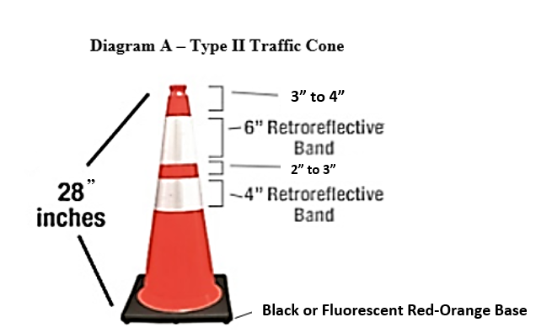

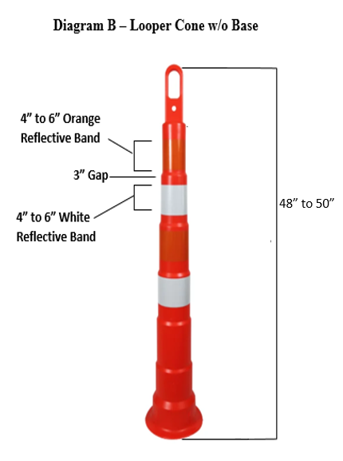

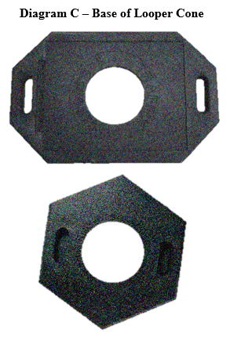


Approved Materials List

Product Category : Reflective Sheeting
MATERIAL : 1015M00250 Reflective Sheeting, TIII,TrafConeCollar
APS00001860 3M Company TSSD - St. Paul, MN Phone : 337-244-8331 Ext. # :
3M Center, 235-3W-52 Fax :
St. Paul, MN 55144 Contact : John Boudreaux
(jboudreaux@mmm.com

)
Product Approved On Remarks
Flex Prism White 3340i - 3M 5- 8-2024
APS00016660 All In Safety Corp Phone : 1.800.376.841 Ext. # :
509 Temple Hill Rd Fax :
New Windsor, NY 12553 Contact : Shauly Perlmutter
(sales@allinsafety.com)
Product Approved On Remarks
Xpose Safety Reflective Traffic Cone Col 12- 8-2025
APS00001980 Avery Dennison - Mt. Prospect, IL Phone : 312-543-0907 Ext. # :
902 Freehanville Drive Fax :
Mount Prospect, IL 60056 Contact : Moe Madar
(moe.madar@averydennison.com)
Additional Info : Contact person's mailing address: 7542 N. Natchez Avenue, Niles, IL 60714

Product Approved On Remarks
Avery Dennison White WC-4100 4-20-2020
Avery Dennison White WR-7100 5- 8-2024
APS00002000 Nippon Carbide Industries - Santa Fe Springs, CA Phone : 800-821-4264 Ext. # :
13856 Bettencourt Street Fax : 888-330-7119
Cerritos, CA 90703 Contact : James Hu (cbond@nikkalite.com)
Product Approved On Remarks
NikkaliteFlexULGIIWhiteCS-512,TypeIIITCC 1- 1-2012 Adhesive Class: Class 1 (Pressure Sensitive)
APS00002010 ORAFOL Americas, Inc. - Avon, CT Phone : 860-676-7100 Ext. # :
120 Darling Drive Fax : 800-676-7199
Avon, CT 06001 Contact : Chris Gaudette
(reflective-americas@orafol.com)
Product Approved On Remarks
ORALITE 5934-010 White Reboundable 5- 8-2020

Approved Materials List

Product Category : Reflective Sheeting
MATERIAL : 1015M00255 Reflective Sheeting, T VI,TrafConeCollar
APS00001860 3M Company TSSD - St. Paul, MN Phone : 337-244-8331 Ext. # :
3M Center, 235-3W-52 Fax :
St. Paul, MN 55144 Contact : John Boudreaux
(jboudreaux@mmm.com

)
Product Approved On Remarks
FlexPrismConeShtg White 3340 - 3M 8- 1-2012 Adhesive Class: Class 1 (Pressure Sensitive) Source Adhesive Designation: Regular Adhesive
APS00001980 Avery Dennison - Mt. Prospect, IL Phone : 312-543-0907 Ext. # :
902 Freehanville Drive Fax :
Mount Prospect, IL 60056 Contact : Moe Madar
(moe.madar@averydennison.com)
Additional Info : Contact person's mailing address: 7542 N. Natchez Avenue, Niles, IL 60714

Product Approved On Remarks
Avery Dennison White WR-7100 5- 8-2024
APS00002010 ORAFOL Americas, Inc. - Avon, CT Phone : 860-676-7100 Ext. # :
120 Darling Drive Fax : 800-676-7199
Avon, CT 06001 Contact : Chris Gaudette
(reflective-americas@orafol.com)
Product Approved On Remarks
ORALITE 5934-010 White Reboundable 10-12-2020
ORALITE Vinyl Cone Collar White 5- 5-2015

Approved Materials List

Product Category : Reflective Sheeting
MATERIAL : 1015M00095 Reflective Sheeting,Type III Reboundable
APS00001860 3M Company TSSD - St. Paul, MN Phone : 337-244-8331 Ext. # :
3M Center, 235-3W-52 Fax :
St. Paul, MN 55144 Contact : John Boudreaux
(jboudreaux@mmm.com

)
Product Approved On Remarks
3M DiamondGradeFlexibleWZ White 3910 5- 2-2000 Adhesive Class: Class 1 (Pressure Sensitive) Source Adhesive Designation: Regular Adhesive
3M Flex Prism Wht/Or 3334R/3334L 5- 8-2024
3M Flex Prism Wht/Or 3336R/3336L 5- 8-2024
3M FlexPrismatic Orange 3314 4- 4-2013 Adhesive Class: Class 1 (Pressure Sensitive)
3M FlexPrismatic White 3310 4- 4-2013 Adhesive Class: Class 1 (Pressure Sensitive)
3M FlexPrismatic Yellow 3313 4- 4-2013 Adhesive Class: Class 1 (Pressure Sensitive)
Flex Prism White 3340i - 3M 5- 8-2024
APS00001980 Avery Dennison - Mt. Prospect, IL Phone : 312-543-0907 Ext. # :
902 Freehanville Drive Fax :
Mount Prospect, IL 60056 Contact : Moe Madar
(moe.madar@averydennison.com)
Additional Info : Contact person's mailing address: 7542 N. Natchez Avenue, Niles, IL 60714

Product Approved On Remarks
Avery Dennison FL Orange WR-7114 5- 8-2024
Avery Dennison White WR-7100 5- 8-2024
AveryDennison WR-6100 SERIES Orange-6104 8-11-2000 Adhesive Class: Class 1 (Pressure Sensitive)
AveryDennison WR-6100 SERIES White-6100 8-11-2000 Adhesive Class: Class 1 (Pressure Sensitive)
APS00002000 Nippon Carbide Industries - Santa Fe Springs, CA Phone : 800-821-4264 Ext. # :
13856 Bettencourt Street Fax : 888-330-7119
Cerritos, CA 90703 Contact : James Hu (cbond@nikkalite.com)
Product Approved On Remarks
NikkaliteFlexULGII WhiteCS-512,TypeIII 1- 1-2012 Adhesive Class: Class 1 (Pressure Sensitive)
APS00002010 ORAFOL Americas, Inc. - Avon, CT Phone : 860-676-7100 Ext. # :
120 Darling Drive Fax : 800-676-7199
Avon, CT 06001 Contact : Chris Gaudette
(reflective-americas@orafol.com)
Product Approved On Remarks
ORALITE 5934-010 White Reboundable 5- 8-2020
ORALITE 5934-035 Orange Reboundable 5- 8-2020
ORALITE 5935-010 White Reboundable 6-12-2020
ORALITE 5935-029 Fl Yel Reboundable 6-12-2020
ORALITE 5935-038 Fl Org Reboundable 6-12-2020

