Product ID Number 10039 and 10040 DOTD Spec 190-006

Revised 05/26/2022

Attachment C
RFx number: 3000026031 Contract Title: Emergency: Safety and Traffic Supplies

Louisiana Department of Transportation and Development
Specifications
Safety Product
Type III Barricade Assemblies
Panels and Legs
Description:
This specification sets forth the requirements for the panel and leg assemblies of an NCHRP 350 compliant Type III Barricade to be used by DOTD personnel for traffic channelizing during various roadway maintenance.
Panel Assembly
Product ID 10039 – Type III Barricade Panel Assembly
General
The panel assembly shall consist of three panels and two uprights. The panel shall be supplied fully assembled with an overall assembled measurement of 8’ W x 5’ H (+/- 0.5”) as indicated in Figure 1.
Panels
Each panel of the assembly shall measure 8’ (+/- 0.25”) x 8” (+/- 0.25”) with a thickness of 0.850” (+/- 0.15”).
Panels shall have a core constructed of seven internal I-beams for structural support and shall be fabricated from a high-density polyethylene or polypropylene.
Panels shall have alternating white and orange stripped sheeting on both side, one side shall be left stripped and the other shall be right stripped. Sheeting must be Type III Reflective Sheeting for Barricades that meets the requirements of ASTM D4956 and is an approved product listed on the Approved Materials List (AML) for Reflective Sheeting, Material Category: Reflective Sheeting Type III for Temporary Signs, Barricades, and Channelizing Devices (ReflectSheet, TIII,TempSign,Barr,ChanDev).
Uprights
Uprights shall be square steel posts measuring 1 ¾” x 1 ¾” x 63” (+/-0.25”). Posts shall be made of hot-dipped galvanized steel that conforms to ASTM A653, G90 with a chromate conversion coating and a clear organic polymer topcoat.
Uprights shall have predrilled 7/16” (+/- 1/64”) holes on 1” centers running the length of the posts on all fours sides. Holes shall be on the centerline of each side in true alignment and opposite each other directly and diagonally. Holes shall be spaced so that when telescoping the uprights to the riser sections of the leg assembly, the holes will line-up on all four sides.

Leg Assembly
Product ID 10040 – Type III Barricade Collapsible Leg Assembly
General
Each leg assembly shall consist of one riser and one base, with a collapsible mechanism at the connection site as illustrated in Figure 2. Mechanism shall be either a bracket or other device that stabilizes the leg assembly when in the upright position and will allow the riser to fold flat against the base when struck by a vehicle.
Leg assemblies are to be supplied fully assembled.
Riser and base shall be 2” x 2” square post. Posts shall be hot-dip galvanized steel that conforms to ASTM A653, G90 with a chromate conversion coating and a clear organic polymer topcoat.
Posts shall have predrilled 7/16” (+/- 1/64”) holes on 1” centers running the length of the posts on all four sides. Holes shall be on the centerline of each side in true alignment and opposite each other directly and diagonally. Holes shall be spaced so that when telescoping the uprights in to the riser sections of the leg assembly, the holes will line-up on all four sides.
Riser
Riser posts shall measure 2” x 2” x 1’ (+/- 0.25”).
Base
Base (feet) posts shall measure 2” x 2” x 5’ (+/- 0.25”).
Packaging:
Panel assemblies shall be delivered standing and securely banded together with no more than 25 per bundle. See Figure 3.
Leg assemblies shall be stacked on and securely banded to a pallet, 40-50 assemblies per pallet.
Bundles and pallets must be clearly labeled with the following:
- Company Name
- Brand/Manufacturer Name and/or Model Number
- LADOTD Product ID
- Purchase Order Number
- Quantity per Bundle/Pallet
Warranty:
Must include a standard manufacturer warranty.
Approved Brand/Model:
Telespar or equal

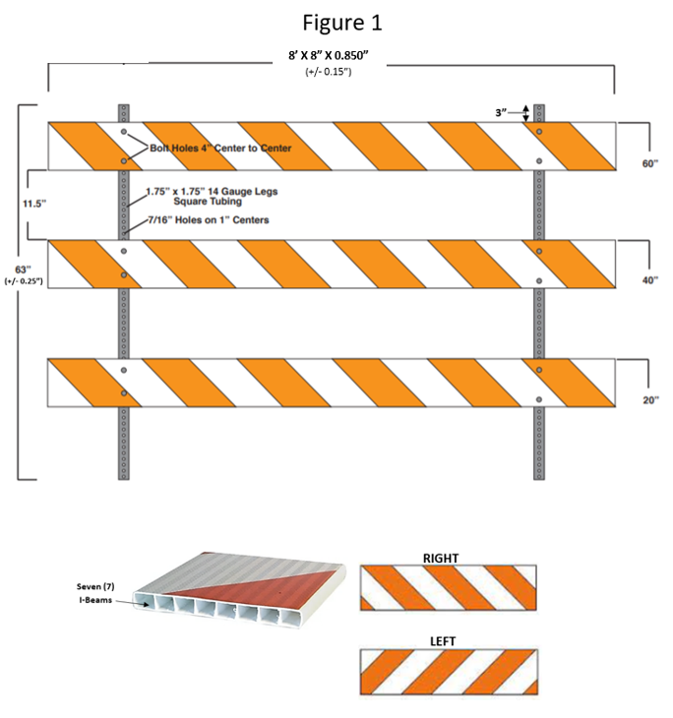

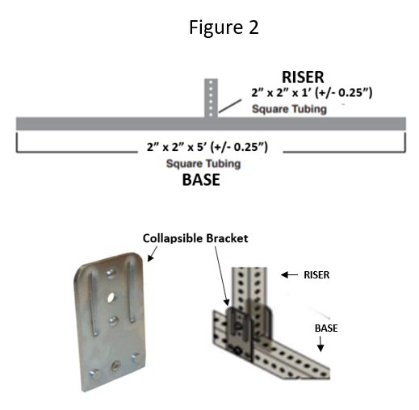

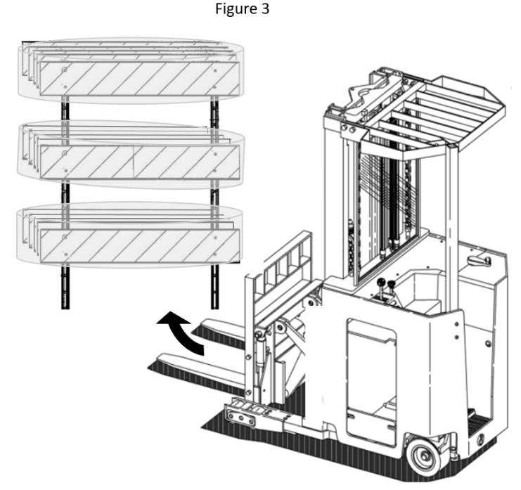

Approved Materials List

Product Category : Reflective Sheeting
MATERIAL : 1015M00245 ReflectSheet,TIII,TempSign,Barr,ChanDev
APS00001860 3M Company TSSD - St. Paul, MN Phone : 337-244-8331 Ext. # :
3M Center, 235-3W-52 Fax :
St. Paul, MN 55144 Contact : John Boudreaux (jboudreaux@mmm.com
)
Product Approved On Remarks
3M Flex Prism Wht/Or 3334R/3334L 4-15-2013 Adhesive Class: Class 1 (Pressure Sensitive) 3M Flex Prism Wht/Or 3336R/3336L 4-15-2013 Adhesive Class: Class 1 (Pressure Sensitive) 3M Flexible Prismatic Orange 3314 4-15-2013 Adhesive Class: Class 1 (Pressure Sensitive) 3M Flexible Prismatic White 3310 4-15-2013 Adhesive Class: Class 1 (Pressure Sensitive) 3M Flexible Prismatic Yellow 3313 4-15-2013 Adhesive Class: Class 1 (Pressure Sensitive) 3M High Intensity PrismBarr Orange 3934 2-25-2010 Adhesive Class: Class 1 (Pressure Sensitive)
Source Adhesive Designation: High Tack Adhesive
SCOTCHLITE Orange 3824 2-25-2010 Adhesive Class: Class 1 (Pressure Sensitive) Source Adhesive Designation: High Tack Adhesive
SCOTCHLITE White 3820 2-25-2010 Adhesive Class: Class 1 (Pressure Sensitive) Source Adhesive Designation: High Tack Adhesive
SCOTCHLITE Yellow 3821 2-25-2010 Adhesive Class: Class 1 (Pressure Sensitive) Source Adhesive Designation: High Tack Adhesive
APS00001980 Avery Dennison - Mt. Prospect, IL Phone : 312-543-0907 Ext. # :
902 Freehanville Drive Fax :
Mount Prospect, IL 60056 Contact : Moe Madar (moe.madar@averydennison.com)
Additional Info : Contact person's mailing address: 7542 N. Natchez Avenue, Niles, IL 60714

Product Approved On Remarks
Avery Dennison Fl Orange WR-7114 5- 8-2024
Avery Dennison Orange W-6504 10-30-2015 Adhesive Class: Class 1 (Pressure Sensitive)
Source Adhesive Designation: Regular Adhesive
Avery Dennison White WC-4100 3-25-2020
Avery Dennison White WR-7100 5- 8-2024
Avery Dennison White/Or W-6200 2-25-2010 Adhesive Class: Class 1 (Pressure Sensitive)
Source Adhesive Designation: Regular Adhesive
APS00002000 Nippon Carbide Industries - Santa Fe Springs, CA Phone : 800-821-4264 Ext. # :
13856 Bettencourt Street Fax : 888-330-7119
Cerritos, CA 90703 Contact : James Hu (cbond@nikkalite.com)
Product Approved On Remarks
Nikkalite Ultralite Grade II White CN512 2-25-2010 Adhesive Class: Class 1 (Pressure Sensitive)
Source Adhesive Designation: High Tack Adhesive
Nikkalite UltraliteGrade II Orange CN507 2-25-2010 Adhesive Class: Class 1 (Pressure Sensitive)
Source Adhesive Designation: High Tack Adhesive
Nikkalite UltraliteGrade II Wh/Or CN517 2-25-2010 Adhesive Class: Class 1 (Pressure Sensitive)
Source Adhesive Designation: High Tack Adhesive

Product Category : Reflective Sheeting
MATERIAL : 1015M00245 ReflectSheet,TIII,TempSign,Barr,ChanDev
APS00002010 ORAFOL Americas, Inc. - Avon, CT Phone : 860-676-7100 Ext. # :
120 Darling Drive Fax : 800-676-7199
Avon, CT 06001 Contact : Chris Gaudette
(reflective-americas@orafol.com)
Product Approved On Remarks
ORALITE 5934-010 White 10-12-2020
ORALITE 5935-010 White 10-12-2020
ORALITE 5935-029 Fl Yellow 10-12-2020
ORALITE 5935-038 Fl Orange 10-12-2020
ORALITE Hi ImpactChannel.TapeC85-1772 Or 5- 5-2015
ORALITE HiImpact Channel.TapeC85-1572 Wh 5- 5-2015

