Attachment B – Specifications

RFx #3000026034

STATE OF LOUISIANA
DEPARTMENT OF TRANSPORTATION AND DEVELOPMENT
TECHNICAL SPECIFICATIONS FOR
MECHANICAL SWEEPER TRUCK, 33,000# GVWR

SERIES NO. 256-850
Equipment Specification 256-850e
REV. 3/4/2026

General
This specification sets forth the minimum requirements for a 33,000# GVWR cab & chassis truck with a mechanical sweeper attachment.
Equipment shall be new, a production model of current manufacture, and must meet all state and Federal safety and emission standards in effect at time of order.
Representative Specifications
A Freightliner M2 106 Plus cab & chassis and an Elgin Broom Bear mechanical sweeper unit, with appropriate options and standard features, was used to develop these specifications and establish equivalency evaluation criteria.
Equipment of similar style, type, character, quality, features, and purpose conforming to the following detailed requirements/specifications will be considered. For evaluation purposes, bidders proposing an exception/equivalent option/feature to those specified herein, may be required to provide manufacturer/product information (catalogue sheets, detailed specifications, pictures, etc.). This information will be evaluated against the minimum requirements of this specification. Proposed submittals that are determined not to be equivalent to the established criteria will be rejected.
Louisiana Authorized Dealer(s)
Proposed item(s) must be from a manufacturer who has at least one (1) authorized dealer within the State of Louisiana where parts and service can be obtained. Authorized dealer(s) must have properly trained technicians plus all other resources necessary to perform warranty and repair services in complete accordance with the manufacturer’s requirements. A letter certifying the ability to meet this requirement, inclusive of the company name(s) and address(es) of the Louisiana authorized dealer(s), should be supplied with the bid submittal and may be required prior to award.
Delivery & Acceptance
Vendor shall perform a test run of each unit to verify that all features and capabilities are operating properly at time of delivery. Documentation of testing may be required prior to acceptance by the Department.
Unit(s) must be delivered completely assembled (including all components, accessories, etc.) and ready for operation without any additional preparation including, but not limited to, ensuring all fluid levels are at their full mark, fuel tank(s) is full, all necessary lubrication has been performed, etc. A Louisiana safety inspection shall be performed on each vehicle prior to delivery and a Louisiana safety inspection sticker properly affixed.
Any unit delivered under this specification is subject to rejection if there is evidence of poor workmanship, by either the vendor or the original manufacturer. Noted defects and/or nonconformance findings may be corrected by the vendor. Corrections must be completed and approved by the Equipment Engineer or his representative prior to final acceptance.
Unit(s) shall be delivered “on the ground;” DOTD will not unload nor provide any unloading equipment to the vendor/delivery driver in order to offload the unit(s).
NOTE: The Department will have space available for equipment to be unloaded.
EACH UNIT MUST BE SUPPLIED WITH THE FOLLOWING DOCUMENTATION AT TIME OF DELIVERY:
- Notarized Bill of Sale
- Original Certificate of Origin (MSO), (no photocopy)
- Dealer's Service Policy
- Owner's/Operator's Manual(s)
  - One (1) Hardcopy
  - One (1) Digital Copy
    - Acceptable Formats: PDF delivered via USB “Flash Drive”, or E-mail
- Service Manual(s)
  - One (1) Hardcopy
  - One (1) Digital Copy
    - Acceptable Formats: PDF delivered via USB “Flash Drive”, or E-mail
- Build Sheet(s) – as applicable
  - One (1) Hardcopy
  - Build sheets should be writing in plain language (not company specific codes) and include, at a minimum, all standard & optional features of the delivered unit.
NOTE: Invoices will not be processed for payment until the unit(s) have been inspected by the Equipment Engineer or their representative and deemed in compliance with the specifications.
Bid Submittals
Any additions, deletions, or variations from the specifications should be noted in the "Bidder’s Exceptions" page of this specification. Exceptions that are noted to be less than a minimum requirement will not be accepted.
Any additions, deletions or variations from the manufacturer’s standard published specifications should be noted on the "Bidder’s Exceptions" page of this specification. Unless otherwise noted, any items appearing in the manufacturer’s standard published specifications furnished by the Bidder are assumed to be included in the Bidder’s submittal.
Bidder should note on their submittal any installation(s) to the equipment that will be performed by the vendor instead of the manufacturer.
Failure to note any specification exceptions, manufacturer specification alterations, and/or vendor installations prior to award may result in rejection of the equipment at the time of delivery.

NOTICE TO BIDDERS
Bidder should review the detailed "Equipment Specification" completely and respond to the compliance question at the end of each section by marking “X”, in the space provided, for "Yes" or "No". Mark "Yes" to indicate that the equipment bid meets the section exactly as specified. Mark "No" if there are exceptions to any part of that section. Exceptions/deviations to any part of the specification are to be detailed on the "Bidder's Exceptions" page of this specification.

IN ORDER TO BE CONSIDERED FOR AWARD, BIDDER SHOULD RETURN THIS SPECIFICATION, COMPLETED IN FULL, WITH THEIR BID SUBMITTAL.

Note: All values listed below are minimums unless noted otherwise.

- Cab & Chassis
  - GVWR: 33,000 lbs.

  - Frame: 1,200,000 RBM (Resisting Bending Moment) - Bidder should list section modulus and yield strength below

Section Modulus: Yield Strength:

  - Cab & Axle Positions
    - Front axle: For the purposes of this solicitation, set-forward-axle (SFA) is considered equal to set-back-axle (SBA); however, SBA is the preferred option
    - Wheelbase: 136” - 144”
    - Cab to Axle (CA): 76” clear*
    - Axle to Frame: 90”
    - Values given here are minimums. Truck vendor and Mechanical Sweeper manufacturer shall coordinate in selecting a wheelbase and cab to axle dimension that is compatible with the required body length and ensures proper load distribution to the axles in accordance with manufacturer and industry practice.

  - Front Bumper
    - Full width all-steel front bumper
    - Two (2) frame mounted tow hooks, one on each frame rail

  - Cab
    - Conventional day cab
    - Dual in-cab drive positions – All sweeper and truck functions available from either driver or passenger side steering controls
    - Tinted safety glass
    - Full width exterior cab mounted sunshade with integral clearance lights
    - Cab entry handles, driver & passenger side
    - Outside mirrors, driver & passenger side
      - Power adjustable
      - 90 sq. in. minimum
      - Heated with integrated turn signals
    - Two (2) adjustable spot mirrors, one (1) per outside mirror
    - Two (2) roof mounted air horns & one (1) standard electric horn
    - Air ride: driver and passenger seat, cab suspension
    - Driver and Passenger seat to be high back with lumbar support
    - Manufacturer’s highest level sound insulation package
    - Wing dash, if available
    - Gauge package including the following gauges:
      - Air cleaner restriction
      - Coolant temperature
      - DEF only if DEF is required to meet emission standards
      - Fuel
      - Oil pressure
      - Primary and secondary air pressure
      - Speedometer
      - Tachometer
      - Voltmeter
      - Gear indicator
      - Odometer
      - Total engine hours
      - Trip hours
      - Trip odometer
      - Rear axle oil temperature
      - Auto transmission oil temperature
    - Dual sun visors
    - Two (2) cup holders, integral to dash
    - 3-point seat belt for each seat. All seat belt webbing must be manufacturer’s high visibility color (Orange, Red, Green, or Yellow).
    - Climate control, including air conditioning, heater, & defroster
    - Power windows & power door locks
    - Tilting steering wheel

  - Engine
    - 8.9 L, electronic diesel, turbocharged, liquid cooled, 6-cylinder inline configuration
    - 300 HP, 860 FT-LBS
    - Engine must include Engine Exhaust brake with Variable Vane Turbo Charger
    - Emission system must comply with emission standards in effect as of date manufactured
    - If DEF is required, DEF tank to be located on driver’s side next to fuel tank
    - If DEF is required, DEF tank must have a minimum capacity of 6 gallons
    - DEF tank protected with Stainless Steel or similar cover to prevent corrosion
    - Engine must be biodiesel compatible
    - Horizontal exhaust after-treatment (DPF) with vertical tail pipe; with tailpipe guard

  - Fuel System
    - Fuel tank shall be metal with drain and a 50-gallon minimum capacity; tank should be located on driver’s side; tank straps Stainless Steel to prevent corrosion
    - Davco fuel processor or equal - mounted to outside of frame
    - Visual element change indication that is integral to and non-removable from unit (to be located on driver’s side near fuel tank)
    - Water-in-fuel sensor with indicator in cab

  - Transmission
    - Automatic, Allison 3500 RDS or equal
    - Wide Ratio, 6 speed with overdrive
    - Neutral at stop
    - Must include PTO aperture
    - To be filled with manufacturer approved synthetic lubricants
    - Transmission Control Module to be mounted in cab to protect from corrosion
    - Transmission cooler lines to be made of stainless steel
    - Transmission oil level sensor

  - Gearing, Speed Governing & Performance
    - Top gear road speed shall be electronically governed at 65 mph maximum
    - Transmission and axle ratio shall be selected for performance to be optimized at 65 mph.

  - PTO
    - PTO must be air shifted and compatible with specified transmission
    - PTO must be activated by dash mounted factory upfitter switch

  - Front Axle
    - Hendrickson Steertek NXT or Detroit DA-F-10.0-3 or equivalent- 10,000 lbs. GAWR @ ground capacity (5,000 lbs. capacity per spring @ ground)
    - Shock absorbers
    - Integral power steering
    - Wet-type, visible cap axle seals, Stemco or equal
    - Axle should be filled with manufacturer approved synthetic lubricants

  - Rear Axle
    - Dana Spicer S23-172 or Meritor RS-23-160 or equivalent, Single speed, 23,000 lbs. GAWR @ ground capacity
    - Air-ride suspension
    - Shock absorbers
    - Axle should be filled with manufacturer approved synthetic lubricants

  - Brakes
    - Full air disc brake system, ABS brake system with traction control
    - 18 CFM air compressor
    - Bendix AD-9SI air dryer or equal

  - Wheels & Tires
    - Hub piloted steel disc, size - 8.25 X 22.5
    - First line, first quality tires, size – 11R22.5
    - Front tires - single highway tread
    - Rear tires - dual on/off road tread
    - Load ratings to be compatible with GVWR
    - Spare tire, jack, & lug wrench are NOT required

  - Electrical System & Lights
    - 12-volt system
    - Minimum of 165-amp alternator
    - Batteries with 2000 CCA combined, maintenance free, top threaded stud
    - Aluminum battery box with plastic cover
    - Remote jump start studs, with tethered protective caps, located outside of the battery box
    - Battery disconnect switch, located inside cab, near driver’s seat, similar to the below picture.
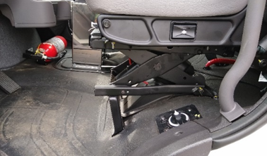

    - Battery Discharge protection
    - Minimum of Four (4) dash mounted, rocker-style, factory installed, body circuit switches (upfitter switches) for simple on/off functions for accessories (PTO, warning lights, etc.; one (1) assigned to activate the PTO; one (1) assigned to operate the flashing warning lights; two (2) blank to be assigned by DOTD personnel.
    - All exterior lighting should be LED except Headlights
    - Headlights:
      - Halogen or LED acceptable
      - Automatic daytime running lights
      - Automatic on if windshield wipers are turned on
      - Automatic on with low ambient light levels
      - Warning buzzer/alarm when headlight switch is on and ignition switch is in off position
    - Intermittent windshield wipers with washers
    - Self-cancelling directional signals
    - Backup alarm, 97 dba
    - AM/FM/WB radio with auxiliary front input, Bluetooth/hands free function and steering wheel controls
    - Two (2) 12V accessory power outlets with covers, mounted in dash (for cell phone chargers, GPS devices, etc.)

  - Paint
    - Cab: Manufacturer’s standard white
    - Chassis: Manufacturer’s standard black
    - Cab and Frame treated for Corrosion Mitigation which will include: all access holes created before primer coat application, weld through epoxy sealant applied, Intercoat® Chemguard or equivalent coating applied to all corrosion prone areas, Line-X® or equivalent applied to floor inside cab , corrosion resistant frame rails

  - FMCSA/DOT Mandated Safety Items
    - One (1) UL listed, 5 B:C rated, or higher, fire extinguisher securely mounted in cab
    - One (1) set of three (3) bidirectional reflective triangles conforming to FMVSS No. 125
    - At least one (1) spare fuse for each type/size used in the truck

Note: The truck vendor and attached equipment manufacturer/vendor must mutually resolve any unexpected truck/attached equipment component conflict with a sound and functional solution as a requirement of this specification.

- Attached Equipment – Mechanical Sweeper
  - Side Brooms
    - Powered by direct drive hydraulic motor mounted to broom disc plate, leading arm, free floating, 4-way motion design, constant rotation speed regardless of engine speed or sweeper ground speed.
    - Down force and rotational speed are adjustable independently by in-cab controls
    - Broom diameter of 46” width, 6 plastic segments filled with 26” long tempered wire (discs drilled for either six or five segment use)
    - Side brooms must be capable of extending from 110” to 144” combined, and each with spotlight

  - Main Broom
    - Powered by direct drive hydraulic motor, 34” diameter by 60” long, full floating type, constant rotation speed regardless of engine or sweeper ground speed
    - Broom will be Prefab disposable type with 34” polypropylene brush material, broom hood and work light included
    - Digging pressure and wear control is to be controlled by Variable geometry spring
    - Mounting for main broom shall be Full-floating trailing arm design
    - Sweeping path width shall be 8’ with one side broom and 10’ with both side brooms
    - The main broom will be raised and lowered hydraulically, and capable of movement independently of conveyor assembly

  - Conveyor
    - Conveyor shall be a Chevron belt conveyor with full width angled cleats
    - The conveyor must be able to load hopper to 100% of rated useable capacity
    - Conveyor driven with a direct drive hydraulic motor. Conveyor speed and direction are independently adjustable in cab regardless of engine or sweeper ground speed.
    - Main broom will stop when conveyor is put into reverse
    - Conveyor floor plate to be a 4-piece bolt in design
    - Conveyor floor plate is to be constructed of abrasion resistant steel plates
    - Conveyor shall be capable of being raised to achieve 12” ground clearance for large object passage
    - Conveyor shall have a cascade wash down system with a fill diverter

  - Hopper
    - Hopper will have a volumetric capacity of 5.4 cubic yards with a lift capacity of 11,000 lbs.
    - Hopper must have an inspection door and shall dump on the right side of sweeper
    - The dump controls are to be Electro/Hydraulic design with controls mounted in the cab
    - The hopper dump height will be variable from 38” to 134”
    - Lift mechanism is to be 2-stage scissor lift design with separate lift and dump cylinders
    - Construction to be of abrasion resistant material
    - Outriggers to stabilize the sweeper during dumping are not acceptable

  - Dust control system
    - The dust control system shall have a water tank of polyethylene construction with a capacity of 360 gallons
    - The water tank shall have a level indicator in the truck cab
    - The dust control system shall have an electrically driven diaphragm water pump that is self-priming and capable of running dry without damage.
    - Pump control in cab with flow control valves at each side broom
    - The dust control system shall have four (4) spray sections: 3 spray nozzles over each gutter broom, 3 spray nozzles over main broom and spray bar mounted to front of sweeper
    - All 4 spray sections independently regulated with in-cab controls
    - The system shall come with a water fill hose 15’ long with a 2.5-inch NST hydrant coupling with a hydrant wrench
    - The system shall have an inline 80 mesh plastic housing filter with a shut off valve

  - Hydraulic System
    - Single PTO driven variable displacement pump, minimum of 15.4 GPM with load sensing capability to power all hydraulic requirements.
    - Hydraulic reservoir capacity of 23 gallons (minimum) with a 10-micron breather filter and a 100 mesh inlet strainer.
    - The hydraulic system shall include a 6 micron return line filter an in-cab restriction indicator
    - All hydraulic valves shall be of the Electro- Hydraulic design with LED indicator lights and manual overrides.
    - The hydraulic system shall include an externally mounted hydraulic oil cooler

  - Pneumatic System
    - Air provided by chassis air system with isolation protection
    - All pneumatic cylinders shall be interchangeable, rated for 150 PSI, and have separate rod seal and wiper

  - Electrical System
    - Sweeper electrical system shall be 12-volt negative ground integral to chassis electrical system via builder plug.
    - All wiring harnesses shall be color coded, hot stamp identified with weatherproof connectors
    - The sweeper shall have circuit protection activated by an ignition switched constant duty solenoid (except lights), circuit breakers and/or fuses.
    - The sweeper shall have a backup alarm, rear identification lights, side broom lights and rear clearance lights.
    - A rear mounted arrow board (must meet MUTCD type C requirements), 30” x 60”, Wanco Model WB or approved equal, with 25 PAR 36 LED lamps, in-cab controller shall be installed

  - Sweeper Operating system
    - The sweeper operating system shall have a memory function which allows the operator to resume all previous sweeping settings with one-touch control
    - Sweeper system shall also include a multi-screen display for tilt angle, broom hours, water level and diagnostic functions
    - Sweeper shall automatically pause when the sweeper is not sweeping and re-engage immediately upon vehicle movement.

  - Controls
    - All necessary sweeper controls and instrumentation shall be mounted in a centrally located console in the truck cab, to be operated by driver in either left or right operating stations.
    - Hydraulic and electrical controls will be located behind large access doors. The sweeper shall include an automatic lubrication system.
    - The sweeper shall have a camera system with views of the brushes with an in-cab monitor which can be viewed by the driver.

  - Warning Lights, Wiring and High Visibility Conspicuity Tape
    - Truck must be delivered with warning lights & high visibility reflective conspicuity tape installed in accordance with the below specifications and layout.
    - All warning lights to be sealed light emitting diode (LED) type, with plug-in connectors.
    - Warning lights shall be installed by an upfitter who is experienced in and regularly engages in the installation of automotive electronics & warning lights.
    - Installer shall use vehicle & lighting manufacturers’ guidance along with industry best practices and techniques to ensure that lights are installed in a safe and neat manner
    - All wiring and cables should be color coded, heat shrink wrapped and logically routed, secured, and protected with convoluted loom where possible
    - All wiring splices must be made using butt or parallel crimp connectors
    - Non-metallic/rubber grommets shall be used where wires and cables penetrate any cab panels, body panels, or chassis structure
    - All cab and body penetrations shall be adequately sealed to prevent water from entering
    - All warning lights to be controlled by a single in-cab, dash-mounted upfitter switch. The switch must be labeled to read “Warning Lights”
    - Installer shall contact DOTD Equipment Section prior to programming to confirm intended flash pattern(s)
    - All lighting must meet Federal and state requirements

  - Mid-size & Mini Light Bars
    - SoundOff Signal nRoads Mini/Mid-Size or equal satisfying the following requirements
    - Two (2) mid-size (21” - 24”) light bars shall be installed in the locations shown below
    - Lengths are nominal and +/- 1” is acceptable
    - Dual color - 12 diodes per module (equal number of green & amber)
    - All diode positions must be capable of displaying both colors
    - Flash pattern capable of alternating between an asymmetric, low-frequency, “wigwag” pattern and a low-frequency double or quad flash.
    - UV resistant clear polycarbonate lens
    - 10-16 VDC
    - Light bars shall meet all applicable federal/state laws and regulations
    - Shall be SAE J845 360-degree Class 1 certified

  - Front Grill Lights
    - Brooking Industries XT12D (or ST6D) perimeter lighthead or equal satisfying the following requirements
    - Size: Length: 4.25-5.26 in., Width: 1.0-2.0 in., Height: 0.3-0.4 inches
    - 12-24 VDC
    - UV resistant clear polycarbonate lens, black bezel trim
    - 12 diodes - dual color - (equal number of green & amber)
    - Lighthead shall be capable of displaying each color across full length
    - Capable of alternating between an asymmetric, low-frequency, “wigwag” pattern and a low-frequency double or quad flash
    - Lighthead shall meet all applicable federal/state laws and regulations
    - Shall be SAE J595 Class 1 certified

  - Lighting Location
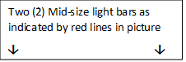
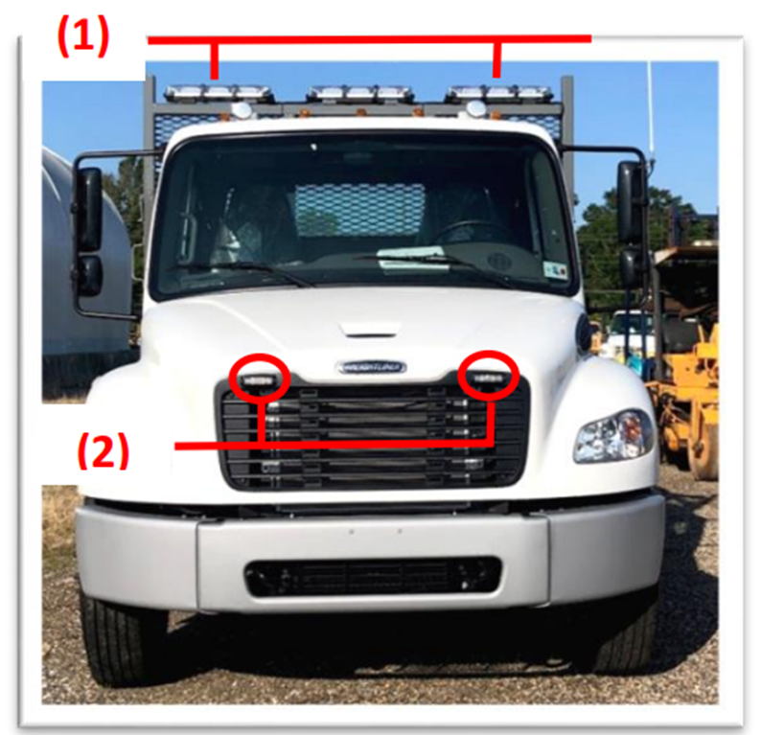
Two (2) front grill lights as indicated by 2 red circles

  - High Visibility Reflective Tape
    - DOT C2 approved high visibility reflective conspicuity tape, 2” wide, with alternating 6” segments of red and white, shall be placed above the rear wheels from front of sweeper body to the rear of sweeper body
    - High visibility reflective conspicuity tape, 2” wide, with alternating 6” segments of green and high visibility yellow, shall be placed on the rear of the body in line with reflective tape on sides of sweeper body

  - Additional Features & Accessories
    - All controlling elements for the sweeper’s systems shall be centrally housed in a single easily accessible locker that is sealed and weatherproof.
    - Rear-mounted arrowboard (must meet MUTCD type C requirements), 30” X 60”, Wanco Model WB or approved equal, with 25 PAR 36 LED lamps, in-cab controller.

  - Body Installation
    - A sill spacer is not required; however, a rubber or plastic (nylon or Delrin) sill spacer is allowed between the frame & body sills; WOOD SPACERS ARE NOT ALLOWED
    - Body should be bolted to frame using brackets or fishplates. U-BOLTS ARE NOT ALLOWED
    - Upfitter should utilize chassis manufacturer’s guidance for body mounting methods
    - Brackets

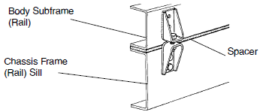

    - Fishplate - to be bolted to chassis frame, utilizing existing holes where possible, and bolted or welded to body sub-frame/sill. (See image below)

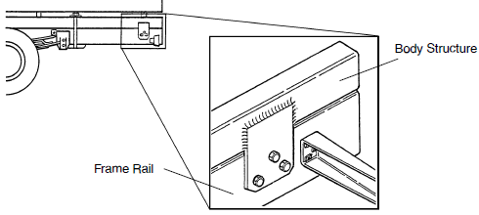

  - Paint
    - All sweeper surfaces shall be treated to be corrosion resistant. The entire body will be High-gloss white Powder Coat. All underslung sweep gear and bracketry shall be corrosion resistant and grey Powder Coat.

  - Manuals
    - The supplier shall provide one printed version and one electronic version of the Operators’ manual for the truck.
    - The supplier shall provide one printed version and one electronic version of the Operators’ manual for the Mechanical Sweeper.
    - The supplier shall provide one printed version and one electronic version of the parts manual for the mechanical sweeper.

  - Installation: The installation of sweeper unit and lighting shall be completed at the supplier’s location. It shall be the responsibility of the supplier to insure that all unit items are properly located and installed.

Instructions: Bidder should note all exceptions in space provided below. List the detail number from the aforementioned specification in the column to the left and the exception in the column to the right. Responses may be typed or hand-written. Handwritten responses must be legible. If additional space is needed, please print a duplicate copy of this sheet. "Bidder’s Exceptions" page(s) should be returned with the bid submittal.
Examples:
1.6 Engine has 325 horsepower
1.18.3 Batteries have 2000 CCA combined.
2.2.8 Crossmembers are 4” channel on 12” centers.

Spec./Detail
Reference Exception

