Attachment B – Specifications

RFx #3000026001

STATE OF LOUISIANA
DEPARTMENT OF TRANSPORTATION AND DEVELOPMENT
TECHNICAL SPECIFICATIONS FOR
TRUCK, CAB & CHASSIS, 22,000# GVWR, WITH HERBICIDE SPRAYER

SERIES NO. 269-000
Equipment Specification 269-000K
REV. 2/6/2026

General
This specification sets forth the minimum requirements for a 2wd regular cab and chassis (22,000# gvwr) outfitted with an herbicide sprayer.
Equipment shall be new, a production model of current manufacture, and must meet all state and Federal safety and emission standards in effect at time of order.
Representative Specifications
A Ford F600 or International CV cab & chassis with a 1,000-gallon spray system, with appropriate options and standard features, was used to develop these specifications and establish equivalency evaluation criteria.
Equipment of similar style, type, character, quality, features, and purpose conforming to the following detailed requirements/specifications will be considered. For evaluation purposes, bidder's proposing an exception/equivalent option/feature to those specified herein, may be required to provide manufacturer/product information (catalogue sheets, detailed specifications, pictures, etc.). This information will be evaluated against the minimum requirements of this specification. Proposed submittals that are determined not to be equivalent to the established criteria will be rejected.
Louisiana Authorized Dealer(s)
Proposed item(s) must be from a manufacturer who has at least one (1) authorized dealer or multiple field service technicians that are domiciled within the State of Louisiana where parts and service can be obtained. Authorized dealer(s) must have properly trained technicians plus all other resources necessary to perform warranty and repair services in complete accordance with the manufacturer’s requirements. A letter certifying the ability to meet this requirement, inclusive of the company name(s) and address(es) of the Louisiana authorized dealer(s), should be supplied with the bid submittal and may be required prior to award.
Delivery & Acceptance
Vendor shall perform a test run of each unit to verify that all features and capabilities are operating properly at time of delivery. Documentation of testing may be required prior to acceptance by the Department.
Unit(s) must be delivered completely assembled (including all components, accessories, etc.) and ready for operation without any additional preparation including, but not limited to, ensuring all fluid levels are at their full mark, fuel tank(s) is full, all necessary lubrication has been performed, etc. A Louisiana safety inspection shall be performed on each vehicle prior to delivery and a Louisiana safety inspection sticker properly affixed.
Any unit delivered under this specification is subject to rejection if there is evidence of poor workmanship, by either the vendor or the original manufacturer. The vendor may correct noted defects and/or nonconformance findings. Corrections must be completed and approved by the Equipment Engineer or his representative prior to final acceptance.
Unit(s) shall be delivered “on the ground;” DOTD will not unload nor provide any unloading equipment to the vendor/delivery driver in order to offload the unit(s).
NOTE: The Department will have space available for equipment to be unloaded.
EACH UNIT MUST BE SUPPLIED WITH THE FOLLOWING DOCUMENTATION:
- Notarized Bill of Sale
- Certificate of Origin (MSO)
- Dealer's Service Policy
- Owner's/Operator's Manual(s)
  - One (1) Hardcopy
  - One (1) Digital Copy
    - Acceptable Formats: PDF delivered via USB “Flash Drive”, or E-mail
- Service Manual(s)
  - One (1) Hardcopy
  - One (1) Digital Copy
    - Acceptable Formats: PDF delivered via USB “Flash Drive”, or E-mail
- Build Sheet(s) – as applicable
  - One (1) Hardcopy
  - Build sheets should be writing in plain language (not company specific codes) and include, at a minimum, all standard & optional features of the delivered unit.
NOTE: Invoices will not be processed for payment until the unit(s) have been inspected by the Equipment Engineer or their representative and deemed in compliance with the specifications.
Bid Submittals
Any additions, deletions, or variations from the specifications should be noted in the "Bidder’s Exceptions" page of this specification. Exceptions that are noted to be less than a minimum requirement will not be accepted.
Any additions, deletions or variations from the manufacturer’s standard published specifications should be noted on the "Bidder’s Exceptions" page of this specification. Unless otherwise noted, any items appearing in the manufacturer’s standard published specifications furnished by the Bidder are assumed to be included in the Bidder’s submittal.
Bidder should note on their submittal any installation(s) to the equipment that will be performed by the vendor instead of the manufacturer.
Failure to note any specification exceptions, manufacturer specification alterations, and/or vendor installations prior to award may result in rejection of the equipment at the time of delivery.

NOTICE TO BIDDERS
Bidder should review the detailed "Equipment Specification" completely and respond to the compliance question at the end of each section by marking “X”, in the space provided, for "Yes" or "No". Mark "Yes" to indicate that the equipment bid meets the section exactly as specified. Mark "No" if there are exceptions to any part of that section. Exceptions/deviations to any part of the specification are to be detailed on the "Bidder's Exceptions" page of this specification.

IN ORDER TO BE CONSIDERED FOR AWARD, BIDDER SHOULD RETURN THIS SPECIFICATION, COMPLETED IN FULL, WITH THEIR BID SUBMITTAL.

Note: All Values listed below are minimums unless noted otherwise.

- Cab & Chassis
  - GVWR: 22,000 lbs.

  - Frame: 500,000 RBM (Resisting Bending Moment) - Bidder should list section modulus and yield strength below

Section Modulus: Yield Strength:

  - Cab to axle (CA) and axle to end of frame (AF)
    - CA: 84”
    - AF: 72”
*Values given here are minimums. The space between cab and body shall not exceed 10 inches. Truck vendor and service body manufacturer/upfitter shall coordinate in selecting a cab to axle dimension that works with the specified body and ensures the wheel well is aligned with the center of the axle. The required AF must be achieved with factory frame rails. Frame extensions to meet the required AF are not allowed. The AF must be sufficient to allow support of the full length of the body.

  - All steel front bumper and 2 frame mounted tow hooks

  - Cab
    - Conventional day cab
    - Tinted safety glass
    - Cab entry handles, driver & passenger side
    - Outside mirrors, driver & passenger side
      - Power adjustable
      - Heated
      - Convex spot mirrors
    - Manufacturer’s highest level sound insulation package
    - 40/20/40 vinyl split bench seat with fold down center console/arm rest
    - Gauge package including the following:
      - Coolant temperature
      - Fuel
      - Oil pressure
      - Speedometer
      - Tachometer
      - Gear indicator
      - Odometer
      - Trip odometer
      - Auto transmission temperature
    - Dual sun visors
    - Two (2) cup holders, mounted in dash or center console
    - Climate control, including air conditioning, heater, & defroster
    - Power windows & power door locks
    - Tilting and telescoping steering wheel
    - Driver and passenger airbags
    - Running boards/cab entry steps

  - Engine & Fuel
    - 6.6 L, diesel, liquid cooled
    - 300 HP, 700 FT-LBS
    - Fuel Tank: 40-gallon min. capacity

  - Transmission
    - Automatic, with PTO provision
    - To be filled with manufacturer approved synthetic lubricants

  - PTO
    - PTO must be activated by dash mounted factory upfitter switch
    - Indication of PTO engagement should be accomplished by lighted switch or separate dash mounted indicator light

  - Front Axle
    - 7,500 lbs. GAWR @ ground capacity
    - Shock absorbers

  - Rear Axle
    - 15,500 lbs. GAWR @ ground capacity
    - Shock absorbers
    - Limited slip or locking differential

  - Brakes: Power assist 4-wheel disc brakes with ABS

  - Wheels & Tires
    - 6.00”x19.5”, 10 bolt steel wheels
    - First line, first quality tires
      - Front – 245/70R19.5G, single highway tread
      - Rear – 245/70R19.5G, dual on/off road tread
    - Combined load ratings must be compatible with axle ratings and GVWR

  - Chassis Electrical System & Lights
    - 12-volt system
    - Alternator to be minimum of 240 amps
    - Dual batteries with 1500 CCA combined
    - Battery disconnect switch, preferably located inside cab, near driver’s seat, similar to the picture below.
      - The switch must be a Perko (or approved equal) marine grade, sealed battery disconnect if located outside of cab.

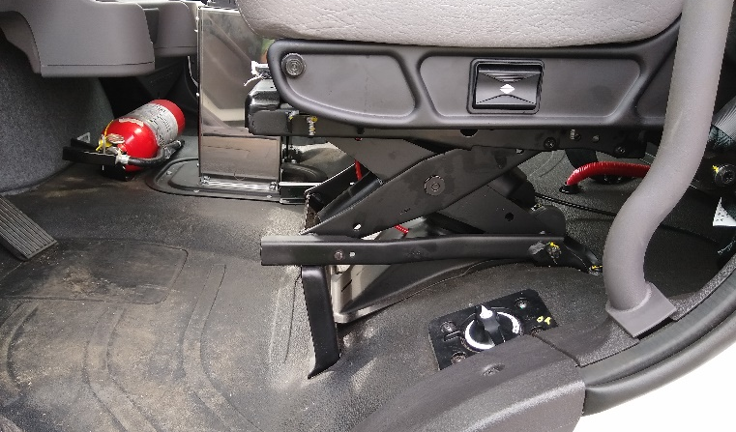

    - Four (4) factory installed body circuit switches (upfitter switches) for simple on/off functions for accessories (PTO, warning lights, etc.; one (1) assigned to activate the PTO; one (1) assigned to operate the flashing warning lights; and two (2) blank to be assigned by DOTD personnel.
    - Headlights:
      - Automatic daytime running lights
      - Automatic on with low ambient light levels
      - Warning buzzer/alarm when headlight switch is on and ignition switch is in off position
    - Taillights:
      - Six (6) 6” oval, recessed, grommet, snap-in mount LED
        - Two (2) Red for Brake Light
        - Two (2) Red for Turn signals
        - Two (2) White for Reverse lights
    - Roof mounted clearance marker lights
    - Cruise control
    - Backup alarm, 97 dba
    - Backup camera
    - AM/FM radio with auxiliary front input, Bluetooth/hands free function and steering wheel controls
    - Two (2) 12V accessory power outlets with covers, mounted in dash (for cell phone chargers, GPS devices, etc.). One (1) 12V power outlet and one (1) USB charging outlet will also satisfy this requirement.
    - Factory trailer brake controller

  - Paint
    - Cab: Manufacturer’s standard, white
    - Chassis: Manufacturer’s standard, black

  - FMCSA/DOT Mandated Safety Items
    - One (1) UL listed, 5 B:C rated, or higher, fire extinguisher securely mounted in cab
    - One (1) set of three (3) bidirectional reflective triangles conforming to FMVSS No. 125
    - At least one (1) spare fuse for each type/size used in the truck

- Truck Bed & Tank Support
**NOTE: Drawings for reference. Dimensions on drawings are approximate. Vendor may deviate slightly to compensate for fabrication tolerances.
    - Bed
      - 8’ x 12’ (minimum)
      - Deck: 1" X 3/16” 19-W-4 welded steel grating.
      - Frame Rail: 2” x 6” x ¼” channel
      - Floor joists: 1 ¼” x 3” x ¼” channel – maximum of 16" centers
      - Side Rail: 1 5/8” x 4” x ¼” channel
      - Rear Plate: ¼” steel plate construction
      - Bumper: 62” wide
      - 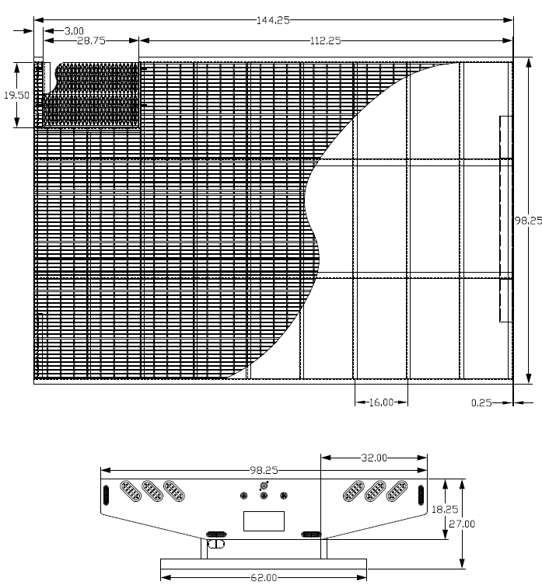

      - The bed shall have all LED stop and running lights and reflectors installed in compliance with Federal DOT regulations.

    - Stairs
      - The bed shall contain recessed stairs to allow access to the center-mounted chemical tank.
      - The recessed stairs shall be located on the front passenger side of the bed.
      - The stairs shall consist of two (2) 9 ½” wide by approximately 28 ¾” long stair treads and one (1) hinged step that swings down to 14-16 inches above the ground.
      - The drop-down step shall lock in place via a sliding hinge point when stowed.
      - The recessed stairs shall be boxed in with ¼” plate.

      - 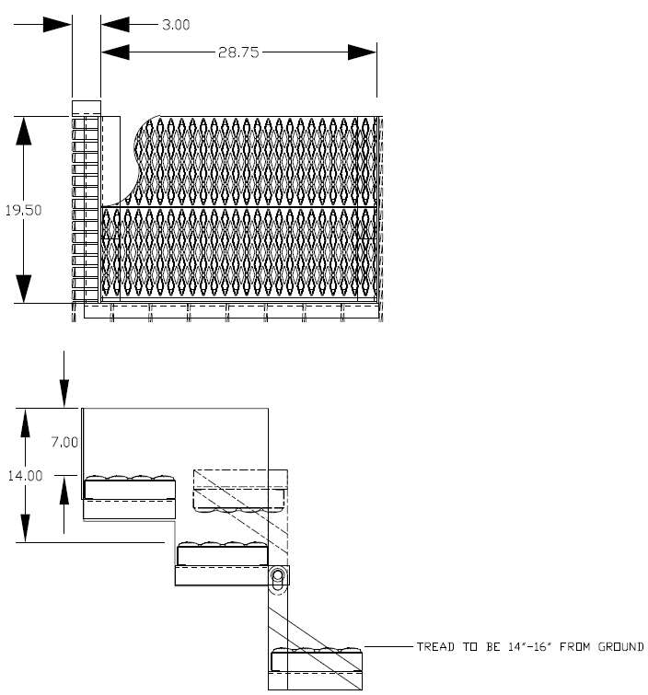

    - Hand Rail
      - 1”, Sch. 80 Tubing
      - 20” wide x 30” tall
      - Two (2) 1 ½” x 4” x ¼” mounting plates to be bolted to the bed.
      - Handrail shall be mounted on the left side of stairs.
      - 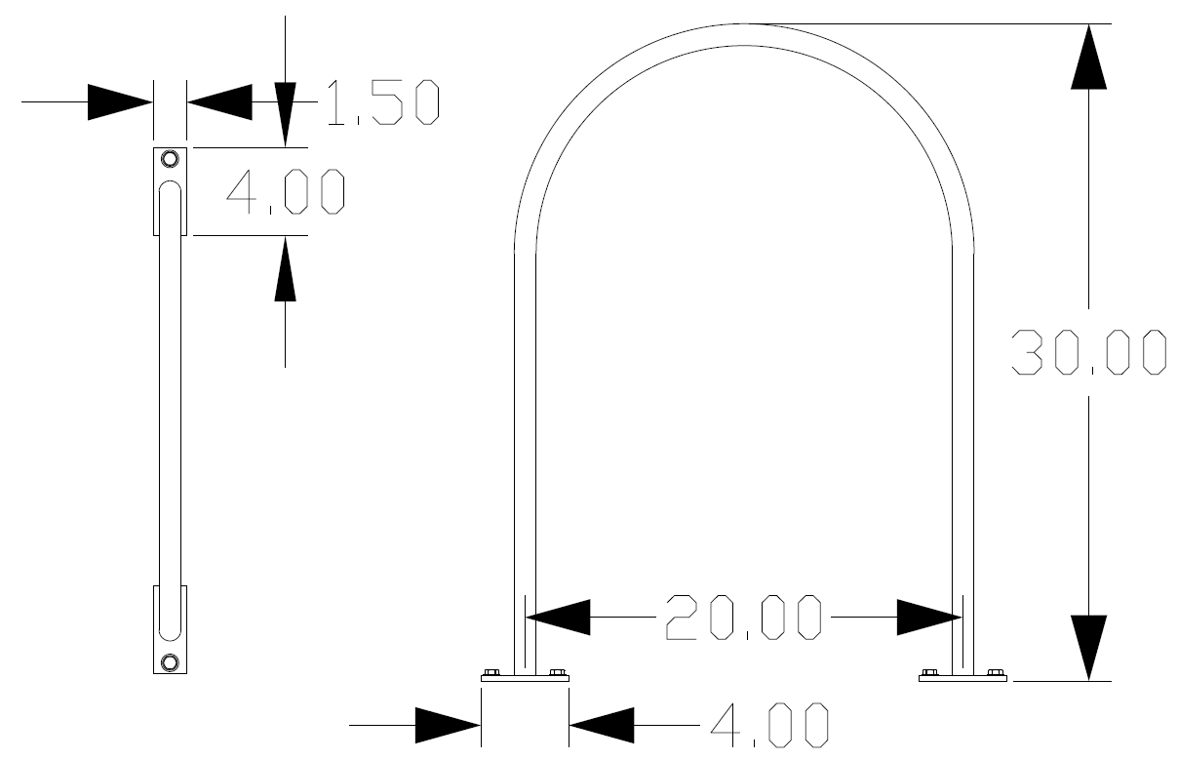

    - Headache Rack
      - The bed shall have a headache rack
      - The headache rack will contain safety lighting as per the attached safety lighting requirements section.
      - The headache rack is not to be more than 5” wider than the truck cab on each side.
      - The headache rack shall follow the contour of the truck cab.

      - 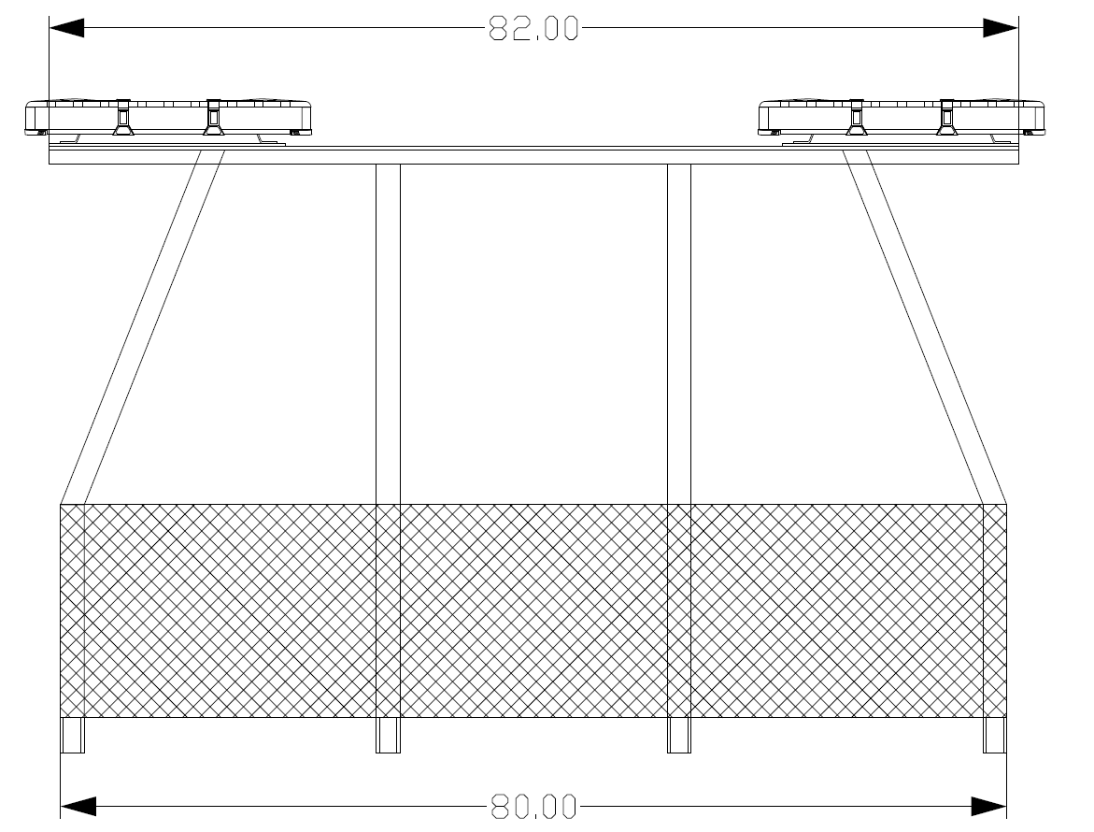

    - Fender and Mud Flaps
      - A round fender is to be mounted under the bed covering the rear dual wheels.
      - Mud flap brackets are to be a permanent part of the body.

    - Coating
      - Entire body to be hot dipped galvanized after fabrication. Sprayed on type coatings are not acceptable.
      - Minor surfaces of the bed that cannot be galvanized shall have two (2) coast of primer, two (2) coats of industrial black paint.

  - Arrow Board
    - The arrow board size shall be 30” vertical X 60” horizontal.
    - The arrow board shall be constructed of aluminum and shall be adequately framed and braced for a permanent vertically mounted position.
    - The arrow board shall be mounted as close to rear of tank as possible.
    - There shall be twenty-five (25) PAR 46 LED amber lamps. The lamps shall be 12-volt and shall have visors that extend at least 5” beyond the lamp face and that encompass 180 degrees or more of the lamp circumference.
    - The lamps must meet all State and Federal regulations.
    - Maximum overall height shall not exceed 10’
    - The arrow board shall be powered by the truck electrical system.
    - The arrow board controller shall be an electronic unit mounted in the cab.
      - The controller shall have an on-off switch, selector for various display modes, and a manual “bright-dim” lamp intensity adjustment.
      - All active components shall be solid state.

- Herbicide Sprayer System
**NOTE: Drawings for reference. Dimensions on drawings are approximate. Vendor may deviate slightly to compensate for fabrication tolerances.
  - The sprayer unit shall be capable of applying chemicals for the following vegetation and ice management applications:
    - Tank mix application of selective type herbicides or foliar applications to control brush across the right-of-way up to a width of 25’.
    - Rear spray bar for brine application.
    - Spot application of herbicide to shoulder edges of pavement, curb and gutters, signs, culvert ends, bridge abutments, and narrow or wide medians.

  - Water/Herbicide Tank
    - The tank shall be an elliptical leg shaped 1,000-gallon capacity unit.
    - The tank shall be UV stabilized, black polyethylene.
    - Tank shall have built in U.S. gallon indicators on each end.
    - A water level gauge shall be installed on both the front and rear of the tank.
    - The tank shall be secured to a chassis mounted flatbed with a minimum of three (3) heavy-duty, galvanized tubular steel bands.
    - The base plate for each band shall be constructed with bolts that pass through the flatbed deck and bed cross member.
    - The bands shall provide adequate support for continuous off-road operation.
    - The tank lid shall be a minimum 16” diameter, positive locking type with an air vent to prevent damage from excessive pressures or vacuum.
    - 1 ½” ball valve installed at each end of the tank as close as possible to the tank bottom.
      - Suction shall be closest to the cab (lower end) and return on the opposite end to ensure proper agitation.
    - A TeeJet Model 46550-1-1/2-PP (or approved equal) eductor shall be installed in the tank on the return side bulkhead fitting.
    - The hose between the tank and the water pump shall be 1 ½” non-collapsible suction type.

  - Quick Fill System
    - There shall be a 2” air gap quick fill system mounted in the top of the tank lid.
    - 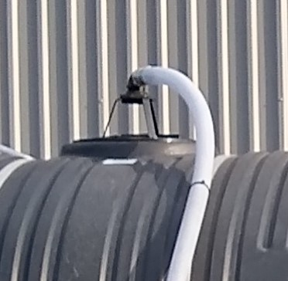
    - A 2” ball valve and “Y” strainer with a male quick disconnect and dust cap shall be installed on the right-hand side of the truck bed.
    - A 2” X 25’ quick disconnect fire hose with standard 2 ½” fire hydrant female swivel shall be mounted by the fill system for easy access.

  - Chemical Tank
    - The unit shall be equipped with one (1) 20-gallon polyethylene cone-type chemical holding tank with a 16” opening lid.
    - The tank shall be mounted in the center of the bed, in front of the main tank.
    - The chemical tank shall be plumbed for easy draining of chemical into the suction line before the centrifugal pump.
    - The tank shall have a shut off valve as close to the bottom of the tank as practical to close off flow once the chemical is added to the main tank.
    - The tank shall include a Chem-Blade Original or equivalent to open, empty and rinse 2.5gal chemical jugs.
    - The rinse system plumbing shall be plumbed to receive a garden hose for fresh water to rinse the jugs.

  - Fresh Water Supply Tank
    - 9-gallon polyethylene tank.
    - Tank shall have a ¾” 90º ball valve for hand washing.
    - Tank shall be mounted to an elevated bracket, bolted between the stairs and the main tank fill hose on the passenger side of the truck.
    - 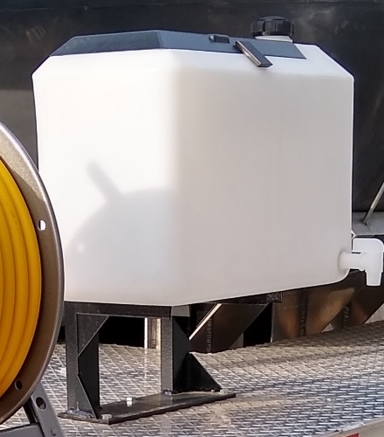

  - Spray Pump System
    - The main system shall have a hydraulically driven centrifugal pump (Hypro 9303S-HM1C or equivalent)
powered by a pressure and flow compensated load sensing hydraulic system.
    - The system will be sized to drive the water pump and spray system in excess of the required flow and pressure when the truck engine is operated at 1,000 RPM.
    - The hydraulic pump must be a variable displacement piston pump driven “live” from the truck transmission.
    - The “on-off” control switches for sprayer pump will be located in the cab control center.
    - A 4 ½” liquid filled pressure gauge for easy viewing from the driver’s seat to monitor system pressure
    - A 30-gallon hydraulic reservoir shall be mounted below the flat bed in an area that allows for easy access.
    - The hydraulic system and tank shall have a suction strainer, return filter, sight gage, filler breather and cut-off ball valve in the return suction lines.

  - Plumbing and Filters
    - All hoses (except where stated) shall be rated at a minimum operating pressure of 150 PSI.
    - All plumbing and filters (except where stated) shall be brass, stainless or polypropylene construction, sized and placed to complete the operation of the unit.
    - A 1 ½” 20-mesh strainer shall be placed between the tank and spray pump and a 1” 40-mesh strainer shall be placed on the pressure side of the pump.
    - Placement of plumbing and filters shall allow easy access for cleaning and repairs.

  - Fittings
    - All fittings shall be brass or stainless steel, or black schedule 80 polypropylene.
    - No galvanized or nylon fittings shall be acceptable.
    - All nozzles shall be stainless steel or brass and machined to provide the various spray patterns as required to distribute the spray solutions in the most efficient and safe manner possible.

  - Application Control System (without injection)
    - The computerized control system shall be a Mid-Tech, Tee Jet TASC 6100 or approved equivalent.
    - The system shall contain a flow meter, auto range valve and speed sensing equipment necessary to automatically maintain the preset gallons per acre.
    - It shall be mounted on a swivel device to allow operation from either the driver or passenger side of the vehicle.
    - It shall automatically control gallons per acre (boomless air induction heads, rear spray bar, or handgun) within a range of plus or minus 2% of the preprogrammed rates.
    - System Display
      - Vehicle actual and simulated test speed – up to 15 MPH for herbicide application and 25 MPH for brine application.
      - Distance traveled in feet and miles.
      - Total area sprayed in acres and the width of each spray section.
    - Control Console
      - The console shall be no greater in size than 9” X 16”.
      - It shall contain all switches for the spray head tilt (up-down) and swing (in-out), beacon lights, water pump on/off, boom valves and rear spray bar.
    - Electronic Ball Valves
      - The system shall contain one (1) 5-valve TeeJet electronic ball valve manifold (or approved equivalent) shall be mounted to the front bumper of the truck and one (1) 3-valve TeeJet electronic ball valve manifold (or approved equivalent) to be mounted at the rear of the truck, for the brine application system.
      - No solenoid valve manifold system will be accepted.
    - Pressure Gauges
      - The system shall contain three (3) 4 ½” liquid-filled pressure gauges.
        - One to be mounted after the water pump, behind the cab.
        - One (two total) at the end of each of the electronic ball valve manifolds.
      - The pressure gauge for the front manifold shall be mounted in view of the operator to insure easy monitoring of the system.
    - No hard wiring to the console shall be accepted.
    - All wiring shall be adequate to safely carry maximum amperage required by the system units.
    - All wiring shall be of a standard code and color for each model unit.
    - All wiring schematics shall be identical from vehicle to vehicle.
    - All fuses shall be centrally located in the cab and identified as to what each one controls.

  - Spray Head
    - The unit shall be equipped with one (1) boomless, air induction spray head mounted on the right front corner of the front bumper, and be easily transferrable to the left for spraying medians.
    - The spray head shall have a minimum of 5 individual sections with no less than 15 nozzles located in a fixed position, supplying a spray swath of 25’ at 10 MPH to insure a streak-free swath that does not alter due to wear.
    - Swath widths of 5’, 5’, 5’, 5’, and 5’ will be achieved with a combination of flat fan and straight stream nozzles.
    - Flat fan nozzles must be attached to brass or stainless steel (plastic is not acceptable) air injectors to provide large droplets and reduce drift.
    - The spray head shall tilt up/down via cab controls.
    - The spray head pedestal shall be mounted on an adjustable break socket to avoid damage to the spray head if contacted by an obstruction.
    - All tips and/or plumbing (except hoses) shall be stainless steel or brass.
    - Plastic or ceramic tips will not be allowed.
    - The tips in the spray head shall be sized for an application rate of 25 GPA @ 10 MPH.

  - Rear Spray Bar / Brine Application System
    - The system shall be capable of applying brine to three lanes at a rate of 30-50 gallons per lane mile at 20 mph.
    - The system shall have three zones, (left lane, center lane, right lane), each controlled independently by the on-board computer control system.
    - The spray bar system shall be approximately 96” wide, mounted to the rear bumper, 18-22” above ground.
      - The center spray bar shall be ¾” stainless steel or galvanized pipe, have eight (8) Teejet single nozzle bodies.
        - Each of the nozzle bodies shall contain one (1) 2.0 GPM, Black spray nozzle (SJ3-20-VP).
      - The brine applicator for the outside lanes (left and right lanes) shall consist of a ¾” stainless steel or galvanized pipe, each mounted above the center spray bar, each with two outward facing nozzles.
        - There shall be a tee at the end of each pipe, with two (2) XP BoomJet (1/2XP80L-VP) nozzles (4 total).

    - 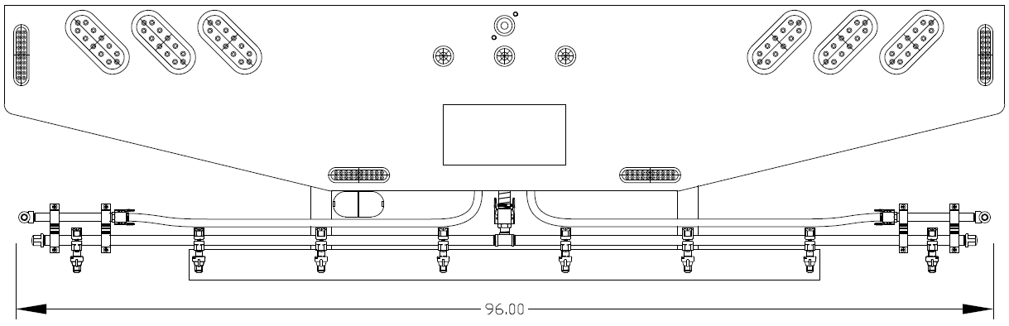

  - Handgun and Hose Reel
    - The unit shall be equipped with one manual hose reel (Hanney 15141718 or approved equal), with a minimum of 100’ of ½” X 600 PSI spray hose and with a #43 spraying systems handgun or equivalent.
    - The hose reel shall be equipped with a shut-off valve.

  - General Arrangement (for reference)
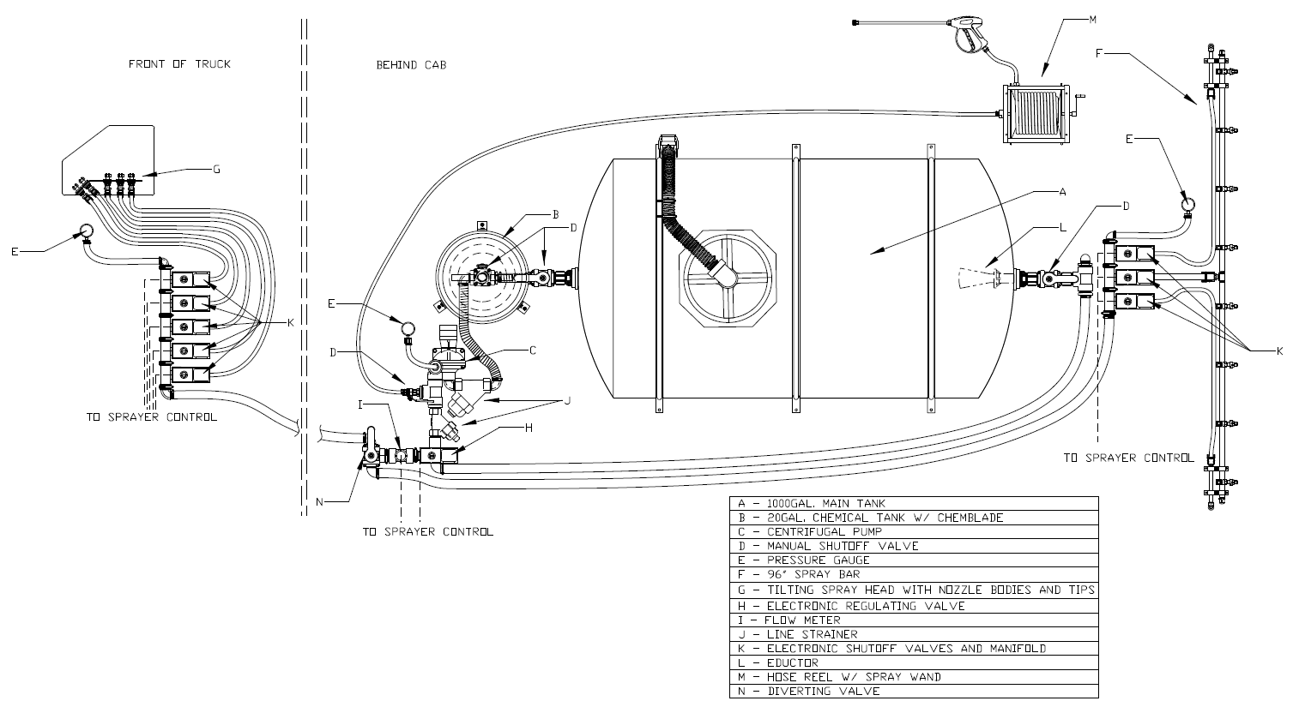

- Safety Lighting/Striping
  - Truck must be delivered with warning lights & high visibility, reflective conspicuity tape installed in accordance with these specifications and the illustrated layout below.
  - Warning lights shall be installed by an upfitter who is experienced in and regularly engages in the installation of automotive electronics & warning lights. Installer shall use vehicle & lighting manufacturers’ guidance along with industry best practices and techniques to ensure that lights are installed in a safe and neat manner.
  - All wiring and cables should be logically routed, secured, and protected with convoluted loom where possible. Rubber grommets shall be used where wires and cables penetrate any cab panels, body panels, or chassis structure. All cab and body penetrations shall be adequately sealed to prevent water from entering.
  - All warning lights must be controlled by a single in-cab, dash-mounted upfitter switch. The switch must be labeled to read “Warning Lights”.
  - Installer must contact the DOTD Equipment Section prior to programming to confirm intended flash pattern(s).
  - Mid-size Light Bars - Two (2) mid-size (24”) light bars that satisfy the following requirements, mounted on top of the headache bar (See label #1 in picture below)
    - SoundOff Signal nRoads Mid-Size or equal
    - Length is nominal and +/- 3” is acceptable.
    - Dual color - 12 diodes per module (equal number of green & amber)
    - All pods/modules must be capable of fully displaying both colors.
    - Flash pattern must be capable of alternating between an asymmetric, low frequency, “wig-wag” pattern and a low-frequency double or quad flash.
    - UV resistant clear polycarbonate lens
    - 10-16 VDC
    - Light bars shall meet all applicable federal/state laws and regulations
    - Shall be SAE J845 360-degree Class 1 certified
  - Perimeter Lights - Twelve (12) perimeter lights that satisfy the following requirements:
    - Grill Lights - Four (4) front mounted at grill level (See label #2 in picture below)
    - Side Lights - Four (4) perimeter lights, two mounted on each side along the bed (See label #3 in picture below)
    - Rear Lights – Four (4) total. Two (2) mounted vertically, centered on each side of the rear plate. Two (2) mounted horizontal at the bottom of the rear plate. (See Label #4 in picture below.)
    - Brooking Industries M16 surface mount perimeter light head or equal
    - Size: Length: 4.5-5.5 in., Height: 1.0-2.0 in., Depth: 0.3-0.5 in.
    - 12-24 VDC
    - UV resistant clear polycarbonate lens, black bezel trim
    - 16 diodes, dual color, equal number of green & amber (interleaved 8x8)
    - Light head must be capable of displaying each color across full length
    - Capable of alternating between an asymmetric, low-frequency, “wig-wag” pattern and a low-frequency double or quad flash
    - Light head shall meet all applicable federal/state laws and regulations
    - Shall be SAE J595 Class 1 certified
  - DOT C2 approved high visibility reflective conspicuity tape, 2” wide, with alternating 6” segments of red and white, shall be placed along the length of the bed on both sides of the truck.

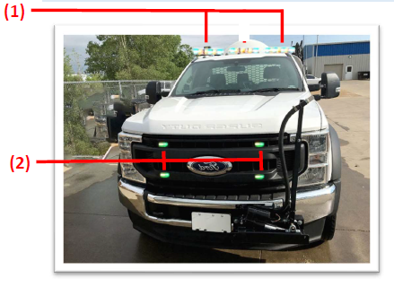
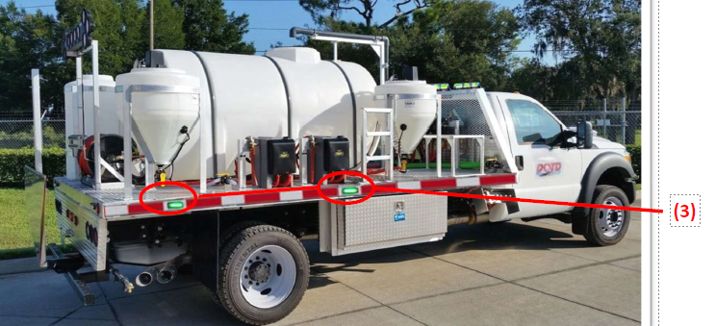

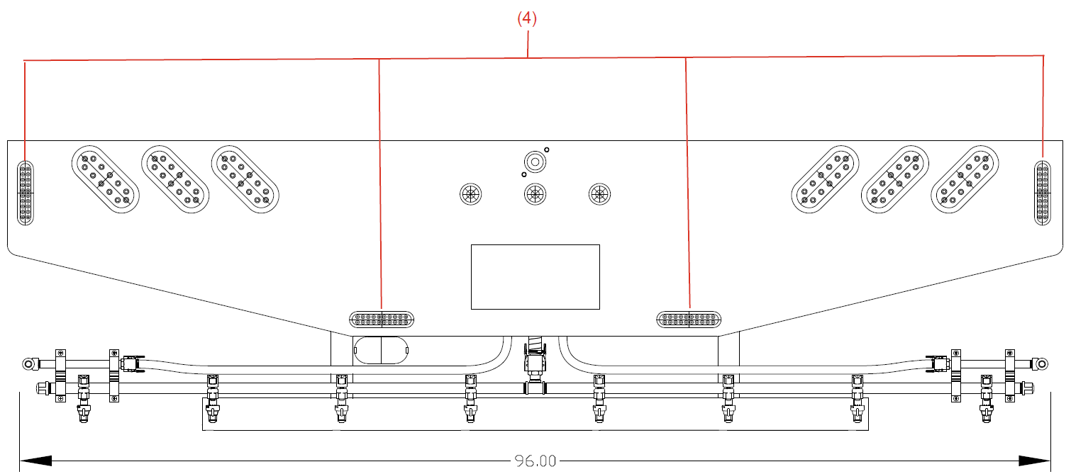

Note: The images are only a representation of the location for safety items on a truck and not the truck in the specifications

  - Tool Box
    - A toolbox with a minimum of 18” X 18” X 24” shall be securely mounted under the bed of the unit, with lockable hasp, weatherproof and of the mentioned size.

- Manuals/Training
  - The supplier shall provide one printed version and one electronic version of the Operators’ manual for the truck.
  - The supplier shall provide one printed version and one electronic version of the Operators’ manual for the herbicide spray bed.
  - The supplier shall provide one printed version and one electronic version of the parts manual for the
Herbicide spray bed.
  - Installation shall be completed at the supplier’s location. It shall be the responsibility of the supplier to insure all unit items are properly located and installed.

- Warranty
  - Minimum of 12 months on total unit. Warranty repairs to be made at user location or vendor will arrange to pick up and return unit.

Instructions: Bidder should note all exceptions in space provided below. List the detail number from the aforementioned specification in the column to the left and the exception in the column to the right. Responses may be typed or hand-written. Handwritten responses must be legible. If additional space is needed, please print a duplicate copy of this sheet. "Bidder’s Exceptions" page(s) should be returned with the bid submittal.
Examples:
1.6 Engine has 325 horsepower
1.18.3 Batteries have 2000 CCA combined.
2.2.8 Crossmembers are 4” channel on 12” centers.

Spec. /Detail
Reference Exception

