Attachment D – Regional Maps
RFx #3000025953

Below is a list of parishes by LDWF Region:

Hammond Region
Ascension East Baton Rouge East Feliciana Jefferson
Lafourche Livingston Orleans Plaquemines
St. Bernard St. Charles St. Helena St. James
St. John the Baptist St. Tammany Tangipahoa Washington
West Feliciana

Lafayette Region
Assumption Avoyelles Concordia Iberia
Iberville Lafayette Pointe Coupee St. Landry
St. Martin St. Mary Terrebonne West Baton Rouge

Lake Charles Region
Acadia Allen Beauregard Calcasieu
Cameron Evangeline Jefferson Davis Vermilion
Vernon

Pineville Region
Catahoula Grant La Salle Natchitoches
Rapides Sabine Winn

Minden Region
Bienville Bossier Caddo Claiborne
De Soto Jackson Lincoln Red River
Webster

Monroe Region
Caldwell East Carroll Franklin Madison
Morehouse Ouachita Richland Tensas
Union West Carroll

Refuge and WMA Locations
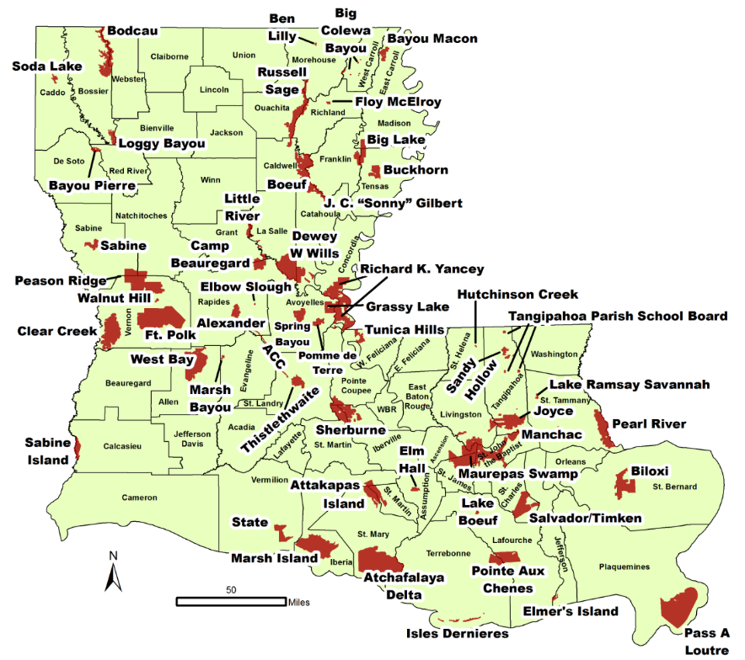

WMA | Regional Management | Parishes | Total Managed Acreage
Atchafalaya Delta | Coastal Lafayette | St. Mary | 141,912.00
Lake Beouf | Coastal Lafayette | Lafourche | 802.00
Pass a Loutre | Coastal Lafayette | Plaquemines | 110,491.00
Pointe Aux Chenes | Coastal Lafayette | Lafourche, Terrebonne | 34,478.37
Salvador | Coastal Lafayette | St. Charles | 32,434.12
Isle Deniere/Terrebonne Barrier Islands | Coastal Lafayette | Terrebonne | 3,401.00
Timkin | Coastal Lafayette | St. Charles | 2,888.00
Elmers Island | Coastal Lafayette | Jefferson | 1,177.73
Marsh Island Refuge | Coastal Lafayette | Iberia | 74,088.00
State Wildlife Refuge | Coastal Lafayette | Vermilion | 14,957.00
Hutchinson Creek | Hammond | St. Helena | 129.00
Joyce | Hammond | Tangipahoa | 39,673.75
Lake Ramsey Savannah | Hammond | St. Tammany | 796.00
Manchac | Hammond | St. John the Baptist | 8,328.35
Maurepas Swamp | Hammond | Ascension, Livingston, St. James, St. John the Baptist, Tangipahoa | 117,728.97
Pearl River | Hammond | St. Tammany | 35,618.88
Sandy Hollow | Hammond | Tangipahoa | 4,654.58
Tangipahoa Parish School Board | Hammond | Tangipahoa | 1,643.25
Tunica Hills | Hammond | West Feliciana | 6,502.70
Biloxi | Hammond | St. Bernard | 39,583.00
St Tammany Wildlife Refuge | Hammond | St. Tammany | 1,115.24
Acadiana CC | Lafayette | Avoyelles, Evangeline, Rapides, St. Landry | 2,285.00
Attakapas Island | Lafayette | Iberia, St. Martin, St. Mary | 27,961.89
Elm Hall | Lafayette | Assumption | 2,839.13
Grassy Lake | Lafayette | Avoyelles | 12,982.70
Pomme de Terre | Lafayette | Avoyelles | 6,434.00
Richard K. Yancey | Lafayette | Concordia | 70,871.94
Sherburne | Lafayette | Iberville, Pointe Coupee, St. Martin | 43,637.34
Spring Bayou | Lafayette | Avoyelles | 12,505.92
Thistlethwaite | Lafayette | Concordia | 11,100.00
Clear Creek | Lake Charles | Vernon | 52,479.00
Fort Polk | Lake Charles | Vernon | 105,545.00
Marsh Bayou | Lake Charles | Evangeline | 655.00
Peason Ridge | Lake Charles | Natchitoches, Sabine, Vernon | 74,309.00
Sabine Island | Lake Charles | Calcasieu | 8,343.39
Walnut Hill | Lake Charles | Vernon | 595.00
WMA | Regional Management | Parishes | Total Managed Acreage
West Bay | Lake Charles | Allen | 59,189.00
Bayou Pierre | Minden | DeSoto, Red River | 2,798.58
Bodcau | Minden | Bossier, Webster | 33,766.08
Loggy Bayou | Minden | Bienville, Bossier | 6,406.98
Soda Lake | Minden | Caddo | 2,500.00
Bayou Macon | Monroe | East Carroll | 6,918.68
Ben Lilly CA | Monroe | Morehouse | 247.00
Big Colewa Bayou | Monroe | West Carroll | 899.12
Big Lake | Monroe | Franklin, Tensas, Madison | 19,231.37
Bouef | Monroe | Caldwell, Catahoula | 51,000.00
Buckhorn | Monroe | Tensas | 11,120.78
Floy McElroy | Monroe | Richland | 680.96
J.C. "Sonny" Gilbert | Monroe | Catahoula | 7,523.84
Russell Sage | Monroe | Morehouse, Ouachita, Richland | 38,212.82
Alexander State Forest | Pineville | Rapides | 8,158.36
Camp Beauregard | Pineville | Grant, Rapides | 12,500.00
Dewey W. Wills | Pineville | Catahoula, LaSalle | 63,894.42
Elbow Slough | Pineville | Rapides | 160.00
Little River | Pineville | Grant | 6,045.15
Sabine | Pineville | Sabine | 7,656.44

