General Description of Services

- BACKGROUND
The State of Louisiana, Office of State Procurement, invites interested Vendors to submit a bid for Courier Services for State Libraries for the Louisiana Department of Culture, Recreation, and Tourism (CRT) in accordance with the following terms and conditions.

The State Library of Louisiana, located in Baton Rouge, Louisiana, is an agency in the Department of Culture, Recreation and Tourism in the Office of the Lieutenant Governor. In accordance with La. R.S. 25:8-10 and La. R.S. 25:31-33, the State Library is charged with giving service and advice to all parish, institutional, and public libraries. The State Library also administers programs to strengthen its own collections as well as the public libraries and to encourage the sharing of resources between libraries.

The State Library of Louisiana provides library services and materials to the public throughout the State of Louisiana. The courier service currently supports approximately 68 libraries with an estimated annual volume of 160,000 packages. The State Library requires regularly scheduled stops at all locations for the exchange of library materials.

- OBJECTIVES
The State Library of Louisiana has the following objectives for the work to fulfill, and it will be the Contractor’s obligation to ensure that the personnel the Contractor provides are qualified to perform their portions of the work. The selected Contractor shall, at minimum, but not limited to:
- Deliver materials to a final/ultimate destination location within 2 business days of pick-up from the original source location. The Contractor must deliver the materials to participating libraries on the scheduled next service day.
- Maintain a consistent delivery window of 8 a.m. to 5 p.m. CT (Monday – Friday) with all libraries.
- Provide detailed monthly invoices via email and reporting for services provided (via email & hardcopy); and
- Ensure that all delivery/pick-up services are to be billed at a statewide per-stop basis for all locations.

- SCOPE OF WORK
The goal of this solicitation is to award a single contract to the overall lowest, responsive, responsible bidder meeting all specifications outlined in this solicitation. The Contractor shall deliver library materials from one participating library to another participating library by using a single shipping system with a predefined daily schedule and list of locations. One site has 1 day a week delivery and 67 sites have 2 days of service per week. The system should accommodate standard packaging and labeling, without requiring packaging and labeling for each individual library item. Additionally, some use of non-standard packaging (cardboard boxes and padded mailers) will be allowed with standard labeling.

The Contractor shall include any courier or other services subcontracted by the Contractor. The contract is with the Contractor and all responsibilities for compliance with the terms of the contract and liabilities associated with the contract resides with the Contractor. The Contractor shall be considered the sole point of contact with regard to contractual stipulations, to include payment of all charges resulting from the purchase of subcontractor services or goods necessary for fulfillment of the contract, and the Contractor shall be responsible for meeting all requirements of the contract.

Statewide delivery services shall be provided to the Participating Libraries as listed in Appendix A. The list is subject to revision due to the addition, change, and/or deletion of Participating Libraries and/or their level of or days of service.

- Definitions:
  - Pick-up and delivery site: A pre-specified location within a building (such as library) where service is provided.
  - Service: Arrival no more than once per day (except where noted), Monday through Friday excluding State holidays, to a pick-up and delivery site for the purpose of picking up and/or delivering library materials. The Contractor is responsible for the loading and unloading of library materials from vehicles to a destination within the Participating Library.
  - Standard business day: 8:00 a.m. to 5:00 p.m. CT (Monday – Friday) unless the Contractor and Participating Library agree to a different time period. Some library locations require delivery services beyond the standard business day.
  - Courier: The firm or individual providing the service, if the Contractor subcontracts this portion of the contract. However, it should be noted that the contract shall be between the Contractor and the State Library, and the Contractor shall be the party responsible for compliance with the terms of the contract and any liability associated therewith.
  - Participating Library: A location where the Contractor provides pick-up and delivery services.
  - Shipping Label: A standard formatted label with information such as From:/To: and Forwarding site information. The label will allow for Contractor-specific information if requested.
  - Library materials: Books, journals, photocopies, CDs, DVDs, and other material normally held in library collections for use by library patrons. The exchange of standard reusable shipping materials is also permitted.
  - Shipment: The set of library materials sent from one pick-up and delivery site to another on a given day.

- Contractor Services and Requirements:
The Contractor must provide the following services and meet the following requirements to perform the work as defined:

- Shipping, Delivery, and Tracking
  - The Contractor must provide a 2 business day delivery schedule from any participating library to any other participating library.
  - The Contractor must ensure the delivery of all materials shipped in accordance with the terms of the contract.
  - The Contractor must ensure the return of any undeliverable items to the sender, at no additional cost.
  - The Contractor must be responsible for parcels, including the library materials and containers (such as bags) while such materials are in the possession of Contractor or Contractor's courier.
  - Materials must be delivered to a designated location within each participating library.
  - All containers should be picked up at the participating library as prepared for that day’s shipment. If there is a large deviation from the standard shipping volume at a participating library, the participating library will contact the Contractor as soon as it is known there will be a change in volume. For a large infrequent deviation in volume, the Contractor may request a second per-stop charge. The Contractor and the State Library contact must agree to this additional charge before the charge can be added to the invoice. * Please note no additional charge can be charged unless there is written confirmation via email.*
  - The use of a lockbox for pick-up and delivery at a Participating Library may be allowed if the participating library agrees.
  - The Contractor is allowed to carry library materials on vehicles with other customer packages.
  - The Contractor shall provide tracking information that allows the Agency to confirm shipment and delivery.
  - The Contractor should provide detailed monthly statistical reporting on service levels and pick-up and delivery volume by location.

- Packaging:
  - The Vendors are to be aware that shipments will include many thousands of packages that will vary from standard to non-standard sizes, volumes and weights. Therefore, the selected Vendor must understand the enormity of the quantity of packages and thus plan accordingly to properly accommodate the workload in the resulting contract.
  - The Contractor must accommodate the use of courier bags and allow for the use of other packaging, including regular envelopes, padded envelopes, small zippered cloth bags, plastic lidded totes, and/or cardboard boxes. The majority of Participating Libraries use orange nylon bags to ship materials (See Appendix C). The nylon bags have clear plastic windows to accept the standardized shipping labels.
  - The Contractor is responsible for handling packages from a Participating Library in a professional manner to eliminate damaging library materials that could be permanently damaged by precipitation, liquids and or dropping. Instances of damage to the shipping containers should be noted and immediately reported to the Participating Library, the State Library, by the Contractor.

- Labeling:
  - The State Library will provide access to a standardized shipping label for use by all Participating Libraries (see Appendices A-D). Participating Libraries will have access to print required labels.
  - The Contractor must accommodate the use of this standardized label indicating the originating library and destination library.
  - The Contractor may request the addition of Contractor-specific information on the standardized label.

- Schedule:
- The Contractor must ensure pick-up and delivery at each Participating Library is completed according to the Schedule specified for that location (see Appendix A). Permitted exceptions to the daily pick-up and delivery schedule are road closures and severe inclement weather, as evidenced by school or other public building closures.
- The Contractor must contact each Participating Library every 6 months to review couriers and the Participating Library's current and future needs. The Contractor shall establish a pick-up location and time during the standard business day for each Participating Library. Service schedules may be changed occasionally, with no less than 1 week (7 business days) prior written notice, and with the agreement by the contact person at the Participating Library.
- If the Contractor is unable to service a Participating Library, the Contractor must contact the Participating Library contact person and the State Library contact person.
- The Contractor must supply the State Library with delivery schedules along with any updates to services for all Participating Libraries within 7 business days of any changes.
- If the Contractor makes delivery driver staffing changes, the Contractor will notify the Participating Library of those changes whenever possible, in no case will notice be provided later than 7 business days. This will ensure the Participating Library is aware of changes in individuals entering and/or leaving their facility; and,
- The Contractor must ensure service at the Participating Library is consistent during normal business hours of 8 a.m. to 5 p.m. CT (Monday – Friday) Permitted exceptions to pick-up time would be road closures and severe inclement weather, as evidenced by school or other public building closures.

- Transit time:
The Contractor must provide 2 business day delivery services between all Participating Libraries. Permitted exceptions to the daily pick-up and delivery schedule are road closures and severe inclement weather, as evidenced by school or other public building closures.

- Communication:
a. The Contractor must communicate directly with the designated Participating Library contact person to resolve routine service problems. The State Library will also communicate with the Contractor regarding service problems.
b. The Contractor must communicate with the State Library regarding the overall delivery program, including service issues and potential changes in service.
c. At the State Library’s discretion, the Contractor and State Library will meet as needed, but at least semi-annually to review the delivery program.
d. If the Contractor's shipping system utilizes multiple couriers, the Contractor must guarantee uninterrupted service.

- Customer Service:
  - The Contractor must provide access via Internet (web) and/or e-mail and toll-free phone for inquiries regarding packages, invoices, producing standardized mailing labels for each Participating Library, tracking information, scheduling updates, on call pick-ups and guidelines regarding timetables, etc.
  - The Contractor must be available to answer inquiries during standard business hours as defined in this solicitation.
  - The Contractor must follow up with the Participating Library by the close of the next business day for any inquires not immediately resolved at the time received.
  - The Contractor must provide a single point of contact for all clients.
  - The Contractor must maintain the ability to communicate directly with all clients (designated site representatives) via phone and e-mail.
  - The Contractor must respond to all client complaints within 48 hours.
  - The Contractor must provide written notice to the Participating Library and the State Library of any delivery service issues within 48 hours of the issue. Record of all client complaints and resolutions will be maintained by the Contractor and accessible to all clients.

- Firm Fixed Pricing:
  - The price is a firm, per-stop fixed price to all Participating Libraries. This rate shall be all inclusive of all costs necessary to provide the services described herein, including but not limited to labor, equipment, vehicle maintenance, overhead, insurance, and fuel. The State Library will not pay a separate fuel surcharge. Bidders must account for potential fuel price volatility within their base "per-stop" bid price; no additional fees, surcharges, or variable costs will be accepted on invoices.
  - Invoicing shall be based on the fixed rate times the number of stops. For example, a participating library with 2 days a week service would be on the invoice as 2 times the per-stop price each week. Whereas, a Participating Library with 1 day a week service would be on the invoice 1 time the per-stop price each week.
  - The Contractor must add any new Participating Libraries with the same per-stop fixed pricing. Next day on call sites will be charged the per-stop price for days they receive a delivery or call for a pick-up. If a delivery falls on a day the library has called for a pick-up, only 1 per-stop price may be invoiced.
  - The price shall remain fixed for the first term of the Contract, which is from the date of award through December 31, 2026. Price changes are limited to once per renewal and restricted to a price increase no higher than the Producer Price Index 49211-49211 for the 12-month period. Any price increase must be agreed during the renewal process and will go into effect at renewal.
  - The Contractor must make available price decreases, cost reduction incentives, or other discounts available to the State Library.

9. Claims
a. The State Library must submit claims for lost or damaged materials directly to the Contractor within 60 calendar days of the incident. The Contractor must reimburse the Participating Library within 30 calendar days of receipt of the claim.
b. The State Library must report service issues such as missed pick-ups or deliveries, service window issues and longer than 2 day deliveries within 2 business days.

10. Penalties
a. The expected level of service shall be greater than 90% on-time pick-up/delivery performance. If the level of service falls below the 90% expectation for a Participating Library during any month, a 20% credit for that month will be applied to the next month’s invoice. The penalty only applies to unexcused performance issues.
b. All complaints must receive a response to the State Library within 48 hours of submission of the complaint. This response must be either a resolution or the steps to be taken to achieve a resolution within 10 business days. Complaints other than service and lost or damaged items must be resolved within 10 business days to the satisfaction of the State Library. Failure to resolve the complaint withing 10 business days will result in the State Library requesting credit on next month’s invoice for the amount related to the complaint.

11. Contract Administration and Billing
a. The Contactor must submit monthly detailed reports of activities including claims for lost or damaged materials at no charge via email to admin@state.lib.la.us .
b. The Contractor must submit detailed monthly invoices to the State Library for services provided.
c. The Contractor will designate a Project Manager to be responsible for the contract and to provide coordination with the State Library Representative and designated site representatives.
d. The Contractor will provide names, titles, and qualifications of individuals that will be assigned to the contract. The Contractor will also provide the areas of expertise and the experience these individuals have with projects/contracts of similar scope and nature. Projected increases in staff during the contract period should also be provided.
e. The Contractor must not use the name of the State Library of Louisiana or any Participating Library in advertising without first obtaining written consent from the State Library and the Participating Library.

- Participating Library and State Library Services and Requirements:
The Participating Libraries and the State Library must provide the following services and meet the following requirements:
  - The State Library and Participating Library contact persons will supply the Contractor with a vicinity map, parking instructions, access to the facility, etc. upon request.

  - If a Participating Library is to be removed from receiving service, the State Library will notify the Contractor with 7 business days advance notice, if possible.

  - If a Participating Library is to be added for receiving service, the State Library will notify the Contractor with 7 business days advance notice, if possible.

  - The State Library and/or Participating Library will provide packaging (cloth bags, plastic lidded totes, padded mailers, etc.) for the delivery of library materials; and,

6. The State Library will provide a labeling system for use by all Participating Libraries. The Contractor will notify the State Library of any changes that will impact information displayed on the labels.

- Contractor’s Responsibilities:
The Contractor must meet all solicitation requirements and perform work as defined in the Scope of Work.

- Fees:
The Contractor will be paid as proposed in this solicitation only after the State Library approval of Contractor provided detailed monthly invoices.

- Bill to Address:
State Library of Louisiana
701 North Fourth Street
Baton Rouge, LA 70802

- MINIMUM CONTRACTOR QUALIFICATIONS
A. Experience:
1. Demonstrated competence and capacity to manage a project of this scope, size and complexity.
2. Demonstrated experience in providing courier services among diverse organizations, to include 1) number and variety of organizations served by projects, 2) duration of projects, 3) budget of projects, 4) similarity of project services to the State Library courier services, and 5) satisfaction of project participants with project services. List all that apply.

B. Project Management Plan:
1. Ability to begin providing full services, without transition delay, once the contract is awarded, and continuing throughout the term of the awarded contract and subsequent renewals.
2. Ability to work with the current Contractor to provide a smooth transition for the State Library and Participating Libraries.
3. Demonstrated ability to provide operational, fiscal, and administrative management of the State Library’s courier services program.

C. Qualifications of Program Manager:
1. A minimum of 2 years of relevant experience managing prior courier services, library resource-sharing programs, or consortium operations.
2. Number and variety of organizations served by project.
3. Managing project budget.
4. Managing project similar to the State Library’s courier service program.

- Contractor References:
Bidders must provide at least one and up to three references for similar projects performed within the last 2 years. Reference information should include the following information for each project:

- Project Contact Name
- Project Contact Address
- Project Contact Telephone Number
- Project Contact Email Address
- Project Name and brief description of the Project
- Project Duration, including dates

Note: This information should be submitted with bid response or within 5 days, upon request by the Office of State Procurement (OSP).

APPENDIX A
PARTICIPATING LIBRARY LIST

LIBRARY NAME | ADDRESS | CITY | ZIP | SCHEDULE
ACADIA PARISH | 1125 N PARKERSON AVE | CROWLEY | 70526 | 2 DAYS
ALLEN PARISH | 320 S. SIXTH ST. | OBERLIN | 70655 | 2 DAYS
ASCENSION PARISH | 708 S. IRMA BLVD | GONZALES | 70737 | 2 DAYS
ASSUMPTION PARISH | 293 NAPOLEON AVE | NAPOLEONVILLE | 70390 | 2 DAYS
AUDUBON REGIONAL | 12220 WOODVILLE ST | CLINTON | 70722 | 2 DAYS
AVOYELLES PARISH | 660 NORTH MAIN ST. | MARKSVILLE | 71351 | 2 DAYS
BEAUREGARD PARISH | 205 S. WASHINGTON AVE | DERIDDER | 70634 | 2 DAYS
BIENVILLE PARISH | 2768 MAPLE ST. | ARCADIA | 71001 | 2 DAYS
BOSSIER PARISH | 4915 SHED RD. | BOSSIER CITY | 71111 | 2 DAYS
CALCASIEU PARISH | 411 PUJO ST. | LAKE CHARLES | 70605 | 2 DAYS
CALDWELL PARISH | 211 JACKSON | COLUMBIA | 71418 | 2 DAYS
CAMERON PARISH | 10200 GULF HIGHWAY | LAKE CHARLES | 70607 | 2 DAYS
CATAHOULA PARISH | 300 BRUSHLEY ST. | HARRISONBURG | 71340 | 2 DAYS
CLAIBORNE PARISH | 909 EDGEWOOD DR. | HOMER | 71040 | 2 DAYS
CONCORDIA PARISH | 408 TEXAS AVE. | VIDALIA | 71373 | 2 DAYS
DESOTO PARISH | 109 CROSBY ST. | MANSFIELD | 71052 | 2 DAYS
EAST BATON ROUGE PARISH | 7711 GOODWOOD | BATON ROUGE | 70806 | 2 DAYS
EAST CARROLL PARISH | 109 SPARROW ST. | LAKE PROVIDENCE | 71254 | 2 DAYS
EVANGELINE PARISH | 916 WEST MAIN ST. | VILLE PLATTE | 70586 | 2 DAYS
FRANKLIN PARISH | 705 PRAIRIE ST. | WINNSBORO | 71295 | 2 DAYS
GRANT PARISH | 300 MAIN ST. | COLFAX | 71417 | 2 DAYS
IBERIA PARISH | 445 E. MAIN ST. | NEW IBERIA | 70560 | 2 DAYS
IBERVILLE PARISH | 24605 J. GERALD BERRET | PLAQUEMINE | 70764 | 2 DAYS
JACKSON PARISH | 614 S. POLK AVE. | JONESBORO | 71251 | 2 DAYS
JEFFERSON DAVIS PARISH | 118 W. PLAQUEMINE | JENNINGS | 70546 | 2 DAYS
JEFFERSON PARISH | 4747 W. NAPOLEON AVE. | METAIRIE | 70001 | 2 DAYS
JENNINGS CARNEGIE | 303 CARY AVE. | JENNINGS | 70546 | 2 DAYS
KROTZ SPRINGS MUNICIPAL | 216 PARK ST. | KROTZ SPRINGS | 70750 | 2 DAYS
LAFAYETTE PARISH | 211 E. PINHOOK RD | LAFAYETTE | 70501 | 2 DAYS
LAFOURCHE PARISH PUBLIC | 314 ST. MARY ST. | THIBODAUX | 70301 | 2 DAYS
LASALLE PARISH | 3108 N. FIRST ST. | JENA | 71342 | 2 DAYS
LINCOLN PARISH | 910 TRENTON ST. | RUSTON | 71270 | 2 DAYS
LIVINGSTON PARISH | 13986 FLORIDA BLVD | LIVINGSTON | 70754 | 2 DAYS
MADISON PARISH | 403 N. MULBERRY | TALLULAH | 71282 | 2 DAYS
MOREHOUSE PARISH | 524 E. MADISON ST. | BASTROP | 71220 | 2 DAYS
MORGAN CITY PUBLIC | 220 EVERETT ST | MORGAN CITY | 70380 | 2 DAYS
NATCHITOCHES PARISH | 450 SECOND ST. | NATCHITOCHES | 71457 | 2 DAYS
NEW ORLEANS PUBLIC | 219 LOYOLA AVE | NEW ORLEANS | 70112 | 2 DAYS
OPELOUSAS | 212 E. GORLEE ST. | OPELOUSAS | 70570 | 2 DAYS
OUACHITA PARISH PUBLIC | 1800 STUBBS AVE. | MONROE | 71201 | 2 DAYS
PLAQUEMINES PARISH | 8442 HWY 23 | BELLE CHASSE | 70037 | 1 DAY
POINTE COUPEE PARISH | 201 CLAIBORNE ST. | NEW ROADS | 70760 | 2 DAYS
RAPIDES PARISH | 411 S. WASHINGTON ST. | ALEXANDRIA | 71301 | 2 DAYS
RED RIVER PARISH | 410 EAST CARROLL ST | COUSHATTA | 71019 | 2 DAYS
RICHLAND PARISH | 1410 LOUISA | RAYVILLE | 71269 | 2 DAYS
SABINE PARISH | 705 MAIN ST. | MANY | 71449 | 2 DAYS
SHREVE MEMORIAL | 885 BERT KOUNS IND LOOP | SHREVEPORT | 71101 | 2 DAYS
SOUTH ST. LANDRY (ARMAND BRINKHAUS) | 235 MARIE ST. | SUNSET | 70584 | 2 DAYS
ST. BERNARD PARISH | 2600 PALMISANO BLVD. | CHALMETTE | 70043 | 2 DAYS
ST. CHARLES PARISH | 105 LAKEWOOD DR. | LULING | 70070 | 2 DAYS
ST. JAMES PARISH | 1879 W. MAIN ST. | LUTCHER | 70071 | 2 DAYS
ST. JOHN PARISH | 2920 NEW HIGHWAY 51 | LAPLACE | 70068 | 2 DAYS
ST. MARTIN PARISH | 201 PORTER ST. | ST. MARTINVILLE | 70582 | 2 DAYS
ST. MARY PARISH | 206 IBERIA ST. | FRANKLIN | 70538 | 2 DAYS
ST. TAMMANY PARISH | 19612 HWY 36 | COVINGTON | 70433 | 2 DAYS
STATE LIBRARY | 701 N. FOURTH ST. | BATON ROUGE | 70802 | 2 DAYS
TANGIPAHOA PARISH | 204 NE CENTRAL AVE. | AMITE | 70422 | 2 DAYS
TENSAS PARISH | 135 PLANK RD. | ST. JOSEPH | 71366 | 2 DAYS
TERREBONE PARISH | 4130 WEST PARK AVE. | GRAY | 70359 | 2 DAYS
UNION PARISH | 202 W. JACKSON ST. | FARMERVILLE | 71241 | 2 DAYS
VERMILION PARISH | 405 E. ST. VICTOR | ABBEVILLE | 70510 | 2 DAYS
VERNON PARISH | 1401 NOLAN TRACE | LEESVILLE | 71446 | 2 DAYS
WASHINGTON PARISH | 825 FREE ST. | FRANKLINTON | 70438 | 2 DAYS
WEBSTER PARISH | 521 EAST AND WEST ST. | MINDEN | 71055 | 2 DAYS
WEST BATON ROUGE PARISH | 830 N. ALEXANDER | PORT ALLEN | 70767 | 2 DAYS
WEST CARROLL PARISH | HWY 17 & MARIETTA ST. | OAK GROVE | 71263 | 2 DAYS
WEST FELICIANA PARISH | 5114 BURNETT ROAD | ST. FRANCISVILLE | 70775 | 2 DAYS
WINN PARISH | 200 N. ST. JOHN ST. | WINNFIELD | 71483 | 2 DAYS

APPENDIX B
Sample Shipping Label

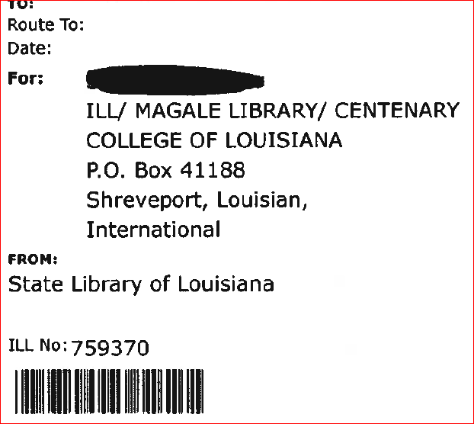

APPENDIX C
Nylon Orange Bag 14” X 18”

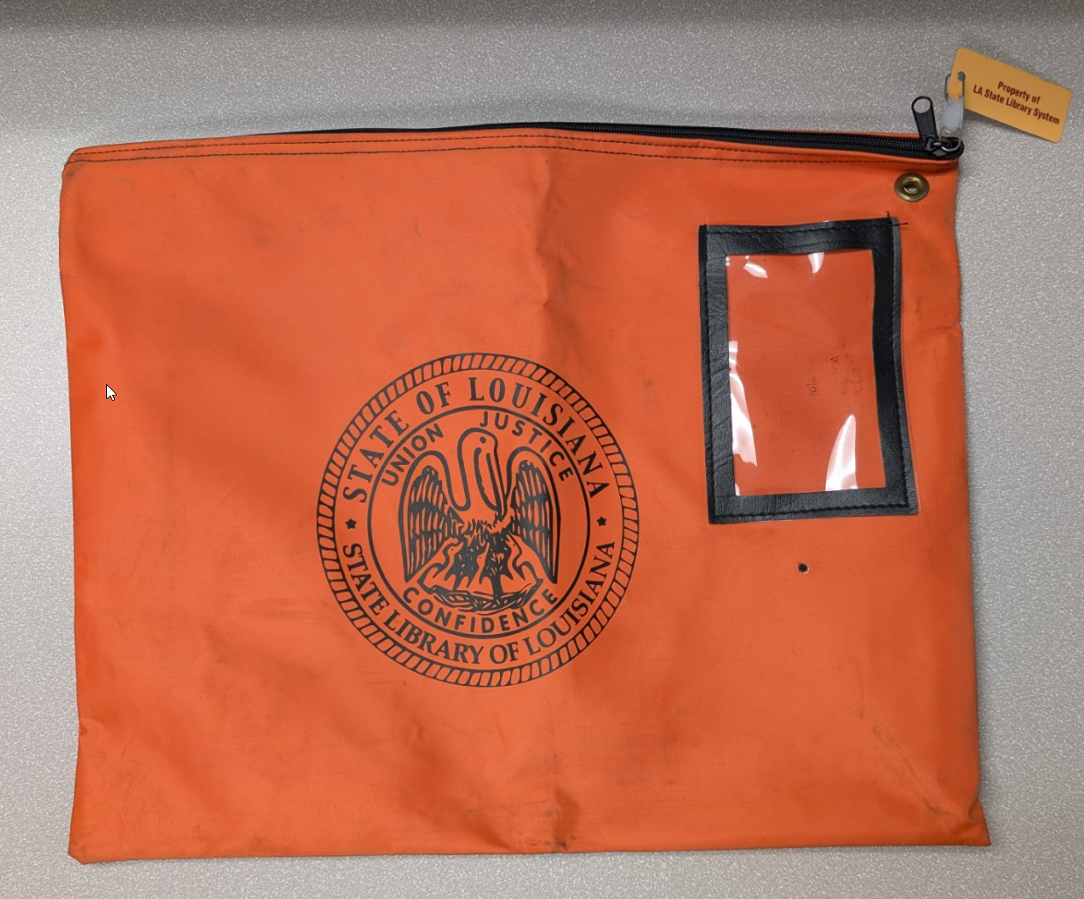

APPENDIX D
Nylon Yellow Bag 14” X 18”

