STATE OF LOUISIANA MILITARY DEPARTMENT (LMD)
Governor’s Office of Homeland Security and Emergency Preparedness (“GOHSEP”)

TECHNICAL SPECIFICATIONS FOR
TRUCK, CAB & CHASSIS, WITH VAN BODY & LIFTGATE

EQUIPMENT SPECIFICATIONS
REV. 9/18/2025

GENERAL
This specification sets forth the minimum requirements for a single axle Class 6 truck cab and chassis with a dry van body and liftgate.
Equipment shall be new (2025 model year or newer), a production model of current manufacture, and must meet all state and Federal safety and emission standards in effect at time of order.

REPRESENTATIVE SPECIFICATIONS
An International MV607 SBA 4x2 truck and 26’ Dry Freight Van body with appropriate options and standard features including power liftgate, was used to develop these specifications and establish equivalency evaluation criteria.
Equipment of similar style, type, character, quality, features, and purpose conforming to the following detailed requirements/specifications will be considered. For evaluation purposes, bidder's proposing an exception/equivalent option/feature to those specified herein, may be required to provide manufacturer/product information (catalogue sheets, detailed specifications, pictures, etc.). This information will be evaluated against the minimum requirements of this specification. Proposed submittals that are determined not to be equivalent to the established criteria will be rejected.

LOUISIANA AUTHORIZED DEALER(S)
Proposed item(s) must be from a manufacturer who has at least one (1) authorized dealer within the State of Louisiana where parts and service can be obtained. Authorized dealer(s) must have properly trained technicians plus all other resources necessary to perform warranty and repair services in complete accordance with the manufacturer’s requirements.
- A letter certifying the ability to meet this requirement, inclusive of the company name(s) and address(es) of the Louisiana authorized dealer(s), should be supplied with the bid submittal and may be required prior to award.

DELIVERY & ACCEPTANCE
Vendor shall perform a test run of each unit to verify that all features and capabilities are operating properly at time of delivery. Documentation of testing may be required prior to acceptance by the Department.
Unit(s) must be delivered completely assembled (including all components, accessories, etc.) and ready for operation without any additional preparation including, but not limited to, ensuring all fluid levels are at their full mark, fuel tank(s) is full, all necessary lubrication has been performed, etc. A Louisiana safety inspection shall be performed on each vehicle prior to delivery and a Louisiana safety inspection sticker properly affixed.
Any unit delivered under this specification is subject to rejection if there is evidence of poor workmanship, by either the vendor or the original manufacturer. Noted defects and/or nonconformance findings may

be corrected by the vendor. Corrections must be completed and approved by the GOHSEP, represented by LPAA prior to final acceptance.
Unit(s) shall be delivered “on the ground;” GOHSEP, represented by LPAA will not unload nor provide any unloading equipment to the vendor/delivery driver in order to offload the unit(s).
NOTE: The Department will have space available for equipment to be unloaded.

EACH UNIT MUST BE SUPPLIED WITH THE FOLLOWING DOCUMENTATION:
- Notarized Bill of Sale
- Certificate of Origin (MSO)
- Dealer's Service Policy
- Owner's/Operator's Manual(s)
  - One (1) Hardcopy
  - One (1) Digital Copy
    - Acceptable Formats: CD, DVD, Flash Drive, or E-mail
- Service Manual(s)
  - One (1) Hardcopy
  - One (1) Digital Copy
    - Acceptable Formats: CD, DVD, Flash Drive, or E-mail
- Build Sheet(s) – as applicable
  - One (1) Hardcopy
  - Build sheets should be writing in plain language (not company specific codes) and include, at a minimum, all standard & optional features of the delivered unit.

NOTE: Invoices will not be processed for payment until the unit(s) have been inspected by GOHSEP, represented by LPAA and deemed in compliance with the specifications.

BID SUBMITTALS
Any additions, deletions, or variations from the specifications should be noted in the "Bidder’s Exceptions" page of this specification. Exceptions that are noted to be less than a minimum requirement will not be accepted.
Any additions, deletions or variations from the manufacturer’s standard published specifications should be noted on the "Bidder’s Exceptions" page of this specification. Unless otherwise noted, any items appearing in the manufacturer’s standard published specifications furnished by the Bidder are assumed to be included in the Bidder’s submittal.
Bidder should note on their submittal any installation(s) to the equipment that will be performed by the vendor instead of the manufacturer.
Failure to note any specification exceptions, manufacturer specification alterations, and/or vendor installations prior to award may result in rejection of the equipment at the time of delivery.

THE NUMBER OF DELIVERY DAYS AFTER RECEIPT OF ORDER (ARO) MAY BE USED AS A FACTOR IN THE AWARD.

EQUIPMENT SPECIFICATIONS
NOTICE TO BIDDERS
Bidder should review the detailed "Equipment Specification" completely and respond to the compliance question at the end of each section by marking “X”, in the space provided, for "Yes" or "No". Mark "Yes" to indicate that the equipment bid meets the section exactly as specified. Mark "No" if there are exceptions to any part of that section. Exceptions/deviations to any part of the specification are to be detailed on the "Bidder's Exceptions" page of this specification.

IN ORDER TO BE CONSIDERED FOR AWARD, BIDDER SHOULD RETURN THIS SPECIFICATION, COMPLETED IN FULL, WITH THEIR BID SUBMITTAL.

Note: All Values listed below are minimums unless noted otherwise.

- Cab & Chassis
1.1. GVWR: 25,999 lbs.

Comply: Yes No

  - Cab & Axle Positions
    - Front axle: For the purposes of this solicitation, set-forward-axle (SFA) is considered equal to set-back-axle (SBA); however, SBA is the preferred option
    - Cab to Axle (CA): 204.90” *
    - Center of rear axle to end of frame (AF): 98.00" *
*Values given here are minimums. The space between cab and body shall not exceed 10 inches. Truck vendor and body manufacturer/upfitter shall coordinate in selecting a cab to axle dimension that works with the specified body and ensures proper load distribution to the front and rear axles in accordance with manufacturer specifications and industry practice. The required AF must be achieved with factory frame rails. Frame extensions to meet the required AF are not allowed. The AF must be sufficient to allow support of the full length of the body.

Comply: Yes No

  - Front Bumper
    - Full width all-steel front bumper

Comply: Yes No

EQUIPMENT SPECIFICATIONS

  - Cab
    - Conventional day cab
    - Tinted safety glass
    - Full width exterior cab mounted sun visor with integral clearance lights
    - Cab entry handles, driver & passenger side
    - one (1) standard electric horn
    - Outside mirrors, driver & passenger side, adequate width for driver to view adjoining traffic lanes
      - Power adjustable
      - 90 sq. in. minimum
      - Heated with integrated turn signals
    - Air suspension driver seat
    - Gauge package including the following gauges:
      - Coolant temperature
      - DEF
      - Fuel
      - Oil pressure
      - Speedometer
      - Tachometer
      - Odometer
      - Total engine hours
      - Trip odometer
      - Rear axle oil temperature
      - Auto transmission oil temperature
      - Engine oil temperature
    - Dual interior sun visors
    - 3-point seat belt for each seat
    - Climate control, including air conditioning, heater, & defroster
    - Power windows & power door locks
    - Tilting & telescoping steering wheel

Comply: Yes No

EQUIPMENT SPECIFICATIONS

  - Engine
    - 6.7 L diesel, liquid cooled
    - 250 HP @ 2400 rpm, 660 lb-ft of torque @ 1600 rpm
    - Heavy Duty Gear Reduction Starter (Delco Remy 38MT Starter or equivalent)
    - CARB-Compliant is not required – Not for registration in CA/MA/OR/NJ/NY/WA

Comply: Yes No

  - Fuel System
    - Fuel tank shall be metal and a 50-gallon minimum capacity
    - Davco 245 fuel processor or equal
    - Emission system must include DEF
    - DEF tank must have a minimum capacity of 7 gallons
    - Visual element change indication that is integral to and non-removable from unit (to be located on driver’s side near fuel tank)
    - Water-in-fuel sensor with indicator in cab
    - Electric heater

Comply: Yes No

  - Transmission
    - Automatic, 6-speed heavy-duty (RDS)

Comply: Yes No

  - Front Axle
    - 12,000 lbs. capacity

Comply: Yes No

EQUIPMENT SPECIFICATIONS

  - Rear Axle
    - 21,000 lbs. capacity
    - Air-ride suspension

Comply: Yes No

  - Brakes
    - Full air, ABS brake system
    - Air Dryer with heater

Comply: Yes No

  - Wheels & Tires
    - Hub piloted steel disc, size – 22.5" x 8.25"
    - First line, first quality tires, size – 11R22.5
    - Front tires - single highway tread
    - Rear tires - dual on/off road tread
    - Load ratings to be compatible with GVWR
    - Spare tire, jack, & lug wrench NOT required

Comply: Yes No

  - Electrical System & Lights
    - 12-volt system
    - 160-amp brushless alternator
    - Batteries with 2,850 CCA combined
    - Dual electric circuits/batteries to allow power while engine off
    - 150A liftgate power source
    - Dash mounted, rocker-style, factory installed, body circuit switches for simple on/off functions for accessories (PTO, warning lights, etc.) including one (1) assigned to energize the cargo lighting circuit

EQUIPMENT SPECIFICATIONS

    - All exterior lighting should be LED
    - Headlights:
      - Automatic daytime running lights
      - Warning buzzer/alarm when headlight switch is on and ignition switch is in off position
    - Cruise control
    - Intermittent windshield wipers with washers
    - Backup alarm
    - AM/FM radio
    - Two (2) 12V accessory power outlets with covers, mounted in dash (for cell phone chargers, GPS devices, etc.). One (1) 12V power outlet and one (1) USB charging outlet will also satisfy this requirement.

Comply: Yes No

  - Paint
    - Cab: Manufacturer’s standard, white
    - Chassis: Manufacturer’s standard, black

Comply: Yes No

  - FMCSA/DOT Mandated Safety Items
    - One (1) UL listed, 5 B:C rated, or higher, fire extinguisher securely mounted in cab
    - One (1) set of three (3) bidirectional reflective triangles conforming to FMVSS No. 125
    - At least one (1) spare fuse for each type/size used in the truck

Comply: Yes No

- Van Body
  - Dimensions
2.1.1. 26' L × 102" W × 102" H

Comply: Yes No

  - Design
    - Front Radius, aluminum tread bright
    - Roof, seamless, riveted around perimeter
    - Roof Bows, anti-sag on 24” centers
    - Sealed unit clearance lights
    - 0.040 pre-painted aluminum sides
    - Extruded aluminum Z-posts on 16” centers
    - ½” exterior plywood lining on side walls

EQUIPMENT SPECIFICATIONS

    - 12” corrugated steel scuff plate on sides and front, one row 24” above floor, one row 48” above floor
    - 1-1/8” hardwood floor, undercoated
    - 3/16” steel reinforcement above rear wheels
    - Grab handles at rear of body (both sides)
    - Composite roll up rear door
    - Interior light switch, illuminated

Comply: Yes No

  - Body Installation
    - A rubber or plastic (nylon or Delrin) sill spacer shall be used between the frame & body sills; WOOD SPACERS ARE NOT ALLOWED!
    - Body should be bolted to frame using brackets or fishplates. U-BOLTS ARE NOT ALLOWED!
      - Upfitter should utilize chassis manufacturer’s guidance for body mounting methods
    - Brackets
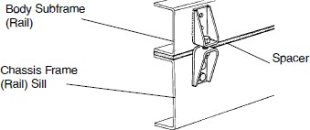

    - Fishplate - to be bolted to chassis frame, utilizing existing holes where possible, and bolted or welded to body sub-frame/sill.
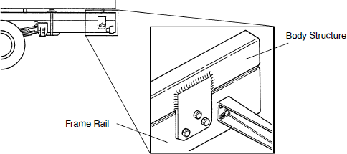

Comply: Yes No

EQUIPMENT SPECIFICATIONS

  - Liftgate
    - Large capacity electric liftgate (example: Palfinger model ILT-35), installed
    - Aluminum platform
2.5.2.1. 86” W x 62” D + 6” ramp
    - Capacity: 4,000 lbs.
    - 150 amp circuit breaker for electrical protection
    - All steel painted manufacturer’s standard black

Comply: Yes No

  - Body Prep/Paint: manufacturer’s standard, white

Comply: Yes No

  - Rear Wheel Mud Flaps
    - Heavy Duty 3/8” x 24”W x 36”L rubber
    - Full width steel angle sandwich type anti-sail mounting brackets
    - Plastic flaps not acceptable

Comply: Yes No

- Lighting, Wiring And High Visibility Conspicuity Tape
  - General
    - Refer to lighting layout illustrations below
    - Truck must be delivered with warning lights & high visibility reflective conspicuity tape installed in accordance with the below specifications and layout
    - All warning lights to be sealed light emitting diode (LED) type, with plug-in connectors
    - 6” oval lights must be grommet mounted
    - Warning lights shall be installed by an upfitter who is experienced in and regularly engages in the installation of automotive electronics & warning lights
    - Installer shall use vehicle & lighting manufacturers’ guidance along with industry best practices and techniques to ensure that lights are installed in a safe and neat manner
    - All wiring and cables should be color coded, heat shrink wrapped and logically routed, secured, and protected with convoluted loom where possible
    - All wiring splices must be made using butt or parallel crimp connectors

EQUIPMENT SPECIFICATIONS

    - All fasteners used for light mounting must be corrosion resistant stainless steel
    - Non-metallic/rubber grommets shall be used where wires and cables penetrate any cab panels, body panels, or chassis structure
    - All cab and body penetrations shall be adequately sealed to prevent water from entering
    - All warning lights to be controlled by a single in-cab, dash-mounted upfitter switch. The switch must be labeled to read “Warning Lights”
    - All lighting must meet Federal and state requirements

Comply: Yes No

  - Cargo Lighting
    - Phillips Permalite XB corner cargo lamps, or equal
3.2.3. 10-12V DC
    - 1200 lumen output
    - Clear polycarbonate lens
    - Moisture-proof circuit board
      - One in-cab upfitter switch should also serve as a master switch for the cargo lighting circuit

Comply: Yes No

  - Perimeter Warning Lights
    - Twenty-two (22) perimeter lights required
      - Eight (8) front, installed in the locations shown below
      - Six (6) rear, installed in the locations shown below
      - Four (4) each side, installed in the locations shown below
3.3.4. 12-24 VDC
    - Shall be SAE J595 Class 1 certified

Comply: Yes No

EQUIPMENT SPECIFICATIONS

  - Oval Warning Lights
    - Two (2) lights required, installed in the locations shown below
    - 6” L x 2¼“ W , recessed, grommet, snap-in mount
    - Clear polycarbonate lens
    - Half amber, half green
    - Capable of double or quad flash pattern
    - 12-24 VDC, with plug-in connector
    - Shall be SAE J595 Class 2 certified

Comply: Yes No

  - High Visibility Reflective Tape
    - DOT C2 approved high visibility reflective conspicuity tape, 2” wide, with alternating 6” segments of red and white, shall be placed on each side of the body as shown below
    - High visibility reflective conspicuity tape, 2” wide, with alternating 6” segments of green and high visibility yellow, shall be placed on the rear of the body as shown below

Comply: Yes No

  - Lighting and Tape Layout: The following pictures are intended to show a general representation of a truck with a dry van body. Only the labeled lighting and conspicuity tape details apply here. No other features of the trucks shown are intended to be included unless stated elsewhere.
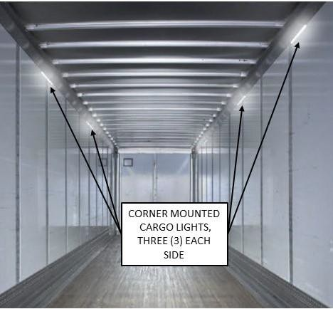

EQUIPMENT SPECIFICATIONS
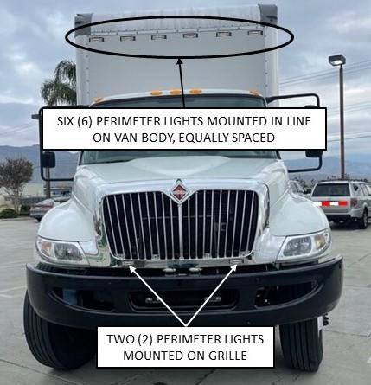
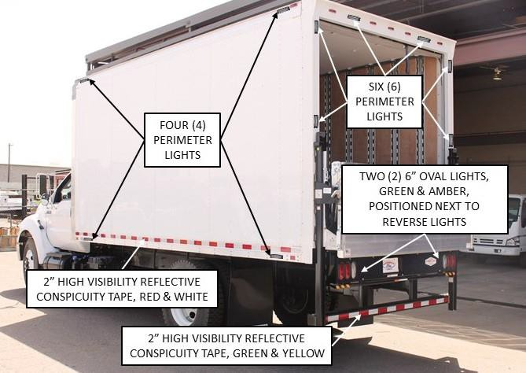

Comply: Yes No

BIDDER’S EXCEPTIONS
Crossmembers are 4” channel on 12” centers.
2.2.8
Batteries have 2000 CCA combined.
1.18.3
Engine has 325 horsepower
1.6
Instructions: Bidder should note all exceptions in space provided below. List the detail number from the aforementioned specification in the column to the left and the exception in the column to the right. Responses may be typed or hand-written. Handwritten responses must be legible. If additional space is needed, please print a duplicate copy of this sheet. "Bidder’s Exceptions" page(s) should be returned with the bid submittal.
Examples:

Spec./Detail
Reference Exception

