**Scope of Work:**

The Contractor shall furnish all labor, commercial grade materials, tools, and equipment necessary to remove and replace 28 windows at the Crowley Readiness Center for the Department of Military Affairs (DMA).

**Location:**

Crowley Readiness Center

140 Standard Mill Road

Crowley, LA 70525

**DMA Contact:**

Thomas Breaux

(337) 678-9597

thomas.l.breaux.nfg@army.mil

**Specifications:**

* The Contractor shall provide glazing systems capable of withstanding normal thermal movement and wind impact loads (where applicable) without failure, including loss or glass breakage attributable to the following: defective manufacturer, fabrication, and installation; failure of sealants or gaskets to remain watertight and airtight; deterioration of glazing materials; or other defects in construction.
* The Contractor shall remove windows on the North and West side of the building and replace with hurricane-rated windows systems in accordance with the manufacturer’s installation instructions. Windows shall be rated to meet or exceed current impact resistance and wind load requirements for hurricane-prone areas.
* 13 of the windows measure approximately 42” x 36”, 12 of the windows measure approximately 44” x 54”, and 3 of the windows measure approximately 44” x 108”. All work shall be performed in accordance with building codes and National Guard Facility standards.

**General Information:**

* The Contractor shall be responsible to provide storage containers. If an onsite storage area is required, the Contractor shall confirm a storage location for any materials, fixtures, equipment, trailers, etc. stored on site during the term length of the contract. The location shall be approved by the Project Manager during the pre- construction meeting.
* The Contractor shall take all precautions necessary to prevent damages when delivering materials to site and provide covering to prevent rusting.
* The Contractor shall take all necessary precautions to prevent damages during repairs, to include movement and parking of equipment on grass, other improved, or unimproved areas surrounding site.
* All work shall comply with all applicable State and Local Safety and Environmental requirements. Occupational Safety and Health Administration (OSHA), National Electrical Code (NEC), Parish, City and State regulation shall be required. The Contractor shall supply all employees with PPE.
* The Contractor shall call LA 1-Call and all utility companies prior to digging.
* The Contractor shall secure the building, and any sensitive items at the end of each workday in accordance with the designated unit POC.
* Hours of operation Tuesday- Friday, 7:00 AM to 5:30 PM and closed on all recognized state and federal holidays.
* The Contractor shall contact, prior to mobilization and demobilization, facility point of contact which will be provided herein.
* The Contractor shall be responsible for disposal and storage of all materials being removed or installed throughout the project.
* The Contractor shall provide a construction work schedule (Gnant like) 48 hours prior to start of work detailing each task of work.
* All specification sheets and submittals shall be pre-approved by the Project Manager prior to ordering.
* The Contractor shall warranty their workmanship and the completed project for a one year period. One year period starts the date of the filing of the certificate of completion.
* The Contractor shall provide all associated warranty documents to the Project Manager upon completion and final payment.
* 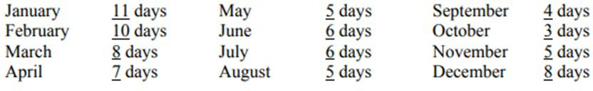Weather days are included in the contract time.