**Scope of work:**

The Contractor shall provide all materials and labor to construct six parking lots 100’ by 100’, one 150’ by 150’ camping area with pipe fence and one 17’ pipe gate on four of the parking lots for the Louisiana Department of Wildlife and Fisheries (LDWF).

**Location:**

Wildlife Management Area

HWY 3049 & HWY 71

Shreveport, LA 71107

**Agency Contact**

Seth Miller

(318) 371-5225

**Specifications:**

The Contractor shall be responsible for the following:

* Gates shall be tied into pipe fence, each gate shall be capable of protecting four locks. There shall be one ATV/UTV gap next to each gate.
* ATV/UTV gap shall be 68” wide inside distance. Each parking lot shall be 6” above grade with 4” of aggregate spread and packed. Fill dirt can come from onsite pits.
* Fill dirt shall be no less than 60/40 clay/sand/dirt with a minimum plasticity of 19 approximately 200 cubic yds for parking lots #2- #6 and approximately 100 cubic yds for parking lot #1.
* Dirt pit on southern trail shall be used for fill and exited from on Hwy 3049.
* Aggregate shall be #2 ballast. #2 (2-1/2″) crushed stone is a combination of assorted sized material that ranges from 1 1/2″ through 2-1/2″ which has been crushed and compacted in size, then processed through a square screen 3″ in size. Approximately 225 tons for parking lots.
* 8-ounce non-woven filter cloth shall be placed between fill dirt and aggregate on all sites.
* Pipe shall be 2-3/8” round pipe OD.
* Gate posts shall be 4.5” OD.
* Uprights for the swing post and anchor post shall be set a minimum of 24” into the ground and set in concrete.
* ATV/UTV gap posts shall be 4.5” OD.
* All pipes shall be cleaned, primed with Metal Primer Gray and painted Industrial Enamel Safety Yellow.
* Culverts shall be placed and ditches excavated where needed to facilitate drainage and maintain natural hydrology.
  + Minimum of 4 – 18” x 24’ culverts needed
  + LDWF staff shall coordinate with the Contractor on culvert placement locations.
  + Culverts shall be galvanized 14-gauge steel

**Parking Lot #1**

Located along Hwy 3049 (Dixie Shreveport Rd)

32.602346 -93.770492

* Approximately 350’ of pipe fence
* One gate 17’ wide inside
* One ATV/UTV gap 8” wide inside measurement
* 100’ by 100’ parking lot

**Parking Lot #2**

Located along Hwy 3049 (Dixie Shreveport Rd) north of The Dixie Ginn

32.652172 -93.804327

* Approximately 280’ of pipe fence
* One gate 17’ wide inside
* One ATV/UTV gap 68” wide inside measurement
* 70’ by 100’ parking lot

**Parking Lot #3**

Located along Hwy 71

32.641504 -93.829465

* Approximately 225’ of pipe fence
* One gate 17’ wide inside
* One ATV/UTV gap 68” wide inside measurement
* 100’ by 100’ parking lot

**Camping Area**

Located along Hwy 71

32.641504 -93.829465

* 150’ by 150’ camping area
* 416 cu yds of fill dirt
* 475 tons of #2 ballast

**Parking Lot #4**

Located along East side Hwy 71

32.629759 -93.821198

* Approximately 280’ of pipe fence
* One gate 17’ wide inside
* One ATV/UTV gap 68” wide inside measurement
* 100’ by 100’ parking lot
* Cattle gap shall be removed
* One culvert shall be put in place of cattle gap and a second culvert relocated behind the gate
* Trees shall be cleared/grubbed, piled and may be burned on site

**Parking Lot #5**

Located along West side Hwy 71

32.625547 -93.819712

* Approximately 300’ of pipe fence
* One gate 17’ wide inside
* One ATV/UTV gap 68” wide inside measurement
* 100’ by 100’ parking lot

**Parking Lot #6**

Located along East side Hwy 71 toward south end of WMA

32.620244 -93.816809

* Approximately 300’ of pipe fence
* 100’ by 100’ parking lot
* Entry way shall be in the middle of the parking lot

**Gate Design**

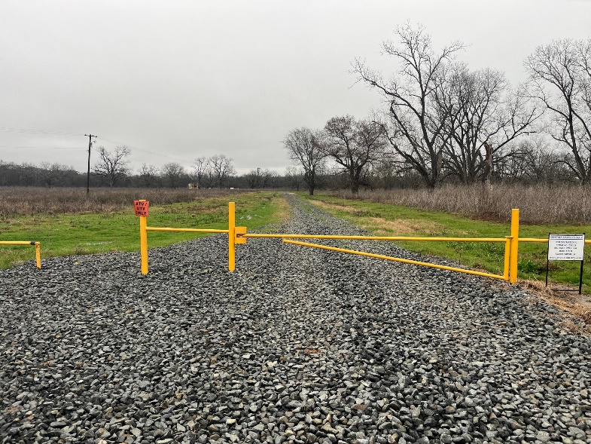

**Locking mechanism**

