**\*\*If bidding other than specified, please provide manufacturer’s specs for “or equal” items. \*\***

**Scope of Work:**

The Contractor shall supply all tools, labor and materials to remodel acoustic ceiling, lighting, and paint in areas specified for the Department of Military Repairs (DMA).

**Location:**

Natchitoches Readiness Center

500 Fairgrounds Rd

Natchitoches, LA 71457

**DMA Contact:**

SFC Devonte Drew; Cell Phone: (318) 469-4669 or Office Phone: (318) 319-6491 x36497

SSG Patrick Condet; Cell phone (318) 560-8029

Project Manager Darren Thomas; Cell Phone: (318) 450-7536 or email [darren.k.thomas.mil@army.mil](mailto:darren.k.thomas.mil@army.mil)

**Specifications:**

The Contractor shall be responsible for the following:

Electrical Work:

* All Old fixtures shall be removed and disposed of. Wiring and conduit shall be reused. Lights shall be installed in the same general location with some subtractions from the locations that held double lights. Refer to images 1 & 2.
* Replacement Fixtures shall be **Cooper Metalux Troffer style FR Series** or equal.

**Specify Brand/Model Bidding:** _____________

* + - No optional dim setup.
    - 4000k to 5000k.
    - High performance 2x4 LED
* Utilize existing wiring and conduit. Estimate minimum 3ft additional wiring and conduit per fixture to conduct and upgrade or repair needed for fixture replacement.

Finishes:

* Wash, clean, and sand/scuff all surfaces to be painted.
* Mask trim etc. surfaces sufficient to protect from overspray.
* **Corotech (Benjamin Moore) Fast Dry Polyamide Epoxy Coating V410** or equal.

**Specify Brand/Model Bidding:** _____________

* Minimum Eggshell finish.
* Clean and prime walls to manufacturer’s recommendations.
* Tint primer to hide behind the finish coat.
* Three coats shall be applied in three layers. Prime, intermediate and finish coat.
* Furnish and maintain all ladders, drop cloths, masking necessary for completion. Any damage to floor, cabinets or any other part of building interior occurring from spills or improper masking will be the responsibility of the Contractor to correct and restore.
* Authorized Color to be used shall be Sherman Williams Reposed Gray.
* Remove and dispose of paneling seen in image 3.

Ceiling Adjustment:

* Where double lights are removed and replaced with single LED, adjust and center the new fixture.
* Provide tile, Grid and trim to match existing when necessary to center replaced double fixtures.
* Ensure minimum 2 ceiling grid wire support per light, 9g or equal to existing.
* The Contractor shall remove and replace approximately 2000 SQFT of acoustic ceiling. The Contractor shall be responsible for estimating exact measurements.
* **Armstrong 769A** or equal tiles

**Specify Brand/Model Bidding:** _____________

* Mold and Mildew resistance, sag resistance, Humi-Guard.

* Ceiling area shall be replaced as shown in image 1, 2, 3, & 4.

Grid & Trim:

* Grid shall be white.
* 9G wire shall be used at minimum of every 4ft from metal ceiling joist to grid.
* Old Grid removed and replaced in areas designated in image 1, 2, 3, & 4.

Insulation:

* R19 Insulation shall be laid across tile.

Wall De-Construction and Construction:

* Remove and dispose of temporary wall seen in image 8.
* Rebuild 2x4 Wall, Finished with ½ inch Floated, taped, and textured sheetrock.
* The Wall will be painted in Sherman Williams Repose Gray.

Door Replacement

* Remove existing door cores (Door Frame Remains) and replace them with new fire rated metal doors and new hardware. See images 5, 6, 7.
* Paint door jams and new doors Sherman Williams 6868 Real Red.

**General Information:**

* The Contractor shall be responsible for field verifying all dimensions and existing site conditions of work to be performed. The Contractor shall inspect and verify information provided herein on existing materials and equipment, etc. is correct and inform the Project Manager (PM) of any errors or questions prior to commencement of work.
* The Contractor shall take all precautions necessary to prevent damages when delivering materials to site and provide covering to prevent rusting.
* The Contractor shall secure the building, and any sensitive items at the end of each workday in accordance with the designated unit POC.
* The Contractor shall take all necessary precautions to prevent damages during repairs, to include movement and parking of equipment on grass, other improved, or unimproved areas surrounding site.
* All work must comply with all applicable State and Local Safety and Environmental requirements. Occupational Safety and Health Administration (OSHA), National Electrical Code (NEC), Parish, City and State regulation will be required. The Contractor will supply all employees with PPE.
* The Contractor must call LA 1-Call and all utility companies prior to digging.
* Hours of operation Tuesday- Friday, 7:00 AM to 5:30 PM and closed on all recognized state and federal holidays.
* The Contractor shall be responsible to provide storage containers. If an onsite storage area is required, the Contractor must confirm a storage location for any materials, fixtures, equipment, trailers, etc. stored on site during the term length of the contract. The location will be approved by the Project Manager during the pre- construction meeting.
* The Contractor shall confirm a storage location for all materials stored on site during the term length of the contract. The location will be approved by the Project Manager prior to delivering.
* The Contractor shall contact, prior to mobilization and demobilization, facility point of contact which will be provided herein.
* The Contractor shall be responsible for disposal and storage of all materials being removed or installed throughout the project.
* The Contractor shall provide a construction work schedule (Gnant like) 48 hours prior to start of work detailing each task of work.
* All specification sheets and submittals must be pre-approved by the Project Manager prior to ordering.
* The Contractor shall warranty their workmanship and the completed project for a one year period. One year period starts the date of the filing of the certificate of completion.
* The Contractor shall provide all associated warranty documents to the Project Manager upon completion and final payment.

Image 1: South Classroom Image 2: North Classroom

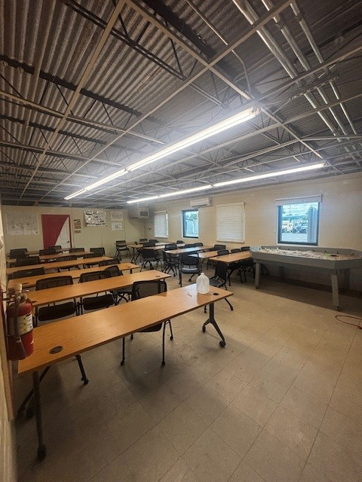

Image 3: Foyer Image 4: Conference Room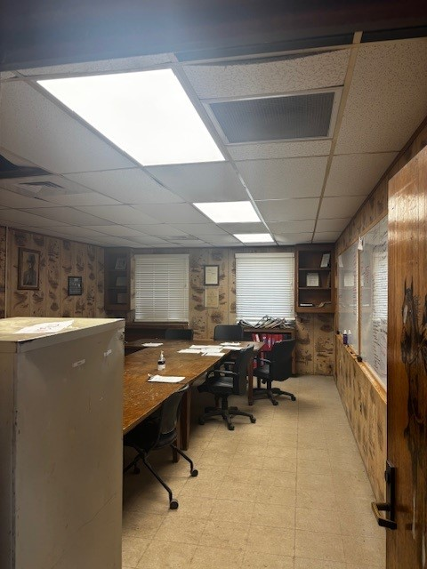

Image 5: South Classroom Door Image 6: North Classroom Door

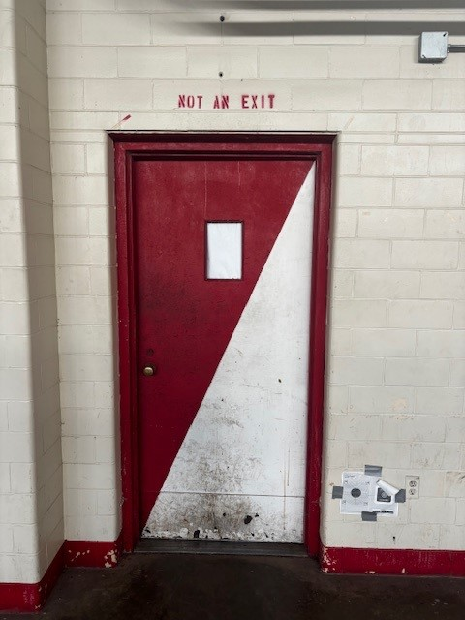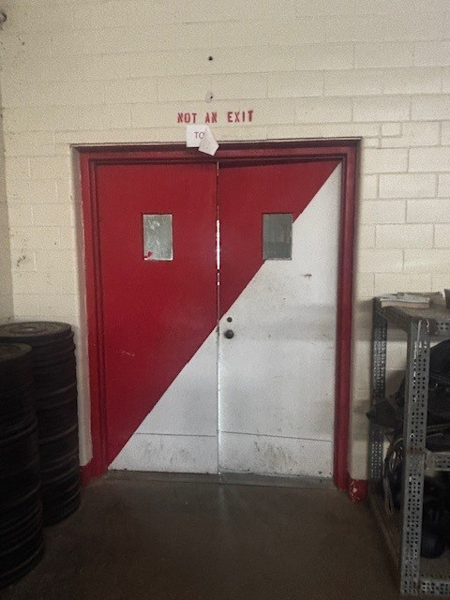

Image 7: Foyer Doors Image 8: Classroom Wall

