**Attachment C - Procedure for the Collection of Bacteriological Samples**

**Louisiana Department of Health, Office of Public Health (LDH/OPH)**

**RFx #3000024507**

**PURPOSE:** The following procedure must be followed for the routine collection of bacteriological samples (total coliform/E. coli) for compliance with the Revised Total Coliform Rule (RTCR) and Ground Water Rule (GWR).

1. **General Preparation:**
2. 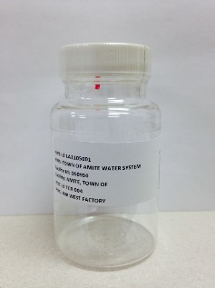Coordinate with LDH/OPH staff on proper sampling locations and supplies. Sample locations (*e.g.,* TCR-001, MRT-001, etc.) are printed on the bottle label and Chain-of-Custody (COCs).
3. Wash your hands thoroughly before handling supplies. Use hand sanitizer or rubbing Alcohol to sanitize hands in the field.
4. Assemble all of the supplies (ice chest, racks, bottles, labels, COC, and LAB 8 Forms as backups).
5. Proper sample tap (faucet) requirements:
6. Sample taps must be at LDH/OPH-approved locations. Taps located on storage tanks, at the point of entry to the distribution system (POE), and taps on the well discharge (unless required by GWR) are not allowed for compliance sampling.
7. The sample tap must be located at least 10-12 inches above any surface to eliminate splashing and to allow sampling without touching the inside of the sample bottle to the tap.
8. If sampling inside a building, the selected tap must be a cold water tap.
9. [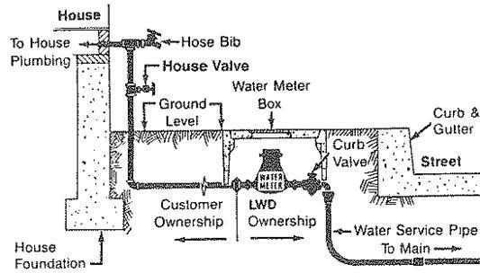](http://www.google.com/url?sa=i&rct=j&q=&esrc=s&frm=1&source=images&cd=&cad=rja&docid=47CSrIZWZbCT-M&tbnid=rpwJ7YftKfoIZM:&ved=0CAUQjRw&url=http://www.ci.azusa.ca.us/index.aspx?NID%3D688&ei=sypMUuq8B4XA9gT-mYGwBQ&bvm=bv.53371865,d.aWM&psig=AFQjCNHFALf5Erh2IkXrCpnMIGDGWUMqfA&ust=1380809709614621)Sample tap must be the smooth nozzle type (no internal threads). Do not take samples from faucets that leak around valve stem, equipped with screw-on vacuum breakers, swivel faucets, or threaded taps that allow for the connection of aerators, strainers or hoses.
10. If sampling from a hose bib outside a building, **only use the hose bib that is directly connected off the service line** (*i.e*., pipe comes from the ground and connects to the house – See Schematic to the right). **Do not sample from the hose**; disconnect the hose and sample directly from hose bib.
11. Disinfect the tap by spraying it with Isopropyl alcohol (preferred) or 50/50 bleach solution and allow to air dry for 2 minutes before flushing the tap.
12. **Taking the Sample:**
13. Flush the tap by running the water until there is a noticeable temperature change in the water (~5 minutes). This clears out the service line. Adjust the flow to an even flow. Avoid a splashing flow.
14. Measure the chlorine residual type with a LDH/OPH-approved and verified DPD Colorimeter in accordance with the LDH/OPH’s **Attachment D – Procedure for Residual Measurement** based on the Public Water Systems (PWS’s) Disinfectant type (see chart below) and record the Disinfectant Residual concentration in the section provided on the COC or LAB 8 form. Designate Free or Total and units of measure (parts per million (ppm) = milligram per liter (mg/L)) by using the appropriate blank. LDH/OPH will provide the appropriate residual measurement type for each water system.

|  |  |
| --- | --- |
| **Type Disinfectant Used** | **Residual Type to Measure** |
| Liquid Chlorine solution | Free Chlorine Residual |
| Gas Chlorine | Free Chlorine Residual |
| Chloramines (formed with ammonia) | Total Chlorine Residual |

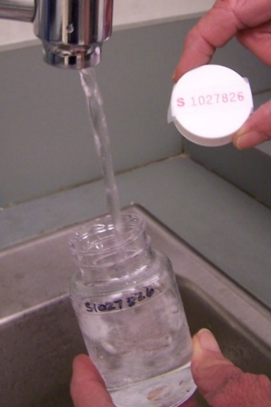

1. Filling the IDEXX Sample Bottle:
2. *Ensure the sterile seal is intact and that the bottle is free from cracks.*
3. *Break sterile seal on bottle after flushing the line and collecting chlorine residual.*
4. *Holding the bottle by the base, open bottle by removing the sterile seal and removing the cap. Hold the cap by the rim and do not set the cap down. DO NOT touch the inside the bottle or cap.*
5. *Do not allow the bottle to touch the tap/faucet. Fill the bottle to the 100 mL line. Slightly overfill is fine, but do not fill past the neck line of the bottle. Under filled bottles are rejected by the lab.*

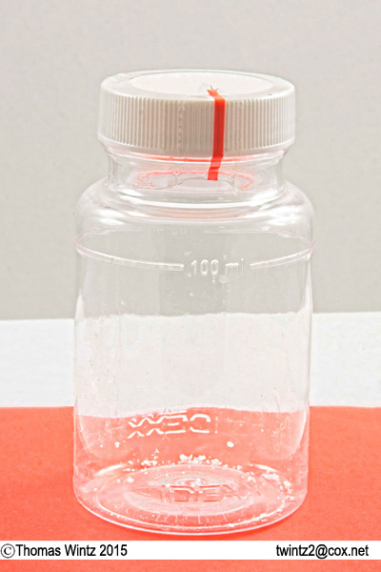

Sterile Seal

100 ml Fill Line

Sodium Thiosulfate

Powder

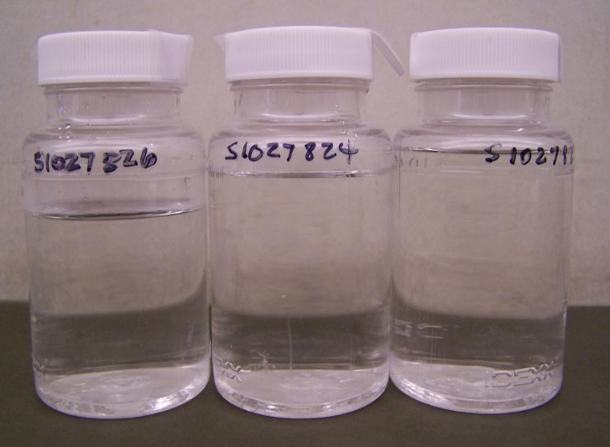

**Over**

**Filled**

**100 m/L Fill Line**

**Not Filled Enough**

**Filled to Line**

1. **Label the sample bottle:**

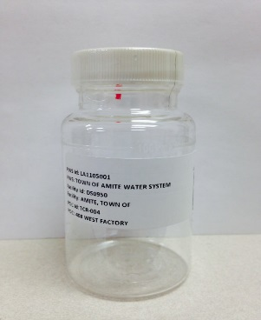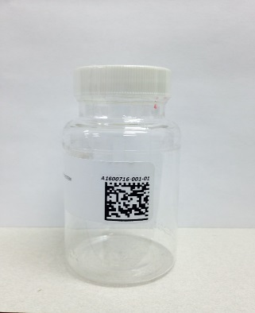

1. For scheduled samples, affix the STARLIMS label to the side of the IDEXX vessel just below the fill line. STARLIMS is the laboratory database that is used for pre-logging samples, and generating the labels and COCs.

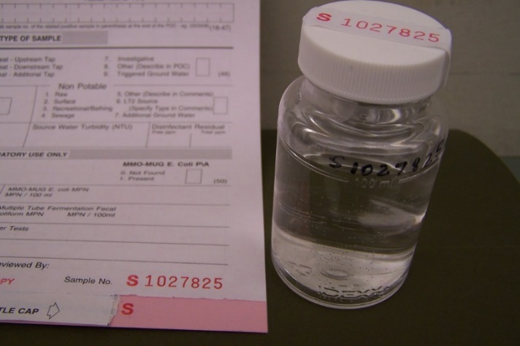

1. For unscheduled (not Pre-Logged) samples, use the LAB 8 form and label. Write the Sample ID number on the bottle side with waterproof (Sharpie) marker just above the fill line. Affix the Label to the lid of the bottle and secure with tape.

1. **Finalizing the Sample:**
2. Properly complete all mandatory fields of the COC or LAB 8 form. The sample collection date and time, POC collection address (for repeats), and the chlorine residual listed must be completed on the COC. The sample will be rejected if the mandatory fields are not completed or inaccurate on the COC/Lab-8 form. *Enter the sample collection time and chlorine residual into STARLIMS by 8:00 A.M. (CT) on the day after the sample was collected. *Initially this will be done by LDH/OPH staff until contractor is setup to access STARLIMS.
3. Place the sample in a rack for protection, keep samples cool with ice packs during transit and hand-deliver samples along with the Chain of Custody or properly completed LAB 8 form to either a LDH/OPH Laboratory (Amite or Baton Rouge) or a sample depot (Health Unit or Regional Office) where the sample truck will pick up for delivery to the LDH/OPH Laboratory. Samples can only be submitted to the LDH/OPH Laboratory on Monday through Wednesday by 2:30 P.M. (CT). Sample submission maybe allowed on Thursday under special circumstances (e.g., resampling if initial sample was rejected). Samples will be rejected if not received by the laboratory within 30 hours from sample collection time. Samples collected prior to 11:00 A.M. (CT) shall be not be dropped off at the sample depot for next-day delivery (i.e., after the pickup time). See LDH/OPH website for Sample Depots locations and pickup times at <https://ldh.la.gov/page/bacteriological-sample-collection>.

