### RFx 3000024953 Attachment B - Specifications

STATE OF LOUISIANA

**Governor’s Office of Homeland Security and Emergency Preparedness (“GOHSEP”)**

TECHNICAL SPECIFICATIONS FOR

**TRUCK, CAB & CHASSIS, WITH VAN BODY & LIFTGATE**

**EQUIPMENT SPECIFICATIONS**

**REV. 05/01/2025**

#### GENERAL

This specification sets forth the minimum requirements for a single axle class 3 truck cab and chassis up- fitted with a dry van body and power liftgate.

Equipment shall be new **(2023 model year or newer)**, a production model of current manufacture, and must meet all state and Federal safety and emission standards in effect at time of order.

#### REPRESENTATIVE SPECIFICATIONS

A **Chevrolet Express Commercial Cutaway 3500** and a **Lyncoach dry freight body** with appropriate options and standard features including **power liftgate**, was used to develop these specifications and establish equivalency evaluation criteria.

Equipment of similar style, type, character, quality, features, and purpose conforming to the following detailed requirements/specifications will be considered. For evaluation purposes, bidder's proposing an exception/equivalent option/feature to those specified herein, may be required to provide manufacturer/product information (catalogue sheets, detailed specifications, pictures, etc.). This information will be evaluated against the minimum requirements of this specification. Proposed submittals that are determined not to be equivalent to the established criteria will be rejected.

#### LOUISIANA AUTHORIZED DEALER(S)

Proposed item(s) must be from a manufacturer who has at least one (1) authorized dealer **within the State of Louisiana** where parts and service can be obtained. Authorized dealer(s) must have properly trained technicians plus all other resources necessary to perform warranty and repair services in complete accordance with the manufacturer’s requirements.

* A letter certifying the ability to meet this requirement, inclusive of the company name(s) and address(es) of the Louisiana authorized dealer(s), should be supplied with the bid submittal and may be required prior to award.

#### DELIVERY & ACCEPTANCE

Vendor shall perform a test run of each unit to verify that all features and capabilities are operating properly at time of delivery. Documentation of testing may be required prior to acceptance by the Department.

Unit(s) must be delivered completely assembled (including all components, accessories, etc.) and ready for operation without any additional preparation including, but not limited to, ensuring all fluid levels are at their full mark, fuel tank(s) is full, all necessary lubrication has been performed, etc. A Louisiana safety inspection shall be performed on each vehicle prior to delivery and a Louisiana safety inspection sticker properly affixed.

Any unit delivered under this specification is subject to rejection if there is evidence of poor workmanship, by either the vendor or the original manufacturer. Noted defects and/or nonconformance findings may

SPECIFICATIONS

REV. **5/1/25**

be corrected by the vendor. Corrections must be completed and approved by **LPAA** prior to final acceptance.

Unit(s) shall be delivered “**on the ground**;” to **LPAA** will not unload nor provide any unloading equipment to the vendor/delivery driver in order to offload the unit(s).

**NOTE:** The Department will have space available for equipment to be unloaded.

#### EACH UNIT MUST BE SUPPLIED WITH THE FOLLOWING DOCUMENTATION:

1. Notarized Bill of Sale
2. Certificate of Origin (MSO)
3. Dealer's Service Policy
4. Owner's/Operator's Manual(s)
   1. One (1) Hardcopy
   2. One (1) Digital Copy
      1. Acceptable Formats: CD, DVD, Flash Drive, or E-mail
5. Service Manual(s)
   1. One (1) Hardcopy
   2. One (1) Digital Copy
      1. Acceptable Formats: CD, DVD, Flash Drive, or E-mail
6. Build Sheet(s) – as applicable
   1. One (1) Hardcopy
   2. Build sheets should be writing in plain language (not company specific codes) and include, at a minimum, all standard & optional features of the delivered unit.

**NOTE:** Invoices will not be processed for payment until the unit(s) have been inspected by **LPAA** and deemed in compliance with the specifications.

#### BID SUBMITTALS

Any additions, deletions, or variations from the specifications should be noted in the "Bidder’s Exceptions" page of this specification. Exceptions that are noted to be less than a minimum requirement will not be accepted.

Any additions, deletions or variations from the manufacturer’s standard published specifications should be noted on the "Bidder’s Exceptions" page of this specification. Unless otherwise noted, any items appearing in the manufacturer’s standard published specifications furnished by the Bidder are assumed to be included in the Bidder’s submittal.

Bidder should note on their submittal any installation(s) to the equipment that will be performed by the vendor instead of the manufacturer.

Failure to note any specification exceptions, manufacturer specification alterations, and/or vendor installations prior to award may result in rejection of the equipment at the time of delivery.

## THE NUMBER OF DELIVERY DAYS AFTER RECEIPT OF ORDER (ARO) MAY BE USED AS A FACTOR IN THE AWARD.

**EQUIPMENT SPECIFICATIONS**

**NOTICE TO BIDDERS**

**Bidder should review the detailed "Equipment Specification" completely and respond to the compliance question at the end of each section by marking “X”, in the space provided, for "Yes" or "No". Mark "Yes" to indicate that the equipment bid meets the section exactly as specified. Mark "No" if there are exceptions to any part of that section. Exceptions/deviations to any part of the specification are to be detailed on the "Bidder's Exceptions" page of this specification.**

**IN ORDER TO BE CONSIDERED FOR AWARD, BIDDER SHOULD RETURN THIS SPECIFICATION, COMPLETED IN FULL, WITH THEIR BID SUBMITTAL.**

**Note: All Values listed below are minimums unless noted otherwise.**

1. **Cab & Chassis**

**1.1.** GVWR: 11,839 lbs.

#### Comply: Yes No

* 1. Cab & Axle Positions
     1. Front axle: For the purposes of this solicitation, set-forward-axle (SFA) is considered equal to set-back-axle (SBA); however, SBA is the preferred option
     2. Cab to Axle (CA): 84.5” clear*
     3. Center of rear axle to end of frame (AF): (no specification, must be adequate for 16’ van body with 177” wheelbase) *

*Values given here are minimums. The space between cab and body shall not exceed 10 inches. Truck vendor and body manufacturer/upfitter shall coordinate in selecting a cab to axle dimension that works with the specified body and ensures proper load distribution to the front and rear axles in accordance with manufacturer specifications and industry practice. The required AF must be achieved with factory frame rails. Frame extensions to meet the required AF are not allowed. The AF must be sufficient to allow support of the full length of the body.

#### Comply: Yes No

* 1. Front Bumper
     1. Full width all-steel front bumper

#### Comply: Yes No

**EQUIPMENT SPECIFICATIONS**

* 1. Cab
     1. Conventional day cab
     2. Tinted safety glass
     3. Full width exterior cab mounted sun shade with integral clearance lights
     4. Cab entry handles, driver & passenger side
     5. Outside mirrors, driver & passenger side, adequate width for driver to view adjoining traffic lanes
        1. Power adjustable
        2. 90 sq. in. minimum
        3. Heated with integrated turn signals
        4. Two (2) adjustable spot mirrors, one (1) per outside mirror
        5. one (1) standard electric horn
     6. Air ride: driver and passenger seat, cab suspension
     7. Manufacturer’s highest level sound insulation package
     8. Gauge package including the following gauges:
        1. Air cleaner restriction
        2. Coolant temperature
        3. Fuel
        4. Speedometer
        5. Tachometer
        6. Gear indicator
        7. Odometer
        8. Total engine hours
        9. Trip hours
        10. Trip odometer
        11. Rear axle oil temperature
        12. Auto transmission oil temperature
        13. Engine oil temperature
        14. Oil Pressure
        15. Volmeter
     9. Dual sun visors
     10. 3-point seat belt for each seat.
     11. Climate control, including air conditioning, heater, & defroster
     12. Power windows & power door locks
     13. Tilting & telescoping steering wheel

#### Comply: Yes No

**EQUIPMENT SPECIFICATIONS**

* 1. Engine
     1. 6.6 L, V8, gasoline, liquid cooled
     2. 401 HP @ 5200 rpm, 464 lb-ft of torque @ 4000 rpm

#### Comply: Yes No

* 1. Fuel System
     1. Fuel tank shall be metal and a 50-gallon minimum capacity

#### Comply: Yes No

* 1. Transmission
     1. Automatic, 6-speed heavy-duty
     2. To be filled with manufacturer approved synthetic lubricants

#### Comply: Yes No

* 1. Gearing, Speed Governing & Performance
     1. Transmission and axle ratio shall be selected for performance to be optimized at 65 MPH

**Comply: Yes No** RPM @ 65 MPH

* 1. Front Axle
     1. Shock absorbers

#### Comply: Yes No

**EQUIPMENT SPECIFICATIONS**

* 1. Rear Axle
     1. Air-ride suspension
     2. Shock absorbers

#### Comply: Yes No

* 1. Brakes
     1. ABS brake system with traction control

#### Comply: Yes No

* 1. Wheels & Tires
     1. Hub piloted steel disc, size - 16" x 6-7"
     2. First line, first quality tires, size – LT225/75R16E
     3. Front tires - single highway tread
     4. Rear tires - dual on/off road tread
     5. Load ratings to be compatible with GVWR
     6. Spare tire, jack, & lug wrench required

#### Comply: Yes No

* 1. Electrical System & Lights
     1. 12-volt system
     2. 220-amp brushless alternator
     3. Batteries with 1,540 CCA combined
     4. Dual electric circuits/batteries to allow power while engine off
     5. One (1) dash mounted, rocker-style, factory installed, body circuit switches (upfitter switches) for simple on/off functions for accessories (PTO, warning lights, etc.); one (1) assigned to energize the cargo lighting circuit
     6. All exterior lighting should be LED
     7. Headlights:
        1. Automatic daytime running lights
        2. Automatic on if windshield wipers are turned on
        3. Automatic on with low ambient light levels
        4. Warning buzzer/alarm when headlight switch is on and ignition switch is in off position
     8. Cruise control
     9. Intermittent windshield wipers with washers
     10. Self-cancelling directional signals
     11. Backup alarm, 97 dba
     12. AM/FM radio
     13. Two (2) 12V accessory power outlets with covers, mounted in dash (for cell phone chargers, GPS devices, etc.). One (1) 12V power outlet and one (1) USB charging outlet will also satisfy this requirement.

#### Comply: Yes No

* 1. Paint

**EQUIPMENT SPECIFICATIONS**

* + 1. Cab: Manufacturer’s standard, white
    2. Chassis: Manufacturer’s standard, black

#### Comply: Yes No

* 1. FMCSA/DOT Mandated Safety Items
     1. One (1) UL listed, 5 B:C rated, or higher, fire extinguisher securely mounted in cab
     2. One (1) set of three (3) bidirectional reflective triangles conforming to FMVSS No. 125
     3. At least one (1) spare fuse for each type/size used in the truck

#### Comply: Yes No

1. **Van Body**
   1. Dimensions

**2.1.1.** 16’0”L x 96”W x 84”H

#### Comply: Yes No

* 1. Design
     1. Sealed unit clearance lights
     2. 12” corrugated steel scuff plate on sides and front, one row 24” above floor, one row 48” above floor
     3. 1-1/8” hardwood floor, undercoated
     4. Grab handles at rear of body
     5. Composite roll up rear door

#### Comply: Yes No

* 1. Body Installation
     1. A rubber or plastic (nylon or Delrin) sill spacer shall be used between the frame & body sills; WOOD SPACERS ARE NOT ALLOWED!
     2. Body should be bolted to frame using brackets or fishplates. U-BOLTS ARE NOT ALLOWED!
        1. Upfitter should utilize chassis manufacturer’s guidance for body mounting methods
     3. Brackets

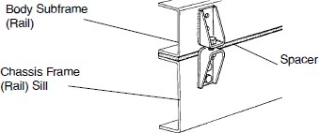

* + 1. Fishplate - to be bolted to chassis frame, utilizing existing holes where possible, and bolted or welded to body sub-frame/sill.

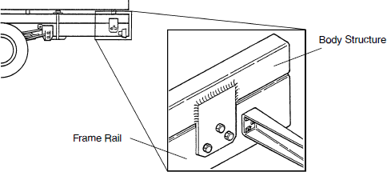

#### Comply: Yes No

**EQUIPMENT SPECIFICATIONS**

* 1. Liftgate
     1. Aluminum platform
     2. Capacity: 3,000lbs
     3. 150 amp circuit breaker for electrical protection
     4. All steel painted manufacturer’s standard black

#### Comply: Yes No

* 1. Body Prep/Paint: manufacturer’s standard, white

#### Comply: Yes No

1. **Lighting, Wiring And High Visibility Conspicuity Tape**
   1. General
      1. Refer to lighting layout illustrations below
      2. Truck must be delivered with warning lights & high visibility reflective conspicuity tape installed in accordance with the below specifications and layout
      3. All warning lights to be sealed light emitting diode (LED) type, with plug-in connectors
      4. 6” oval lights must be grommet mounted
      5. Warning lights shall be installed by an upfitter who is experienced in and regularly engages in the installation of automotive electronics & warning lights
      6. Installer shall use vehicle & lighting manufacturers’ guidance along with industry best practices and techniques to ensure that lights are installed in a safe and neat manner
      7. All wiring and cables should be color coded, heat shrink wrapped and logically routed, secured, and protected with convoluted loom where possible
      8. All wiring splices must be made using butt or parallel crimp connectors

# EQUIPMENT SPECIFICATIONS

* + 1. All fasteners used for light mounting must be corrosion resistant stainless steel
    2. Non-metallic/rubber grommets shall be used where wires and cables penetrate any cab panels, body panels, or chassis structure
    3. All cab and body penetrations shall be adequately sealed to prevent water from entering
    4. All warning lights to be controlled by a single in-cab, dash-mounted upfitter switch. The switch must be labeled to read “Warning Lights”
    5. All lighting must meet Federal and state requirements

#### Comply: Yes No

* 1. Cargo Lighting
     1. Phillips Permalite XB corner cargo lamps, or equal

**3.2.3.** 10-12V DC

* + 1. 1200 lumen output
    2. Clear polycarbonate lens
    3. Moisture-proof circuit board
       1. One in-cab upfitter switch should also serve as a master switch for the cargo lighting circuit

#### Comply: Yes No

* 1. Perimeter Warning Lights
     1. Twenty-two (22) perimeter lights required
        1. Eight (8) front, installed in the locations shown below
        2. Six (6) rear, installed in the locations shown below
        3. Four (4) each side, installed in the locations shown below

#### Comply: Yes No

**EQUIPMENT SPECIFICATIONS**

* 1. High Visibility Reflective Tape
     1. DOT C2 approved high visibility reflective conspicuity tape, 2” wide, with alternating 6” segments of red and white, shall be placed on each side of the body as shown below
     2. High visibility reflective conspicuity tape, 2” wide, with alternating 6” segments of green and high visibility yellow, shall be placed on the rear of the body as shown below

#### Comply: Yes No

* 1. Lighting and Tape Layout: The following pictures are intended to show a general representation of a truck with a dry van body. Only the labeled lighting and conspicuity tape details apply here. No other features of the trucks shown are intended to be included unless stated elsewhere.

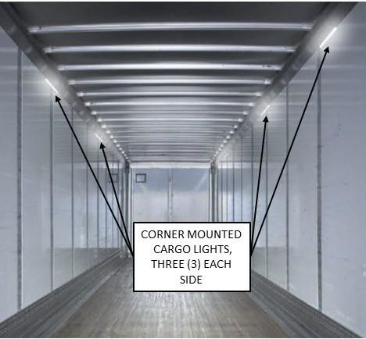

# EQUIPMENT SPECIFICATIONS

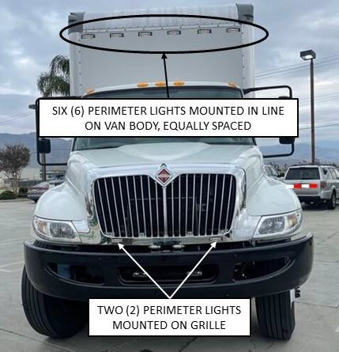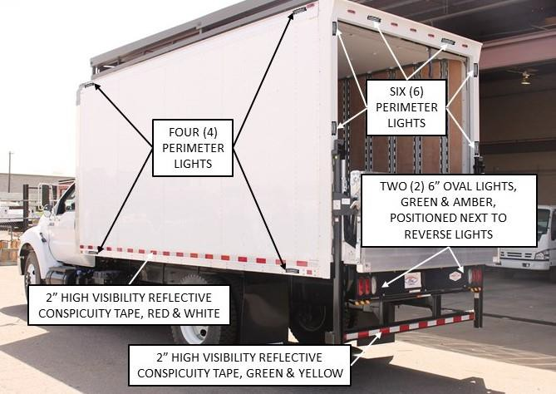

#### Comply: Yes No

**BIDDER’S EXCEPTIONS**

Crossmembers are 4” channel on 12” centers.

2.2.8

Batteries have 2000 CCA combined.

1.18.3

Engine has 325 horsepower

1.6

**Instructions:** Bidder should note all exceptions in space provided below. List the detail number from the

aforementioned specification in the column to the left and the exception in the column to the right. Responses may be typed or hand-written. Handwritten responses must be legible. If additional space is needed, please print a duplicate copy of this sheet. "Bidder’s Exceptions" page(s) should be returned with the bid submittal.

Examples:

**Spec./Detail**

**Reference Exception**