**SCOPE OF WORK**

**SABINE NATIONAL WILDLIFE REFUGE STRUCTURE REPLACEMENT (CS-0023) OPERATIONS AND MAINTENANCE CONTRACT**

**THE COASTAL PROTECTION AND RESTORATION AUTHORITY (CPRA)**

1. **PROJECT HISTORY**

The Sabine National Wildlife Refuge Structure Replacement Project (CS-0023) project area is located within the Sabine National Wildlife Refuge, approximately 9 mi (14.5 km) south of the town of Hackberry in Cameron Parish, Louisiana. Established on December 6, 1937, the Sabine Refuge is bound on the east by Calcasieu Lake, on the west by Sabine Lake, on the north by the North Line Canal, and on the south by the South Line Canal, pastureland and coastal ridges.

The Sabine Refuge Structure Replacement Project was authorized by Section 303(a) of Title

III Public Law 101-646, the Coastal Wetlands Planning Protection and Restoration Act (CWPPRA) enacted on November 29, 1990 as amended and approved on the third Priority Project List. The Sabine Refuge Structure Replacement Project has a twenty –year (20 year) life, which began in September 10, 2003 and ends in September 10, 2023. The CWPPRA program has authorized a project life extension for an additional 20 years, with a new project end of life date of September 10, 2043. With the extension, CPRA was given authority to manage the gate operations at the three (3) water control structures on the Refuge. The water control structures were replaced in 2005 and have been operated and maintained by the U.S. Fish and Wildlife Service. The structures are as follows:

|  |  |  |
| --- | --- | --- |
| Hog Island Gulley WCS | 29˚ 54’ 33.79” N | 93˚ 22’ 57.68” W |
| Headquarters Canal WCS | 29˚ 53’ 22.24” N | 93˚ 24’ 05.99” W |
| West Cove WCS | 29˚ 51’ 58.89” N | 93˚ 27’ 10.94” W |

# PROJECT MANAGEMENT

The Coastal Protection and Restoration Authority (CPRA) and the U.S. Fish and Wildlife Service (USFWS) provide financial and technical support for operations of the Project. The proper maintenance and operation associated with the Project is essential in achieving the long-term benefits envisioned and prescribed in the Operations Plan. The CS-23 Monitoring and Operations Plan will be provided to the successful bidder for informational purposes only.

Management of the water control structures regulates salinity and water levels within the basin, in order to protect, preserve, and create healthy marsh.

# OBJECTIVE

The objective of this scope is to carry out the operations and maintenance measures including water control structure gate operations and minor maintenance of the structures.

A non-mandatory pre-bid conference is scheduled as provided in the Invitation to Bid. The conference will be held at the CPRA Lafayette Regional Office, 635 Cajundome Blvd., Lafayette, LA 70506.

# CONTRACT TERM

The term of this contract begins July 1, 2025 and ending June 30, 2026 with option to renew at the same price, terms and conditions for two additional 12 month periods not to exceed a total of 36 months.

# CERTIFICATE OF DEBARMENT/ SUSPENSION STATUS

Contractor certifies with its execution of this agreement that it is not suspended, debarred or Ineligible from entering into contracts with any department or agency of the Federal Government or of the State of Louisiana, or in receipt of notice of proposed debarment or suspension.

Contractor agrees to secure from any contractor(s) and subcontractor(s) for the captioned project certification that such contractor(s) and subcontractor(s) are not suspended, debarred or declared ineligible from entering into contracts with any department or agency of the Federal Government or of the State of Louisiana, or in receipt of a notice of proposed debarment or suspension.

Contractor shall provide immediate notice to the CPRA in the event of it or its contractor(s) or any subcontractor(s) being suspended, debarred or declared ineligible by any department or agency of the Federal Government or of the State of Louisiana, or upon receipt of a notice of a proposed debarment or suspension, either prior to or after execution of this agreement.

Upon receipt of notice of suspension, debarment, or declaration that Contractor or its contractor(s) or any subcontractor(s) is/are ineligible to enter into contracts with any department or agency of the Federal Government or of the State of Louisiana, either prior to or after execution of this agreement, CPRA reserves the right to review cause for said debarment, suspension, or declaration of ineligibility, and to terminate this Contract pursuant to the terms of the article in this agreement entitled TERMINATION FOR CAUSE, or take such other action it deems appropriate under this Contract.

1. **Insurance and Bonds**

The Contractor shall purchase and maintain without interruption, for the duration of the contract, insurance against claims for injuries to persons or damages to property which may arise from or in connection with the performance of the Work hereunder by the Contractor, its agents, representatives, employees or subcontractors. The duration of the contract shall be from the inception of the contract until the date of final payment.

**Minimum Scope and Limits of Insurance**

1.1 Worker’s Compensation

Worker’s Compensation insurance shall be in compliance with the Worker’s Compensation law of the State of Louisiana. Employers Liability is included with a minimum limit of $500,000 per accident/per disease/per employee. If Work is to be performed over water and involves maritime exposure, applicable LHWCA, Jones Act or other maritime law coverage shall be included and the Employers Liability limit increased to a minimum of $1,000,000. A.M. Best’s insurance company rating requirement may be waived for Worker’s compensation coverage only.

1.2 Commercial General Liability

Commercial General Liability insurance, including Personal and Advertising Injury Liability and Products and Completed Operations Liability, shall have a minimum limit per occurrence of $1,000,000.00 and a minimum general aggregate of $2,000,000.00. The Insurance Services Office (ISO) Commercial General Liability occurrence coverage form CG 00 01 (current form approved for use in Louisiana), or equivalent, is to be used in the policy. Claims-made form is unacceptable.

1.3 Automobile and Watercraft Liability

Automobile Liability Insurance and Watercraft Liability Insurance shall have a minimum combined single limit per occurrence of $1,000,000. ISO form number CA 00 01 (current form approved for use in Louisiana), or equivalent, is to be used in the policy. This insurance shall include third-party bodily injury and property damage liability for owned, hired and non-owned automobiles and/or watercraft. If any non-licensed motor vehicles and/or watercraft are engaged in operations within the terms of the contract on the site of the work to be performed thereunder, such insurance shall cover the use of any such vehicles.

NOTE: If the Contractor does not own an automobile and/or watercraft and such vehicles are utilized in the execution of the contract, then hired and non-owned coverage is acceptable. If an automobile and/or watercraft is not utilized in the execution of the contract, then automobile and/or watercraft coverage is not required.

1.4 Excess Umbrella

Excess Umbrella Insurance may be used to meet the minimum requirements for General Liability, Automobile Liability, and Watercraft Liability only.

1.5 Pollution Liability *(required when asbestos or other hazardous material abatement is included in the contract)*

Pollution Liability insurance, including gradual release as well as sudden and accidental, shall have a minimum limit of not less than $1,000,000 per claim. A claims-made form will be acceptable. A policy period inception date of no later than the first day of anticipated Work under this contract and an expiration date of no earlier than 30 days after anticipated completion of all Work under the contract shall be provided. There shall be an extended reporting period of at least 24 months, with full reinstatement of limits, from the expiration date of the policy. The policy shall not be cancelled for any reason, except non-payment of premium.

1.6Deductibles and Self-Insured Retentions

Any deductibles or self-insured retentions must be declared to and accepted by the Agency. The Contractor shall be responsible for all deductibles and self-insured retentions.

**Other Insurance Provisions**

**The policies are to contain, or be endorsed to contain, the following provisions:**

2.1 Worker’s Compensation and Employers Liability Coverage

The insurer shall agree to waive all rights of subrogation against the Agency, its officers, agents, employees and volunteers for losses arising from Work performed by the Contractor for the Agency.

2.2 Commercial General Liability and Automobile Liability

The Agency, its officers, agents, employees and volunteers shall be named as an additional insured as regards negligence by the Contractor. ISO Form CG 20 10 (for ongoing work) and CG 2037 (for completed work) (current forms approved for use in Louisiana), or equivalent, are to be used when applicable. The coverage shall contain no special limitations on the scope of protection afforded to the Agency.

The Contractor’s insurance shall be primary as respects the Agency, its officers, agents, employees and volunteers for any and all losses that occur under the contract. The coverage shall contain no special limitations on the scope of protection afforded to the Agency, its officers, officials, employees or volunteers. Any insurance or self-insurance maintained by the Agency shall be excess and non-contributory of the Contractor’s insurance.

The Contractor’s insurance shall apply separately to each insured against whom claim is made or suit is brought, except with respect to the policy limits.

2.3 All Coverages

Coverage shall not be canceled, suspended, or voided by either party (the Contractor or the insurer) or reduced in coverage or in limits except after 30 days written notice has been given to the Agency. Ten-day written notice of cancellation is acceptable for non- payment of premium. Notifications shall comply with the standard cancellation provisions in the Contractor’s policy.

Neither the acceptance of the completed Work nor the payment thereof shall release the Contractor from the obligations of the insurance requirements or indemnification agreement.

The insurance companies issuing the policies shall have no recourse against the Agency for payment of premiums or for assessments under any form of the policies.

Any failure of the Contractor to comply with reporting provisions of the policy shall not affect coverage provided to the Agency, its officers, agents, employees and volunteers.

2.4 Acceptability of Insurers

All required insurance shall be provided by a company or companies lawfully authorized to do business in the jurisdiction in which the Project is located. Insurance shall placed with insurers with an A.M. Best’s rating of A-:VI or higher. This rating requirement may be waived for Worker’s compensation coverage only.

If at any time an insurer issuing any such policy does not meet the minimum A.M. Best rating, the Contractor shall obtain a policy with an insurer that meets the A.M. Best rating and shall submit another certificate of insurance as required in the contract.

2.5 Verification of Coverage

Contractor shall furnish the Agency with Certificates of Insurance reflecting proof of required coverage. The Certificates for each insurance policy are to be signed by a person authorized by that insurer to bind coverage on its behalf. The Certificates are to be received and approved by the Agency before Work commences and upon any contract renewal thereafter.

The Certificate Holder must be listed as follows:

State of Louisiana

Office of State Procurement

1201 N. Third St. Suite 2-160

Baton Rouge, LA 70802

State of Louisiana

Coastal Protection and Restoration Authority 150 Terrace Avenue

Baton Rouge, LA 70802

Attn: Project #

In addition to the Certificates, Contractor shall submit the declarations page and the cancellation provision endorsement for each insurance policy. The Agency reserves the right to request complete certified copies of all required insurance policies at any time.

Upon failure of the Contractor to furnish, deliver and maintain such insurance as above provided, this contract, at the election of the Agency, may be suspended, discontinued or terminated. Failure of the Contractor to purchase and/or maintain any required insurance shall not relieve the Contractor from any liability or indemnification under the contract.

If the Contractor does not meet the insurance requirements at policy renewal, at the option of the Agency, payment to the Contractor may be withheld until the requirements have been met, OR the Agency may pay the renewal premium and withhold such payment from any monies due the Contractor, OR the contract may be suspended or terminated for cause.

2.6 Subcontractors

Contractor shall include all subcontractors as insureds under its policies OR shall be responsible for verifying and maintaining the certificates provided by each subcontractor. Subcontractors shall be subject to all of the requirements stated herein. The Agency reserves the right to request copies of subcontractor’s certificates at any time.

If Contractor does not verify subcontractors’ insurance as described above, Agency has the right to withhold payments to the Contractor until the requirements have been met.

2.7 Worker’s Compensation Indemnity

In the event Contractor is not required to provide or elects not to provide Worker’s compensation coverage, the parties hereby agree that the Contractor, its owners, agents and employees will have no cause of action against, and will not assert a claim against, the State of Louisiana, its departments, agencies, agents and employees as an employer, whether pursuant to the Louisiana Worker’s Compensation Act or otherwise, under any circumstance. The parties also hereby agree that the State of Louisiana, its departments, agencies, agents and employees shall in no circumstance be, or considered as, the employer or statutory employer of Contractor, its owners, agents and employees. The parties further agree that Contractor is a wholly independent Contractor and is exclusively responsible for its employees, owners, and agents. Contractor hereby agrees to protect, defend, indemnify and hold the State of Louisiana, its departments, agencies, agents and employees harmless from any such assertion or claim that may arise from the performance of this contract.

2.8 Indemnification/Hold Harmless Agreement

Contractor agrees to protect, defend, indemnify, save, and hold harmless, the State of Louisiana, all State Departments, Agencies, Boards and Commissions, its officers, agents, servants, employees and volunteers, from and against any and all claims, damages, expenses and liability arising out of injury or death to any person or the damage, loss or destruction of any property which may occur, or in any way grow out of, any act or omission of Contractor, its agents, servants and employees, or any and all costs, expenses and/or attorney fees incurred by Contractor as a result of any claims, demands, suits or causes of action, except those claims, demands, suits or causes of action arising out of the negligence of the State of Louisiana, all State Departments, Agencies, Boards, Commissions, its officers, agents, servants, employees and volunteers.

Contractor agrees to investigate, handle, respond to, provide defense for and defend any such claims, demands, suits or causes of action at its sole expense and agrees to bear all other costs and expenses related thereto, even if the claims, demands, suits, or causes of action are groundless, false or fraudulent. The State of Louisiana may, but is not required to, consult with the Contractor in the defense of claims, but this shall not affect the Contractor’s responsibility for the handling of and expenses for all claims.

# LAND OWNER REQUIREMENTS

The Contractor will be responsible for obtaining all landowner permissions and access approvals from Sabine National Wildlife Refuge.

## USFWS, Southwest Louisiana National Wildlife Refuge Complex

Shaun Ziegler

Project Leader / Refuge Complex Manager

U.S. Fish & Wildlife Service 209 Nature Road

Lake Arthur, LA 70549

(337) 774-5923

# ITEMS OF WORK

## Mobilization to and from the Structure Site:

The Contractor will be responsible for providing all equipment, labor, transportation and means necessary to mobilize and demobilize from the site for each operation and maintenance activity. The water control structures are accessible by land and are located on or along LA-

27. The cost for mobilization and demobilization is considered incidental to the work. No separate payment will be made for mobilization and demobilization.

The gates are fitted with Rotork IB7 & IB9 actuators, allowing them to be operated electronically via push button switches. In case of an emergency, power outage or failure of the control network, IQ actuators can be operated by hand. A manual clutch and handwheel

allow an operator to disengage the motor and operate the valve independently, without risk of damage or injury.

Should the actuators need servicing or electrical/mechanical maintenance, the contractor shall notify CPRA. The contractor is not expected to service or provide electrical/mechanical maintenance to the actuators. Only Rotork approved service companies and technicians shall be permitted to service the Rotork actuators. Should such work need to be performed, CPRA will create a separate purchase order, payable to the licensed servicing company, to perform the additional work.

In the event that the gate actuators need to be evaluated for servicing, the Contractor shall meet an authorized technician on-site to identify the problem actuators and demonstrate or describe the problems encountered. Such a site visit will constitute a gate operation and will be paid per event under Bid Items No. 2, 3, or 4.

Custom Actuation & Machine is a Baton Rouge based company that is a licensed Rotork distributor and technical service provider. Should the Contractor need technical support for the actuators, it is suggested that Custom Actuation be contacted for assistance.

Custom Actuation & Machine 13021 South Choctaw Drive Baton Rouge, LA 708151

(225) 272-9437 (Voice)

(225) 272-2720 (Fax)

## Water Control Structure Operations (Bid Item No. 1)

This bid item provides for accessibility to the contractor throughout the year. This retainer is necessary because operations are required to be executed within forty-eight (48) hours and in emergency cases twenty-four (24) hours from notification by CPRA. In addition, operations for this location are not on a defined schedule due to varying environmental conditions and the Contractor must be available to respond when needed.

As there may be months of no gate operations directed by CPRA, the contractor shall go to the site(s) monthly to exercise the gates and perform a general inspection of the water control structures to ensure proper operation. The Contractor will report to CPRA on the status and operability of the actuators, gates, and structures. Provide photos to document any items that may need corrective action and coordinate with CPRA & Rotork technician where required to document repair needs.

For operation of the Sabine National Wildlife Refuge Structure Replacement Project, payment will be made per month as per Bid Item No. 1.

## Operations of Hog Island Gully, Headquarters Canal, West Cove Water Control Structures (Bid Item No. 2, 3, 4)

**Hog Island Gully** - (4) 7.5 foot wide gates (HG1, HG2, HG5, and HG6)

* + - (2) 3.0 foot wide gates (HG3 and HG4).
    - Each gate is 8 foot deep, assuming that water level is at marsh elevation (1.0’ NGVD). Each gate is equipped with stop logs on slide gates that may be used to preclude all water flow.
    - Of the four (4) 7.5 foot wide gates, three have exterior flap gates (HG1, HG2, and HG6).

**Headquarters Canal** - (3) 5 foot diameter culverts (HQ1, HQ2, and HQ3)

* + - The top of each culvert is at marsh level (1.0’ NGVD)

**West Cove** - (3) 7.5 foot wide gates (WC1, WC3, and WC5)

* + - (2) 3.0 foot wide gates (WC2 and WC4)
    - Each gate is 8 foot deep, assuming that water level is at marsh elevation (1.0’ NGVD). Each gate is equipped with stop logs on slide gates that may be used to preclude all water flow.

The Contractor will be responsible for operating the gated structures, performing routine minor maintenance, and inspecting the water control structures for condition, vandalism or other problems. All operations will be in compliance with applicable Federal, State and local permits. Payment will be made per Operation event.

### Line of Communication

All operations by the Contractor will be authorized by designated CPRA personnel (Project Manager) through email or fax; or at the discretion of the Project Manager, authorization may be provided verbally and followed up immediately in writing. ***All gate operations are to be determined by CPRA.***

Once authorized by CPRA personnel, normal structure operations will have to be completed within forty-eight (48) hours after notification. The Contractor shall notify CPRA if the structure operation cannot be completed within the specified timeframe. In the case of emergency operations (e.g., abnormal rainfall events, flooding, hurricanes, etc.), structure operation, once authorized by designated CPRA personnel, will have to be completed within twenty-four (24) hours. In the event the Contractor is unable to complete the gate operations within the required time-frame without satisfactory justification, CPRA reserves the right to deduct one operation event per structure on the next pay application.

Upon completion of authorized operations, notification by email or fax to the designated CPRA personnel by the Contractor will be required. This notice will state time, date, and actual operation performed by the Contractor at the structure.

### Operations and Maintenance

The Contractor will provide the personnel and equipment necessary to open or close the gates at the specified water control structure as directed by CPRA in accordance

with the Monitoring and Operations Plan. Equipment includes but is not limited to salinity meter, grease, degreaser, rags, paint, and camera. The total number of structure operations per year are dependent on the salinity and water level values within the vicinity of the structures and within the watershed. Each structure operation will be directed by CPRA.

The Contractor will record the Operation performed and will measure and record the Salinity, Specific Conductivity, Temperature, and Water Levels at the Water Control Structure sites during each structure operation using a Handheld Meter. Excel forms will be provided by CPRA.

The Contractor will perform a visual inspection of mechanical parts and gate function, perform minor cleanup and maintenance of the structure, and ensure the ability to operate the gates. Maintenance will include routine mechanical upkeep of all moving parts on the water control structures, including periodic greasing. All equipment and materials necessary for maintenance of the structures will be provided by the Contractor. Upon inspection and identifying broken or missing parts, the Contractor shall report anticipated repairs to the CPRA project manager.

### Payment for Parts and Repairs Outside of Current Contract

Repair parts or materials needed to repair equipment and hardware will need to be addressed through a Purchase Order separate from this Operations Contract. A quote showing an itemized list of parts, description, and associated cost shall be provided to CPRA for approval prior to purchasing the equipment.

## Annual Maintenance of Water Control Structures (Bid Item No. 5)

In addition to routine maintenance, the following maintenance shall be required annually. Payment will be made per structure.

To maintain the smooth functionality of the gates, the stems are required to be cleaned. When necessary, degrease the threaded shaft, brushing and wiping debris from threads, and replacing a very thin layer of grease on the stem. Over greasing will attract dirt and debris, which will hinder the operation of the gear. Stem cover removal shall be avoided unless permission is granted by CPRA. Access to the stem threads should be from the lower level of the platform, with the gates fully closed.

All incidental waste generated from the degreasing and greasing process shall be stored in a closed container and disposed offsite.

## Paint Repair at Water Control Structures (Bid Item No. 6)

Based on Contractor inspections during routine site visits, CPRA may require paint repairs at the Water Control Structures. The following outlines the repair procedures to the painted metal surfaces, primarily the gear drive housings and pedestals.

The Contactor shall clean and properly prepare the repair surface prior to the paint application. All paint products within the coating system shall be compatible with each other. The Contractor shall follow the paint manufacturer specifications for paint storage, mixing, thinning, application conditions, and clean up. A minimum of two coats shall be required. Payment for paint repairs shall be made based on a 1ft x 1ft square area of work.

### Surface Preparation – Cleaning

The Contractor shall clean all surfaces by removing deposits of grease or oil prior to painting in accordance with the paint manufacturer specifications. Cleaning methods shall be in accordance with the SSPC Standards. SSPC-SP1 shall apply where chemical cleaning is used.

### Surface Preparation – Rust Removal

For areas where rusting has occurred, the rust and scale shall be removed as necessary to meet the paint manufacturer specifications for proper coating adhesion. Hand Tool or Power Tool techniques are required for this application to limit effects on the surrounding environment. Cleaning techniques shall be performed in accordance with the applicable SSPC standard, i.e. SSPC-SP2 – Hand Tool Cleaning, SSPC-SP3- Power Tool Cleaning, or SSPC-SP11- Power Tool Cleaning to Bare Metal. Where the surface is not taken down to bare metal, a rust converter may be applied provided it is compatible with the paint system/coating used on the project. Glossy surfaces should be dulled as necessary for proper coating adhesion.

### Paint Products & Application

When applying the paint, surfaces must be clean, dry, and free of dirt, dust, and other contaminants that could interfere with the adhesion of the coating.

Paint:

An approved Zinc Chromate Metal Primer and Acrylic Enamel paint shall be used. All paints shall be in accordance with Richard’s Rust Shield Zinc Chromate Metal Primer (Product No. 1017) and Richard’s Rust Shield II 100% Acrylic Industrial Gloss Enamel (Product No. 1200 Series) or approved equal.

The minimum dry film thickness shall be eight (8.0) mils per primer coat and finished coat. Based on the paint specifications, multiple layers per coat will be required to meet this minimum dry film thickness. For this project, the color of the finished topcoat shall be Grey. The color of the primer coat should be visually distinguishable from the finished coat.

Application:

The paint system may be applied by brush or roller in accordance with the manufacturer’s specifications. Spray application will not be allowed for this project to limit effects on the surrounding environment. The coverage shall be complete and each coat shall be so applied as to produce an even film of uniform thickness, completely coating corners and crevices, and bonded to the underlying surface. Stripe coats shall be applied to welds, fasteners, crevices and corners where the paint thickness has a tendency to contract and thin upon drying.

Paint shall be applied within the minimum and maximum coat thicknesses and recoating periods specified in the paint manufacturer’s specifications. Missed or damaged spots shall be touched up before succeeding coats are applied. Successive coats shall not be applied until the minimum recoat period has been met to prevent gassing or failure of the coating system.

Weather Limitations:

The Contractor is responsible for ensuring that weather conditions are within the manufacturer’s specifications before the paint is applied. If fresh paint is damaged by the elements, it shall be replaced by the contracting party at no direct pay.

The paint shall be applied when the surface and ambient temperatures meet the minimum and maximum temperature limitations stated in the paint manufacturer’s specifications. Paint shall not be applied in temperatures that will cause blistering or porosity, or otherwise will be detrimental to the life of the paint. The paint shall be approximately the same temperature as that of the surface on which it is applied.

The Contractor shall adhere to the paint manufacturer’s maximum relative humidity or dew point limit for applying the paint. Paint shall not be applied during, rain, snow, fog, or misty conditions. Paint shall not be applied to wet or damp surfaces.

### Pollution Control

The Contractor shall undertake measures to ensure that all debris, spent water, removed paint, or chemical products will not result in harmful effects to the environmental surroundings, nor be deposited into the waterway or onto the ground surfaces in the vicinity of the work area. Care shall be taken to avoid spillage during paint preparation, mixing, thinning, clean up, etc. If a spill occurs, it shall be cleaned up as soon as discovered. The Contractor is responsible for containing, collecting, and the temporary storage of all waste materials. Waste generated by the Contractor shall be stored in sealed containers, removed daily, and disposed of in an approved facility in accordance with State and Local regulations.

# DELIVERABLES

The Contractor will provide documentation of the Operations that occur at each water control structure.

## Reporting:

1. After each Structure Operation Event, digitally deliver an excel spreadsheet (to be provided by CPRA) which indicates the open/close status of each gate upon arrival and departure, time and date of operation, description of maintenance performed, water elevation, water temperature, specific conductivity, and salinity.
2. Report by email the dates that maintenance work occurred, outline of the procedure used, and photos documenting the completed maintenance.

The reports should be emailed to:

Dion Broussard, P.E., Project Manager, CPRA, [dion.broussard@la.gov](mailto:dion.broussard@la.gov) Leigh Anne Sharp, Monitoring Manager, CPRA, [leighanne.sharp@la.gov](mailto:leighanne.sharp@la.gov)

# PAY REQUESTS

Invoices shall be submitted to CPRA for processing. Pay requests shall be submitted on a monthly basis for the Operations and Maintenance performed during that period. All invoices shall indicate the Purchase Order Number, Project Name, Line Item Number and Description, invoiced amount by line item, and total invoice amount for that period.

Submit Pay Requests to:

|  |  |  |
| --- | --- | --- |
| Coastal Protection and Restoration Authority | Or | Electronically (preferred) |
| ATTN: Dion Broussard, P.E. |  | [dion.broussard@la.gov](mailto:dion.broussard@la.gov) |
| P.O. Box 62027 |  |  |
| Lafayette, LA 70596-2027 |  |  |

**SCHEDULE OF BID ITEMS**

# CS-0023 SABINE NATIONAL WILDLIFE REFUGE STRUCTURE REPLACEMENT OPERATIONS AND MAINTENANCE CONTRACT

|  |  |  |  |  |  |  |
| --- | --- | --- | --- | --- | --- | --- |
| **ITEM NO.** | **ITEM** | **QTY.1** | **UNIT** | **UNIT PRICE2**  Using Words | **UNIT PRICE2**  Using Numbers | **EXTENTED TOTAL**  Using Numbers |
| **1** | To establish a Contract for Operations of SNWR  Structures | 12 | Months | Dollars  Cents | $ . | $ . |
| **2** | Operation of Hog Island Gully Structure | 60 | Events | Dollars  Cents | $ . | $ . |
| **3** | Operation of Headquarters Canal Structure | 60 | Events | Dollars  Cents | $ . | $ . |
| **4** | Operation of West Cove Structure | 60 | Events | Dollars  Cents | $ . | $ . |
| **5** | Annual Maintenance of Water Control Structures | 3 | Events | Dollars  Cents | $ . | $ . |
| **6** | Paint Repair at Water Control Structures (Based on a 1ft x 1ft area) | 20 | Events | Dollars  Cents | $ . | $ . |
| **TOTAL AMOUNT OF BASE**  **BID** **Dollars** **Cents** | | | | | | |

**PROJECT FEATURES MAP**

RFx 3000024561 Attachment B - Scope of Work *Pre-Bid Conf* O&M of Water Control Struc

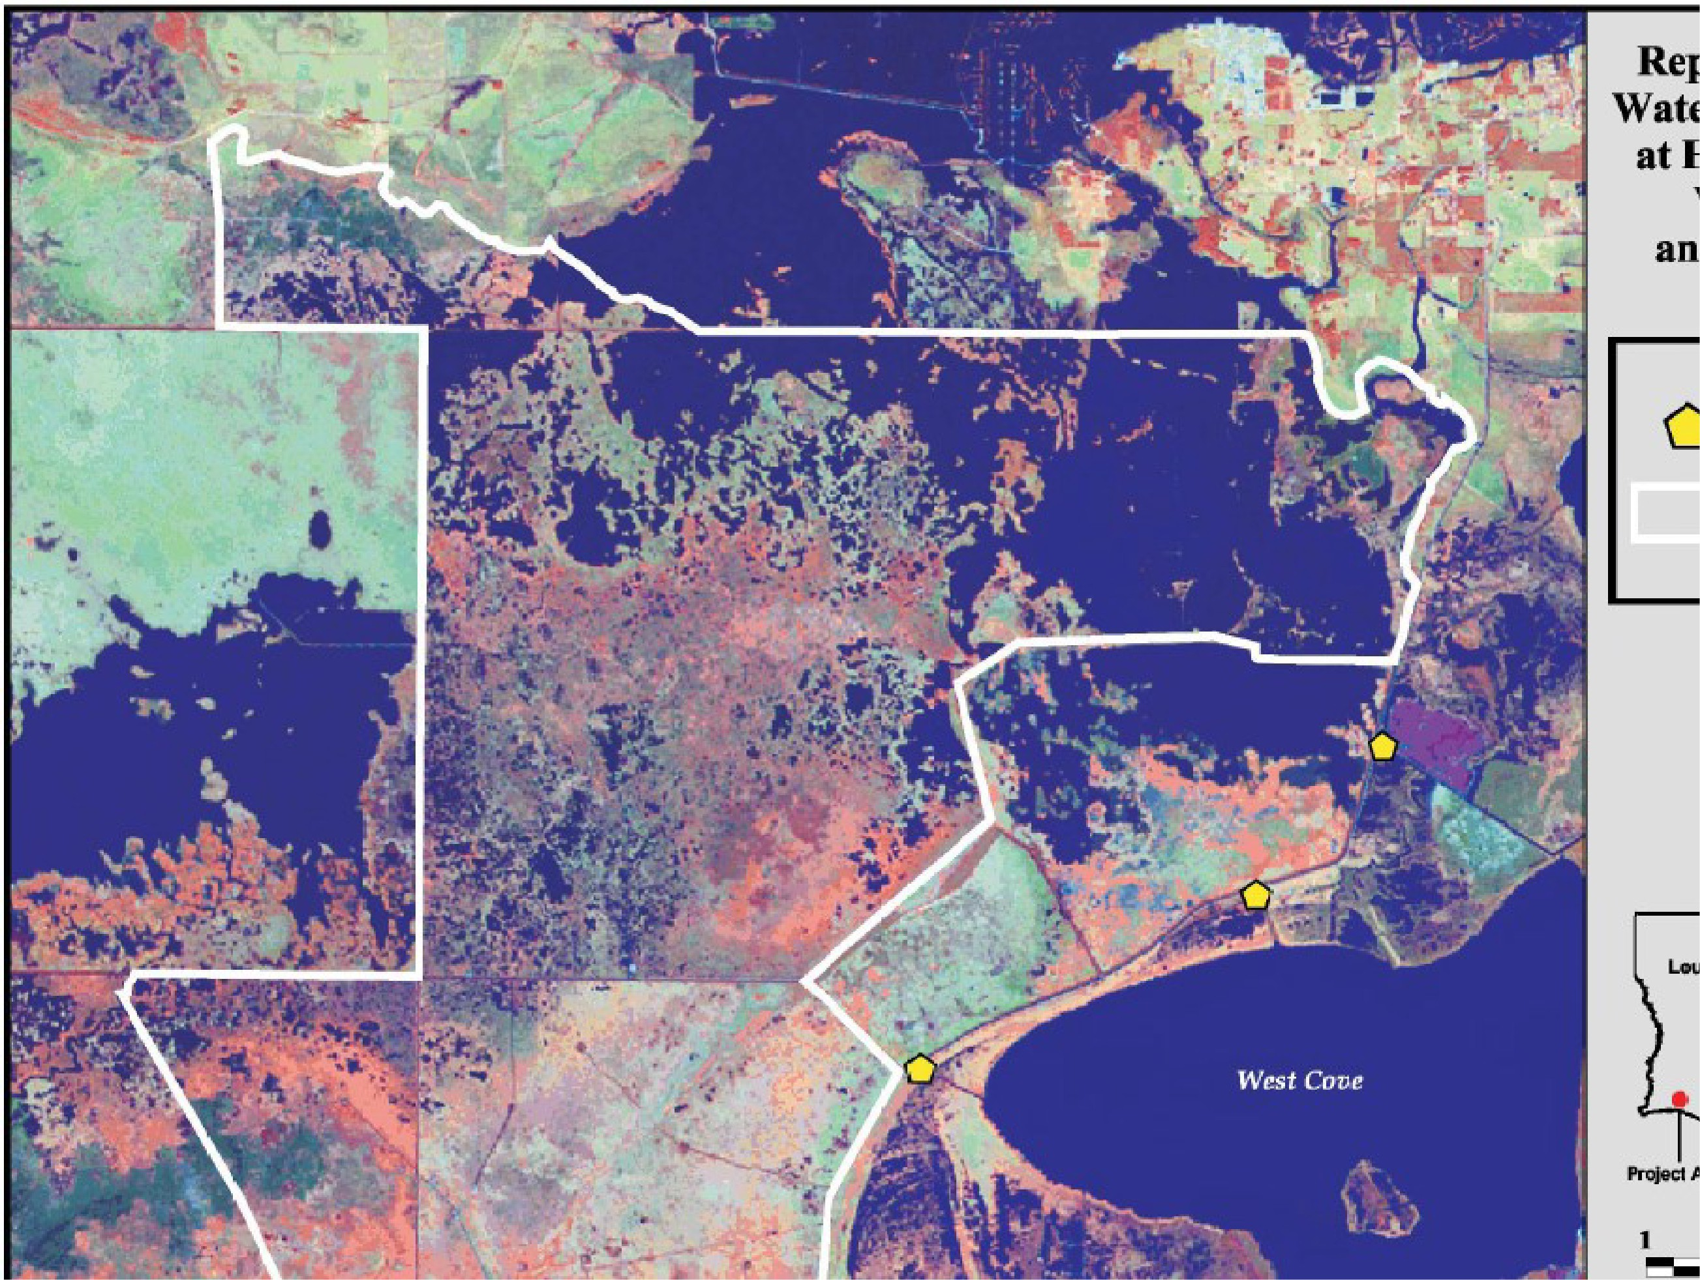

15

**ATTACHMENT #1**

**PROJECT FEATURES LOCATION & DESCRIPTION**

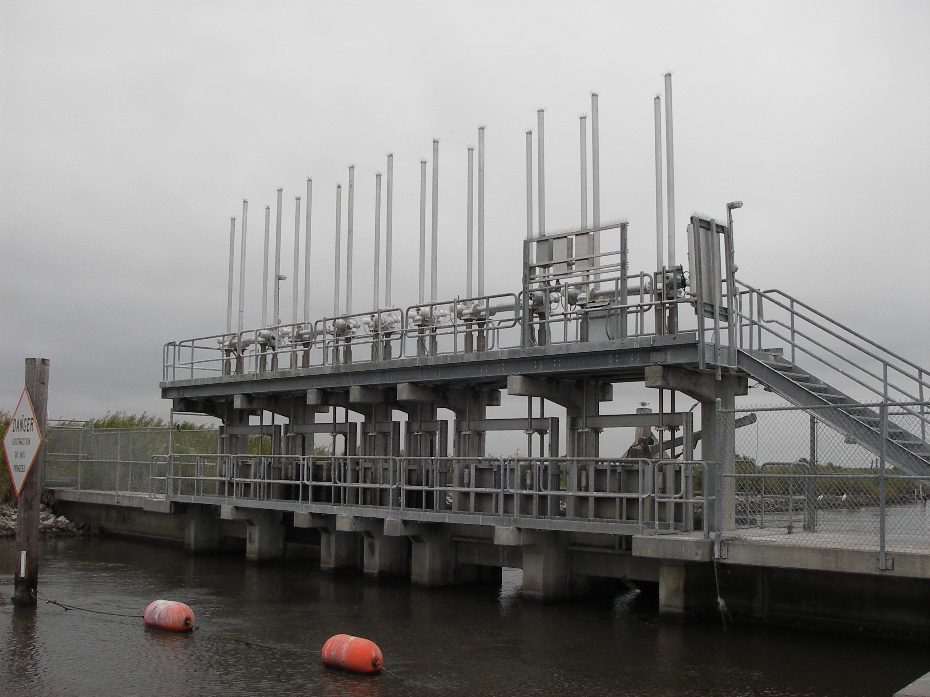

**Hog Island Gully** - (4) 7.5 foot wide gates (HG1, HG2, HG5, and HG6)

* (2) 3.0 foot wide gates (HG3 and HG4).
* Each gate is 8 foot deep, assuming that water level is at marsh elevation (1.0’ NGVD). Each gate is equipped with stop logs on slide gates that may be used to preclude all water flow.
* Of the four (4) 7.5 foot wide gates, three have exterior flap gates (HG1, HG2, and HG6).

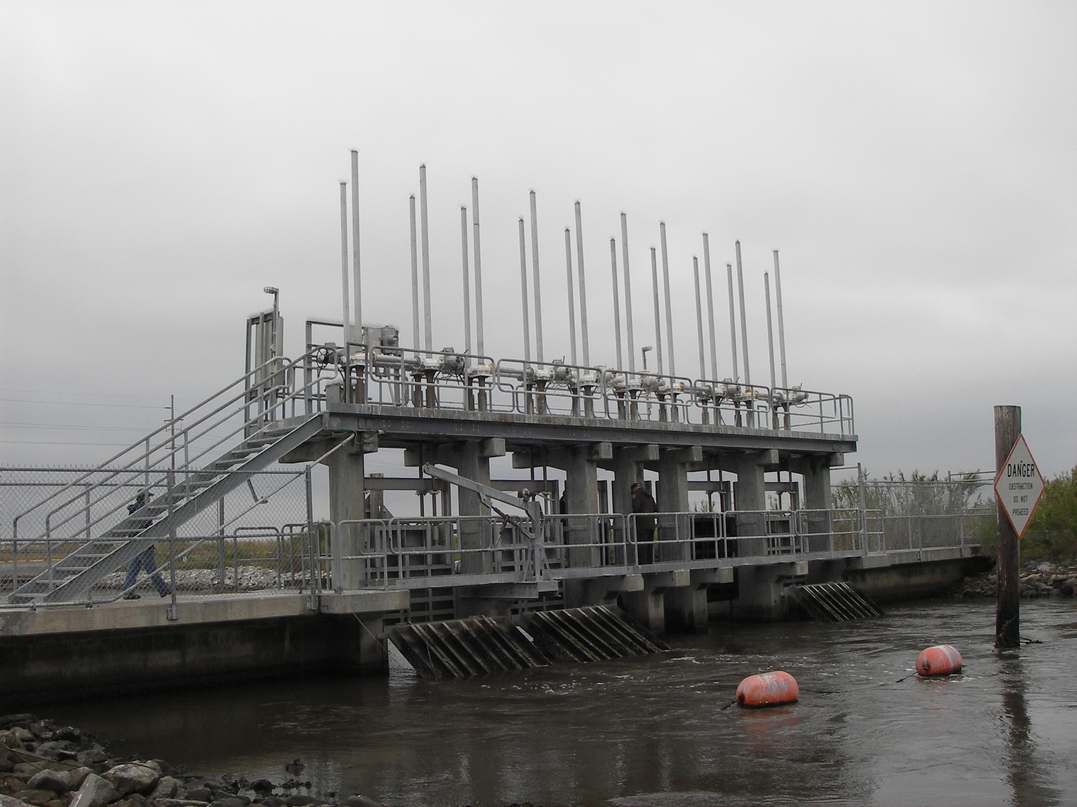

**Headquarters Canal** - (3) 5 foot diameter culverts (HQ1, HQ2, and HQ3)

* The top of each culvert is at marsh level (1.0’ NGVD)

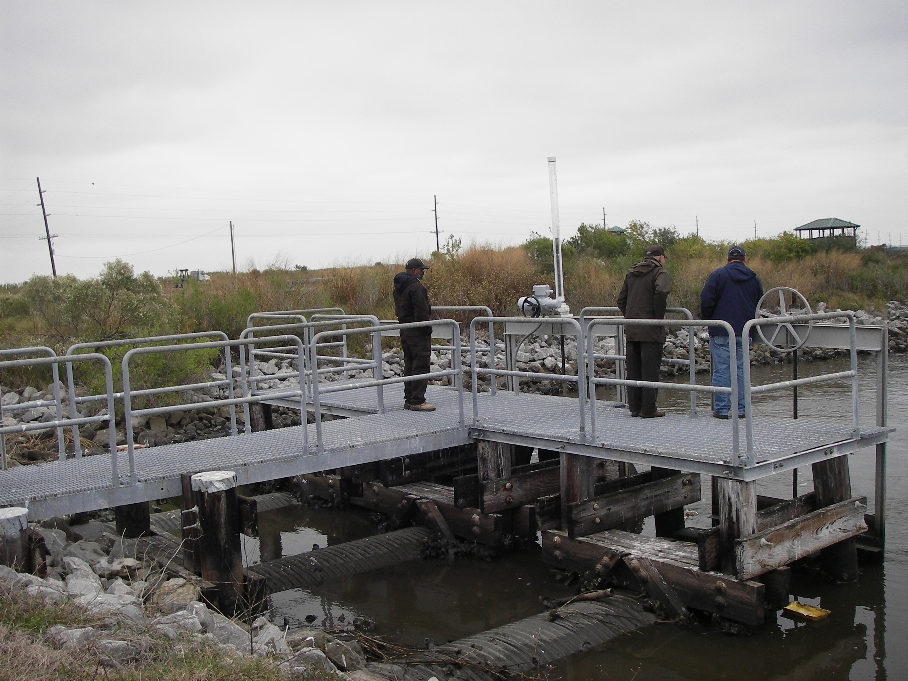

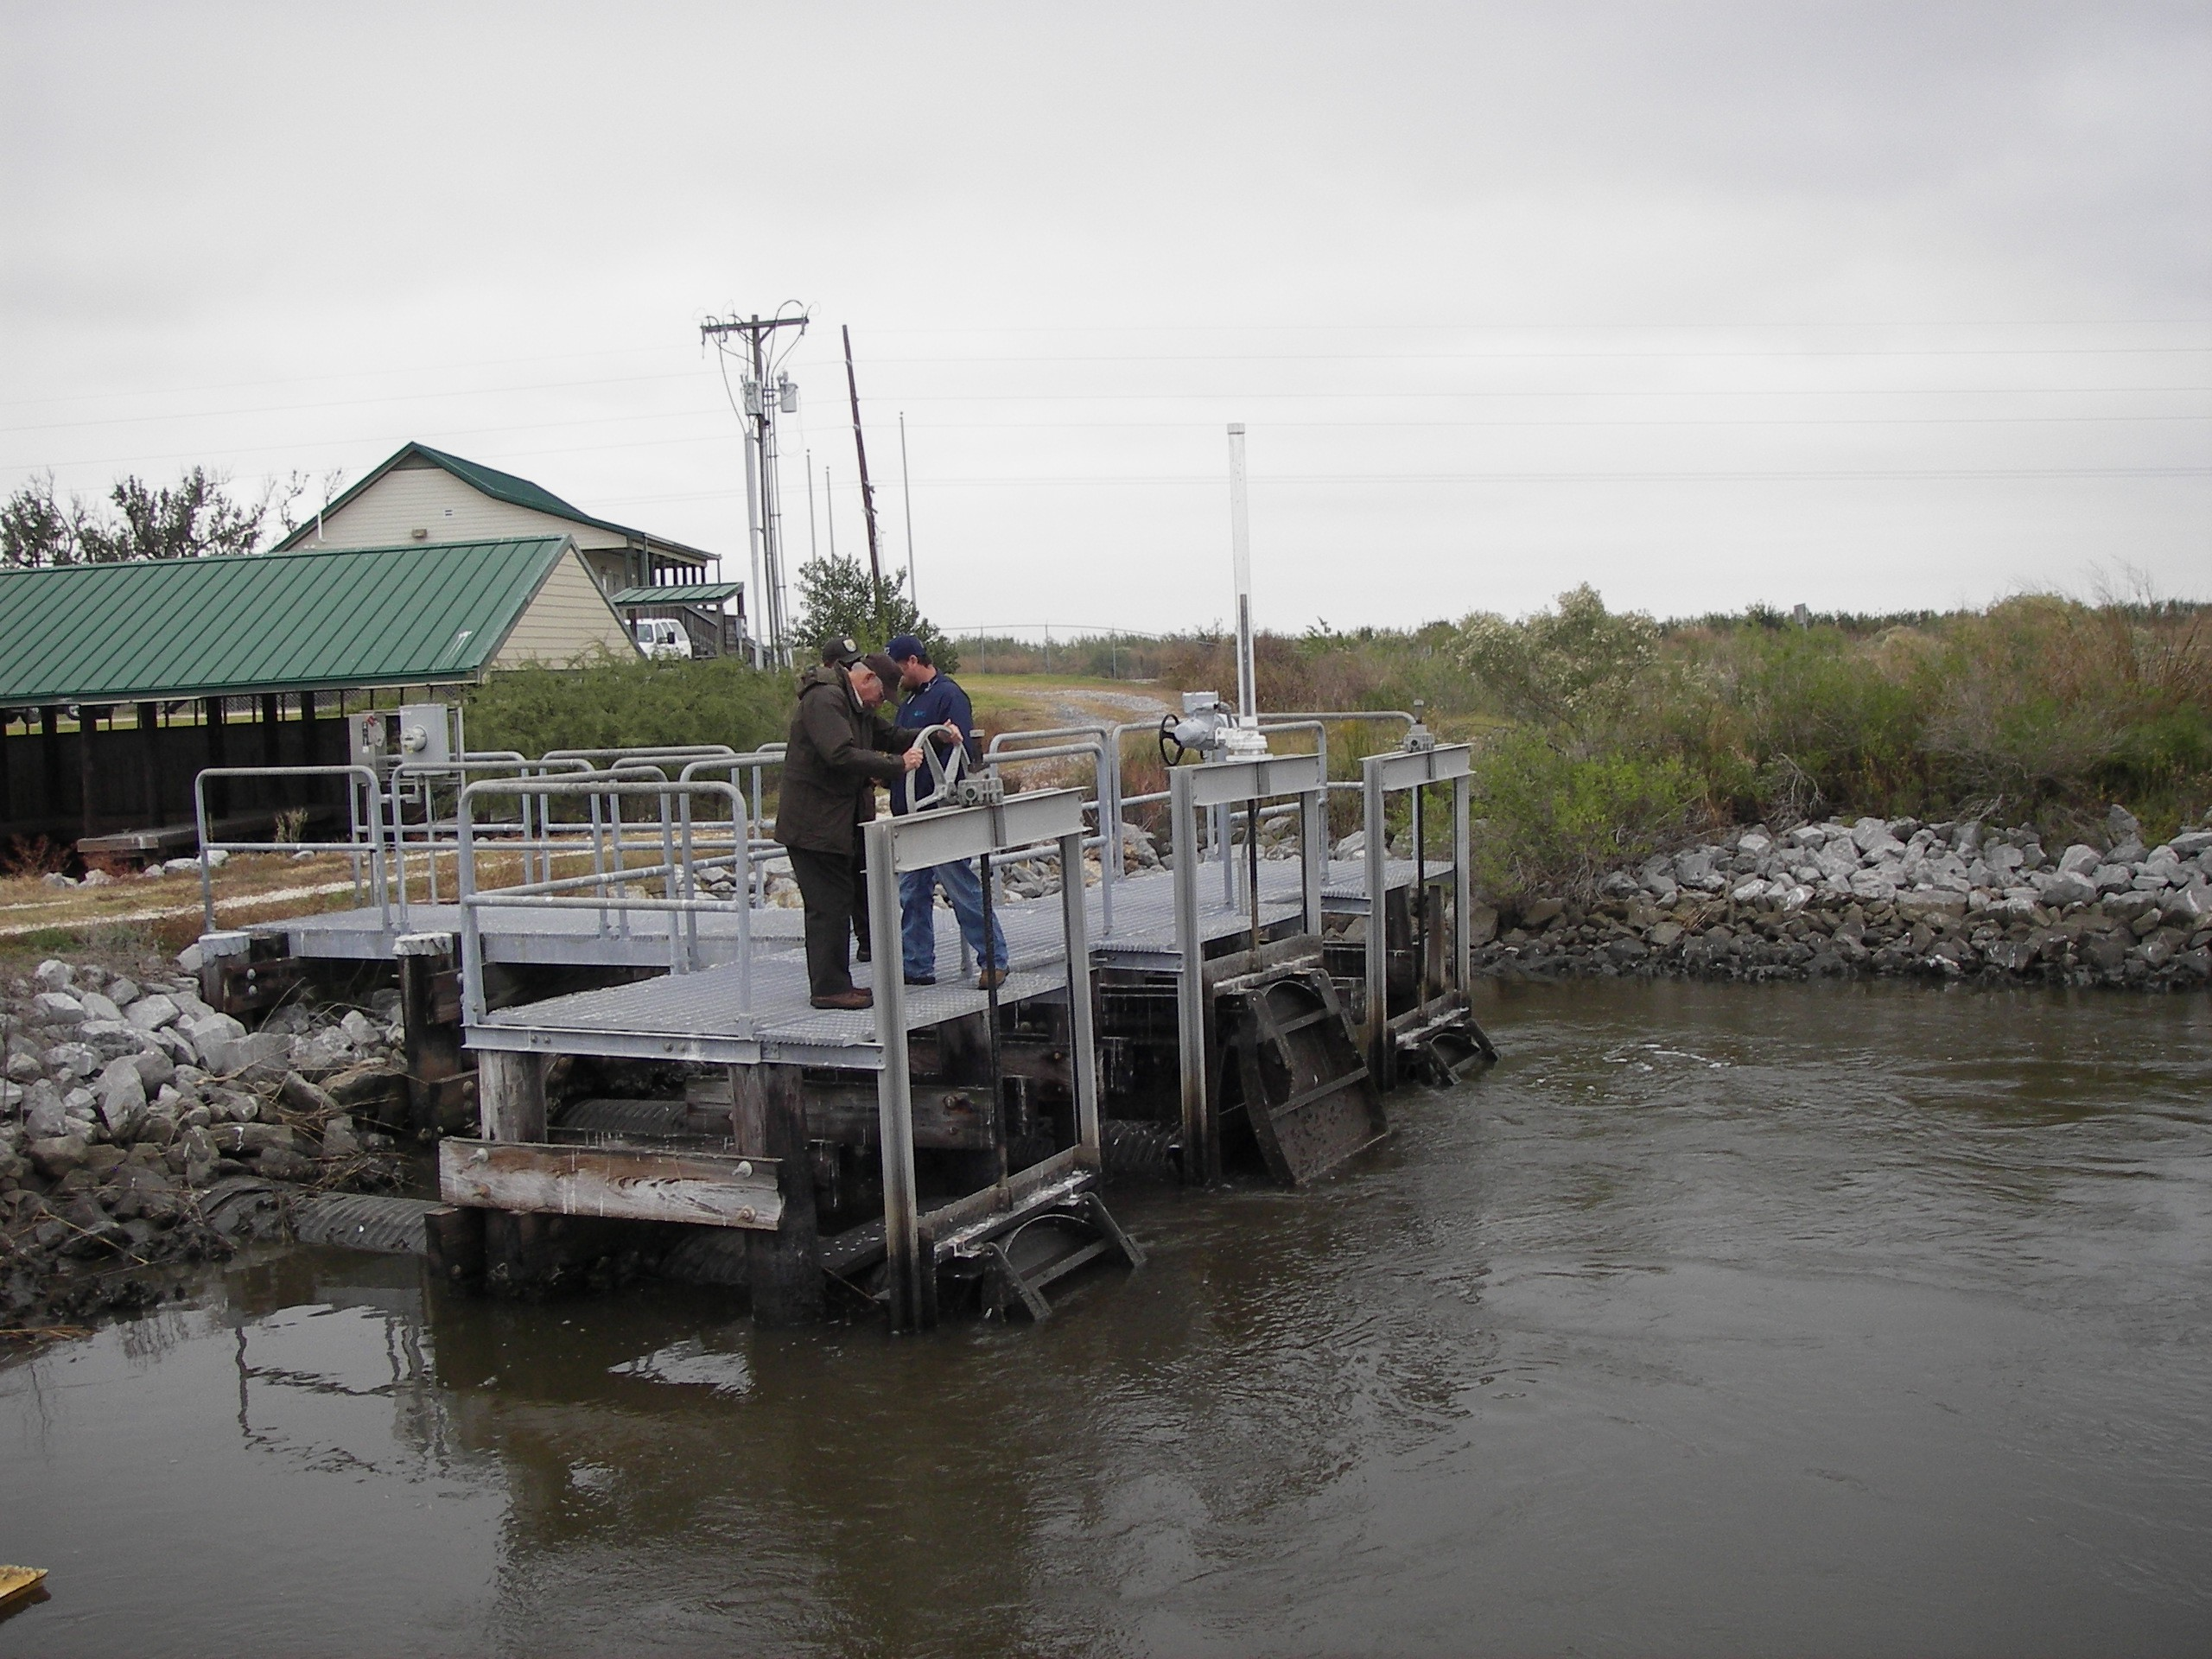

**West Cove** - (3) 7.5 foot wide gates (WC1, WC3, and WC5)

* (2) 3.0 foot wide gates (WC2 and WC4)
* Each gate is 8 foot deep, assuming that water level is at marsh elevation (1.0’ NGVD). Each gate is equipped with stop logs on slide gates that may be used to preclude all water flow.

