**Scope of Work**

The Contractor shall provide, deliver, offload and spread #57 limestone aggregate to multiple sites on Marsh Island Refuge (Iberia Parish) and State Island Refuge (Vermilion Parish) for the Louisiana Department of Wildlife and Fisheries (LDWF).

**Site Location**

Marsh Island Refuge

State Island Refuge

**Site Contact:**

Lance Campbell

(337) 523-0305

Operation #1 Hurricane Delta:

* Aggregate must be spread out evenly and level for all sites except the East Impound WCS by the Contractor. For the East Impound WCS site, aggregate will be distributed out in multiple piles as per LDWF instructions.

|  |  |  |  |  |
| --- | --- | --- | --- | --- |
| Latitude | Longitude | Refuge | Sites | Tons |
| 29.670656° | -92.144098° | State Wildlife | South Lake WCS | 216 |
| 29.544225° | -91.906885° | Marsh Island | MI tractor shed | 241 |
| 29.577495° | -91.884011° | Marsh Island | Big Dam WCS | 294 |
| 29.581759° | -91.829598° | Marsh Island | Gordy Dam WCS | 132 |
| 29.599382° | -91.863771° | Marsh Island | Belly Dam WCS | 150 |
| 29.543877° | -91.906968° | Marsh Island | East Impound WCS | 288 |

Operation #2 Headquarters Sites:

* Aggregate will be distributed out in multiple piles as per LDWF instructions.

|  |  |  |  |  |
| --- | --- | --- | --- | --- |
| Latitude | Longitude | Refuge | Sites | Tons |
|  |  |  |  |  |
| 29.674751° | -92.135817° | State Wildlife | SW HQ | 505 |
| 29.624320° | -91.878867° | Marsh Island | MI HQ | 277 |

See water depths information attached.

**Specification gradation for #57 limestone:**

**Gradation Sieve Size % Passing**

1-1/2" (37.5 Mm) 100 100

1" (25.0 Mm) 95 100

1/2" (12.5 Mm) 25 60

#4 (4.75 Mm) 0 10

#8 (2.36 Mm) 0 5

**Specific Gravity (Astm C 127 Aashto T-85)**

Bulk Dry 2.64

Saturated Surface Dry 2.67

Apparent 2.71

Absorption 1.00

**Los Angeles Abrasion (Astm C 131 Aashto T-96)**

Grading A

% Loss 27.00

**Unit weight - lbs. per cubic foot (Astm C 29 Aashto T-19)**

Dry Loose 81.00

Dry Rodded 92.00

**Sodium Sulfate Soundness (Astm C 88 Aashto T-104)**

% Loss 3.50

**General Terms and Conditions:**

* The Contractor shall provide bid amounts for every site for Job 1 and Job 2 (all-or-none basis)
* The Contractor shall provide all aggregate for Job 1 and Job 2 (all-or-none basis)
* Bids should reflect unit price per ton of specified aggregate
* Unit prices should be all inclusive (aggregate, delivery, offloading, spreading, etc.) to each site.
* See attached maps and tables for site locations, possible access routes, water level estimates, etc.
* Invoice(s) must have individual site quantities separated.
* All work to be completed by June 30, 2025.
* Invoice(s) must be received by LDWF by July 7, 2025.

|  |  |  |  |  |  |  |
| --- | --- | --- | --- | --- | --- | --- |
| **LAKE TOM APPROXIMATE WATER DEPTHS FOR GORDY DAM WCS LIMESTONE** | | | | | | |
|  |  |  |  |  |  |  |
|  |  |  |  |  |  |  |
|  |  |  | Average Depths for 2024 (feet) | | | |
| Location | Northing | Easting | March | April | May | June |
| G15 | 29.58699 | 91.82304 | 7.12 | 7.36 | 7.81 | 7.62 |
| G14 | 29.58727 | 91.82253 | 5.52 | 5.76 | 6.21 | 6.02 |
| G13 | 29.58715 | 91.82222 | 5.32 | 5.56 | 6.01 | 5.82 |
| G12 | 29.58709 | 91.82204 | 4.72 | 4.96 | 5.41 | 5.22 |
| G11 | 29.58677 | 91.82085 | 3.32 | 3.56 | 4.01 | 3.82 |
| G10 | 29.58683 | 91.81974 | 3.32 | 3.56 | 4.01 | 3.82 |
| G9 | 29.58657 | 91.81909 | 3.42 | 3.66 | 4.11 | 3.92 |
| G8 | 29.58658 | 91.81719 | 3.82 | 4.06 | 4.51 | 4.32 |
| G7 | 29.58615 | 91.81664 | 4.12 | 4.36 | 4.81 | 4.62 |
| G6 | 29.58593 | 91.8149 | 4.12 | 4.36 | 4.81 | 4.62 |
| G5 | 29.58624 | 91.81428 | 4.12 | 4.36 | 4.81 | 4.62 |
| G4 | 29.58622 | 91.81267 | 4.12 | 4.36 | 4.81 | 4.62 |
| G3 | 29.58571 | 91.81094 | 4.52 | 4.76 | 5.21 | 5.02 |
| G2 | 29.58456 | 91.80883 | 6.62 | 6.86 | 7.31 | 7.12 |
| G1 | 29.58452 | 91.80861 | 8.22 | 8.46 | 8.91 | 8.72 |

|  |  |  |  |  |  |
| --- | --- | --- | --- | --- | --- |
| **BIG DAM AND BELLY DAM WCS SHALLOWEST WATER DEPTHS** | | | | | |
|  |  |  |  |  |  |
|  |  |  |  |  |  |
|  |  | Average Shallowest Depths for 2024 (feet) | | | |
|  | Sites | March | April | May | June |
|  | Belly Dam Canal | 2.97 | 3.21 | 3.66 | 3.47 |
|  | Big Dam | 3.57 | 3.81 | 4.26 | 4.07 |

The information above is intended only as general knowledge of normal, average, monthly water levels and in no way is a guarantee of actual water levels at any time. Water levels will vary and change constantly with lunar tides and winds. Interested bidders should assess each site and routes prior to submitting bids.

**GENERAL MAP OF SITES**

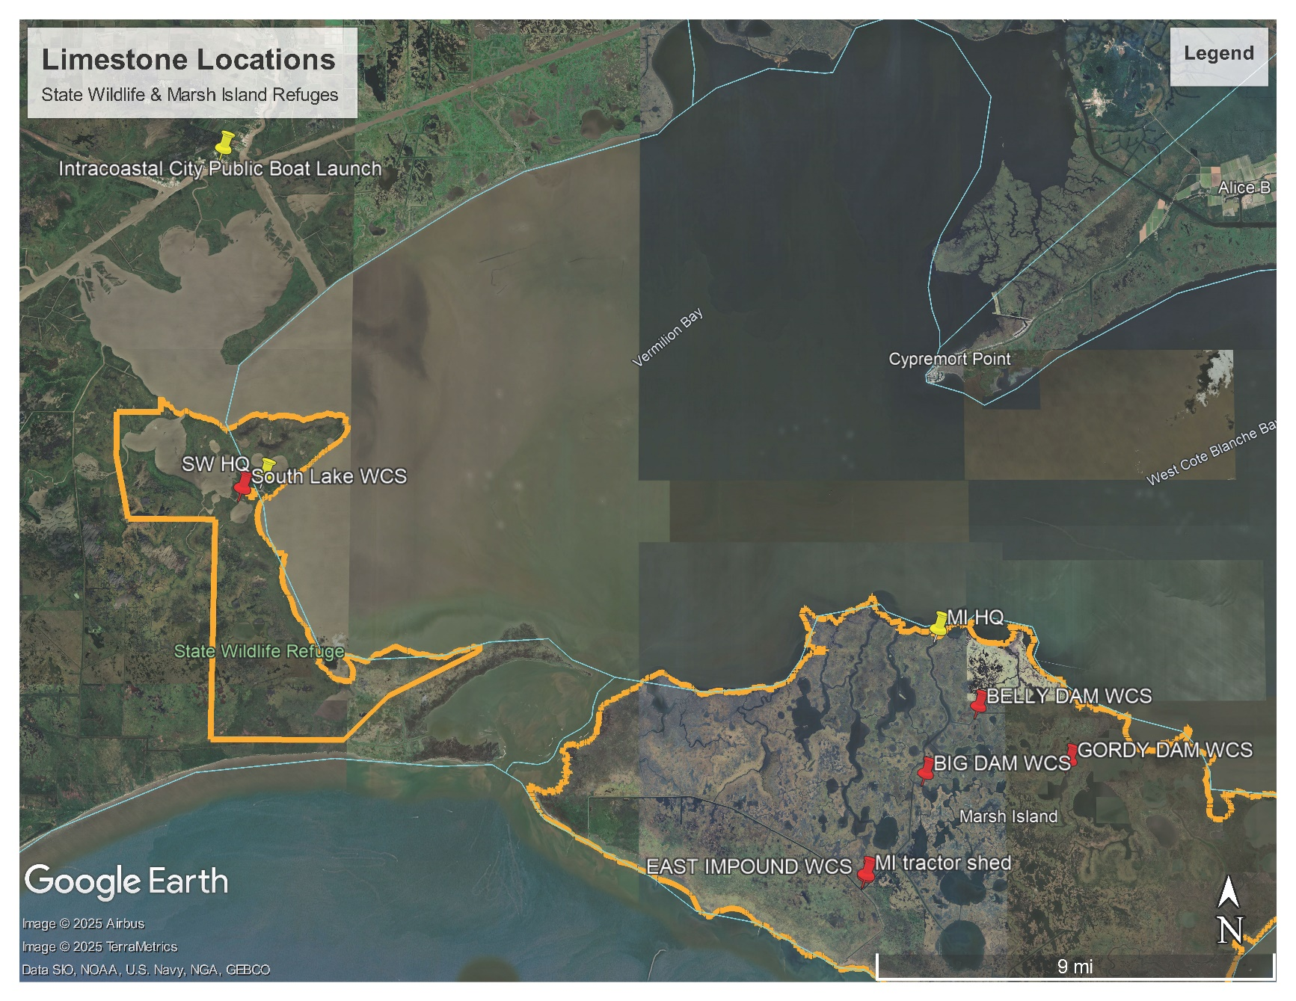

**MAP OF SITES ON STATE WILDLIFE REFUGE**

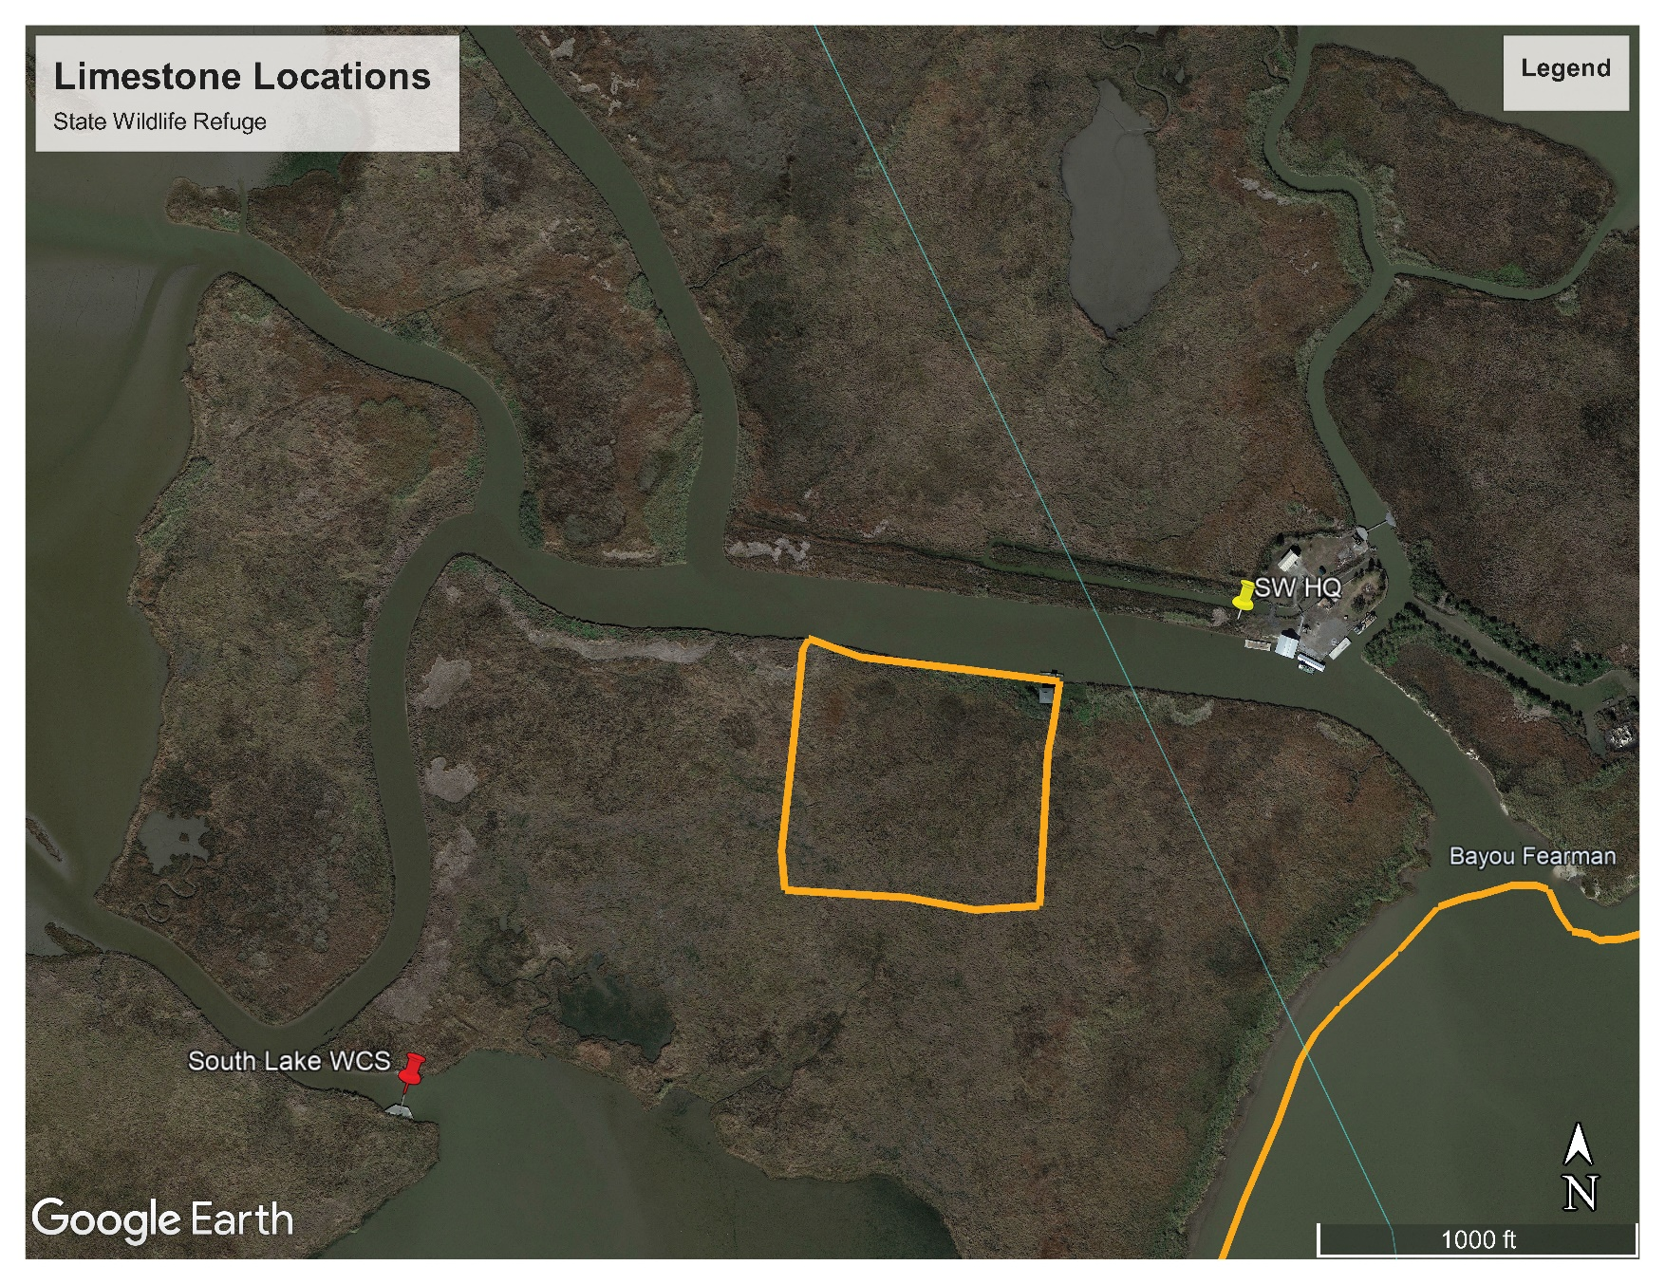

**Map of sites on Marsh Island Refuge**

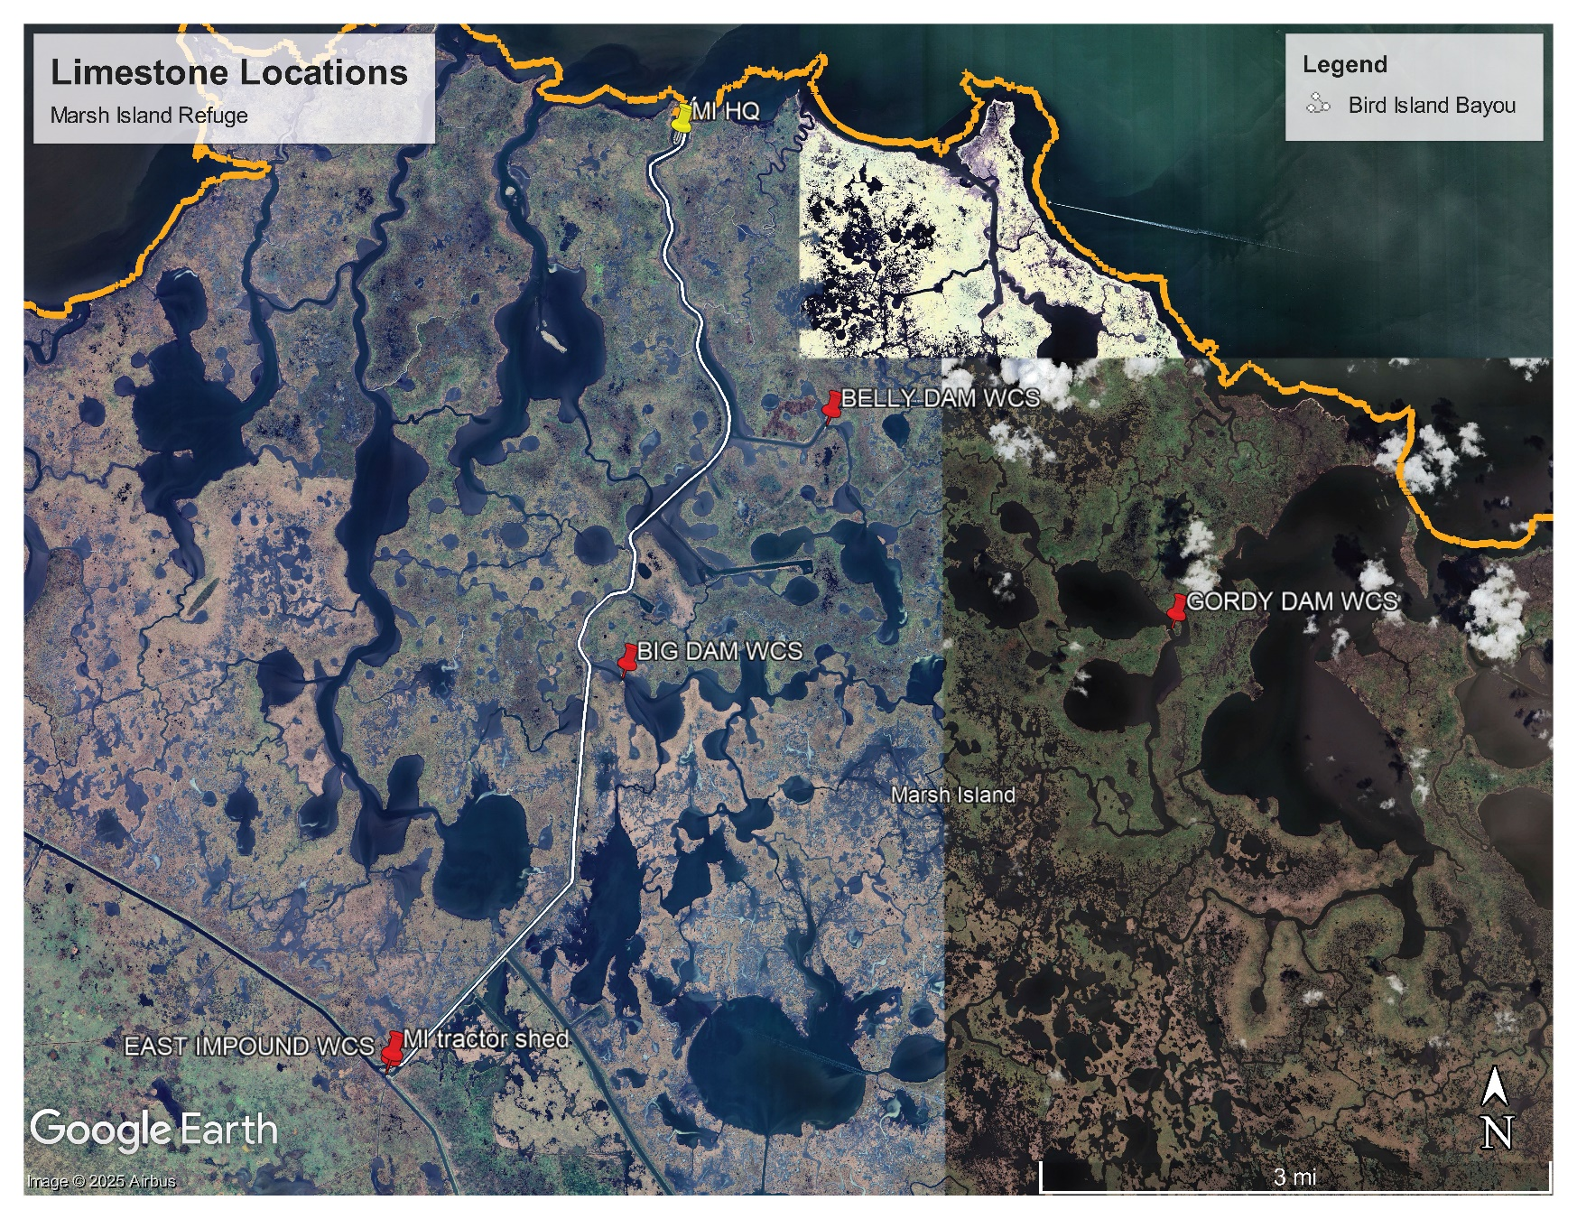

**WATER DEPTH LOCATIONS TAKEN FOR GORDY DAM WCS ACCESS ON MARSH ISLAND REFUGE**

