**Group 1 Line 1**

**Warehouse Cooler Evaporator**

**Brand/Model** – Climate Control CEL0155BS6EEAB0403 or Equal

* Hinged, removable front access panels on each side providing access to electrical and refrigeration components
* Molded fan guard, NSF and UL sanitation rated
* Liquid line solenoid wire harness factory installed
* Sweat connections on refrigeration components
* Copper tubing aluminum fin evaporator coils
* Electric element defrost coils and drain pan
* ¾” diameter drain hole in drain pan
* Mounted TXV { 404A}/std. solenoid
* DTFD fixed {defrost termination fan delay}
* Heater high limit switch included
* Heavy gauge aluminum cabinet {stucco}
* Power 208-230-60-1
* BTU capacity- Minimum 14,000 BTU 10° TD/-20°

**Line 2**

**Warehouse Freezer Condensing Unit**

**Brand/Model** – Climate Control CCH0045LCBCZA0300 or Equal

* Cabinet and construction
  + Microchannel technology condenser coils
  + Copper tubing with aluminum fins
  + Painted steel cabinets and corrosion protection
  + Heavy duty steel base
  + Air cooled
* Serviceability
  + Service valves located outside of cabinet-
  + Receiver with fusible plug, liquid shut off valve and charging port
  + Electrical panel for access
  + Prefabricated wiring harness connections and consistent labeling
  + Unit stays on when hood is removed for servicing
  + Sight glass and liquid line filter drier standard and easily visible
* Quality
  + Leak tested, bump tested.
  + Low and high pressure controls tested
  + Electrical circuitry tested, piping and or vibration eliminators secured
  + Auto-reset high pressure
  + Adjustable low pressure control
* Additional Features
  + Electric defrost timer
  + Crankcase heater
  + Low ambient control
* Power – 208-230/60/3
* R404A refrigerant compatible
* Warranty: Minimum 4 years
* BTU capacity – Minimum 15,470 BTU -20° @95°F Ambient

**Line 3**

**Warehouse Cooler Evaporator**

**Brand/Model** – Climate Control CEL0190AS6AMAB0403 or Equal

* Specs – hinged, removable front access panels on each side providing access to electrical and refrigeration components.
* Molded fan guard, NSF and UL sanitation rated
* Liquid line solenoid wire harness factory installed
* Sweat connections on refrigeration components
* Copper tubing aluminum fin evaporator coils
* Electric element defrost coils and drain pan
* ¾” diameter drain hole in drain pan
* Mounted TXV { 404A}/std. solenoid
* DTFD fixed {defrost termination fan delay}
* Heater high limit switch included
* Heavy gauge aluminum cabinet {stucco}
* Power 115/60-1
* BTU capacity- 18,000 BTU 10° TD/ 20° f SST

**Line 4**

**Warehouse Freezer Condensing Unit**

**Brand/Model** – Climate Control CCH0020MCACZA000 or Equal

* Cabinet and construction – microchannel technology standard on air cooled condenser coils, copper tubing with aluminum fins, painted steel cabinets and corrosion protection, heavy duty steel base
* Serviceability - service valves located outside of cabinet-
  + Receiver with fusible plug, liquid shut off valve and charging port
  + Electrical panel for access
  + Prefabricated wiring harness connections and consistent labeling
  + Unit stays on when hood is removed for servicing
  + Sight glass and liquid line filter drier standard and easily visible
* Quality - Leak tested, bump tested. Low and high pressure controls tested
  + Electrical circuitry tested, piping and or vibration eliminators secured
  + Auto-reset high pressure
  + Adjustable low pressure control
* Additional Features
  + Crankcase heater
  + Electric defrost timer
  + Low ambient control
* Power – 208-230/60/3
* R404A refrigerant compatible
* Extended warranty of 4 years/ option
* BTU Capacity – Minimum 20,700 BTU @ +25° @95°F Ambient

**Line 5**

**4 Compartment Warehouse Freezer with Floor**

**Brand/Model:** Amerikooler or Equal Custom build

* Exterior dimension:
  + Width: 19’
  + Length: 46’ 6”
  + Height: 8’-7” *with floor/rectangular

*\*Exterior Dimensions must be as listed due to existing space limitations\**

* Interior dimension:
  + Width: 19’
  + Length: 11’ 1½”±4”
  + Height: 7’-11”
* Temperature: -20 degrees
* Insulation: 4” thick AK-XPS4 or Equal extruded foam with R-values of R-32 with 50 year thermal warranty.
  + UL classified core flame spread 15, smoke rating less than 165
  + Hydrophic / Moisture Resistant
* Warranty: 15 year panel warranty and 1 year parts warranty **{*minimum*}**
* Finishes: interior & exterior wall/interior & exterior ceilings: 26 gauge stucco embossed acrylume
* Floor:
  + Application: foot traffic-no rolling carts
  + NSF floor panel rated for 1700lbs. /sq. ft. , stainless steel integrated
* Door: 36” x 78” left handed flush door with brushed hardware.
  + Heavy duty deadbolt handle latch with ¼ turn release.
  + Regulating thermostat heater wire and heated vent.
  + Digital LED thermometer with pilot light switch.
  + Vapor proof 120 volt LED light fixture
  + Interior & exterior finish: 26 gauge stucco embossed acrylume
* Accessories:
  + Rain proof membrane with 10 ft. long termination bars/1 screw every 12 inches (membrane should be 1 ft. larger in both directions minimum)
  + Drain hood for door 22 gauge stainless steel, with tek screws.
  + Perimeter reinforcement floor angle (.050 thick aluminum) 1 ½” x 6” x 48” each section – supplied with stainless steel tek screws, to secure wall and floor concrete anchors (concrete anchors provided by DOC.)
  + NSF/ DOE & ASTM compliant

**-Item shall be delivered as a kit to be assembled by DOC personnel. Vendor will need to notify facility in advance of delivery and go through security at front gate. Facility has unloading means.-**

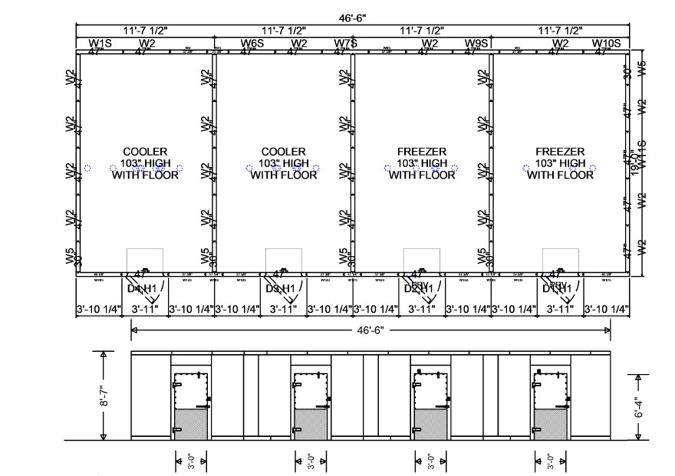

**Group 2 Line 6**

**Kitchen Freezer with Floor**

**Brand/Model:** Amerikooler or Equal Custom build

* Interior dimension:
  + Width: 9’-1 ¾” ±4”
  + Length: 16’-11 ½” ±4”
  + Height: 7’-6 ¼” ±4”
* Temperature: -20 degrees
* Insulation: 4” thick AK-XPS4 or Equal extruded foam with R-values of R-32 with 50 year thermal warranty.
  + UL classified core flame spread 15, smoke rating less than 165
  + Hydrophic / Moisture Resistant
* Warranty: 15 year panel warranty and 1 year parts warranty **{*minimum*}**
* Finishes: interior & exterior wall/interior & exterior ceilings: 26 gauge stucco embossed acrylume
* Floor:
  + Application: foot traffic-no rolling carts
  + NSF floor panel rated for 700lbs. /sq. ft. , stainless steel integrated
* Door: 36” x 78” left handed flush door with brushed hardware.
  + Heavy duty deadbolt handle latch with ¼ turn release.
  + Regulating thermostat heater wire and heated vent.
  + Digital LED thermometer with pilot light switch.
  + Vapor proof 120 volt LED light fixture
  + Interior & exterior finish: 26 gauge stucco embossed acrylume
* Accessories:
  + Rain proof membrane with 10 ft. long termination bars/1 screw every 12 inches (membrane should be 1 ft. larger in both directions minimum)
  + Drain hood for door 22 gauge stainless steel, with tek screws.
  + Perimeter reinforcement floor angle (.050 thick aluminum) 1 ½” x 6” x 48” each section – supplied with stainless steel tek screws, to secure wall and floor concrete anchors (concrete anchors provided by DOC.)
  + NSF/ DOE & ASTM compliant

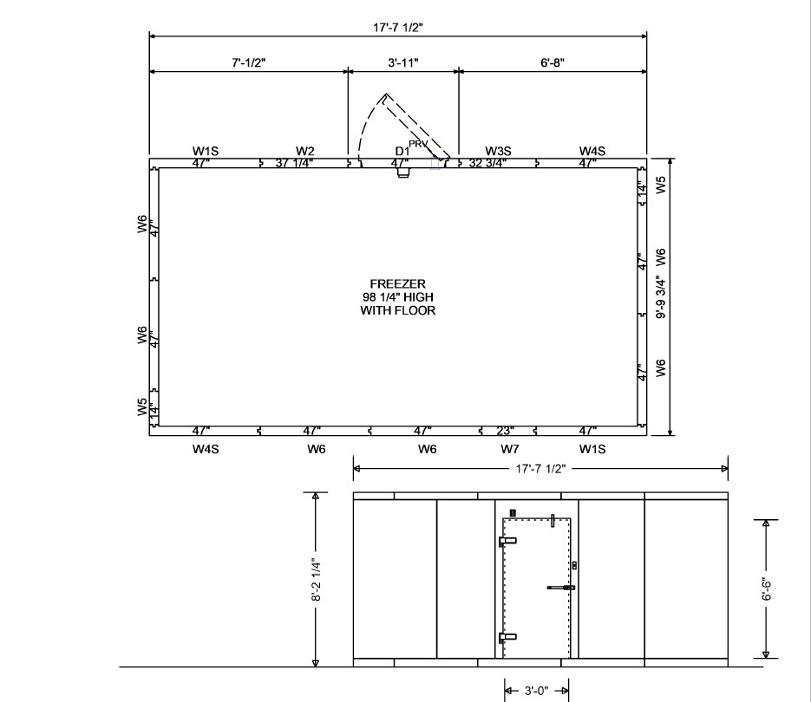

**Line 7**

**Kitchen Cooler Evaporator**

**Brand/Model** – Climate Control CEL0130BS6EEAB0403 or Equal

* Molded fan guard, NSF and UL sanitation rated
* Hinged, removable front access panels on each side providing access to electrical and refrigeration components
* Liquid line solenoid wire harness factory installed
* Sweat connections on refrigeration components
* Copper tubing with aluminum fin evaporator coils
* Electric element defrost coils and drain pan
* ¾” diameter drain hole in drain pan
* Mounted TXV { 404A}/std. solenoid
* DTFD fixed {defrost termination fan delay}
* Heater high limit switch included
* Heavy gauge aluminum cabinet {stucco}
* Power: 115-60-1
* BTU Capacity: Minimum 12,000 BTU 10˚ TD / -20˚

**Line 8**

**Kitchen Freezer Condensing Unit**

**Brand/Model** – Climate Control 12 x 20 CCH0055LCBCZA0300 or Equal

* Cabinet and construction
  + Microchannel technology on condenser coils
  + Copper tubing with aluminum fins
  + Painted steel cabinets and corrosion protection
  + Heavy duty steel base
  + Air cooled
* Serviceability
  + Service valves located outside of cabinet
  + Receiver with fusible plug, liquid shut off valve and charging port
  + Large electrical panel for easier access
  + Prefabricated wiring harness connections and consistent labeling
  + Unit stays on when hood is removed for servicing
  + Sight glass and liquid line filter drier standard and easily visible
* Quality
  + Leak tested, bump tested
  + Low and high pressure controls tested
  + Electrical circuitry tested, piping and/or vibration eliminators secured
  + Auto-reset high pressure
  + Adjustable low pressure control
* Additional Features
  + Electric defrost timer
  + Crankcase heater
  + Low ambient control
* Power – 208-230/60/3
* BTU Capacity: Minimum 15,470 BTU -20˚ @ 95˚F ambient
* R404A refrigerant compatible
* Warranty: Minimum 4 years

**-Item shall be delivered as a kit to be assembled by DOC personnel. Vendor will need to notify facility in advance of delivery and go through security at front gate. Facility has unloading means.-**