**Scope of Work**

This is a furnish and install project of a Stucco Monument. The vendor shall furnish all labor, materials, equipment, and tools to install a stucco monument at the entrance of Dixon Correctional Institute.

**Project Location:** Dixon Correctional Institute (Front Entrance)

5568 Highway 68

Jackson, LA 70748

1. Successful vendor shall pour a concrete slab with fiber 4” thick, having a dimension of 4 feet wide, 10 feet long, and 12” wide footing to anchor the stucco monument.
2. Successful vendor shall install 5’ height X 9’ width X 1.9” depth double sided basic stucco finished monument with poly-armor or equal and polystyrene coating. The monument must have been tested for impact resistance, elongation, tensile strength, tear strength, and flexibility, and be fire retardant and does not crack, rot, or deteriorate due to extreme weather conditions.
3. Successful vendor shall install verbiage on stucco monument with raised Stucco, 6” lettering, painted black, reading “Dixon Correctional Institute”, verbiage in raised stucco, 3” lettering, painted in black, reading “Warden” & “Secretary”, and verbiage in recessed/inset sections, 3” lettering for Warden and Secretary names to be interchanged. (All lettering is to be capitalized).
4. See provided picture below: 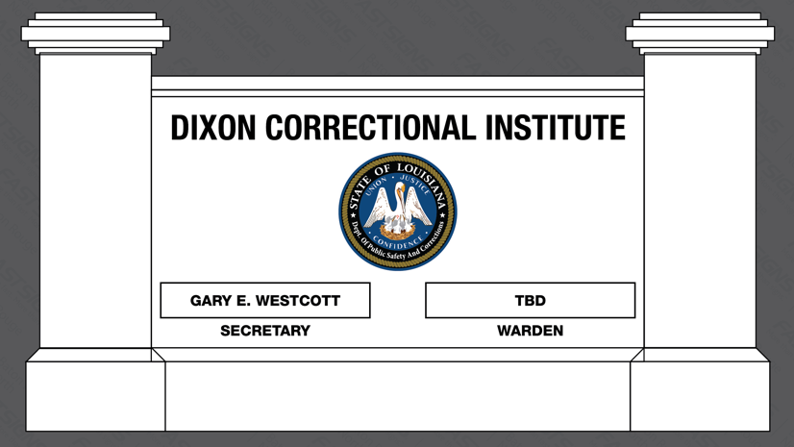

**Additional Requirements**:

* Standard Warranty
* Awarded vendor must comply with all local, state, and federal regulations.
* Work shall be performed during normal business hours: Monday-Friday from 7:00AM – 3:30PM. The successful vendor is to contact Facility Maintenance Coordinator Will Bunch @ 225-634-6101 or e-mail [William.Bunch2@la.gov](mailto:William.Bunch2@la.gov) to schedule.
* Vendor representatives are subject to a search of their vehicles, possessions, and persons. This is necessary to preclude the introduction of weapons, ammunition, explosives, cell phones, alcohol, escape devices, drugs, drug paraphernalia, or other forbidden items or contraband into the prison environment. All searches of visitors shall be conducted in accordance with Department Regulation No. C-02-005 and Penitentiary Directive No. 09.004 and 09.004A.
* Vendor’s representatives must follow all institutional policies and procedures while performing work on facility grounds.
* Vendor is subject to a conference/training with facility staff after the contract is executed and before performing any work.