**Scope of Work:**

The Contractor shall provide all labor and materials in order to replace a chiller compressor and line driers for the Louisiana Department of Health (LDH).

**Location:**

Villa Feliciana Medical Complex

5002 Highway 10

Jackson, LA 70748

**Specifications:**

**Chiller Information:**

Chiller Brand: York Serial #11551B96162242

Model Number: YLAA0155SE17XFBSDTXHSXBLXCXX42SE1XXXHXXXYAXGTXX5XXXXNF1XXXX

Compressor Type: GSD80385VAB262

Voltage: 208-230

Frequency: 60 Hz

* The Contractor shall lockout/tagout Chiller 2 according to proper safety procedures.
* The Contractor shall disconnect all electrical wiring from the existing compressor contactor as necessary.
* The Contractor shall demo and remove the existing contactor from compressor two on circuit two.
* The Contractor shall recover all refrigerant (approximately 70 lbs) from circuit two and dispose.
* The Contractor shall drain oil from both compressors and dispose.
* The Contractor shall use a torch/solder to disconnect all copper connections from existing compressor.
* The Contractor shall disconnect all electrical connections from the existing compressor.
* The Contractor shall demo and remove the existing compressor from the chiller.
* The Contractor shall perform acid mitigation to remove all residual burnt oil from the line sets.
* The Contractor shall demo and remove the existing core drier and replace with a new OEM replacement
* The Contractor shall furnish and provide a new OEM replacement compressor to the job site and set it in place.
* The Contractor shall use a torch/solder to reconnect all copper connections. Modify as necessary.
* The Contractor shall charge the system up with nitrogen and leak check all new connections.
* The Contractor shall pull a vacuum and charge the system with the recommended amount of R410A refrigerant.
* The Contractor shall provide and install a new OEM replacement contactor. Reconnect all electrical connections.
* The Contractor shall start up and ensure proper operation of the system upon completion of work.
* The Contractor shall clean up the worksite and dispose of any trash per proper EPA Guidelines.

**Chiller Info:**

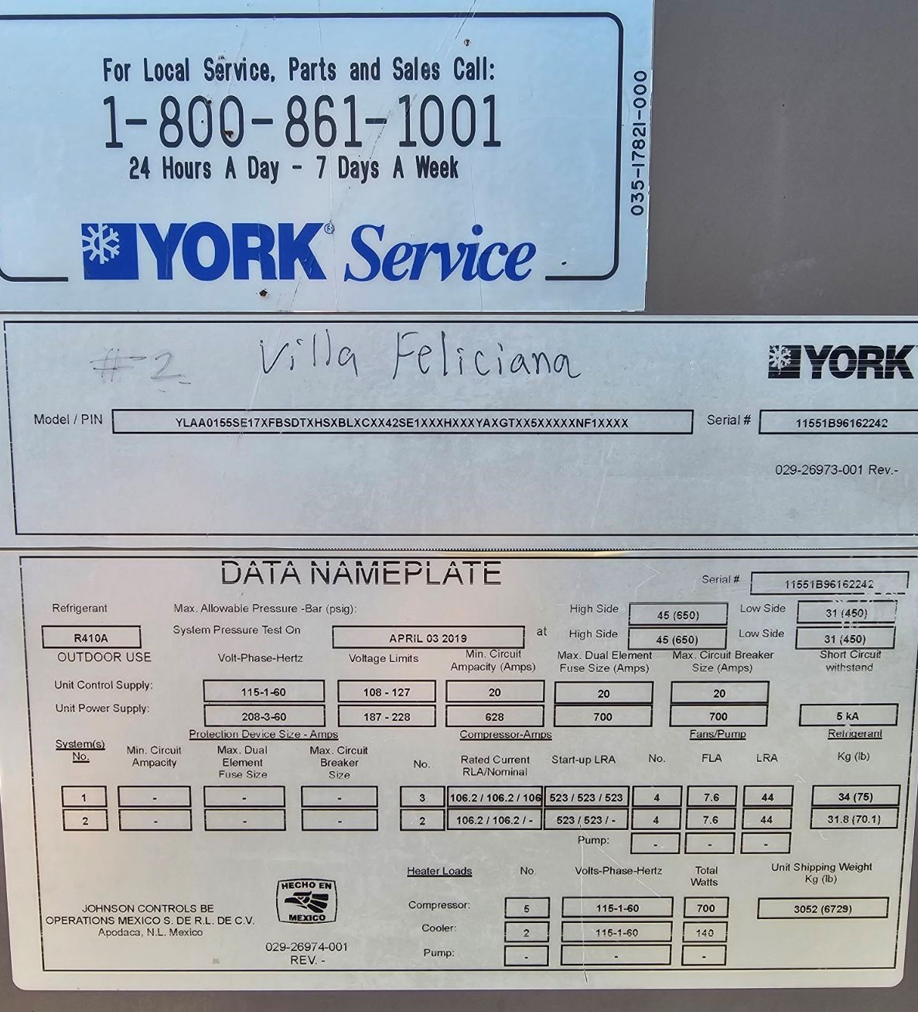

**Compressor Info:**

