November 8, 2024

**ADDENDUM NO. 01**

Your reference is directed to RFx Number 3000023758 for the Invitation to Bid (ITB) for the State of Louisiana – Planetary Scanner - SOS which is currently scheduled to open at 10:00AM CT on 11/13/24.

The following change is to be made to the referenced solicitation:

******************************************************************************

**RFx Currently Reads:** Scheduled to open at 10:00 AM on November 13, 2024.

**RFx Changed to Read:** Scheduled to open at 10:00 AM on November 20, 2024.

*****************************************************************************

**Line 1 of RFx currently reads:** FADGI and ISO 19264 Compliant

**Line 1 of RFx changed to read:** FADGI 4 Star Compliant and ISO 19264 Compliant

*****************************************************************************

**Questions from the Vendor and State’s Responses:**

**Vendor Question 1.** Do we have to complete the mandatory onsite visit by a specific date?

***State’s Response:*** *The site visit must be completed before the bid opening date and should be completed as early as possible,*

**Vendor Question 2.** The requested model is an i2s QUARTZ A0 HD LED which has a scan area of 36.4 x 51.2 inches. The requested scan area is 24 x 40 inches which is the scan area of the i2s QUARTZ A1 HD. Is the state requesting the QUARTZ A0 or the QUARTZ A1? Or would they like us to bid both options?

***State’s Response:*** *The 24” x 40” Scan Area requested in the specifications is a minimum requirement. Meaning the scan area must be at least 24” x 40.”*

**Vendor Question 3.** Can a vendor submit two bids using the online vendor portal?

***State’s Response:*** *Vendors can submit multiple/alternate bids using the vendor portal.*

**Vendor Question 4.** The specifications states that the scanner needs to be FADGI compliant. However, FADGI compliancy uses a star rating to describe the level of compliance the scanner meets. The QUARTZ is a FADGI 4 star scanner. Can you please verify that the scanner should be FADGI 4 star compliant?

***State’s Response:*** *Yes, FADGI 4 star compliant.*

**Vendor Question 5.** Does the scanner need to capture 600 dpi over the full scan surface?

***State’s Response:*** *Yes, over the full scan surface.*

**Vendor Question 6.** Is the scanner required to have a book cradle? Or is the primary function of the scanner to scan large flat items? A book cradle can cause a significant price increase on certain models.

***State’s Response:*** *The scanner should have the capabilities of scanning large flat items like maps, blueprints, plats, and posters. We also want it to have the capabilities to scan large bound books, so a book cradle would be a necessity.*

**Vendor Question 7.** The bid states that materials that must be scanned include TEXTILES and ARTWORK. Can we get a more detailed description of these materials - material type, thickness, and dimensions? Can sample pictures of these materials be provided?

***State’s Response:*** *By "artwork" we mean posters. The primary purpose of the scanner was to scan maps that may measure greater than 24" X 36" and large bound books. The books vary in size. Most are around 19.5" X 14" X 3", but some are as large as 19.5" X 16.5" X 6". Textiles would rarely be imaged. If we did, the object would have the thickness of a flag.*

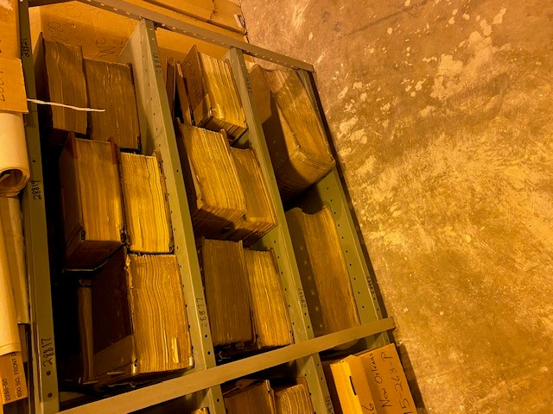

******************************************************************************

All else remains as on original Invitation to Bid.

******************************************************************************

**This addendum is hereby officially made a part of the referenced SOLICITATION.**

**ACKNOWLEDGEMENT:** If you have already submitted your bid and this Addendum does not cause you to revise your bid, you should acknowledge receipt of this Addendum by identifying your business name and by signing where indicated. You may return this Acknowledgement by mail or delivery by hand or courier to: Office of State Procurement, 1201 N. 3rd Street, Ste. 2-160, Baton Rouge, LA 70802, or by fax to: (225) 342-9756. The State reserves the right to request a completed Acknowledgement at any time. Failure to execute an Acknowledgement shall not relieve the bidder from complying with the terms of its bid.

Addendum Acknowledged/No changes:

For: ________________________ By: __________________________

**REVISION:** If you have already submitted your bid and this Addendum requires you to revise your bid, you must indicate any change(s) below, identify your business name and sign where shown. Revisions shall be delivered prior to bid opening by mail or delivery by hand or courier to: Office of State Procurement, 1201 N. 3rd Street, Ste. 2-160, Baton Rouge, LA 70802, or by fax to: (225) 342-9756, and indicate the RFx number and the bid opening date and time on the outside of the envelope for proper identification, or by fax to: (225) 342-9756. Electronic transmissions other than by fax are not being accepted at this time

**Revisions received after bid opening shall not be considered and you shall be held to your original bid.**

Revision:

For: ________________________ By: __________________________

By: Alex Jackson

Office of State Procurement

Telephone No. 225-342-8014

Email: [Alexsandra.Jackson@la.gov](mailto:Alexsandra.Jackson@la.gov)