Illuminated Central Louisiana State Hospital Signs

**Scope of Work:**

The Contractor shall provide all labor and materials in order to construct and install two illuminated signs for the Louisiana Department of Health (LDH).

**Location:**

6250 Esler Field Rd

Pineville, LA 71360

**Specifications:**

**One Illuminated Central Louisiana State Hospital sign, visible from Esler Field Road**

* Approximate sign dimensions, 6 ft. high and 12 ft. length, 2 ft. width

* The sign shall have an illuminated channel cabinet with push through letters, "Central Louisiana State Hospital"

* The sign shall incorporate the Central Louisiana State Hospital logo and colors

-Blue #040570

-Gold #AC850F

-LDH can provide Vector Logo to Contractors, if requested

* Mount address flush and centered, "6250 Esler Field Road"

* The Contractor shall install a concrete base with approximate dimensions of 14 ft. length, 3.5 ft. width, 4” deep.

**One Illuminated Central Louisiana State Hospital sign, visible at entrance between Magnolia and Cypress buildings.**

* Approximate sign dimensions, 4 ft. high and 6 ft. length, 2 ft. width

* The sign shall have an illuminated double sided, monument style cabinet

* The sign shall incorporate the Central Louisiana State Hospital logo and colors, with "Visitor Entrance" printed beneath, flush and centered

-Blue #040570

-Gold #AC850F

-LDH can provide Vector Logo to Contractors, if requested

* The Contractor shall install a concrete base 7 ft. length, 3.5 ft. width, 4” depth.

***NOTE: Central Louisiana State Hospital shall be responsible for all electrical work, hookups, and excavation in order to source the illuminated sign.***

Jobsite Visit Contact Joy Biro at 318-484-6856 or [joy.biro@la.gov](mailto:joy.biro@la.gov)

**Logo Picture:**

**Entrance Sign Drawing:**

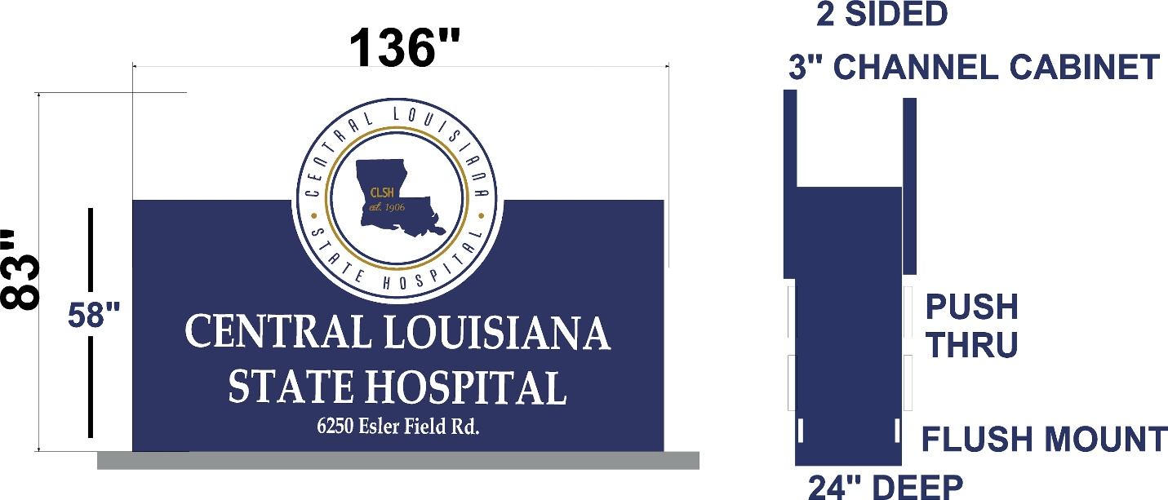

**Visitor Entrance Sign:**

