**Scope of Work:**

The Contractor shall provide all labor and materials in order to remove and replace a 75-ton air cooled chiller at the Louisiana Real Estate Commission (LREC) Central Plant.

**Location:**

Louisiana Real Estate Commission (LREC)

Central Plant and Controls   
9071 Interline Ave

Baton Rouge, LA 70809

**Specifications:**

-The Contractor shall remove and replace one existing McQuay 75-ton air-cooled chiller and two chilled water pumps in accordance with local, state, and federal regulations. The newly installed unit shall be a Trane- CGAM080A2 75-ton or equal and shall include a 2-5 year compressor warranty.

**Specify Brand/Model of Chiller Bidding:___________________________________________**

-Work shall include barricading work location, lock out tag out, refrigerant recovery, disconnecting (existing electrical, controls, anchors, piping, etc) crane lifts for unit demolition and setting reconnecting (electrical, controls, anchors, etc) and clean up.

-The Contractor shall relocate the newly installed chiller away from plant yard fencing a minimum of 6’ from fencing.

-The Contractor shall extend chiller pad as required for relocation. See Attachment D – Drawing.

-OEM Notes: Recommended minimum clearances:

-Side to wall – 6'; rear to wall – 6'

-Control panel to end wall – 4'0''

-Top – no obstructions allowed

-The Contractor shall demo all chilled water piping in the mechanical yard and install new piping.

-The Contractor shall insulate all newly installed piping.

-The Contractor shall field verify all pipe sizes, existing unit capacities, and electrical needs for turn-key installation of new systems.

-The Contractor shall properly label newly installed systems.

-The Contractor shall upgrade existing central plant controls to newest software revision and test operation.

-The contractor shall perform a start-up and test operation upon completion.

-The Contractor shall remove and replace 28 VAV box controllers with new.

-The Contractor shall update existing databases, program controllers, and update graphics, trends, and alarms on front-end interface including analytics package.

-Controls integration of central plant and VAV box controls shall be extended and modified by the Contractor.

-Existing equipment shall be removed from job site and disposed of per EPA guidelines.

-The Contractor shall provide warranty paperwork of new Chiller and control system installation.

-The Contractor shall coordinate all proposed installation schedules with LREC representatives before execution of project.

Existing Chiller

Existing Chiller and piping

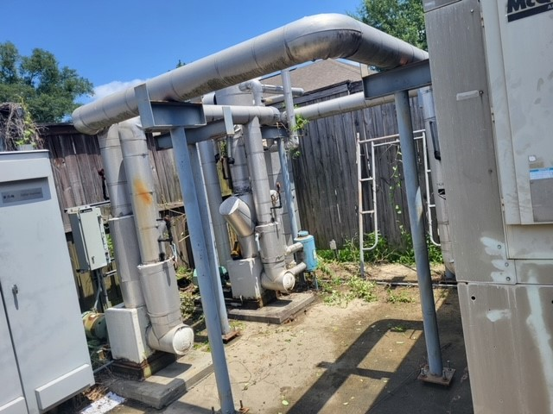Existing Chilled Water pumps and piping.