August 14, 2024

**ADDENDUM NO. 01**

Your reference is directed to RFx Number 3000023300 for the Invitation to Bid (ITB) for the State of Louisiana – Shower Shoes - DOC-PE which is currently scheduled to open at 10:00AM CT on 08/14/24.

The following changes are to be made to the referenced solicitation:

******************************************************************************

RFx Currently Reads: Scheduled to open at 10:00 AM on August 14, 2024.

RFx Changed to Read: Scheduled to open at 10:00 AM on August 21, 2024.

*****************************************************************************

**Questions from the Vendor and State’s Responses:**

**Vendor Question 1.** What was the previously awarded amount?

***State’s Response:*** *The agency does not have a current contract or one for 2023. However, the 2022 contract was $2.37.*

**Vendor Question 2.** Are samples required?

***State’s Response:*** *Per Attachment A – Special Terms and Conditions, page seven, the agency may request samples prior to award.*

**Vendor Question 3.** There are 6 sizes in the bid documents. Will these sizes be acceptable 7-8, 9-10, 11-12, 14-15?

***State’s Response:*** *The awarded items must match the specifications listed in the bid.*

**Vendor Question 4.** Is it mandatory to provide shoes within 5-7 days?

***State’s Response:*** *Delivery is a factor in the award and the delivery terms are 5-7 days ARO.*

**Vendor Question 5.** Is there a specific brand we are required to maintain?

***State’s Response:*** *If awarded, you will be responsible for providing the brand/style you bid.*

**Vendor Question 6.** Will an orange translucent color be acceptable?

***State’s Response:*** *The awarded items must match the specifications listed in the bid.*

**Vendor Question 7.** Not sure if this was intentional or an oversight but it appears size 13 was skipped 9, 10,11,12,14 & 15.

***State’s Response:*** *This is correct, size 13 is NOT needed.*

**Vendor Question 7.** Can you please provide me reference images for items you purchase previous year?

***State’s Response:*** 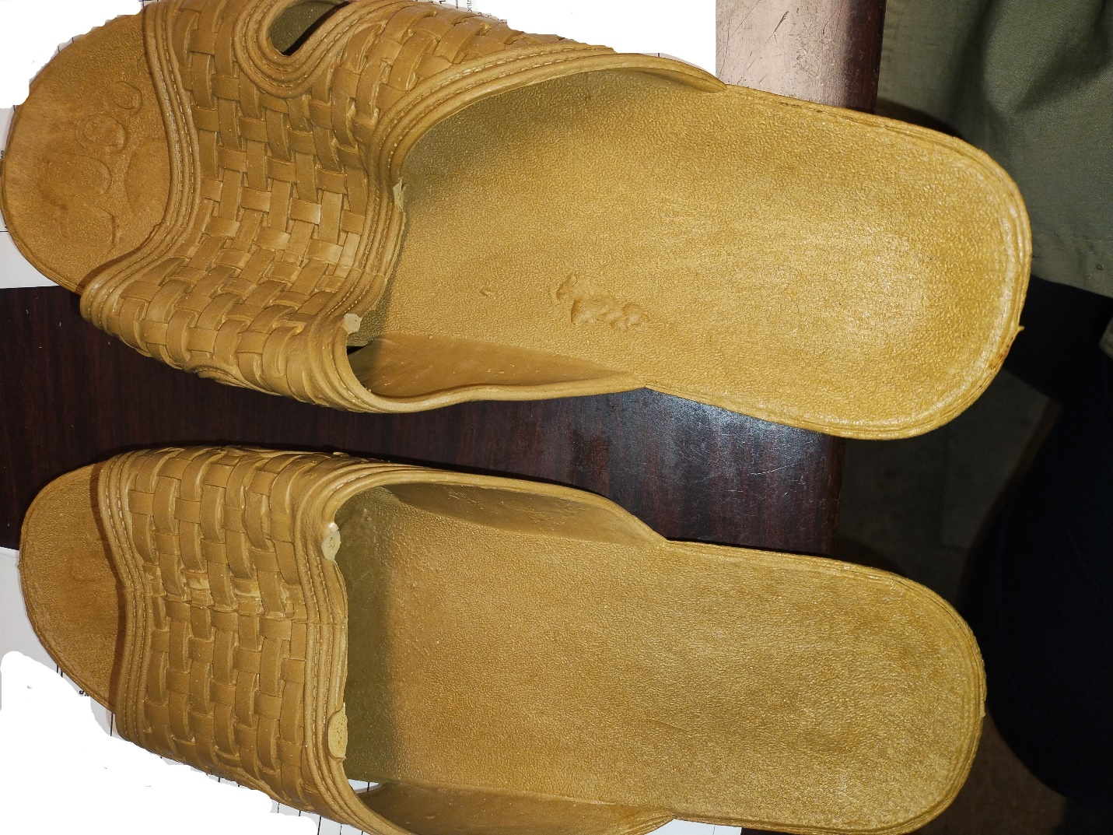

******************************************************************************

All else remains as on original Invitation to Bid.

******************************************************************************

**This addendum is hereby officially made a part of the referenced SOLICITATION.**

**ACKNOWLEDGEMENT:** If you have already submitted your bid and this Addendum does not cause you to revise your bid, you should acknowledge receipt of this Addendum by identifying your business name and by signing where indicated. You may return this Acknowledgement by mail or delivery by hand or courier to: Office of State Procurement, 1201 N. 3rd Street, Ste. 2-160, Baton Rouge, LA 70802, or by fax to: (225) 342-9756. The State reserves the right to request a completed Acknowledgement at any time. Failure to execute an Acknowledgement shall not relieve the bidder from complying with the terms of its bid.

Addendum Acknowledged/No changes:

For: ________________________ By: __________________________

**REVISION:** If you have already submitted your bid and this Addendum requires you to revise your bid, you must indicate any change(s) below, identify your business name and sign where shown. Revisions shall be delivered prior to bid opening by mail or delivery by hand or courier to: Office of State Procurement, 1201 N. 3rd Street, Ste. 2-160, Baton Rouge, LA 70802, or by fax to: (225) 342-9756, and indicate the RFx number and the bid opening date and time on the outside of the envelope for proper identification, or by fax to: (225) 342-9756. Electronic transmissions other than by fax are not being accepted at this time

**Revisions received after bid opening shall not be considered and you shall be held to your original bid.**

Revision:

For: ________________________ By: __________________________

By: Alex Jackson

Office of State Procurement

Telephone No. 225-342-8014

Email: [Alexsandra.Jackson@la.gov](mailto:Alexsandra.Jackson@la.gov)