Scope of Work
Contractor shall all furnish labor and materials to construct a stainless steel guardrail on the edge of the concrete landing area in the rear of the Louisiana University Marine Consortium’s (LUMCON) New Blue Works Facility.

Site Location
LUMCON Blue Works Houma
335 Dickson Rd
Houma, La 70363

Specifications
- Contractor shall fabricate, and install approximately 92 feet of stainless steel guardrail at LUMCON's Blue Works Facility in Houma, LA.

- Guardrail shall be fabricated entirely of stainless steel and shall be approximately 42-1/2 inches tall and approximately 92 feet long.

- Guard rail shall be fabricated in sections that will be anchored to the concrete using concrete wedge type anchors and include 4 hinged gates.

- Each section of the guardrail shall be comprised of 1-1/2 inch stainless steel round tubing legs, welded stainless steel wire mesh panels with a 2 inch x 2 inch opening, and a 2 inch stainless steel handrail made of polished 180 grit stainless steel.

- The gated portion shall have a stationary post or posts in the center with an opening of approximately 10-12 feet per side allowing for two 5-6 feet lockable latching hinge gates on each side.

- All measurements shall be verified by the Contractor.

General Terms and Conditions
• All work shall be performed Monday through Friday from 7:00 AM to 4:00 PM. Agency contact is Donna Lottinger (985) 851-2812.
• Contractor's representatives shall follow all agency policy and procedures while performing work on facility grounds.
- All waste and debris shall be removed from the site daily and disposed of properly by the contractor. All waste and debris shall be assessed by the appropriate site staff before it is removed from the site.
- Contractor shall restore all areas disturbed by their work activity to pre-work conditions.

Guardrail Picture
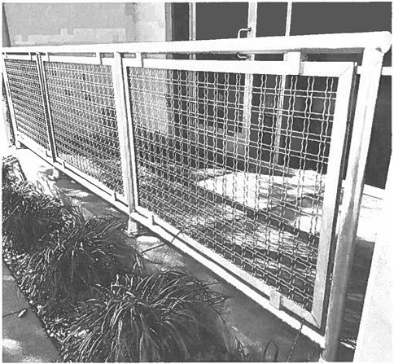

Guardrail Drawing
