Description of Work:

  - Contractor shall provide all labor, commercial grade materials, tools, and equipment necessary to install approximately 272 feet of 8” smooth flow pipe with 8 (each) 16”x 16” or 18” x 18” catch basins at the Marksville Readiness Center located at 510 West Waddil Street, Marksville, La. 71351. All measurements in this scope of work are approximate and shall be verified by the contractor. Contractor shall be responsible for providing any lifting capability to complete all new installations and repairs.

  - Site work and demolition.
- Contractor shall protect all paved surface in location for dumpsters with ¾” plywood as applicable.
- Contractor shall provide any required selective demolition to complete the installation.

  - The tops of the catch basins shall be installed 3” below the top of the armory’s existing slab. All smooth flow pipe shall be sub-surface to the existing ground. Contractor shall have to reshape the existing aggregate to meet the above requirement and provide a gentle slope from the existing parking lot toward the catch basins.
  - All catch basins shall be linked together using the smooth pipe. This will allow flow
for the collected water to drain into the city provided ditch. Please see Attachment D – Drawings for more information.

Specifications of material:
8” PVC Smooth flow pipe approximately 272’
8 Composite Plastic Catch basins 16”x16” or 18”x18”

- General Conditions

1. Contractor shall be responsible for field verifying all dimensions and existing site conditions of work to be performed. Contractor shall inspect and verify that the information provided herein on existing materials and equipment, etc. is correct and inform Project Manager (PM) of any errors or questions prior to commencement of work.

- Contractor shall make the building and any sensitive items secure at the end of each workday by any means necessary to secure same and by the approval of the unit POC.

- Contractor shall take all precautions necessary to prevent damages when making the repairs. This includes movement and parking of equipment on grass or unimproved areas surrounding site, as well as surrounding walls in stairwell areas.
- All work shall comply with all applicable State and Local Safety and Environmental requirements. Occupational Safety and Health Administration (OSHA), National Electrical Code (NEC), Parish, City and State regulation will be required. Contractor will supply all employees with PPE.
- Contractor must call LA 1-Call and all utility companies prior to digging.
- Contractor shall warranty their workmanship, repairs, and installations for a minimum of a 1 year.

II. Special Conditions:

- Hours of operation Tuesday- Friday, 7:00 AM to 5:30 PM and closed on all recognized state and federal holidays.
- Contractor shall contact, prior to mobilization and demobilization, the Project Manager for staging and for satisfactory completion.

- Contractor shall be responsible for providing storage containers. If an onsite storage area is required, the contractor must confirm a storage location for any materials, fixtures, equipment, trailers, etc. stored on site during the term length of the contract. The location will be approved by the Project Manager during the pre- construction meeting.

- Contractor shall be responsible for disposal and storage of all materials being removed or installed throughout the project.
- Contractor shall provide warranty information for the materials used in completing this project upon request.

- Contractor shall provide a construction work schedule forty-eight (48) hours prior to start of work detailing each task of work.

- All specification sheets and submittals must be pre-approved by the Project Manager prior to ordering.

- Contract time for the project shall be specified as 60 calendar days.
- Weather Days are included in the contract time.
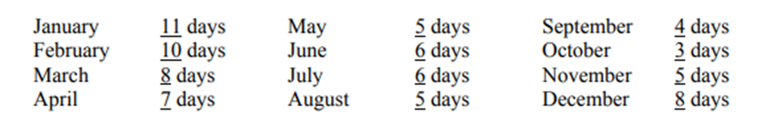

III. Contact information:
The project manager for the project is Ryan LaCroix, cell phone (318) 623-9950 or email ryan.c.lacroix.nfg@army.mil. The point of contact at the facility job site is SSG Jeremy Dekle, phone (318)-305-0409.

