IFTA Decal Specifications for IFTA Licensing Year 2025

Scope of Services
The Vendor will be responsible for manufacturing and delivering to the Office of Technology Services (OTS), Production Support Services (PSS) the 2025 IFTA decals. The decals shall be manufactured in sets of two per liner and serialized such that each decal in a set will have duplicate serial numbers; however, each set shall be consecutively and uniquely numbered. Application instructions will be printed on the back of the liner. Additionally, the decals must meet all of the following specifications. Inadequate facilities to comply with all of the following specifications and provisions will constitute grounds for rejection of bid.

Quantity: 50,000 sets of 100,000 individual decals (two duplicate decals per set)

Decal Size: 3" x 3" (overall size 6" x 3" for two duplicate decals side-by-side on one liner)

Material: Reflective material that has a counterfeit-deterrent mark integral in the sheeting, making unauthorized reproduction extremely difficult, is required. The marks should be visible during daylight, but disappear by reflected light at night. The day and night color of the sheeting are similar and they will remain highly reflective when viewed at wide entrance angles. The decals must be destructible when an attempt is made to remove them. This material must fracture if tampered with, making it impossible to remove in one piece for reapplication. The decals cannot be removed without showing evidence of tampering. The decals must have a counterfeit and official use only mark embedded for instant identification to make it virtually impossible to be replicated or forged. Specifically, the decal must have a security "void" feature where any attempt to remove the decal, once applied, will result in its destruction or will cause the word "VOID" to appear, thereby preventing its reuse.

The material is to be designed for use as annual decals on the outside of vehicles and should withstand temperatures ranging from -10°F to 125°F. The sheetings are to be pre-coated with permanent, pressure sensitive adhesive (requiring no water, solvent, or any wetting agent for activation) protected by a removable paper liner. Finger pressure should be sufficient for the application of the decals to areas that are properly prepared (i.e., smooth, dry, and clean surfaces). Sheeting should have a minimum thickness of .005" (which includes adhesive). The required slit to facilitate removal and protection of stock from breakage should be between the two decals on the front of the liner.

NOTE: The preferred stock is Adcolite No. 6000 (or an equivalent) with all features specified above.

Coating: Decals must be clear coated with a Coating Clear U10V or R101 or equivalent that will guarantee surface exposure to the elements for a period of 18 months. A minimum dry thickness of .0004 inches (4 mil) should be obtained. The surface shall be sufficiently solvent-resistant to permit cleaning with solvents including VM&P naphtha, mineral spirits, turpentine, or other solvents commonly used on vehicle finishes. Rinsed and dried, the surface shall show no appreciable change following cleaning when compared to a new, clean decal.

Ink Colors:
- The color of the background will be blue as specified and matched to Pantone PMS 299C.
- The color of the border, lettering, and geographical outline of the jurisdiction (Louisiana) will be white.
- The color of the application instructions on the back of the liner will be black. The color of the serial numbers will be black.

Over-lamination is not acceptable. All inks used must have a minimum life of 18 months without fading, peeling, or cracking after the decal has been properly applied in service to a smooth, dry, clean surface.

Fabrication: The sheetings should be press printed with the designated transparent ink color (Pantone® 299C) to produce the IFTA color and design combinations and serial numbering (in black ink) as specified below:

Printing: The background color fields and IFTA logo will be processed by offset, screen-print/, flexography, digital, or other similar, appropriate method of printing. Two duplicate decals should be printed side-by-side on one liner to create a decal set.

Copy: Each decal must have a white border 1/8" thick on all four sides. The letters I F T A are to be printed in a minimum height of 3/4" (1.88 centimeters) with the letter I located in the upper left hand corner, the letter A to be located in the lower right corner, and with the letters F T evenly spaced between to form a diagonal design from the upper left to lower right corner. The letters I F T A are to be printed in Arial Black 72 font in the color white. The two-letter jurisdiction designation (LA) shall be displayed in the lower left-hand corner and the last two numbers of the appropriate year (25) are to be displayed in the upper right-hand corner. The two-letter jurisdiction designation (LA) and the last two numbers of the appropriate year (25) are to be printed in Arial Black 36 font in the color white. The geographical outline of the jurisdiction (Louisiana) shall be centered behind the letters I F T A and the outline shall be white.

Numbering: Each decal set shall be serially numbered with each set of two decals having the same number. The serial number shall be centered on the bottom of the decal and shall be no less than 3/16" (0.47625 centimeters) high. Numbering should begin with 00001 and end with 50000. Missing or duplicate numbered sets are not allowed.

Example: The example below is not PMS 299C, but is intended only as an example.

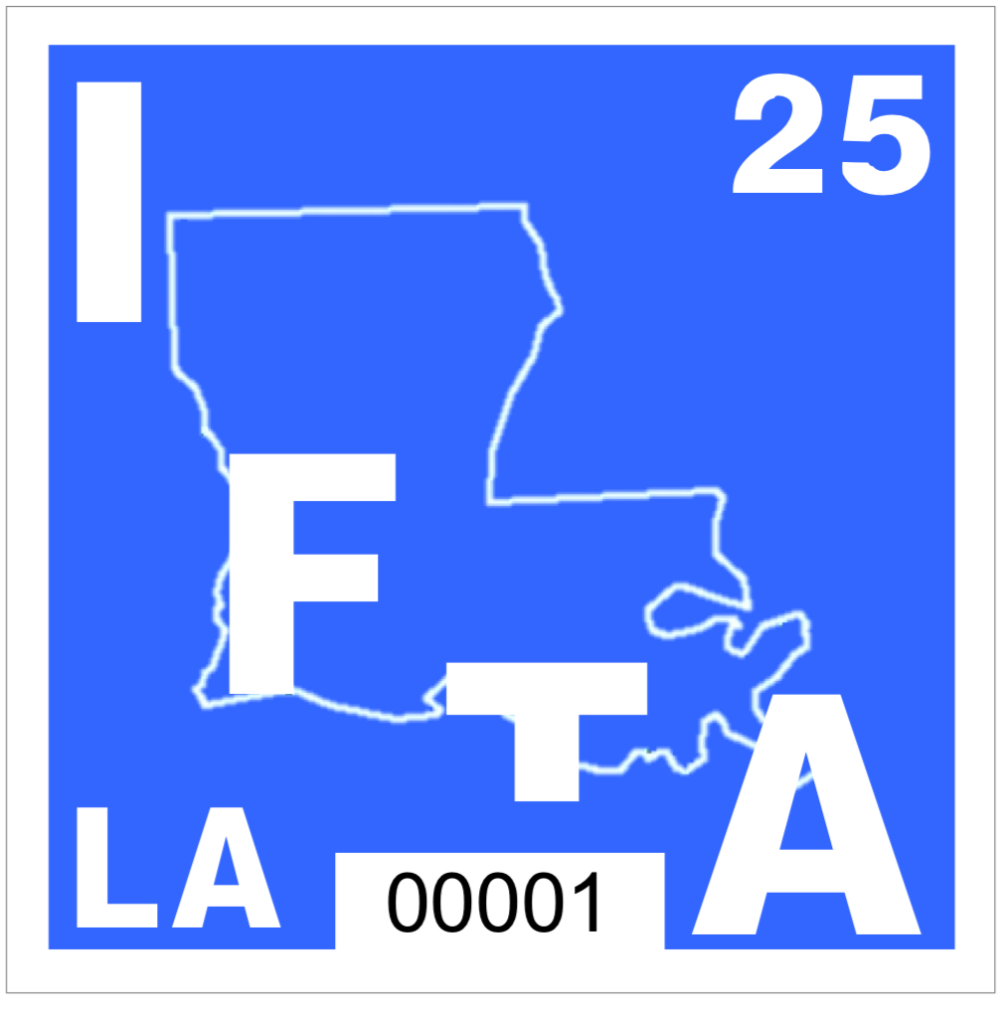

Clear Coating: Decals must be clear coated with a Coating Clear U10V or R101 or equivalent that will guarantee surface exposure to the elements for a period of 18 months. A minimum dry thickness of .0004 inches (.4mil) should be obtained.

Adhesive: The adhesive shall not exude from the edges of the sheeting when processed into finished decals so as to cause stacked pieces to stick together during shearing, cutting, printing, or handling or while packaged in shipment and distribution.

Liner: The back of the decal set (backing material/liner) shall be printed in black ink per the illustration provided below on page #4.

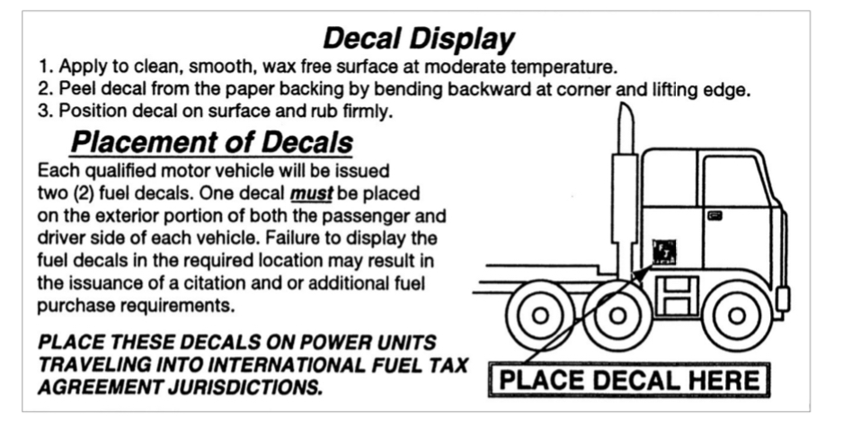

Appearance: Decal sets shall be free from ragged edges, cracks, and blisters. Decals shall be moisture resistant.

Additional Provisions
All bidders must furnish the following either with their bid or within five calendar days of request by OSP:

1. A notarized letter stating that all art work, composition, plate making, printing, numbering, coating, die cutting, slitting and packaging will be done on the vendor's premises and no portion of it will be sublet. The State reserves the right to enter the vendor's premises at any time during the production of the decals to inspect the method of production in full compliance with all provisions of the contract.

2. Evidence of capacity and experience for completing the job including a detailed list of all cameras, plate making equipment, presses, numbering machines, coating and drying machinery, slitting machines, die cutting machines and packaging facilities.

3. 10 completed numbered decal samples that the bidder has produced for other users as evidence of material and quality.

4. A list of five users for whom the vendor has produced decals of similar complexity and quantity, as well as the name of the person that OTS/PSS can contact to inquire as to their satisfaction with the vendor's product and service.

5. A complete description of the plant security precautions. Decals have a monetary value and the vendor must take every precaution to protect them from all hazards. Proper security measures and adequate supervision must be provided to assure that all decals printed are delivered and that only one copy of each decal set will be produced.

Pre-production Proof: The successful bidder shall provide a pre-production proof. The proof shall be furnished at the vendor's expense and must be received within 14 days of the award notification. Approval from OTS/PSS must be given prior to final production.

The pre-production proof should be sent:
- by email to: PSS.CustomerService@LA.gov
- or by mail to: OTS Production Support Services, PO Box 94095, Baton Rouge, LA 70804
- or by package or parcel (e.g., FedEx) to: OTS Production Support Service, 627 N 4th St, Baton Rouge, LA 70802

Packaging: The decals must be shrink-wrapped in 50 decal sets per unit, and boxed 100 units per box (5,000 decals per box) in containers no larger than 21" wide, 15" long, and 12" high and weighing no more than 40 pounds.

Delivery:
Delivery no later than July 15, 2024, made to:

OTS Production Support Services
627 North 4th Street
Baton Rouge, LA 70802

Late Penalty: The successful bidder will be solely responsible for meeting the delivery date as specified above. If the specified delivery date is not met because of any fact or circumstance that is or was within the control of the vendor (including delays in shipment), a late penalty may be imposed at the discretion of the State for every day that the items remain undelivered. Such late penalty shall be equal to 1% of the bid amount per day.

Other Penalties: The successful bidder will be solely responsible for the final product and for meeting all specifications. If the final product does not meet all specifications and the cause or circumstances is or was within the control of the vendor, a penalty of $5,000 may be imposed on the vendor at the discretion of the State. Such penalty shall be in addition to any late penalty that may also be imposed.

