NOTE: Turn off all pop-up blockers before you begin.
- Go to the LaPac Website and locate the Bid Number. If you received an email notification of the bid invitation you may click the link in the email to access LaPac and the bid invitation.
- Open the Bid Invitation by clicking on the Bid Number in the Description column.
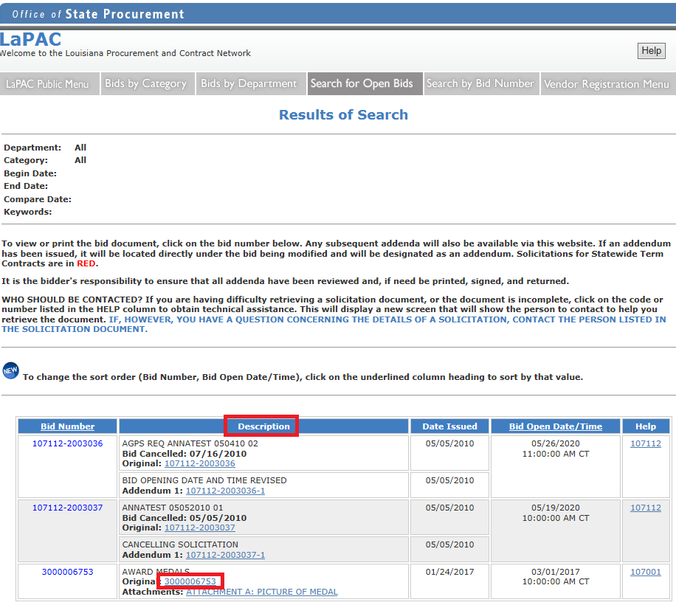

- Click the ONLINE BID RESPONSE LINK on the Bid Invitation.
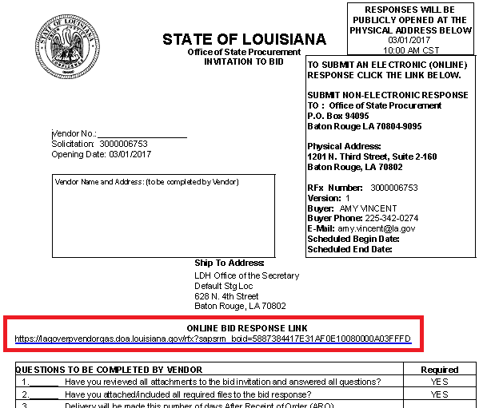
- Enter your LAGOV vendor ID number and password. Note: Your ID and Password were created and activated during the vendor registration process in the LAGOV Vendor Portal site. If you have not registered in LAGOV, go back to the Bid Invitation and click the link to the LAGOV registration site.
- The Bid Invitation (aka RFx) is displayed. Click the button at the top of the screen. This registers your company as a bidder on this particular Bid Invitation. If there is no button, you are already registered to the bid and can skip this step.
- Click the button at the top of the screen. Your RFx Response number is displayed at the top of the screen.

- To proceed read the Notice and check the box to accept the terms.
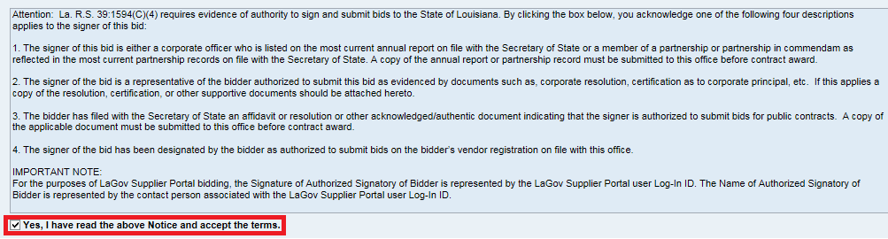

- Click on the words “Notes and Attachments” under the RFx Information tab. In the Notes section of the screen click on the link to open Header Tendering Text.
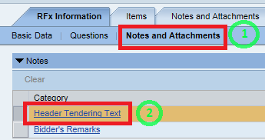
These are the same notes shown on the Bid Invitation Document in LAPAC. Click the button.
See the Notes and Attachments Additional Information section at the end of this document for more information.

- Bidder remarks may be added to the Bid Response. Click the Bidder’s Remarks link.
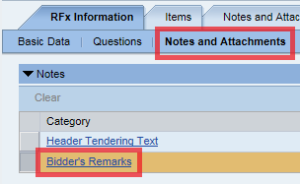
- A pop-up window appears. Type remarks as desired then click the button.
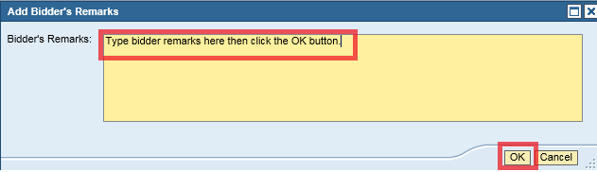

- In the Attachments section of the screen all attachments to the Bid Invitation are shown. These are the same attachments that are shown in LaPac. Each attachment can be opened by clicking on the Description link and downloaded to a local file if desired.

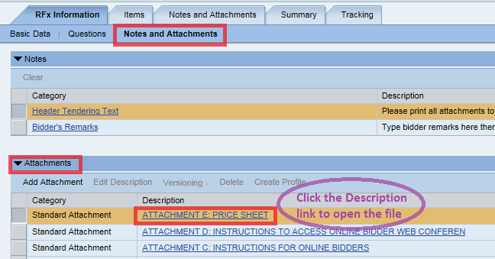

- Click the Items tab near the top of the screen.
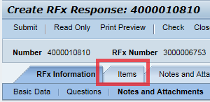

- Each line item of the Bid Invitation is displayed. Highlight the first line item by clicking in the gray box to the left of the Line Number. Then click the Details button.
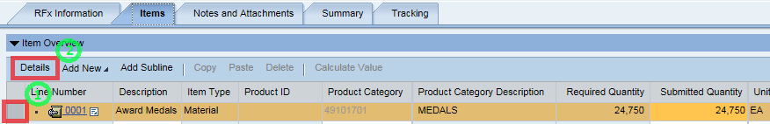

- The Details specific to the line item selected are displayed. The Item Data tab displays information related to Product Category, Item Description, Required Quantity and Delivery Date. This is also the screen in which the bid price and number of days after receipt of order (ARO) are entered. Be sure to note the per/unit of measure for the price to be quoted. In this example the unit of measure is EA (Each).
Enter the bid price for the line item.

Note, if a Price Sheet is attached to the Bid Invitation, then enter prices only on the Price Sheet; not on each line item.

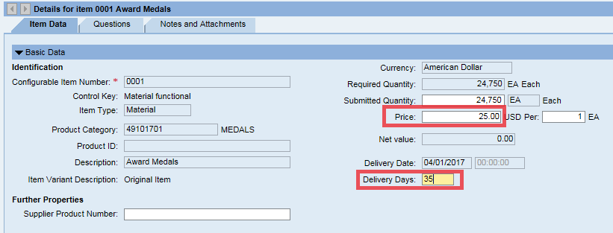

- Click on the Questions tab for the selected line item. Answer any questions presented.
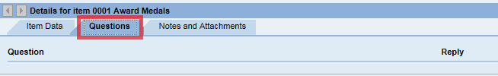

- Click on the Notes and Attachments tab for the selected line item. Read any notes by clicking on the Category Link and review any attachments relevant for the selected line item. In this example there is a note for Item Tendering Text but no attachments relevant to the specific line item.
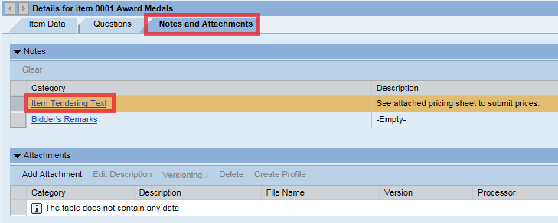

- Repeat steps 16 – 19 for each item on the Bid Invitation. In this example there is only 1 line item.

- A Price Sheet may be attached to the Bid Invitation. If so, prices are to be entered on the Price Sheet. Download the Price Sheet to a local Excel file and complete it accordingly. Then, attach it to the Bid Response as follows:
Click the Notes and Attachments tab at the top of the page then click Add Attachment.
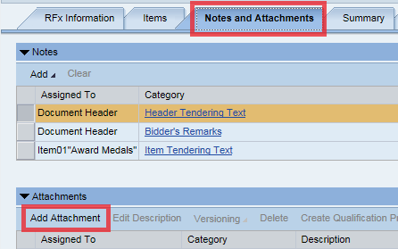

Browse your computer and select the file (for example, completed Price Sheet) to be attached to the Bid Response. Enter a description of the attached file, i.e. Price Sheet, then click the button.

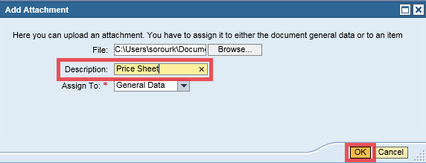

- Click on the RFx Information tab at the top of the screen and click on the word “Questions”.
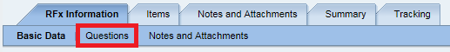

- Answer the questions presented. Questions with a red * are required and must be answered.
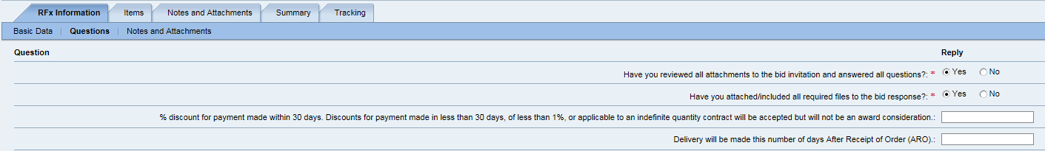

- Once all notes and attachments are reviewed, all questions are answered and all prices are entered click the button at the top of the page. Any red error messages must be cleared before the bid response can be submitted. If errors are present, correct any errors and click again.
- The following message will be presented if there are no errors: 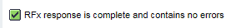
- Click the button at the top of the page to submit your Bid Response.
- A message will be presented with the RFx (Bid) Response number showing it has been submitted.
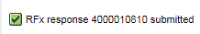
- Click the button to exit the Bid Response. The Bid Invitation is displayed.
- Click the button to refresh the screen.
- Your RFx (Bid) Response number is shown in the upper right section of the screen. It is a link to your Bid Response. It is not necessary to open your Bid Response again. But if you wish to access your Bid Response Click on the Bid Response Number link.

Note: For future access to your Bid Response go to the LaPac website and locate the Bid Invitation number. Open the link to on the Bid Invitation, Log into the LAGOV Vendor portal as you did at the beginning of this process. The Bid Invitation opens and your RFx (Bid) Response number will be available.
- Click the button to exit the Bid Invitation.
- The process is complete.

Other Information:
- The Bid Response may be viewed by the submitter anytime by accessing the Bid Invitation on the LaPac website. See step 27 above.
- If you receive notification of an addendum or change to the Bid Invitation, the submitter is responsible for editing the Bid Response and resubmitting if any changes are done. Follow steps 1 – 4 to access the Bid Invitation.
- The submitter of the bid may change the bid any time prior to the bid opening date by accessing the Bid Response and clicking the button. If the Bid Response is edited it MUST be SUBMITTED again.
- The Bid Response can be saved by clicking the 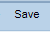button. This might be used if the submitter is partially finished with the Bid Response and will add more information at a later time. Important note, saving the Bid Response does not submit the Bid Response for bid consideration. It MUST be SUBMITTED.
- The submitter of the bid may withdraw the bid any time prior to the bid opening date by accessing the Bid Response and clicking the 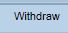button.
- The State of Louisiana buyer does not have access to your Bid Response until after the bid opening date has passed.
- Only the submitter of the Bid Response can view it before the bid opening date. It is never available to other vendors. Procurement employees at the State of Louisiana can view the bid after the bid opening date.

Notes and Attachments – Additional Information

There are three places on the Bid Response that may contain information on notes and attachments.

- RFx Information→Notes and Attachments This area contains header level notes and attachments that come from the Bid Invitation. Header level notes apply to everything in the Bid Invitation – they are not line item specific.

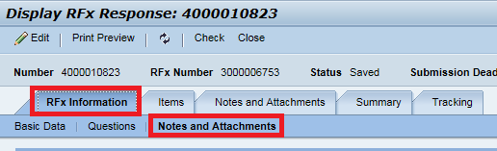

- Notes and Attachments tab This area contains both header and line item specific notes. It also contains attachments that are added to the RFX Bid Response Document.

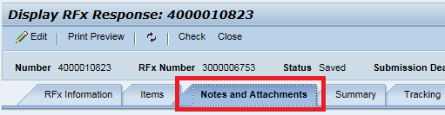

- Items tab→Highlight line item→Details→Notes and Attachments tab at bottom of screen This area contains line item specific notes and attachments. These notes and attachments are only relevant for the selected line item.
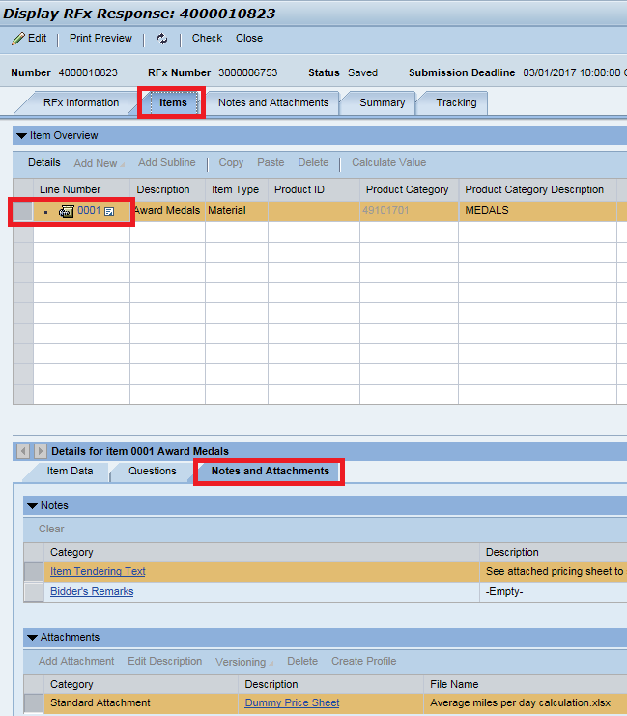

- There is no need to go to the Notes and Attachments tab for every line item. Only those with notes or attachments need to be reviewed. To identify if there are notes or attachments relevant for a specific line item in the Bid Invitation select the Items tab. In the Overview section of the screen, scroll to the right to the RFx/Response columns. The column with the shows if there are attachments and the column with the shows if there are notes. In this example there is 1 attachment and 1 note.

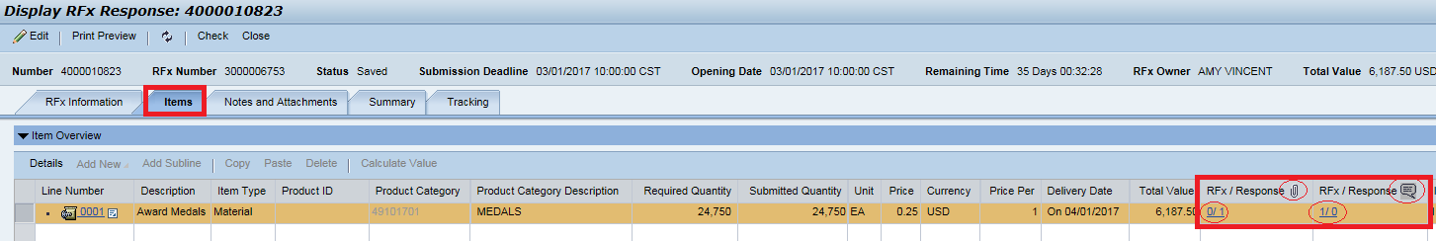

ONLINE BIDDING QUICK REFERENCE GUIDE

- Click the Bid Invitation link on the LaPac website. The Bid Invitation opens.
- Click the Online Bid Response link on the Bid Invitation.
- Login with your vendor number and password. The Bid document opens in the LaGov website.
- Review the Bid Invitation and attachments.
- Click . If there is no button you are already registered and can skip this step.
- Click . The Bid Response number appears at the top of the screen.
- Read the notice and accept the terms.
- Review all Notes and Attachments
- Click
- Click to view line item details (product category, unit of measure, etc.)
- Enter Price or complete the Pricing Sheet, whichever applies.
- Add any notes or attachments from the bidder (i.e., Bidder Remarks, Completed Price Sheet)
- Repeat steps 10 – 12 for each line item.
- Click
- Clear any hard (red) errors. Click again if any changes were made to clear errors.
- Click
- Click
- Click

