Statewide Articulation and Transfer
Council (SATC)

March 17, 2025
1:00 p.m. to 2:30 p.m.
Claiborne Building
6th Floor, (Board of Regents Collaboration Room)
1201 N. Third Street
Baton Rouge, LA 70802
**Meeting Details to Follow**

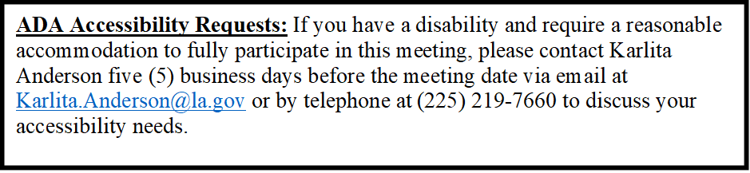

To customize this letterhead,

View the header and footers and update the text with your department’s name, address and other contact information. Then delete this message and save the file as a template.

- Do not change the size of the text.
- Do not delete the EEO statement or the footer.

