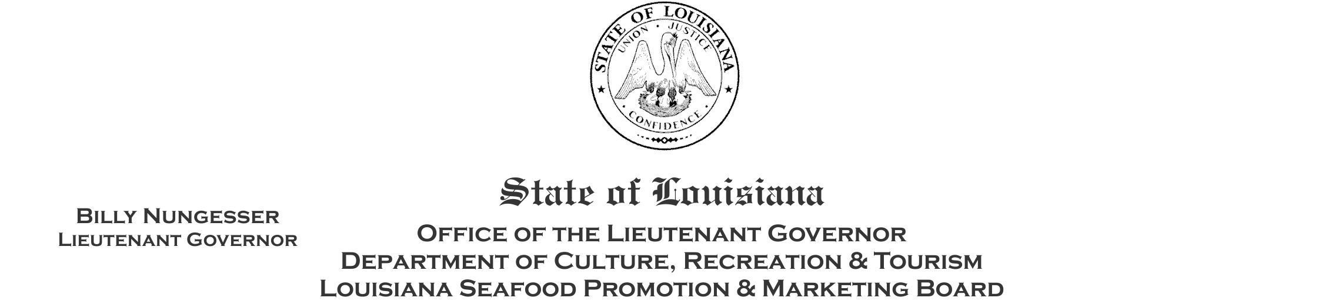

Seafood Safety Task Force
Regular Meeting Agenda
January 15, 2025, 1:00 p.m.
Senate Committee Room E
Louisiana State Capitol Senate Chamber
900 N. 3rd Street, Baton Rouge, LA 70802

- Call to Order by Lt. Governor Billy Nungesser
- Pledge of Allegiance
- Roll call
- Adoption of the Agenda for January 15, 2025 meeting
- New Business
  - Lt. Governor Billy Nungesser - remarks
  - Ag Commissioner Mike Strain - remarks
  - Introduction of SSTF members
  - Chairperson Nominations
  - 2024 Legislative Session Updates (Overview of recent and new laws pertaining to the seafood industry)
  - Financial Review & Budget Updates (financial allocations and expenditures)
  - Department of Agriculture Update (seafood testing and label inspections)
  - Genetic testing of seafood
  - Marketing proposal and budget recommendations for 2025
- Public Comment
- Schedule next Board Meeting
- Adjourn

