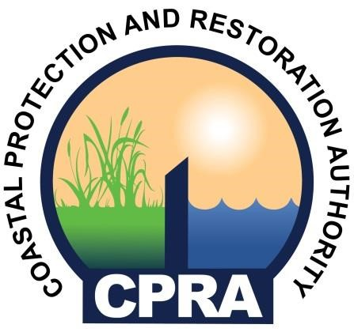

NOTICE OF PUBLIC MEETING
COASTAL PROTECTION AND RESTORATION AUTHORITY OF LOUISIANA

The meeting of the
Coastal Protection and Restoration Authority of Louisiana has been scheduled for:

Wednesday, July 17, 2024
9:30 AM
State Capitol Building
House Committee Room 1
900 N. Third Street
Baton Rouge, LA 70802

If you need further information, please call
The Office of Coastal Activities at (225) 342-7669

Please contact Enger Kinchen, 225-342-7669, enger.kinchen@la.gov at least 24-hours prior to the meeting to request accommodations for ADA-qualifying disabilities.

