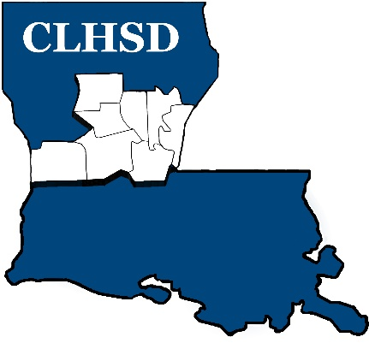

PUBLIC NOTICE
Meeting Cancellation

The Board of Directors of Central La Human Services District will not hold the July 9th meeting:

We will be conducting board business at the next meeting, August 13, 2026, at 5:30

