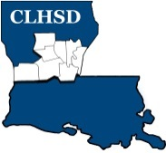
Central Louisiana Human Services District
May 1, 2025
- Call to Order/Quorum
- Prayer/Pledge

- Read and Approve May 2025 Meeting Agenda
Solicit Public Comment Requests

- Approval of Minutes
April 2025 Board Meeting Minutes
- District Reports

  - Financial Report H1
  - ED Monthly Report H2

- Policy Reviews
Executive Limits
  - II. F. Emergency ED Succession with corresponding procedure H3- Desirae Bruce

- Board Business
- Board Development/Training
- District Advisory Council – Becky
- Community Engagement – Josh Butcher
- Annual Ethics Training and completion of Tier 2.1 – Covering Calendar
Year 2024 to be completed by May 15th
- Board Member Self-Assessment distributed to be completed and turned in prior to the June meeting

- Next Month
- Convene nominating committee

- Review Board Member Self -Assessment
- Prioritized Strategic Initiatives for Coming Year

- Questions/Comments As Solicited

- Announcements
- Next meeting is June 5, 2025
- Adjourn

