BOARD
OF
DIRECTORS
MEETING

Wednesday, August 28, 2024
9:00 a.m.

3100 General DeGaulle Drive
New Orleans, LA 70114
Large Conference Room

PUBLIC NOTICE

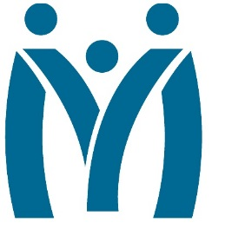
Metropolitan Human Services District
Board of Directors Meeting
August 28, 2024 | 9 AM
3100 General DeGaulle Drive, New Orleans, LA 70114

MHSD fulfills its statutory role as the planning body for the behavioral health, addiction and intellectual/developmental disability services for the residents of Orleans, Plaquemines and St. Bernard Parishes by ensuring that eligible residents in these parishes have access to person centered and recovery focused supports designed to optimize their role in the community.
Agenda

- Call to Order

- Introduction and Oath of Appointed Board Members

- Attendance

- Approval of the June 26, 2024 Minutes

- Monitoring Reports
  - Monthly Dashboard
  - Fiscal Report
  - Reports
    - FY24 Risk Management Audit (Last audit took place in 2023 with a score of 99.35% compliance)
    - Inspection of architectural plans, physical space and intake procedure to confirm compliance with best practices (will be presented in October 2024 meeting)
    - FY24 4Q Report on Incidents
- Decision Information
  - FY 25 Budget Approval
  - LA Legal compliance questionnaire

- Consent Agenda

- Self-evaluation: Board Performance Review

- Adjourn

