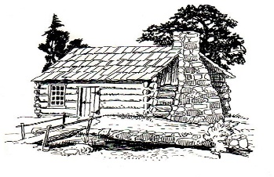
This Photo by Unknown Author is licensed under CC BY-SA
Notice of Meeting
Germantown Colony Museum
Advisory Board
November 4, 2021
4:30 p.m.
The HOCKS RED BARN
1383 Hwy 531
Minden, la
due to covid restrictions
Meeting is open to board members only.
Phone: 318-377-6061
P. O. Box 178 Minden, LA 71058

