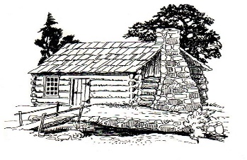
This Photo by Unknown Author is licensed under CC BY-SA
Notice of Meeting
GermANTOWN COLONY MUSEUM
Advisory Board
November 2, 2023
4:30 p.m.
The HOCKS RED BARN
1383 Hwy 531
Minden, la
Meeting is open to the public.
Phone: 318-377-6061
P. O. Box 178 Minden, LA 71058

