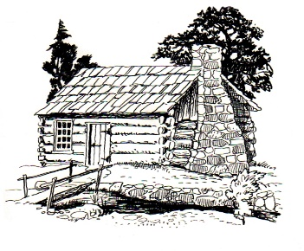
This Photo by Unknown Author is licensed under CC BY-SA
Notice of Meeting
Germantown Colony Museum
Advisory Board
Thursday, May 4, 2023
Meeting 4:30 p.m.
Germantown Colony Museum
200 Museum Road
Minden, LA
Phone: 318-377-6061
P.O. Box 178 Minden, LA 71058
Open to the public

