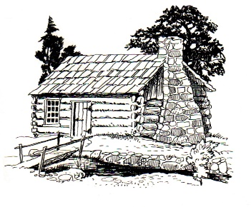
This Photo by Unknown Author is licensed under CC BY-SA
Notice of Meeting
Germantown Colony Museum
Advisory Board
Thursday, August 6, 2026
Meeting 4:30 p.m.
Hock’s Red Barn
1383 HWY 531
Minden, LA 71055
Meeting is open to the public.
Phone: 318-377-6061
P.O. Box 178 Minden, LA 71058

