NOTICE OF EMERGENCY MEETING

Date: Tuesday, September 10, 2024
Time: NOON
Place: 220 Clendenning Road
Houma, LA 70363

AGENDA:

- Meeting Called to Order

- Prayer & Pledge of Allegiance

- Roll Call

- Public Comments

- Discussion and Possible Action of Resolution No. 24-019 - Declaration of Emergency for Approaching Tropical Storm Francine

- Adjourn

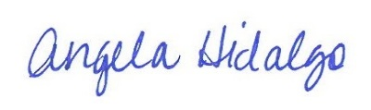
Angela Hidalgo, Secretary

