TENSAS BASIN LEVEE DISTRICT
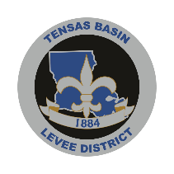
BOARD OF COMMISSIONERS-REGULAR MEETING

Tuesday, August 11, 2026, 9:30 a.m.
505 District Drive, Monroe, Louisiana 71202

AGENDA
CALL TO ORDER
ROLL CALL
PRAYER
PLEDGE OF ALLEGIANCE
PUBLIC COMMENT ON AGENDA ITEMS
ACTIONS
1. Minutes of the July 2026 Meeting
2. Bills for July 2026
3. Kinetix Contract
4. CoreTechs Contract
5. Diversion Canal Schedule
6. Transfer Campsite SB-4B From Jeff Crawford to Coty Ryland (Non-Family Transfer)
7. Take action on Catahoula 8 Lease 392.34 acres.
8. Humvee CEA

REQUESTS
PRESENTATIONS
ITEMS FOR DISCUSSION
UPDATE ON LEVEE PROJECTS
FINANCIAL STATEMENTS
9. Review Financials
PUBLIC COMMENT
ADJOURN
ANNOUNCEMENTS

In compliance with the Americans with Disabilities Act, individuals needing special accommodations during this meeting should notify the Tensas Basin Levee District Board of Commissioners at 318-323-1130 at least three working days before the meeting.

