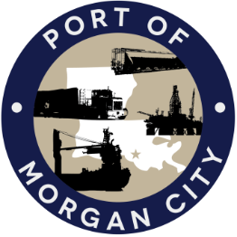

AGENDA

MORGAN CITY HARBOR AND TERMINAL DISTRICT
Regular Meeting of May 10, 2021 – 5:00 p.m. – 7327 Highway 182

- Call to Order

- Roll Call, Invocation and Pledge of Allegiance

3. Minutes – approval of Regular Meeting of April 12, 2021

4. Finance Report
A. Presentation and discussion of financial reports for April 2021 – Deborah Garber
B. Invoices

5. Guest(s)/Public Comment
A. Corps of Engineers, New Orleans District
B. United States Coast Guard

6. Raymond “Mac” Wade - Executive Director’s Report
A. Consultant – Michael Knobloch, Knobloch Professional Services, LLC
B. Consultant – Charles Brittingham, Cassidy & Associates
C. Consultant – Terral Martin, Providence Engineering
D. Consultant - O’Neil Malborough, GIS Engineering
E. Consultant – Eric Matte, T. Baker Smith
F. Cindy Cutrera, Manager of Economic Development

7. Gerard Bourgeois - Legal Report

8. New Business
A. Discussion and any action on agreement for services of Cassidy & Associates, Inc, principally through Charles Brittingham for assistance with dredging and sediment management issues
B. Discussion and any action on Insurance Renewal Quotes from Paul’s Agency, LLC
C. Discussion and any action on adoption of millage rate(s) for tax year 2021

9. Old Business
A. Discussion and any action on leasing, improvements, maintenance and repairs to facility(ies), including Coast Guard lease(s) and Youngswood Yard rehabilitation project
B. Discussion and any action regarding the U.S. Department of Homeland Security grant program, including request for proposals, bids, purchases, maintenance for equipment, TAACS software and NOAA ports system(s)
C. Discussion and any action on Atchafalaya River Channel including dredging and sediment management, equipment purchases, reports, survey services, consulting services, economic study(ies), landowner agreements; right of entry for U.S. Army Corps of Engineers and cooperative agreement(s)
D. Discussion and any action on Port Construction and Development Priority Program project requests and related purchase of property adjacent to the District’s Dock

10. Adjournment

In accordance with the Americans with Disabilities Act, if you need special assistance, please contact Tori Henry at 985-384-0850, describing the assistance that is necessary.

