Finfish Task Force Meeting Minutes
Wednesday, August 27, 2025, 10:00am
LDWF Headquarters
2000 Quail Drive
Baton Rouge, LA 70898

I. Pledge of Allegiance
II. Roll call and introduction of guests
Voting Members Present:
James Pelas
David Alphonso
Jay Trotter
Stuart Billeaud
Ben Graham
George Huye
Steve Rockwieler

Voting Members Absent:
Wayne Rollo
Daryl Simon
Daniel Edgar
Adam Guillory
Senator Hensgens
Representative Stefanski

Non-Voting Members Present:
Jason Adriance
Davis Madere
Jack Isaacs
Gene Cavalier

Non-Voting Members Absent:
John Walters

III. Steve Rockwieler motioned to approve the February 12, 2025 meeting minutes, 2nd by George Huye. Motion carries.

James Pelas motioned to amend the agenda by removing item, B under new business, To Request that LDWF Submit a Follow Up Letter to the US Department of Ag Seeking Relief from the Regulations Governing Wild-Caught Catfish, 2nd by Stuart Billeaud. Motion carries.

Steve Rockwieler motioned to approve the August 27, 2025 meeting agenda as amended, 2nd by Stuart Billeaud. Motion Carries.

V. New Business
- Dr. Raborn and Dr. Naisbett-Jones from LGL provided the results of the menhaden by-catch study
LGL looked at the three steps of bycatch processing on pogie boats.
- Rollover – fish that remain in the net and are released over the net, or which are restricted by an excluder device at the front of the pipe hose.
- Chute – fish that go through the pipe, but are caught by an excluder grate that sends them down a release chute.
- Retained – fish are not excluded or removed. They get processed along with menhaden.

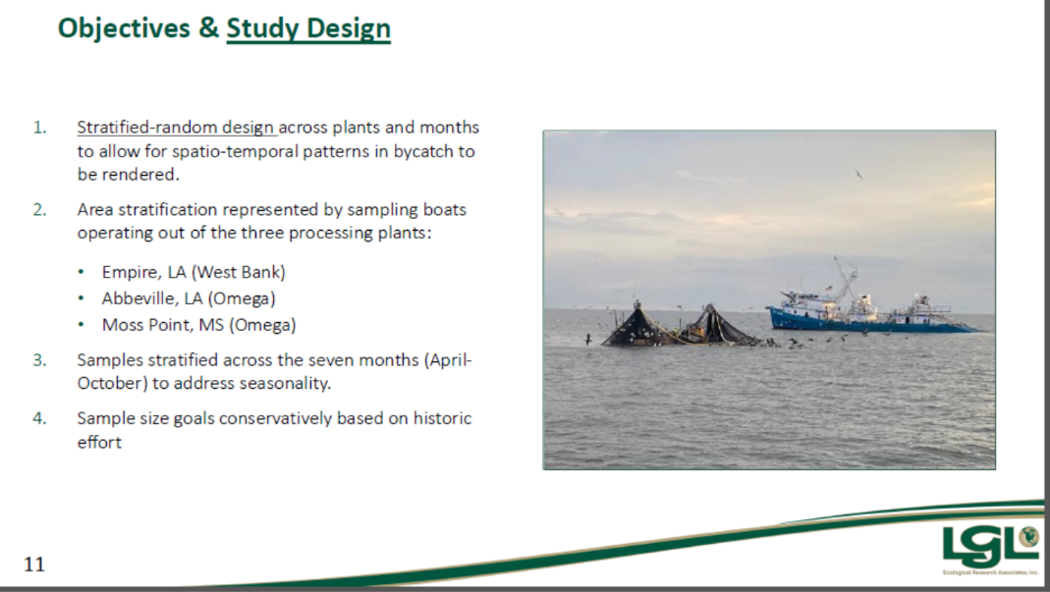
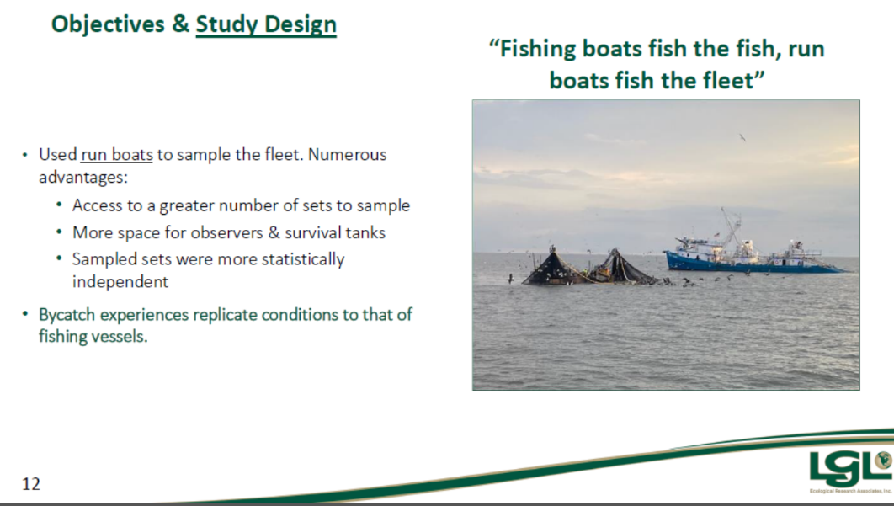
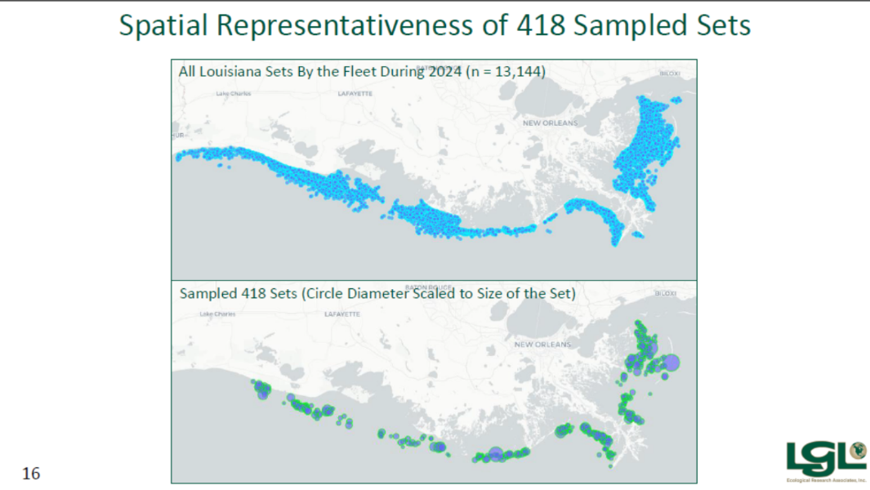
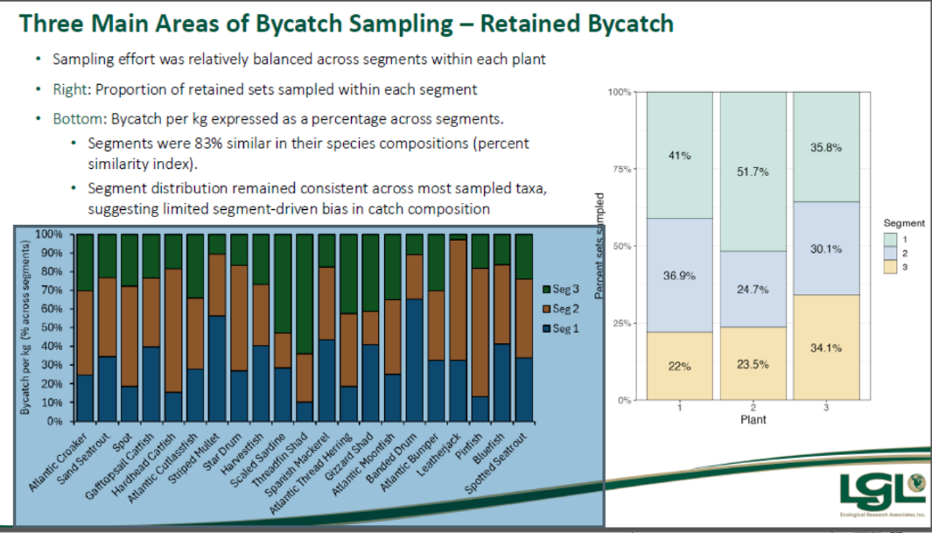
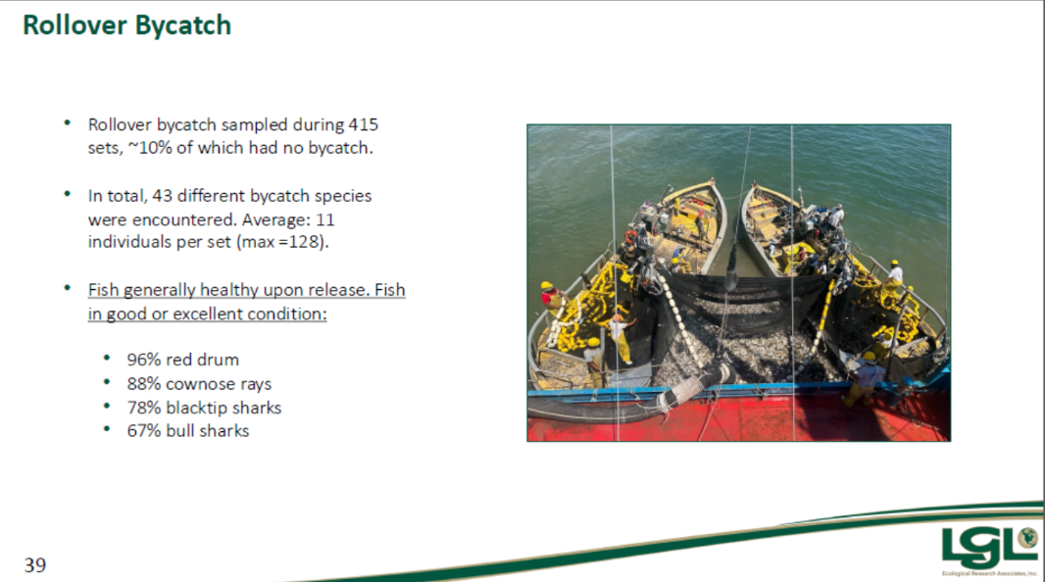
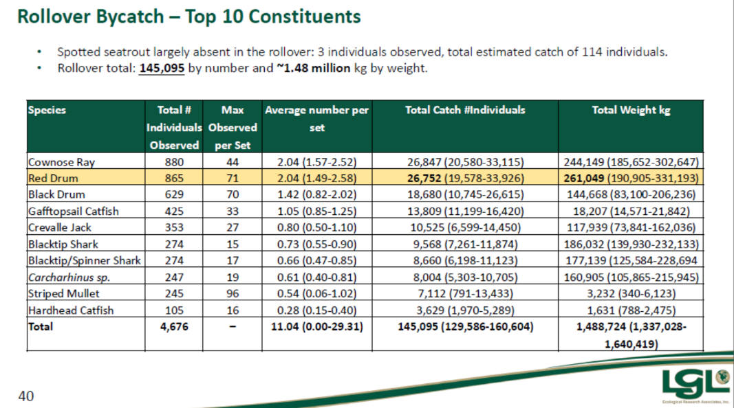
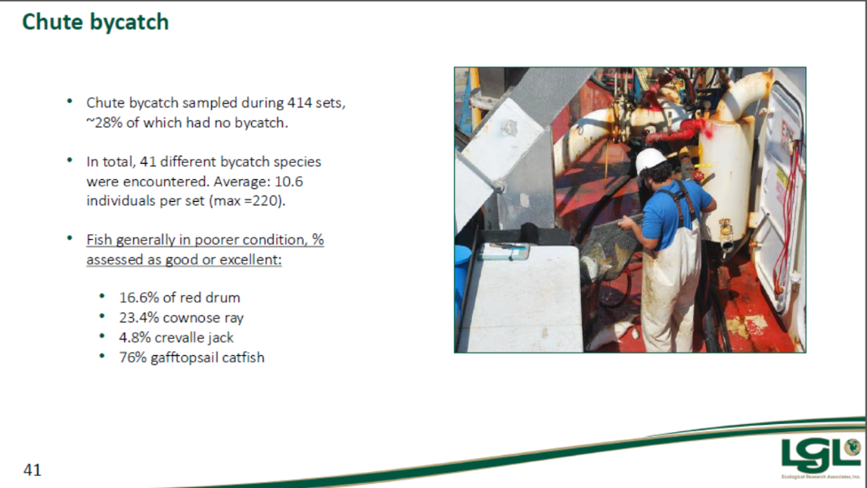
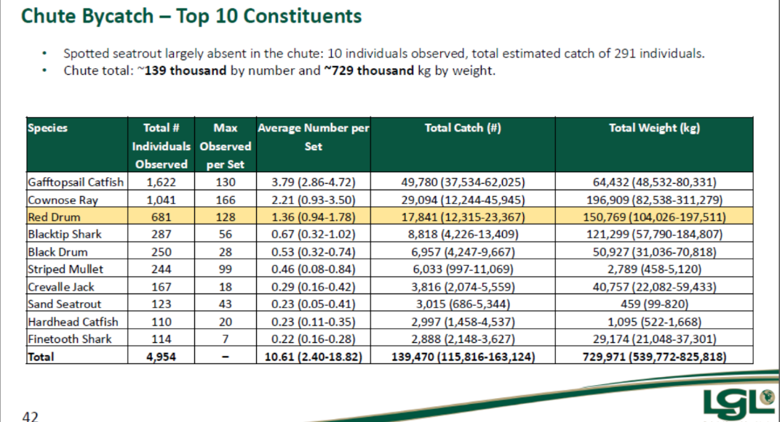
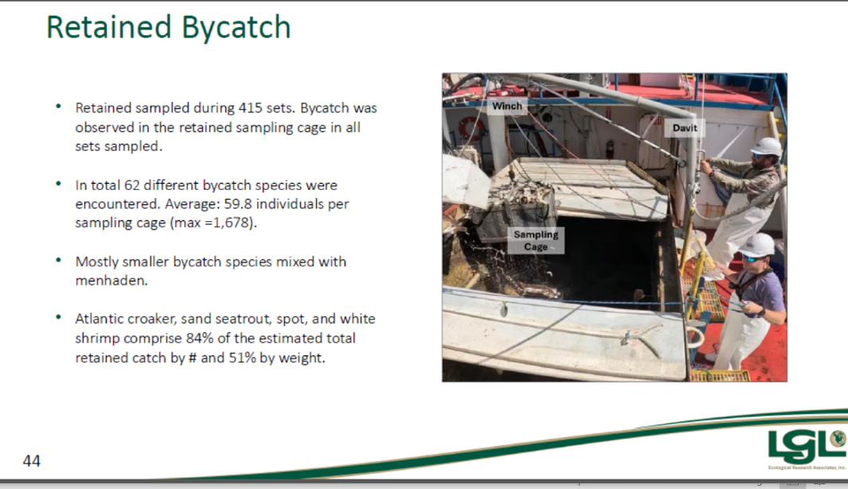
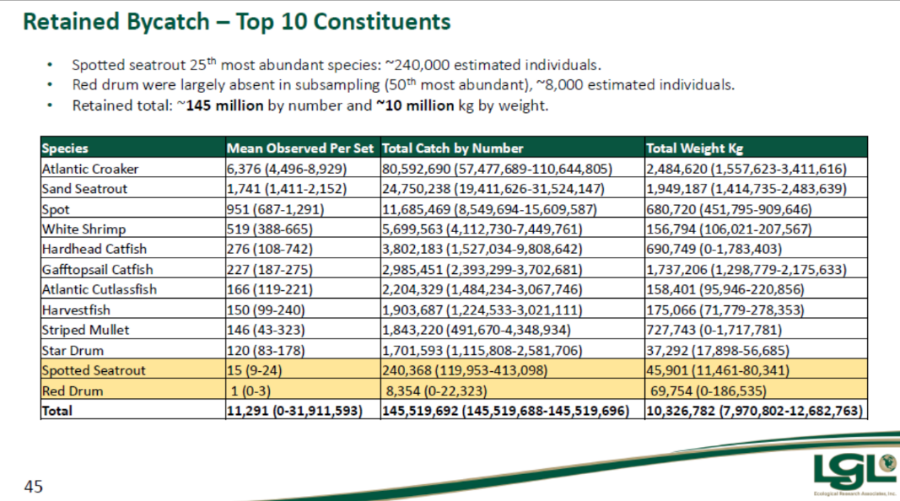
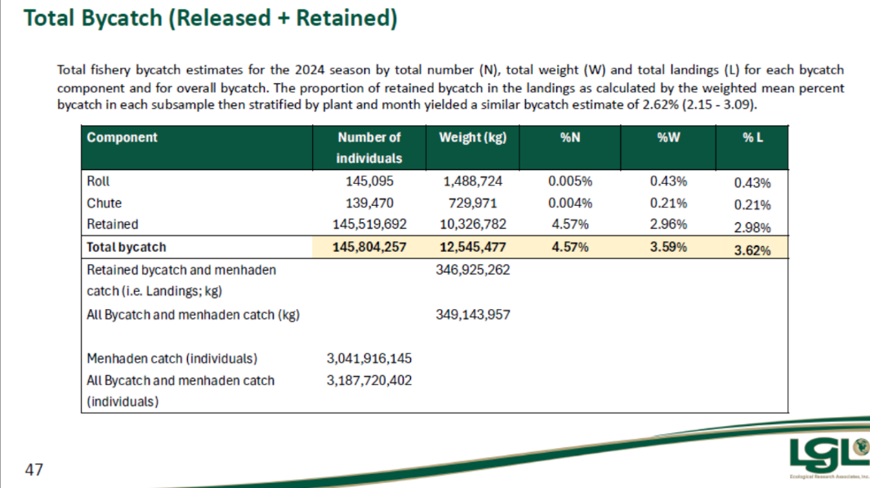
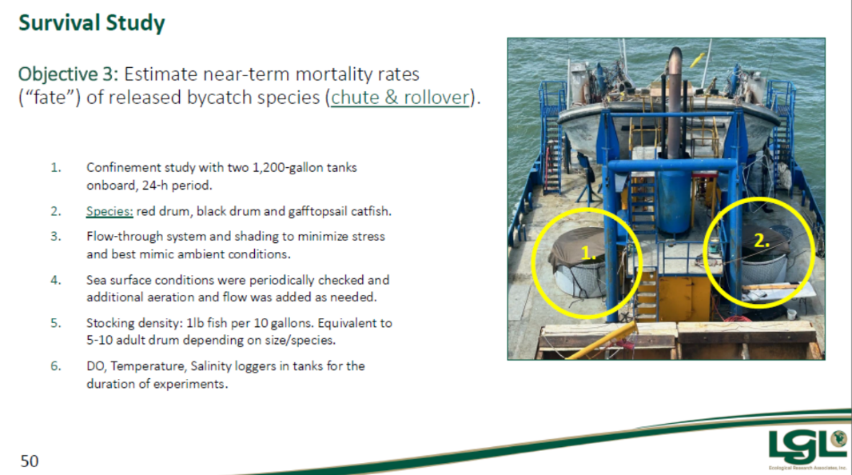
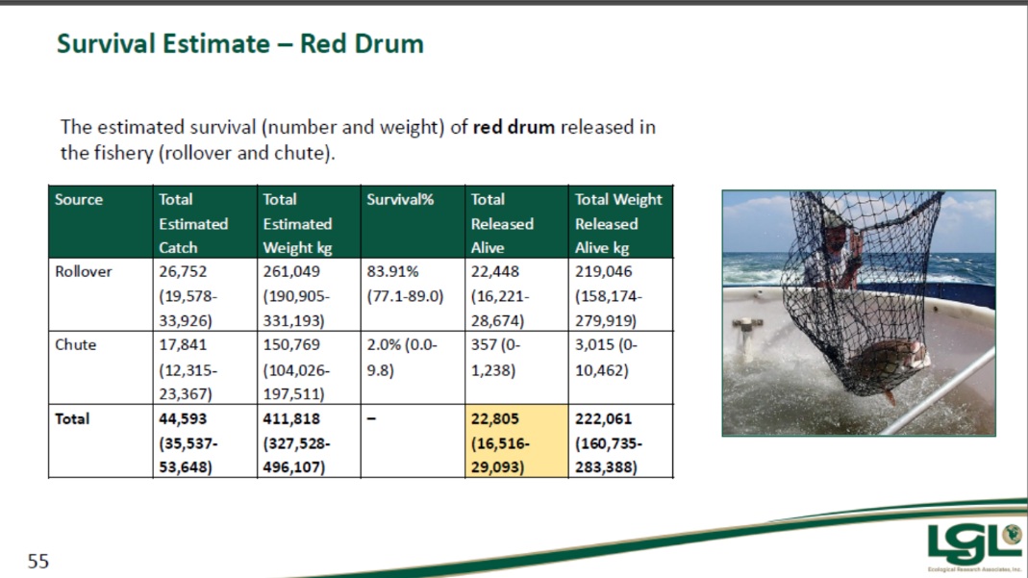
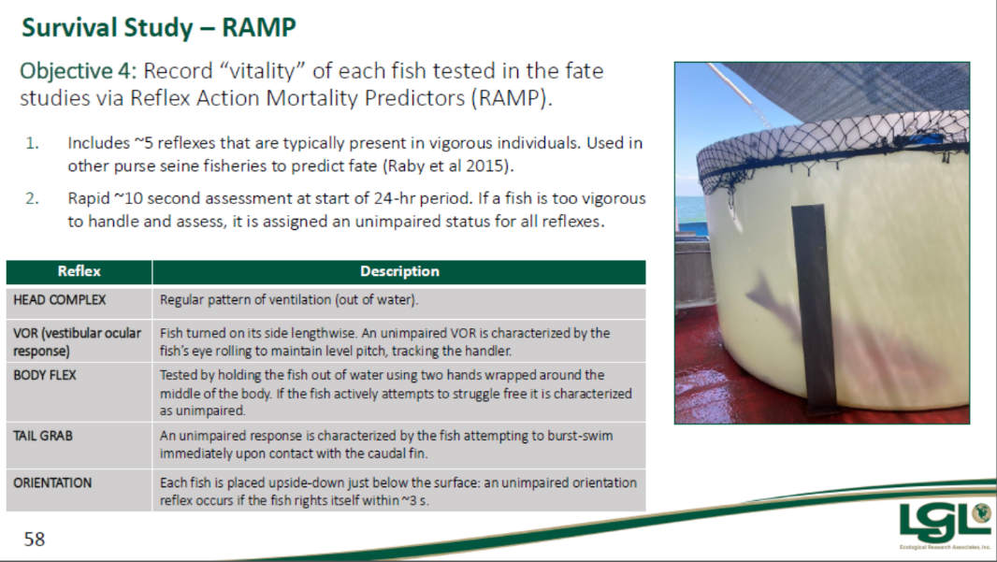

Ben Graham asked if it was possible to get data on how many sets were done in this study outside of the 3-mile line
David Alphonso asked for feedback on the contour line
Stuart Billeaud stated that in the 60s/70s when the pogie boats showed up the tarpon disappeared, always have wondered what happened, based on gulf-wide population est 1-3% removed of menhaden
- Jack Isaacs provided an presentation on recent LDWF commercial fishing reports

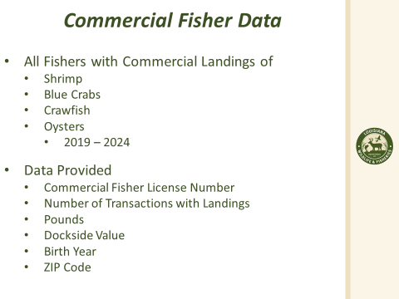
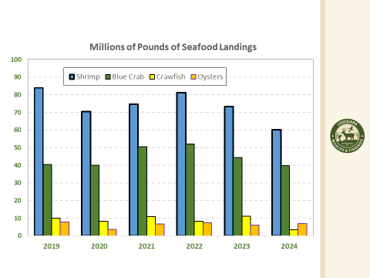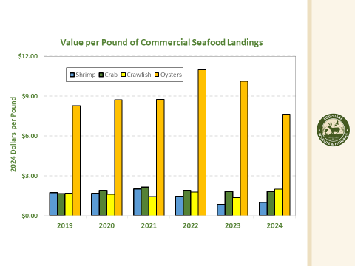
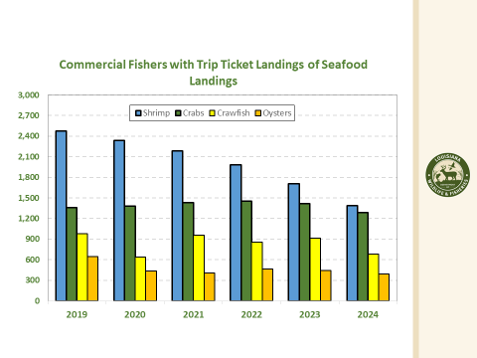
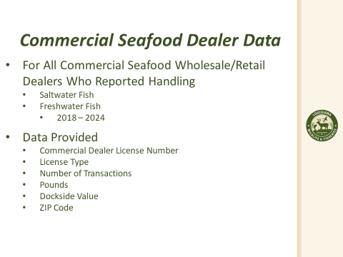
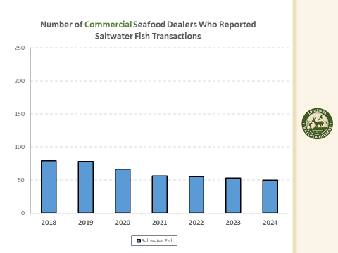
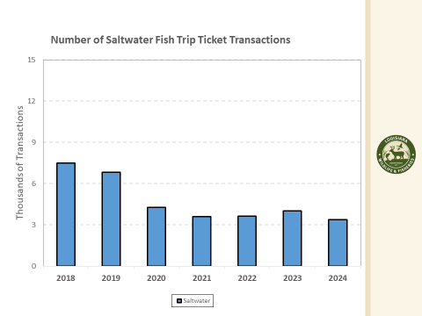
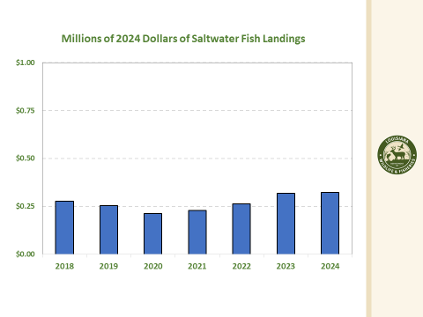
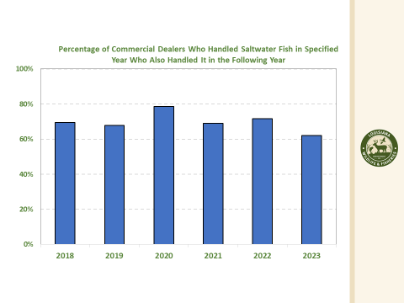
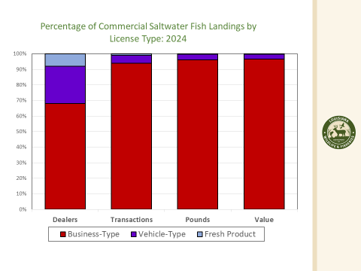
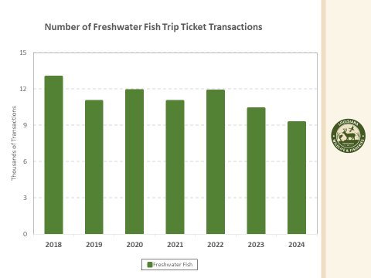
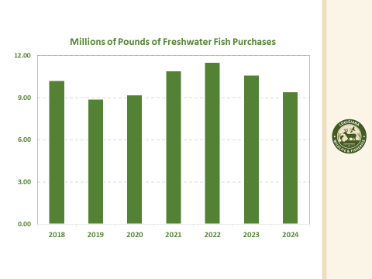
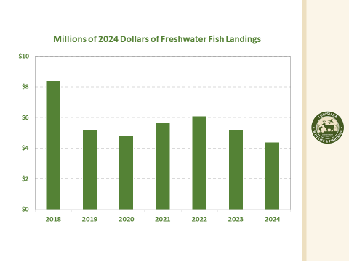
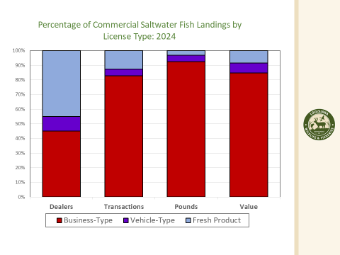
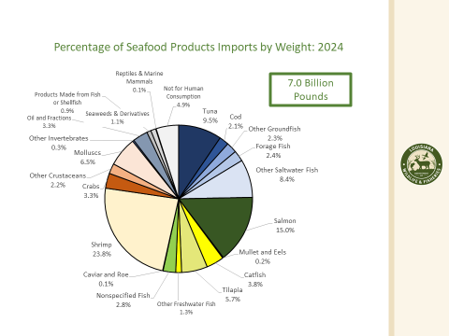
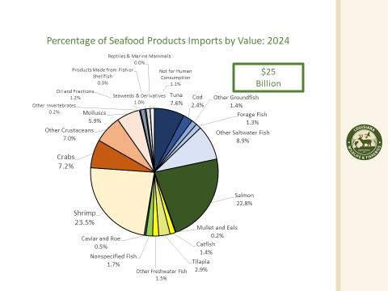
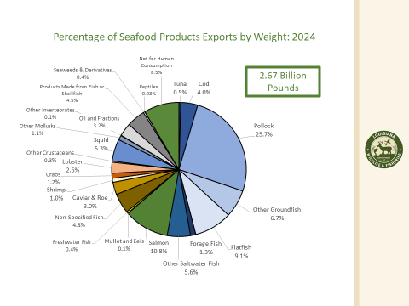
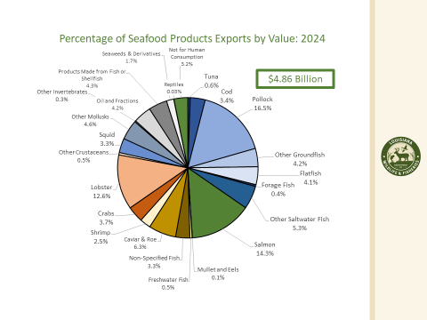
Ben Graham asked for feedback on a table that would show total catch and total dollar value of that catch on Finfish
Kendra Arnesen asked about presenting the information on new regulations that were rolled out during the presented time periods to show why some of these drops might have happened in these reports
Eddie Lejeune suggested that there should be something implemented to get a true assessment of trout and redfish from year to year, currently there is no mechanism at this point to get an accurate assessment, need to use the commercial guide sector to get this information
David Alphonso stated that he sees a correlation with increased imports and that is driving down prices and that is what driving commercial exit
Ben Graham asked for a more comprehensive regulations, imports, weather, quantify impacts or identify where the largest impacts are and then they can be addressed, requested that LDWF look into what is the largest impact from a regulatory, market perspective need this information before we have any real change
Kendra Arnesen stated that the issues are with the shark fin ban at the federal level, strike nets, don’t have access to more than 100lbs of bait per day, need to look at any regulations proposed in the last two decades, Ben Graham asked for specifics, reviewing every regulation is a tall task, we need to pinpoint the issue to a certain species or regulation to point to and ask for data
Jason Adriance stated that LDWF has been working with LA Sea Grant on addressing some of the shark issues and they are doing what they can
- James Pelas led discussion on the state of the commercial fishing industry,
James Pelas stated that there are gear issues, not allowed to fish anything anymore, mullet season but no buyers, shark fin issue, Spanish mackerel season
Jay Trotter stated that to keep the mullet market going you would need to be able to fish mullet year round
One of the issues may be resolved if the State seeks control of amberjack from the federal government
- James Pelas led discussion on skimming for sheephead and drum from January to March
James Pelas stated that there are issues with land erosion and catching sheephead, allowing skimming from January to March would allow fishermen to catch more and would provide work in the summer, right now only allowed to use skimmer gear to fish for finfish during open shrimp season, would like to use the gear during closed shrimp season, this would be a legislative change to allow finfish trawl gear
Ben Graham asked for feedback on how this will affect the shrimp and asked for feedback from the shrimp task force on how they feel about this change, need the legislature to authorize that gear to target finfish
The task force requested feedback on the current regulations on sheepshead and shrimp season dates
Douglas Olander stated that skimming for fish has been going on for years since they outlawed gill nets they catch too much fish at one time takes market price and drops it down to rock bottom come fall have to fish for no income
Eddie Lejeune expressed seeing some issue with catching sheephead in skimmer nets
VI. Public Comment: Jack Isaacs stated that he is looking for some feedback from anyone who buys or sells black drum, asked that anyone interested in speaking with him to be in touch after the meeting
VII. The board considered future agenda item proposals
VIII. The next Finfish Task Force meeting is set for Wednesday, November 12th for 10am at LDWF headquarters
IX. Stuart Billeaud motioned to adjourn the meeting, 2nd by James Pelas. Motion carries.

