Finfish Task Force Meeting
Wednesday, July 24, 2024, 10:00am
LDWF Headquarters
2000 Quail Drive
Baton Rouge, LA 70898

I. Pledge of Allegiance
II. Roll call and introductions of guests
Voting Members Present:
James Pelas
Daryl Simon
Jay Trotter
Daniel Edgar
Ben Graham
George Huye
Steve Rockwieler

Voting Members Absent:
Acy Cooper, III
Stuart Billeaud
Adam Guillory
Senator Bob Hensgens
Representative John Stefanski

Non-Voting Members Present:
Jason Adriance
Jack Isaacs
Gene Cavalier

Non-Voting Members Absent:
Major Edward Skena

III. George Huye motioned to approve the April 17, 2024 meeting minutes, 2nd by Daryl Simon. Motion carries.

IV. Daniel Edgar motioned to approve the July 24, 2024 meeting agenda, 2nd by Daryl Simon. Motion carries.

V. New Business
A. Jason Froeba provided and update on the Equipment Modernization Grant

The program launched in September 2023, applications open in December and full review process started in March, 1700 applications valid and submitted, 775 either started or completed the review process, 334 approved for payment or paid out, been refining the process to make things faster, over 1700 messages in the system and over 3500 contacts whether it’s an email or phone call, anticipated 4.5 hours and is currently taking a little over 8 hours for an application to process, submitted formal request to NOAA to start approving supplies and it sounds like it should be approved and this will speed things up,

Jason Froeba stated that a spend plan was submitted to NOAA for hurricanes in 2020-2021 and the current plan is a direct payment program, that’s currently what has been proposed and this was submitted at the beginning of the year, new law that NOAA has 90 days to provide a response

B. Jason Adriance provided a handout with the new red fish regulations
New Red Drum size and daily creel limits go into effect and will be enforced beginning June 20, 2024.
The new regulations are as follows:
- Daily Creel: 4- fish daily limit per angler
- Size Limit: 18-inch minimum and 27-inch maximum total length
- Bull Reds: keeping Red Drum over 27 inches is prohibited
- The retention of Red Drum by captain and crew on charter or head boats while on a for-hire trip will be prohibited.

Charter captains and crew will still be allowed to engage in fishing on charter trips to demonstrate how to catch red drum, but will not be allowed to retain red drum towards any limit on the vessel.

Ben Graham asked that feedback has the department got on the new regulations? Jason Adriance stated that online there is a mix of responses in regards to the changes

Steve Rokwieler asked is there ongoing sampling for the next assessment? Jason Adriance stated, yes there is ongoing sampling but will not know recruitment for this year for a while

Had a stock assessment and sampling data, independent and dependent data feeds into the assessment

C. Brooke Bergeron with South Central Planning provided a presentation and update on the Restore LA Small Business Loan Program

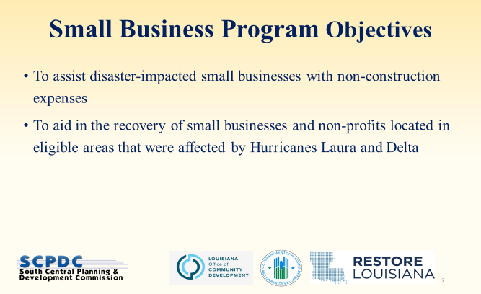
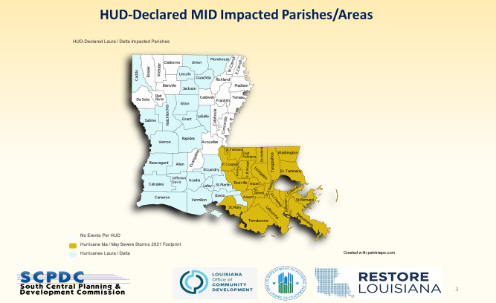




APPLY: https://www.scpdc.org/programs/restore-small-business/
- Ida/May – no longer accepting applications. More applications than funding.
- Laura/Delta – accepting application but funding rapidly depleting.
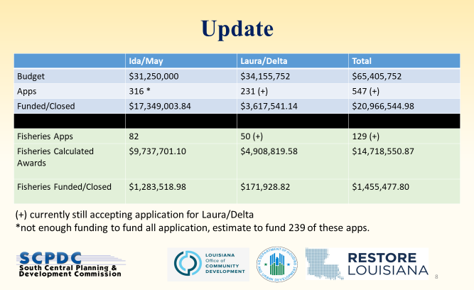
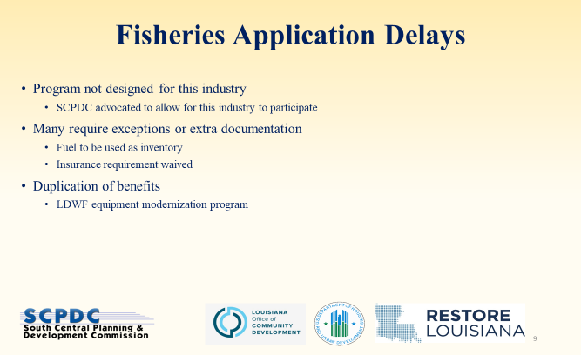

D. Richard Fischer, LA Charter Boat Association, 7-8 years ago this committee made a motion to add a Charter Boat Association seat to the Finfish Task Force, this needs to be done legislatively. Charter Boat Association had a few bills so decided to add this addition to the bill beginning on August 1, CBA and the Women’s Southern Fishing Alliance will both submit 2 nominations for the Governor to consider an appointment for the task force representing both of these entities

E. Jay Trotter led discussion on commercial Spanish mackerel regulations

Stated that he would like to get the three-mile limit lowered down to a mile, the three-mile limit for Spanish mackerel is prohibiting fishing for this species, when you target Spanish mackerel that is basically what you will catch. As a commercial fisherman there is hardly anything left to catch. This change would help the industry

Ben Graham would like to understand the history on landings, etc.

Jason Adriance stated that the issue is not with the Spanish mackerel fishery itself, 12” minimum size, the issue is what’s an allowable gear and what’s not, the issue is with the strike net, in terms of federal permits outside the 3-mile there are currently 39 registered to fish and this change would be legislative, not a distance from shore issue but more of a gear issue, pompano and mullet are fisheries that strike nets are allowable,

Jason Adriance stated that in the entanglement net ban there were specific species carved out, no catch limit, the federal allowable catch is somewhere around 9M lbs Gulf wide quota
Kindra Arnesen suggested making a motion to suggest that legislation be changed, the motion to have this discussed at the next meeting, have to expand commercial fisheries in the state, need to make a recommendation for a possible pilot program to test out making this change from 1 to 3 miles for 24-36 months

Ben Graham would like to know the departments position if it can be changed how this would happen, mullet, Spanish mackerel and pompano, would welcome input from the board on logical next steps forward, do not feel there is enough information available to make a decision at this point

Daniel Edgar motioned to request that LDWF consider the use of the strike net in the harvest of Spanish Mackerel, requested for data on Spanish mackerel and requested to add it as an agenda item at the next meeting, 2nd by Jay Trotter. Motion carries

Jason Adriance stated that biologically not an issue with Spanish mackerel, the issue is restrictions on gear, federal season is open March 1st but the quota is never reached

F. Jay trotter led discussion on pompano

Issue with depth, every year is different

Jason Adriance stated that the pompano regulation has a buffer off the islands but it also establishes a depth of 7ft or greater for a strike net

Jay Trotter stated that this rule was passed by one man to benefit his own use and he is no longer with us, if we could just change the depth requirement

Kindra Arnesen stated that when the law was passed for one individual that put this up who had a big boat and wanted to cut out his competition, the issue is that sandbars move, the way the law is currently written we would lose our pompano license, only can strike in 7ft or deeper water, not a responsible way to fish, when looking in 7ft of water or greater you can’t see the bottom, more shallow water will decrease bycatch, would look for support from this body to write a letter to legislature and LDWF to remove the 7ft depth requirement

Jack Isaacs stated that if you will be changing the rules may want to look into the requirement that says you have to have your social security number on your license

Ben Graham stated that we need to understand why this regulation was put there before making a motion on this, how will 7ft depth change impact the fishery and other species that may be impacted by this change

Ben Graham requested that LDWF provide any and all important data on pompano, would like more information on why the depth requirement was put into place and then at the next meeting have more discussion

VI. Public Comment-

snapper landings data- 65% of quota has been met, will have update coming this week, now at weekends only 3 day weekends, 4 fish, update on the number of bow fishing permits roughly 700 recreational and approximately 30 charter permits, one charter captain permit covers all customers on the boat, menhaden bycatch study sampling should be done at the end of the season which is November 1 possibly October commission meeting update, should have full report sometime early next year. Can adjust state regulations and looking at adjusting some recreational shark regulations, unless quotas increase, won’t open much but we are looking at increasing the quotas for some species of shark, issues may be with the fin ban and transportation whole through Texas,

VII. Some items discussed by the task force for possible consideration on the next agenda: adding a Recreational representative to the FTF, Hurricane Ida update, stocking fish in Bayou Labeouf, need some help to establish a stock in Bayou Des Allemands to help the fishery, would like some feedback from LDWF on stocking fish in these areas (2.) Would like to know more about South Central Planning, historically there has been some issues
VIII. The next meeting set for Tuesday, October 29, 2024 Wednesday, November 13, 2024 for 10am at LDWF headquarters
IX. George Huye motioned to adjourn the meeting, 2nd by Daryl Simon. Motion carries.

