Finfish Task Force Meeting Minutes
Wednesday, April 17, 2024, 10:00am
LDWF Headquarters
2000 Quail Drive
Baton Rouge, LA 70898

I. Pledge of Allegiance
II. Roll Call and introduction of guests
Voting Members Present:
George Huye
Adam Guillory
Stuart Billeaud
Ben Graham
Daniel Edgar
Daryl Simon

Voting Members Absent:
Acy Cooper, III
James Pelas
Wayne Rollo
Jay Trotter
Steve Rockwieler
Senator Hensgens
Representative Stefanski

Non-Voting Members Present:
Jason Adriance
Gene Cavalier
Edward Skena

Non-Voting Members Absent:
Jack Isaacs

III. Stuart Billeaud motioned to approve the March 15, 2023 meeting minutes, 2nd by George Huye. Motion carries.

IV. Stuart Billeaud motioned to approve the April 17, 2024 meeting agenda as presented, 2nd by Daniel Edgar. Motion carries.

V. New Business
A. The board heard an update on the new menhaden regulations

Jason Adriance provided an update on the new menhaden regulations, there was a NOI out to adjust the quarter mile menhaden buffer to ½ mile, before that NOI moved forward, there was a subsequent LDWF Commission meeting where that buffer was adjusted to a half mile. There was a proposed 3 mile buffer off Rutherford and Holly Beach, that was also adjusted to a one mile just off Holly Beach. There were a few changes to some of the notification requirements when there is a spill occurs or a loss of gear, the notification timeline adjusted to 12 hours after an incident, where is the NOI now? There is a public meeting next Tuesday to take comments on these amended changes, that’s a one-time comment hearing. Comments will be collected at this meeting and summarized and sent to oversight and there will be the typical 30-day oversight period before that can go final. In the meantime, knowing that the season would start on the 15th of this month, at the same time the LDWF Commission issued a declaration of emergency to put those proposed changes into effect so they would be in place for the season while the rule goes through the process. So essentially everything in the NOI is being enforced

Not clear on the boundaries in Breton Sound, currently bound by the double rig line, meeting Tuesday 10:00am April 23rd for public comment

B. Jason Froeba provided an update on the 2019 Equipment Modernization Grant Program
Have about 25% of applications that are in, about 400 applications that are in some component of the review process at this point. Either they are in initial review or we have completed that review and have moved on to inspection or they have received payment or about to receive payment, in the process of trying to get through as many applications as we can, about 6 weeks in, 25 checks were cut last week and another 55 are about to go out. Something that needs to be clarified is that LDWF does not have the funding, we have access to the funds and this is accomplished through requesting the funding and as grant payments come in we request the funding from NOAA and they send the funding, in discussions with the administration right now on how to speed up the process, plan to increase staffing to process these applications, right now looking at anywhere from 4-6 months to process the rest of the applications, currently have more requested than we have available in funding but it’s not much more and we do expect some people to be ineligible.

Daryl Simon asked how many people are working on this, 9 staff at SCP and 4 LDWF staff that work on this 75% of the time

Ben Graham asked what the total number of applications were, Jason Froeba stated that there was 2267 applicants, however 300 of those were canceled and some are ineligible

What is the difference in LA and the program in MS, work with MS fishermen and the program was set up completely different, Jason Froeba stated that each state is required to submit their own plan to NOAA, after hearing that it was not probable for NOAA to accept direct payments to the industry this program was the best way to get money into fishermen hands,

Richard Fischer stated that there was issue with fishermen who live in one state and work in another, these people are getting cut out of the grant funding, asked that in the future when these programs are being laid out to keep these sorts of situations in mind

C. Jason Adriance provided an update on the pompano fishery

Pompano Life History
- Spawning season is protracted from spring through fall with peaks in April-June and September-October, however mature females have been found in December and ripe males year-round. Spawning is mostly offshore.
- Reach maturity at approximately age 1 (10-14 inches). 50% maturity occurs about age1 (11-12 inches) and 100% maturity by age 2 to 3 (14-16 inches). Maturity has been observed as low as 10 inches in size.
- Maximum lifespan is approximately 7 years, but live 3 to 4 on average.
- Can grow to 12 inches in the first year (male and female growth rates are similar)
- Juveniles occur mainly in the surf zones of beaches but in general Pompano inhabit inshore and nearshore waters out to 130 feet with a general offshore movement in the winter. Pompano range throughout the Gulf of Mexico
- Feed on crabs, mollusks and shrimp.
Pompano Fishery
•Recreational fishery has no established limits.
•Commercial fishery also has no established size or harvest limits, however there are restrictions for an allowable strike net fishery (other legal gear year-round).
- Strike net season is from August 1 through October 31 each year
- Waters more than 7 feet deep and beyond 2,500 feet from land within Breton and Chandeleur Sounds.
- No strike net use between sundown and sunrise, no weekends, and not on Labor Day.
- No other fish or gear on board when fishing with a strike net.
- Mesh must be at least 5 inches stretched and net no longer than 2,400 feet.
- May not anchor or secure net to bottom, may not leave net unattended, and must inform Enforcement before fishing under strike net Pompano permit.

Pompano Landings
- Recreational landings have ranged from 113 fish to 4,819 fish a year (2014-2023) with average landings in the last five years at 2,555 fish (2018-2023)

- Commercial landings of Pompano have averaged 50,234 pounds per year (1999-2022) at a dockside value of $177,742, with the most recent years (2018-2022) averaging 24,782 pounds at a dockside value of $98,033.

- As of 2023 there were 9 Pompano permits and 9 Pompano Strike Net Gear Licenses

D. Cullen Curole provided a presentation on the Restore Louisiana Small Business Loan Program

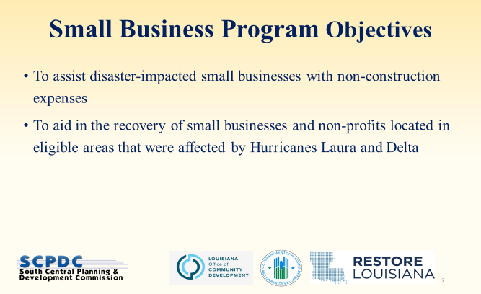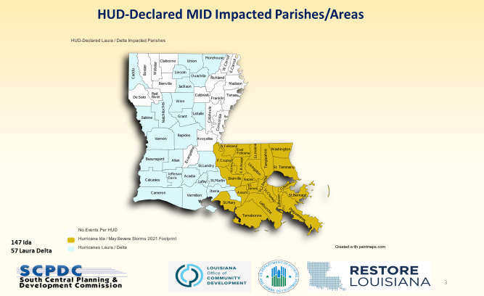
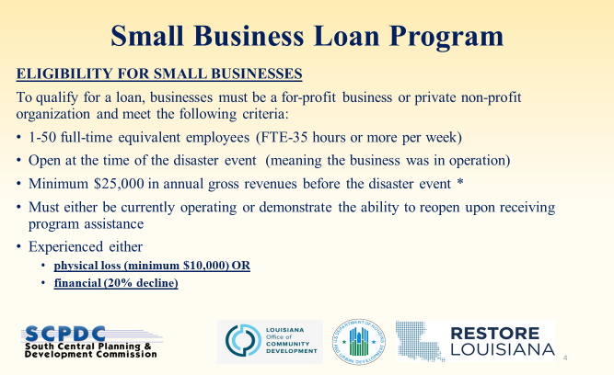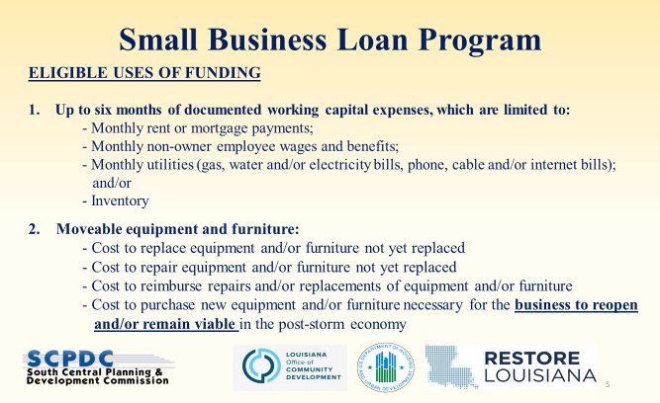

Office of Community Development to attend the meeting to explain why this is taking so long

E. Kindra Arnesen led discussion on the times and seasons for harvest striped mullet
Kindra stated that here in Louisiana we have 4.6 million residents, with 364,000 holding recreational fishing license. More than 90% of Louisiana residents access finfish by visiting restaurants or grocery stores. Over 40 million tourists visit Louisiana each year with 43,500 going recreational fishing. The 99% of visitors access fi fish by restaurants or grocery store purchases access for 90 plus percent of residents, and 99% of nonresidents is provided by a commercial harvest to finfish. Speaking with chefs throughout New Orleans, the number one problem they have shared with me is lack of access to Louisiana finfish. It is time to change this. It is time to consider expanding access to all species. For this very large user group, mullet is a great source of protein. Current regulations hinder the year-round harvest of mullet as a food fish, not a bait fish as such. It’s time for this task force to take the number one task it is charged with and that is coordinating efforts to increase finfish production and marketability for the commercial sector. Seeking support from task force to send LDWF Commission and legislators for the following: in order to have a successful harvest of mullet we need 1. commercially permitted use of no less than 24’ cast net; 2. A year round harvest of no less than 2500 pounds per day yield by harvest of cast net, also need 3. 10% retainment of other commercially harvested finfish with the use of cast nets. These requests are not to impact the current harvest of gillnet in any way. It is not fair that our restaurants have to use only imports to serve Louisiana tourists. It's not fair that our grocery stores do not have access to commercially harvested finfish year round, and it's time to bridge that gap.
Ben Graham asked where we stand with the resource and can the resource handle this additional pressure; change and can we cap it/ what’s the history, how can this be changed (legislative/ rule making), how many licenses are current, the task force will need some feedback on this;

Jason Adriance stated that the mullet stock has been healthy for some time, a new assessment will be available this February to present to the LDWF Commission, health, stock, the fishery is currently underutilized, historical takes from the last 10-15 years, stated that he can get the task force the last assessment and some landings in between

George Huye stated that he is happy to dedicate some time to helping look into this

Ben Graham stated that he would like to see this discussed further in Committee with commercial guys from task force, to set chairman at a later time, will have a follow up email with the commercial guys to establish the committee

There is currently some dormant fishermen; may require some legislation with the gear change, wil need legal to weigh in

Daryl Simon was appointed as chair of the research committee, George Huye will also participate

F. Task force did not discuss, “To Request a Federal Study on Spawning Redfish” at this time, will possibly discuss at a future meeting

G. The task force did not take action on the item, “To Consider Writing a Letter of Support for the Continued Work on a Documentary Depicting the Industry During the BP Oil Spill and the Aftermath” at this time

H. The task force discussed membership and the removal of non-active members

Ben Graham stated that the task force needs to be effective and in order to be effective must be engaged, been having issues with meeting a quorum, issue with board members not participating

Richard Fischer stated that in 2017-2018 a resolution was passed by this body to add the Charter Boat Association, had a commitment by former state senator and it never happened, would appreciate the opportunity to see if there is an opportunity to add a seat on the task force representative

Reach out to individuals who are not active participants and see if they plan to attend or resign

I. Officer elections

Stuart Billeaud motioned to open the floor for nominations, 2nd by Daryl Simon. Motion carries.

Daryl Simon motioned to nominate Ben Graham as the Finfish Task Force chairman and vice-chair Stuart Billeaud, 2nd by Adam Guillory. Motion carries.

Adam Guillory motioned to close officer elections, 2nd by Stuart Billeaud. Motion carries.

VI. Public Comment: no comments were made
VII. Future agenda item proposals (1) Sheephead stock assessment and (2) to discuss the commercial harvest of mullet

VIII. Next meeting date set for Wednesday, July 24, 2024 for 10am at LDWF headquarters

IX. Adam Guillory motioned to adjourn, 2nd by Stuart Billeaud. Motion carries.

