Finfish Task Force Meeting
Wednesday, February 12, 2025, 10:00am
LDWF Headquarters
2000 Quail Drive
Baton Rouge, LA 70898

I. Pledge of Allegiance
II. Roll call and introduction of guests
Voting Members Present:
James Pelas
Daryl Simon
Jay Trotter
Daniel Edgar
Stuart Billeaud
Ben Graham
George Huye
Steve Rockwieler

Voting Members Absent:
Wayne Rollo
Adam Guillory
Senator Hensgens
Representative Stefanski

Non-Voting Members Present:
Jason Adriance
Captain Davis Madere
Jack Isaacs
Gene Cavalier

Non-Voting Members Absent:
John Walters

III. Stuart Billeaud motioned to approve the November 13, 2024 meeting minutes, 2nd by Daryl Simon. Motion carries.

James Pelas motioned to add an item to the agenda to, E. To Discuss the State of the Finfish Industry- FTF, 2nd by Jay Trotter. Motion carries.

Jay Trotter motioned to add an item, F. To hear a Gulf Council Recommendation on Greater Amber Jack, 2nd by James Pelas. Motion carries.

IV. Stuart Billeaud motioned to accept the agenda as amended, 2nd by James Pelas. Motion carries.

V. New Business:

Jason Adriance heard recommendations from the task force on bag limit and season structure for the upcoming recreational red snapper season

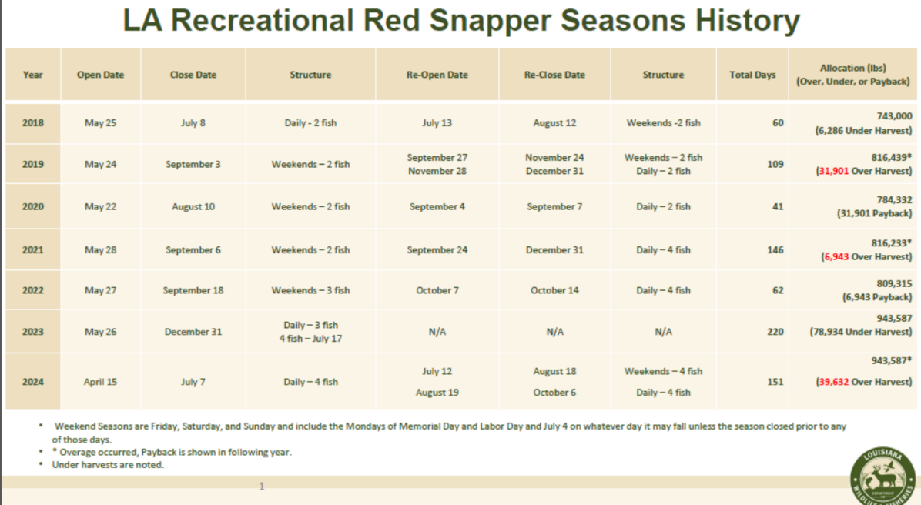

Stuart Billeaud suggested sticking with the same season as last year; try to make it until Labor Day, 4-day bag limit

Daniel Edgar stated that he is good with it as long as Labor Day is included in the season

Ben Graham agreed with the Labor Day inclusion, a lot of positive feedback on starting the season earlier, think 4 is great if it’s going to squeeze on Labor Day, 3 is fine

George Huye stated that August always starts the natural pumping of the breaks because it’s back to school, heard nothing but good things about the way the season was ran last year

Jack Isaacs stated that this is an important issue to LDWF and to angers, LDWF put together surveys on red snapper management, the first part is a random survey for people who hold an RRLP sent out to about 13k and have received about 3,000 responses back so far, will close this one next Monday and will be able to look through the data on this, access to this questionnaire is available on the LDWF website should anyone be interested in completing, takes about 3 minutes and focuses on these issues

James Pelas stated that snapper was over by 29,000 lbs., how did this happen? Jason Adriance stated that there is a delay in the information coming in and the overage will be deducted from this year’s snapper quota

Richard Fischer stated that opening the season April 15th for private recs as well as for the state charter guys creates a booking trips crisis for Federally permitted charter guys, Gulf Council opens the season for Federal charter guys on June 1st, that leaves 45 days between the two seasons and creates an economic crisis for federal guys, the difference in season openings created an artificial market for the state charter boats, more state management is the answer to this issue, would like for some consideration to be put into this when considering the opening and closing dates, holding a LCBA board meeting next week and will gather a statement for the LDWF Commission meeting on this

State charter boat landings- 67,000
Federal charter boat landings- 103,000

Jack Isaacs suggested sending the Federal charter guys over to take the LDWF Red Snapper survey that way they have some feedback from this community

B. Chris Schieble provided recommendations for the Task Force to consider on potential new wahoo regulations

During the June 2024 Gulf Council meeting held in Houston, TX, we were presented with some Wahoo management decisions to make, so the folks from the Flower Gardens National Marine Sanctuary gave a presentation to the Council, these are some of those slides that they presented to us here. Therefore, this is not slides of what the department wants. These are slides from the flower garden banks. So, looking at the map here, you can see the layout of the flower garden banks themselves, they stretch from due south of Texas and Galveston all the way over to due south of about Vermillion Bay, off of the Louisiana coast
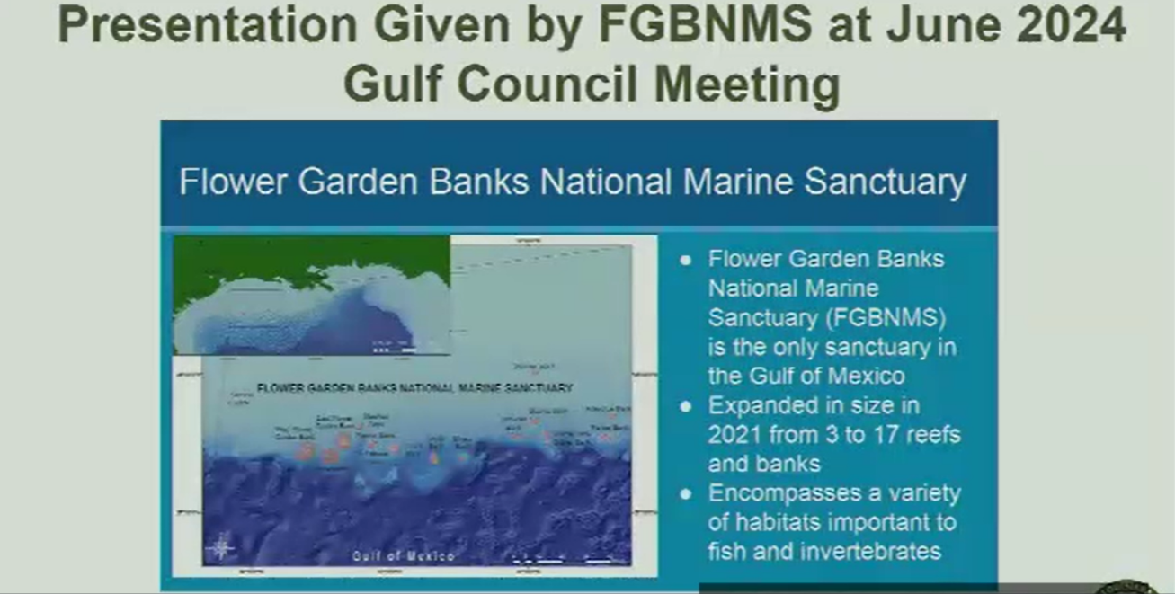

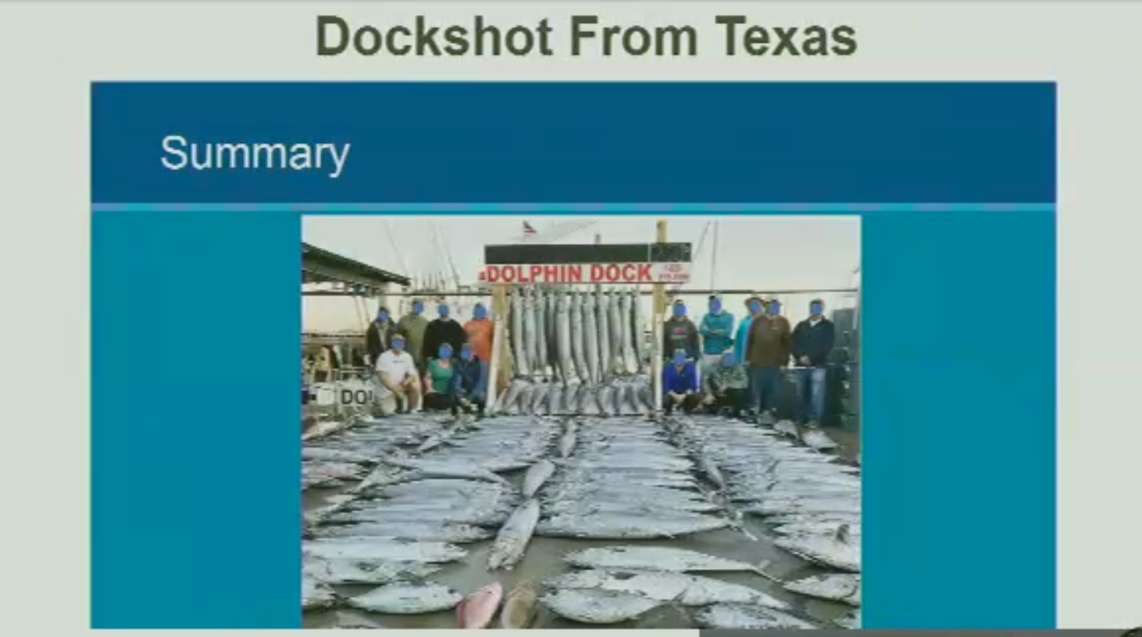

- They have Texas landings data in the below graph, and they have LA Creel data in this graph for Wahoo, specifically statewide landings. I do not know how they got LA Creel landings from prior to 2014, but they are somehow on here. This is statewide landings and most of our wahoo that we get in Louisiana are landed pretty much in our Barataria Basin. That is Venice Marina, Cypress Cove, and Grand Isle. They are not coming from Cameron or Lake Charles area, which would be closer to the primary portion of the flower garden banks. Brought that topic up. I pulled up a table after they presented this information and showed where the basins are, that our landings are coming from on Wahoo, and it seems implausible that boats coming out of Venice are going to run 200 miles to the flower garden banks from Venice to catch Wahoo and 200 miles back. It just do not make sense. I think the data was sort of misinterpreted or misrepresented here when they gave it to us at the meeting. That is part of why I pulled this up for you people just to see what they gave to the Council.
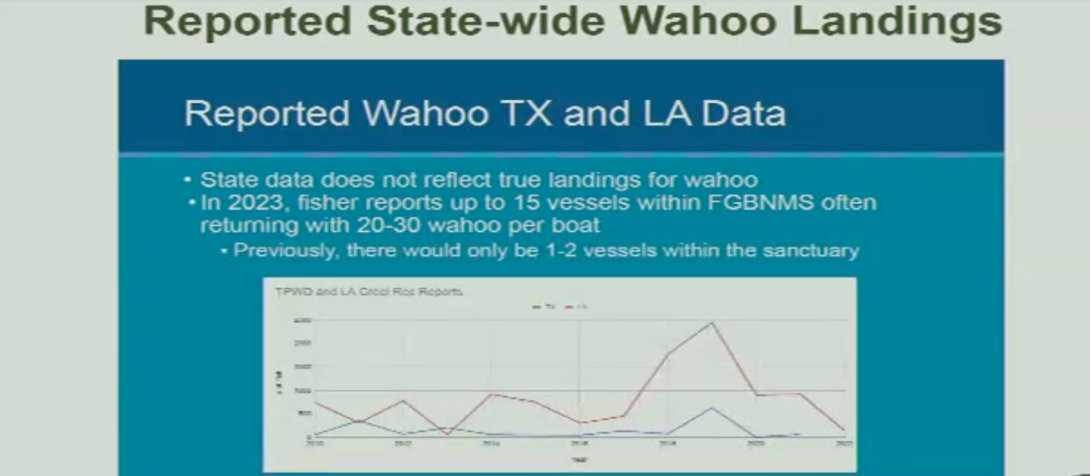

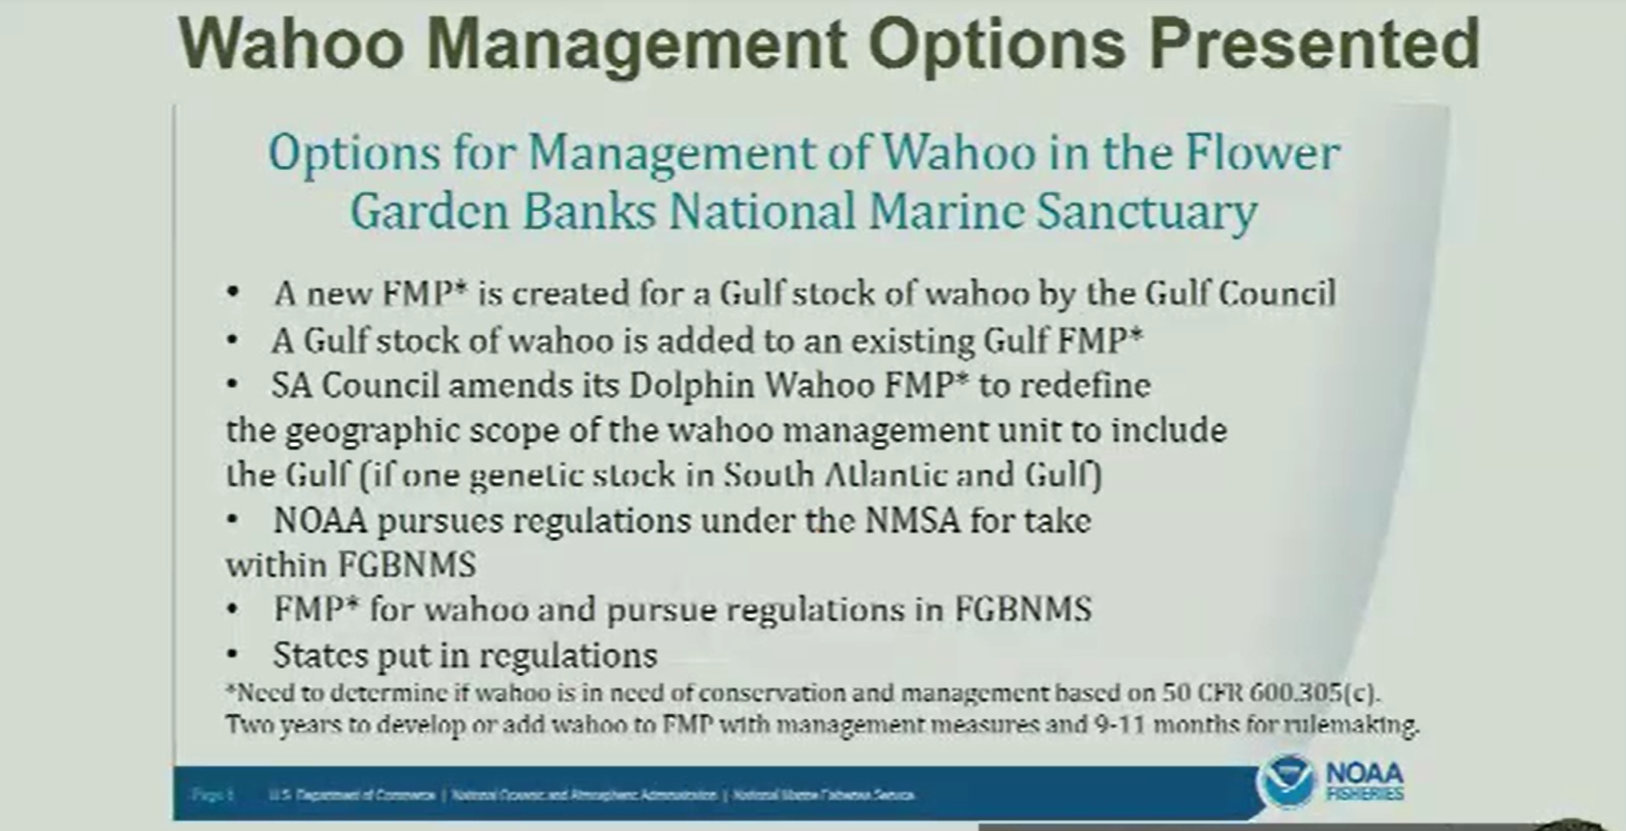

The Council is wanting feedback from the States somewhere between April or the June meeting as to whether States would be willing to want to take on that responsibility of managing the species in the absence of an FMP or Federal regulations under the Magnuson Stevens Act, it allows for the management of a species by a state out to 200 nautical miles. Therefore, that is the status right now there is no Federal management for Wahoo in the Gulf of Mexico. The only management currently taking place is by Florida, they have a two fish bag limit, and they manage it out to 200 nautical miles off their coast because of the absence of Federal regulations.
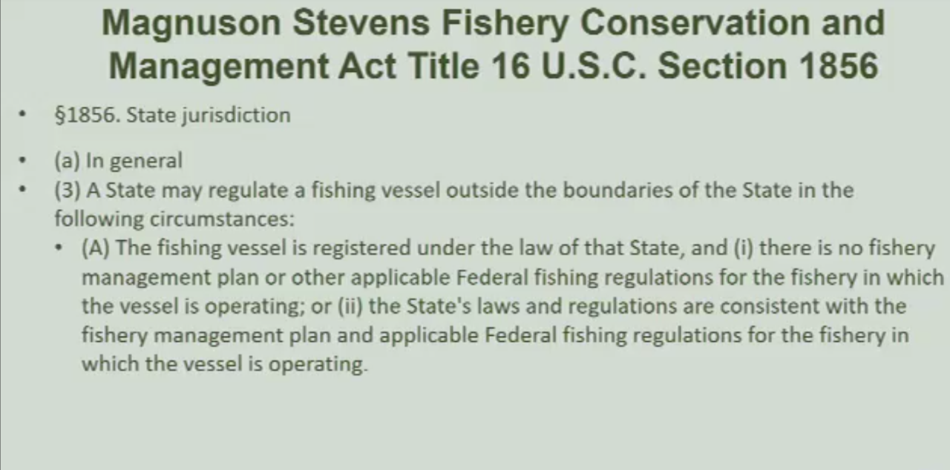

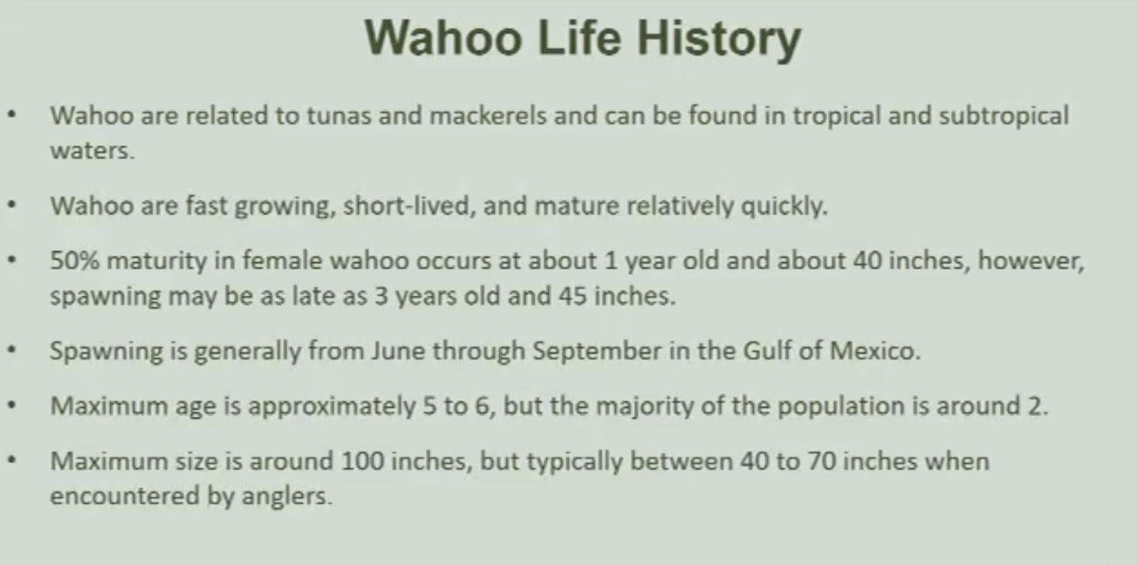

Ben Graham stated that he would be in favor of the state putting up a proposal to regulate wahoo, do not see there really being an issue, support would be behind state management to get a head of it

George Huye stated that he agrees with staving off the federal government from imposing regulations that are more restrictive and rally for state management

George Huye motioned to create a state recreational management system for wahoo, to manage the species on a state level that will be lasting so the Federal government does not come in, 2nd by Daniel Edgar. Motion carries

Ben Graham stated that 4-5 fish sounds reasonable

C. The task force discusses fisheries stocks after the snowstorm event

Preliminary report linked in press release

Jason stated that as soon as LDWF was able to get out and sample they did, so far have investigated approximately 77 fish kills, trying to get an accurate number on how many were killed, will have an idea in end of season abundance, put together a winter severity index and use water temp below 44 degrees, mean water temp and plot this against landings, in this report the specific example is for spotted seatrout for winter severity, if you look at that this winter freeze lines up with 96, 2000, 2014 but in those winters the water cooled a little slower with this event we had rapid cooling of water, would lean that this is more like the 2018 winter event, hit hardest between the Mississippi and Atchafalaya, where we saw the majority of mortality, will have more information at the end of the season

Douglas Olander stated that down 30% on catch compared to previous years

Eddie Lejune stated that fish cannot make it back to deeper water quick enough, did not open the weirs quick enough if at all, all about accuracy in fishery reports, there should be a trip ticket program for fishermen also, will be able to keep up on stock assessments

D. Jason Adriance led discussion on southern flounder

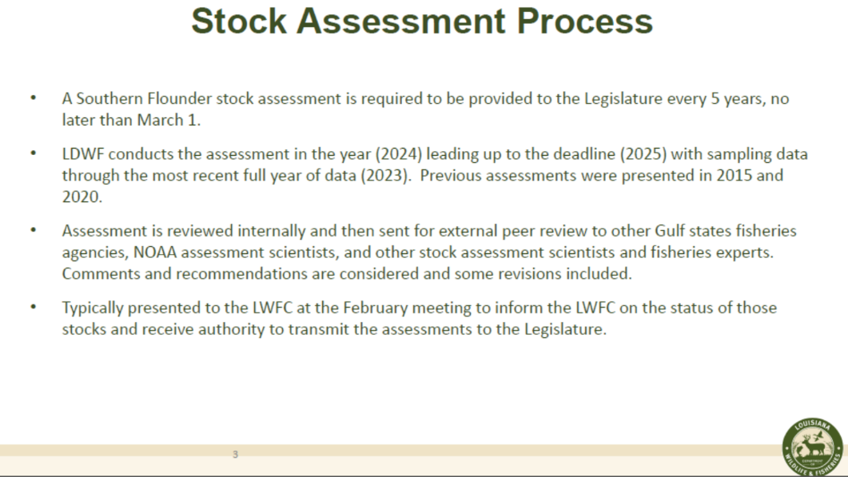
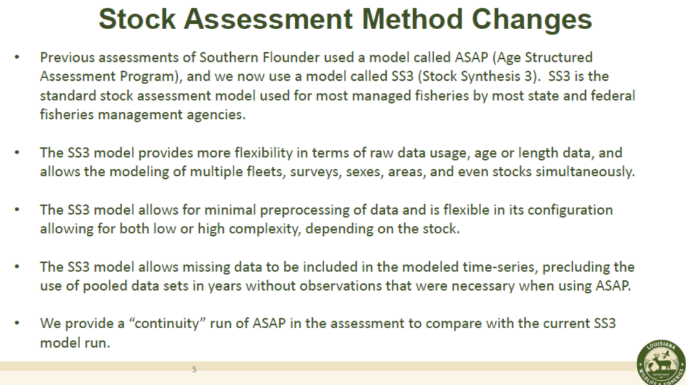
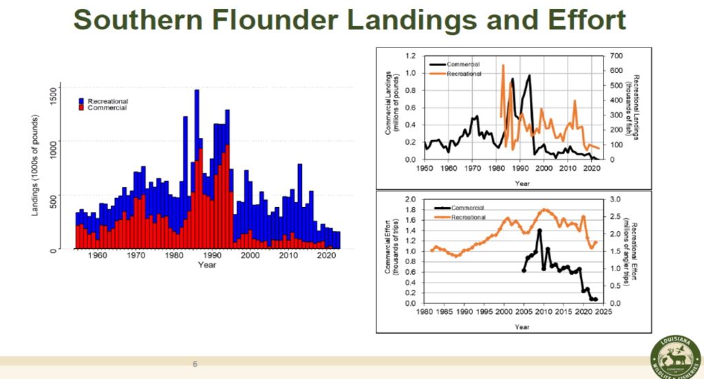

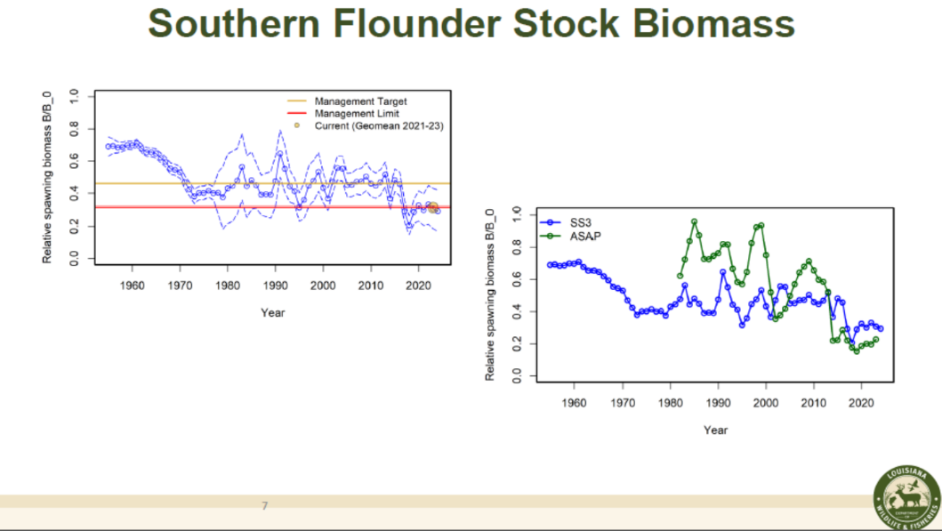
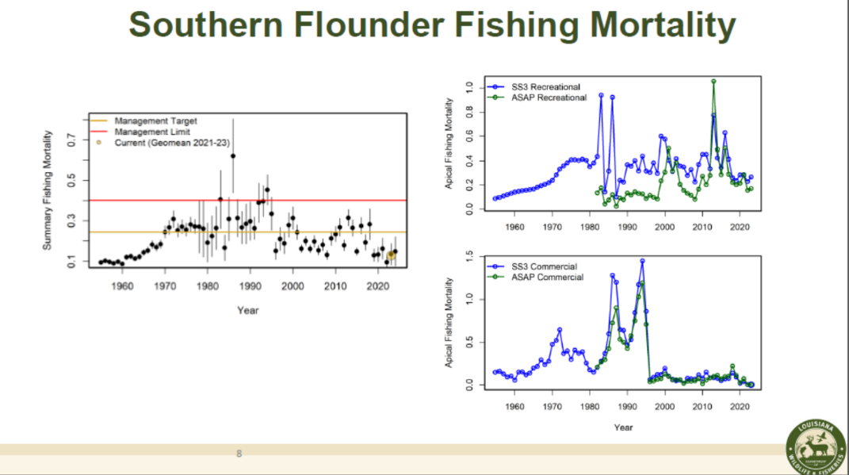
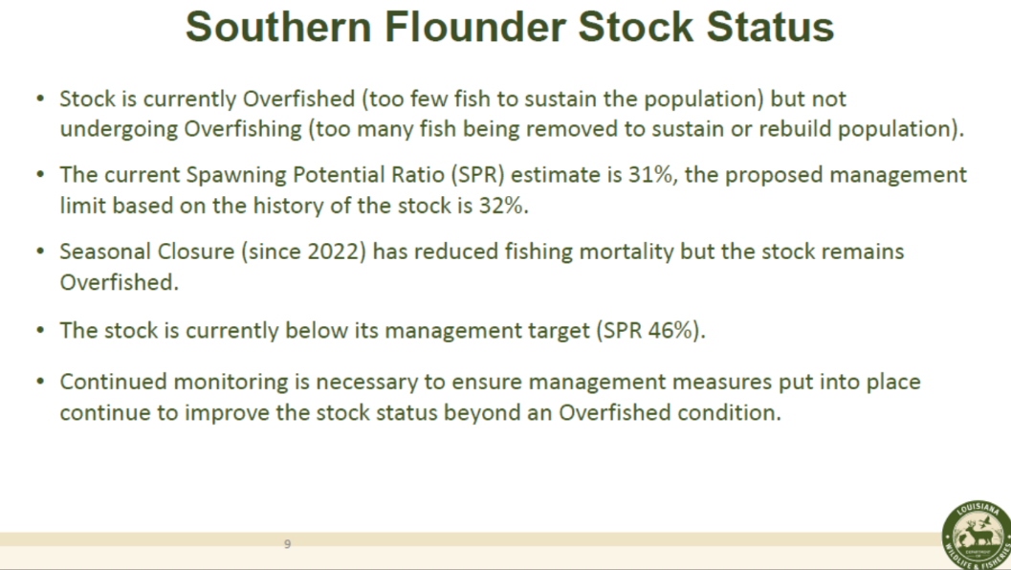

Jason Adriance stated that through the closure we will let the majority of the females escape, and will cut down the fishing mortality on the spawning females, which will increase the spawning biomass, the recruitment has not been where is should be, but if the marsh temps is above a certain threshold they all become make flounder

David Alfonso asked if there is a reason there is not a minimum size limit on flounder, is there a reason why? Jason Adriance stated that never addressed a minimum size limit, when they looked at management measures looked at size limit and reducing landings and we would have had to go to a restrictive size limit to make a difference, the closure is more effective than a size limit

Eddie Lejune asked why does this stated that the stock is being over-fished? Jason Adriance stated that with flounder when that is said, it just means the biomass is below allowable limits, it is reflective of the status of the stock rather than being reflective of over fishing

Daryl Simon stated that in the commercial sector would not buy anything under a 1 lb., anything a pound or bigger they will buy

E. James Pelas led discussion on the state of the industry

You can’t fish catfish due to FDA inspection regulations, lost sharks with fin bill was passed, only thing left is sheepshead and drum fish and struggling with this, as an industry don’t see us making it, lost mullet season as well

Ben Graham stated that he is hearing issues on not having a market for certain fish and certainly have heard about the issue with shark, but the shark issue is a federal issue

James Pelas stated that catfish have to be inspected by FDA you have to have on hand a USDA inspector

Gene Cavalier stated that he could get some feedback on the catfish inspector issue and get back to the task force

Ben Graham asked that James Pelas provide a list of issues and how they can possibly be addressed and provide that for further discussion at the next meeting

Daryl Simon asked about the SPMB, promote shrimp, crabs, and crawfish but not fish, would like to see if they can also promote fish; suggested that a SPMB representative come to the next meeting for discussion

Acy Cooper stated that the SPMB hardly meets, need to change legislation to where the board is more than just an advisory board but rather makes the decisions; Acy Cooper suggested making a motion to send the commission a letter to send something to the Governor’s office to make some changes

Jason Adriance all sharks put under CITIES import/export permits that are required, so for each shipment there has to be a permit with it from US and whatever country the shark is going into, can get several of the permits at once if you know a head of time how many you might need, this is an international issue and the permits are sometimes hard to get

F. The task force considered a Gulf Council recommendation on Greater amberjack

Jay Trotter would like to propose a recommendation to the Gulf Council on Greater amberjack, would like to make changes to how we can catch the fish that they have allotted us
Chris Schieble stated that the 2021 stock assessment showed that Greater amberjack was overfished and overfishing and that prompted this change on an overall catch limit. The overall catch limit for recreation and commercial fishing was brought down to around 600,000lbs. Also recreationally there was an emergency action put into place, as a result, this past year, recreationally they fished in May, which was beneficial to our snapper guys, but we are not going to have that this year, the new season is only September 1st through October 31st, 2 months, and that is if they don't achieve the quota within that time period, it could be cut even shorter than that. Both the commercial and recreational sectors have had severe haircuts. The good news of all this is that there is a new stock assessment currently underway. It is called the Great Amberjack count and it may show that there are more amberjack out there than the previous assessment. As a State, we are pushing at Gulf Council right now for State management of Amber Jack recreationally, because we feel that this assessment will allow for that when it shows a higher allocation to come out of it, we potentially could have higher catch limits and State management, should have this results on amberjack count by the end of 2026, beginning of 2027, but in the meantime can work on some of these things concurrently through the Council process
G. Finfish Task Force- Officer Elections:

Daniel Edgar motioned to elect Ben Graham as chairman of the task force and Stuart Billeaud as the vice-chairman, 2nd by Steve Rockwieler. Motion carries.

VII. Public Comment:
Daniel Edgar- Waterman’s Association need an organization that represents the industry as a whole, we as an industry should think about forming an organization like this that represents the whole industry

Douglas Olander stated that more issues for the industry and need some financial help to assist the industry when they are having issues, see a bill going through right now that specializes in shrimp and crawfish only, need finfish to be included in this

VIII. The task force mentioned possible items to take up at the next meeting, catfish inspection issue and SPMB inclusion of finfish promotion

IX. The next meeting set for May 7, 2025 for 10am in Baton Rouge. Tuesday, May 13, 2025 for 10:00am at the LDWF headquarters located at 2000 Quail Drive, Baton Rouge, LA

X. George Huye motioned adjourn the meeting, 2nd by Stuart Billeaud. Motion carries. Meeting adjourned

