Finfish Task Force Meeting Minutes
Wednesday, November 13, 2024, 10:00am
LA Department of Wildlife and Fisheries Headquarters
2000 Quail Drive, Baton Rouge, LA

I. Pledge of Allegiance
II. Roll call and introduction of guests
Voting Members Present:
Daryl Simon
Daniel Edgar
Stuart Billeaud
Ben Graham
George Huye
Steve Rockwieler

Voting Members Absent:
James Pelas
Wayne Rollo
Jay Trotter
Adam Guillory

Non-Voting Members Present:
John Walters
Jason Adriance
Davis Madere
Jack Isaacs
Gene Cavalier

Non-Voting Members Absent:
Senator Hensgens
Representative Stefanski

III. George Huye motioned to approve the July 24, 2024 meeting minutes, 2nd by Daniel Edgar. Motion carries.

IV. Stuart Billeaud motioned to approve the November 13, 2024, 2nd by Steve Rockwieler. Motion carries.

V. New Business
- Gary Vitrano provided a Large Mouth Bass Assessment Post Hurricane Ida
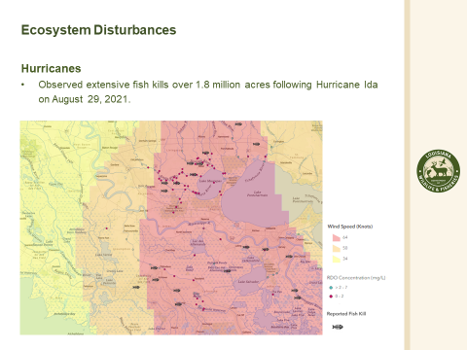
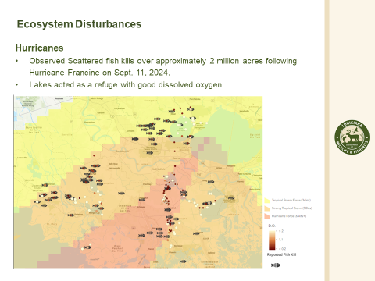

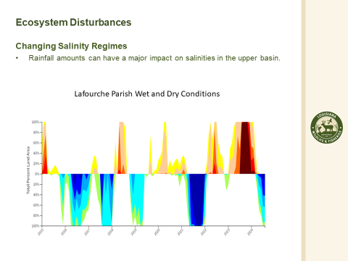

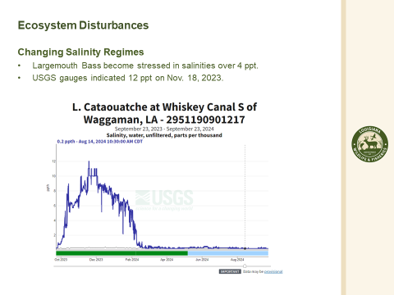

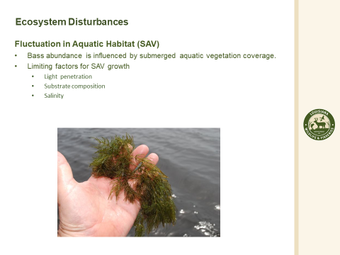
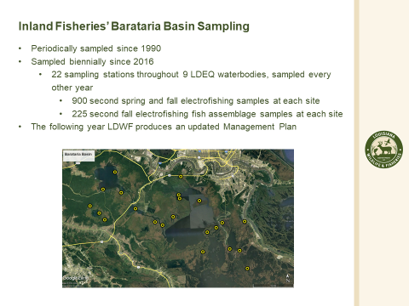

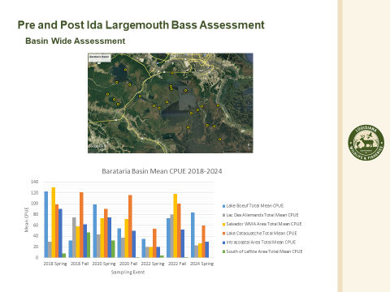
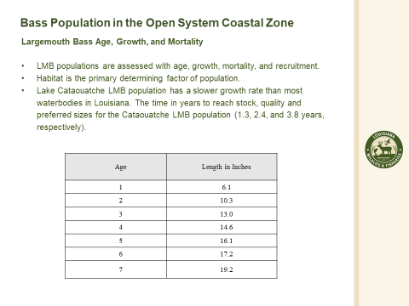
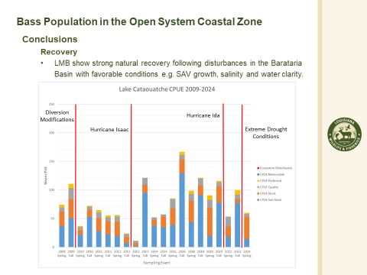
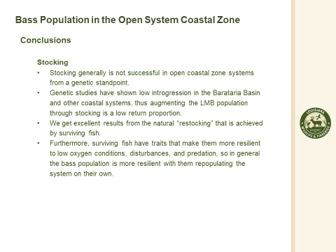

Steve Rockwieler stated that groups approached him to see if the state can stock some of the Phase 2 fish, want something to boost the area after a storm, usually takes around 4-5 years after a storm to naturally bring the fish back
- Jason Adriance provided a presentation on the summary of the 2024 red snapper season

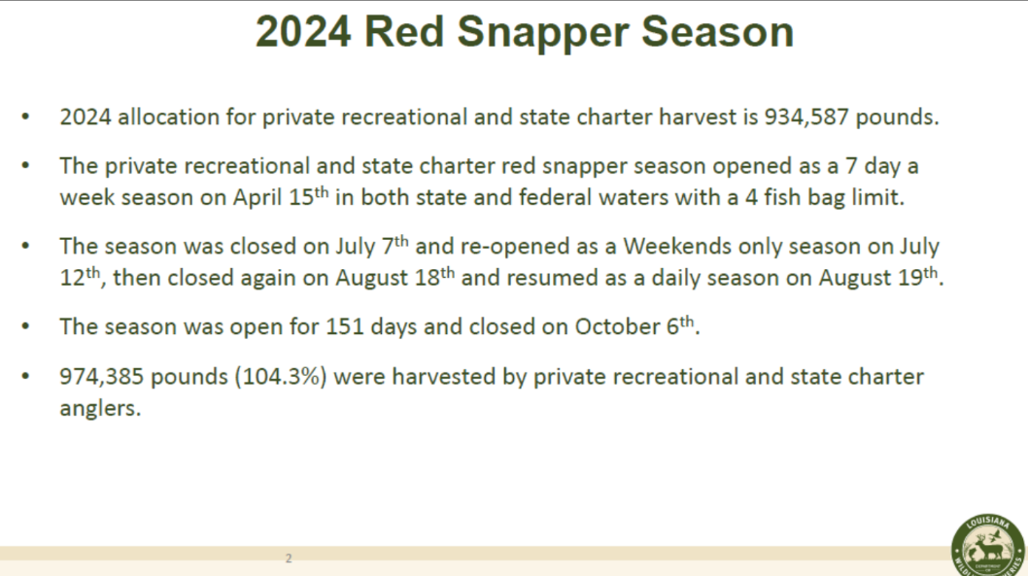
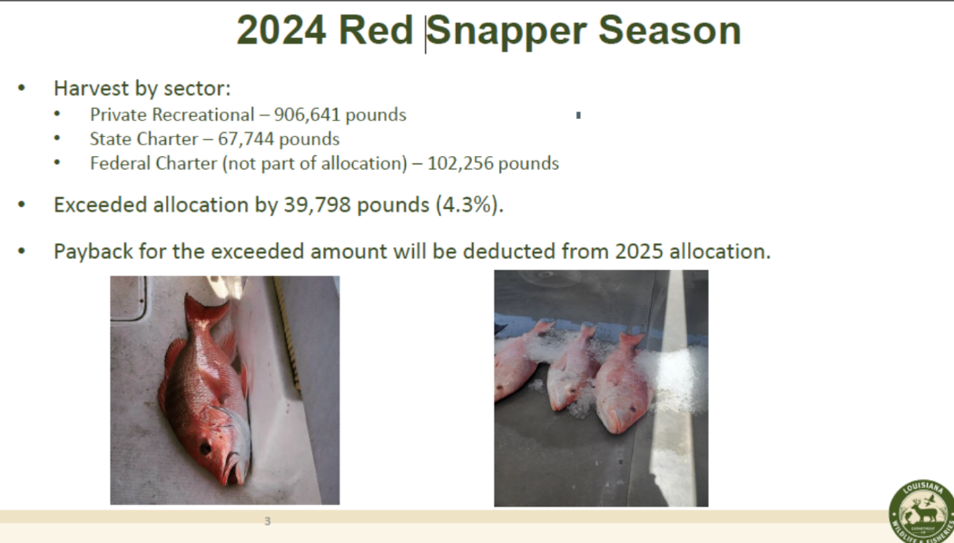

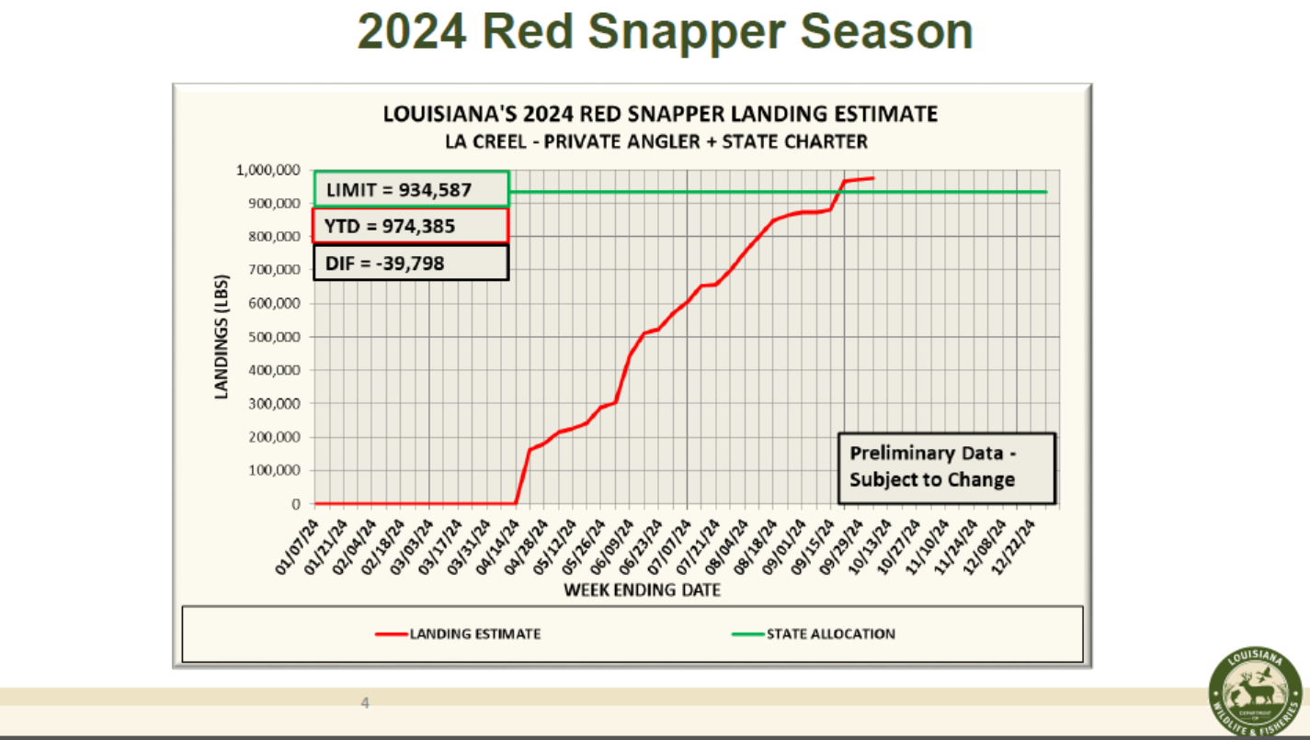
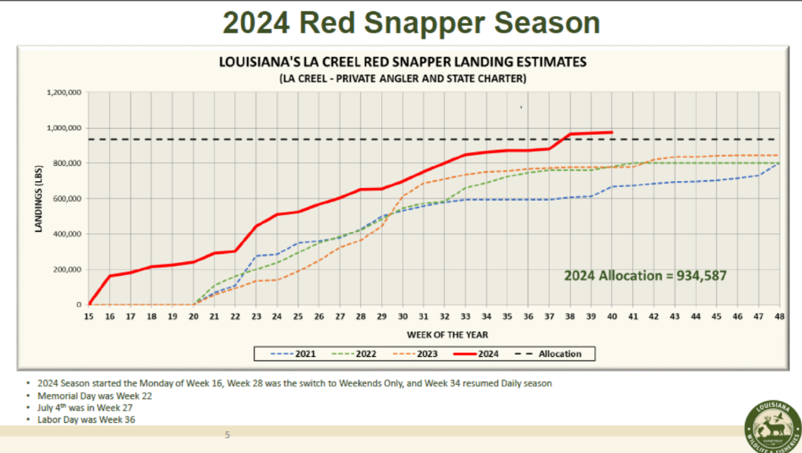
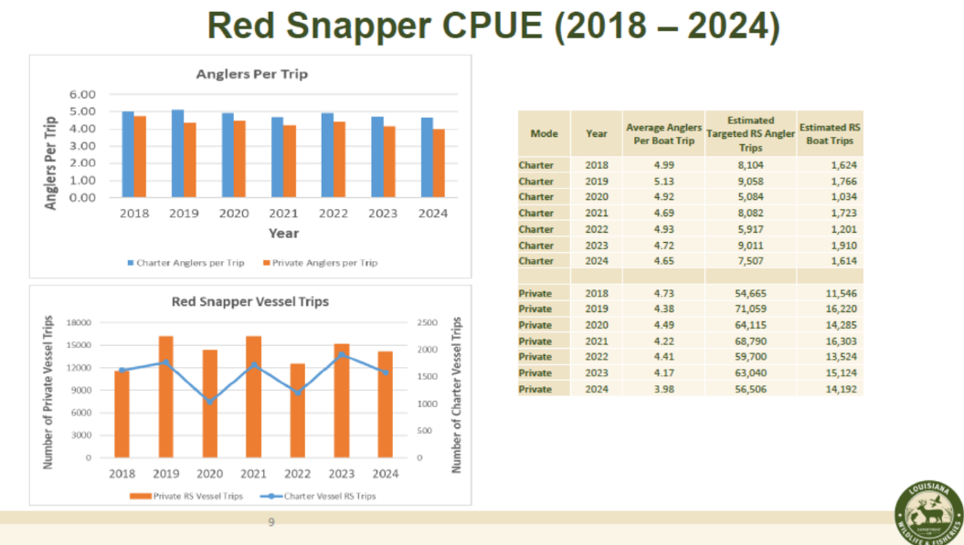
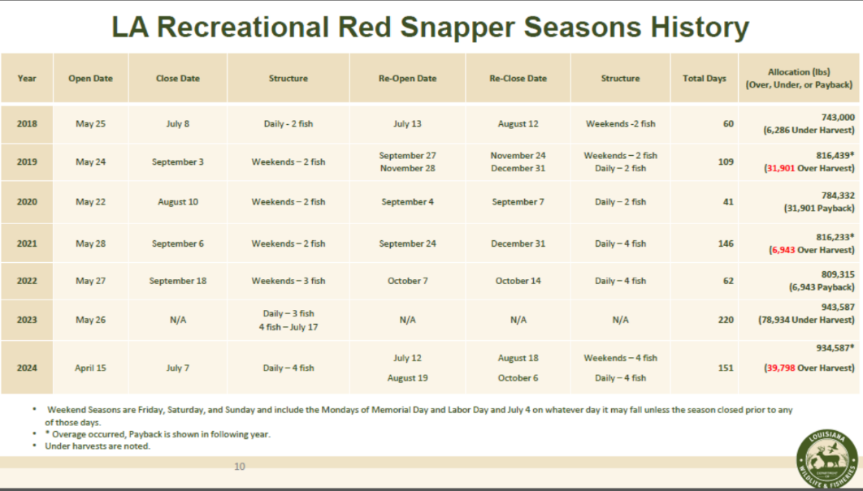

Jason Adriance stated that right now LDWF does not have any recommendations as of yet but they are open to hearing the industry’s recommendations and comments and will consider these when formulating the Commission recommendation

Stuart Billeaud stated that LDWF has done a pretty good job of opening at the right time of the year, obviously want as many fishing days as possible, but over all think LDWF has done a great job of opening at the right time

Richard Fischer stated that the plan is only for the state charter boats, the fed guys have much smaller profit margins and the state guys are catching 2/3 of the quota, this creates a negative situation for the federally chartered guys who have to have a permit that costs $40,000, inability for federal guys to book trips for the duration of the season, 100,000 federal and 67,000 state, would like for some thought to leveling the playing field whether that be starting the season later, state season starts in April and federal season starts in June 1st, advocating for the federal management to go back to the state

Jason Adriance stated that Gulf-wide the federal numbers are down 30%

Richard Fischer stated that hurricanes are a factor and more pressure and less biomass in the Eastern Gulf than the Western Gulf almost two completely different stocks, the Federal Government doesn’t want to give up power but it would help the resource to be managed on a state level, hearing quite a bit that state charter boats are going into federal waters
- The task force discussed the effects of the redfish regulation changes
Ben Graham would like to understand what the response was on the regulation changes
Jason Adriacne stated that they are currently five months into the red drum regulation changes and have not had a lot of feedback as of yet
- The task force discussed trout regulation changes
Jason Adriance stated they they are currently almost a year into the trout regulation changes, aside from the initial blowback, have heard positive feedback
- The board led discussion on the effects of new buffer for the menhaden fishery
Jason Adriance stated that he is hearing a lot of questions in terms of spills and net tears in relation to the buffer and there is not any information to indicate the buffer has affected either of the things, the industry has invested in stronger nets, really no data yet
A coastal buffer zone for the commercial harvest of menhaden 1-mile off the entire Louisiana coastline and three miles from the area between Holly Beach and Rutherford Beach in western Louisiana. This action will extend the existing ¼-mile buffer and the existing 3-mile buffer at Grand Isla, La. will remain in place.
- The board inquired about the Menhaden Bycatch Study and a timeline for it’s release
Jason Adriance stated that ultimately this is between the Gulf States Marine Fisheries Commission and the contractor, should be available prior to the next season, possibly before the summer
- The task force considered amending their bylaws to reflect new seat changes
Proposed changes (highlighted):
Section 4. Membership

Affairs of the Louisiana Finfish Task Force shall be managed by a board of voting members.
Membership in the Task Force shall include both voting and non-voting members.
There shall be 9 voting members appointed by the Governor pursuant to R.S.56:301.10, consisting of the following:

1. Three (3) commercial fishermen each of whom shall possess a commercial fisherman’s license with a certified endorsement pursuant to R.S.56:301.103(E)
2. One (1) active Louisiana dock buyer of finfish
3. Three (3) recreational fishermen each of whom shall possess recreational freshwater and saltwater licenses
4. One (1) nominee submitted by the Louisiana Charter Boat Association
5. One (1) nominee submitted by the Women's Southern Fisheries Alliance.

Section 6. Meetings

A. Task Force meetings shall be conducted under “Roberts Rules of Order”.

B. Task Force meetings shall be held at the LDWF Building in Baton Rouge. The Task Force may, however, hold meetings at other sites, for whatever reasons they deem necessary.

C. Meet regularly, not less often than once in each calendar quarter or at such times as called by the Chairman, or when requested by five members of the Task Force Task Force meetings shall begin at 10:00AM unless otherwise specified.

D. Meeting agendas and draft meeting minutes shall be mailed to Task Force members prior to each meeting.

E. Five voting members shall constitute a meeting quorum.

Daniel Edgar motioned to approve the proposed amendments to the bylaws, 2nd by Daryl Simon, Motion carries with a roll call vote, all voting members were in favor- Daryl Simon, Daniel Edgar, Stuart Billeaud, Ben Graham, Steve Rockwieler
- Jason Froeba provided an update on the Equipment Grant Program
1745 applications submitted, of those, currently averaging just under 90% eligibility, as of yesterday 1093 applications that have been reviewed or under review,682 have been paid or approved for payment that totals around $18.8M, roughly 49% of funding for program, several batches of payments were delayed due to federal lockout period went through October 16th. Hit unexpected delay in LDWF accounting, everything approved since September 20th is still in process of being paid, once funding comes in will have 1-day turnaround on checks, these delays resulted in about two months of no payments, awards on applications averaging $27,600, anticipate being able pay out around 1382 grants, will have to process about 1500 applications to get all the money out the door, each application averages about 15 pieces of equipment right now, few that are over 100 invoices, average processing time is about 8.5 hours per application, talked about adding supplies as an approved expense, this was approved from NOAA and is now active, Some of the review processing has slowed down a little bit, spending a lot of time helping applicants through the process, going to start giving a hard deadline and a one-time change option, folks who submitted quotes have to go out and purchase the equipment allowing these people to switch out these things for something more affordable
Daryl Simon thanked LDWF for coming to provide this feedback, some people are still having issues and not getting anywhere
Daniel Edgar is there a way to simplify the requirements? Jason Froeba stated that LDWF did not get approval for funding until September 2023, the Federal Government gives NOAA and other agencies stricter timelines, notified of an award in February 2024, submitted our spend plan to NOAA in June and have seen a significant increase in speed since these new regulations are in, this time around for the hurricanes decided to do direct payments everything is based on trip tickets and licensing information. The application will be pre-loaded with information they already have in the system
- Cullen Curol provided an update on the Restore LA Small Business Loan Program
Cullen Curol stated that the program started May 2023 accepting applications on the Ida side realized they had more applications than we had funding, feel comfortable that additional funding will come in January, currently communicating with applicants who received letters that they were over-subscribed, will pick back up on applications that were halted. Laura-Delta still accepting applications have until December 6th do not have a whole lot of new applications coming in, started funding in November but it has been a trickle, since May have had loans being closed, 1200 applications about 500-600 being eligible, cannot fund equipment that was already funded through the LDWF Equipment Grant Program, think in spring would be about half way finished, any businesses in the western part of the state that still have not applied there is still an opportunity until December 6
VI. Public Comment- no comment
Gene Cavalier stated that Commissioner Strain documentary working on crab one currently and will have finfish, crawfish and alligator, plan to share the oyster and shrimp documentary at the next meeting, working on finfish, going to try and expand past the catfish farms, email if anyone wants to participate
Daniel Edgar stated that if there is any money coming in, CPRA is getting billions, as fishermen we have no safe harbors, would like to look into safe harbors for boats, there is one in Golden Meadow and LA 1 holds about 10 boats, would like to invite CPRA to attend a future meeting to participate in discussion, also invite shrimp and oyster task forces to the discussion
VIII. Next meeting date set for Wednesday, February 12, 2025 for 10am at LDWF headquarters in Baton Rouge
IX. Stuart Billeaud motioned to adjourn, 2nd by Daniel Edgar. Motion carries.

