Shrimp Task Force Meeting Minutes
Wednesday, August 30, 2023, 10:00am
Terrebonne Parish Main Library
151 Library Drive
Houma, LA

I. Pledge of Allegiance
II. Call to order
III. Roll call

Voting Members Present:
Rodney Olander
Acy Cooper
Lance Nacio
Jeff Drury
Alan Gibson
Andrew Blanchard
Randy Pearce

Voting Members Absent:
Kristen Baumer
Phillip Tran
Chalin Delaune

Non-Voting Members Present:
Neal McMillian
Peyton Cagle
Edward Skena
Jack Isaacs

Non-Voting Members Absent:
Gene Cavalier

IV. Rodney Olander motioned to approve the August 2, 2023 meeting minutes, 2nd by Andrew Blanchard. Motion carries.

V. Alan Gibson motioned to amend the agenda by adding two items under New Business, G. To Consider Writing a Letter to the Governor to Request a Declaration of Emergency for the Shrimp Industry and item H. To Discuss the Catch to Marketing Program- Jason Bergeron, 2nd by Rodney Olander. Motion carries.

Andrew Blanchard motioned to approve the August 30, 2023 meeting agenda as amended, 2nd by Alan Gibson. Motion carries.

VI. The task force heard the Federal Shrimp Permit Report

VII. New Business
- Jason Froeba provided an update on the 2019 Fisheries Disaster funding
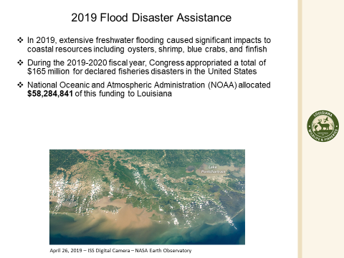
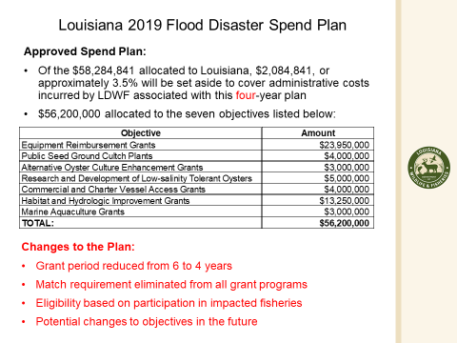
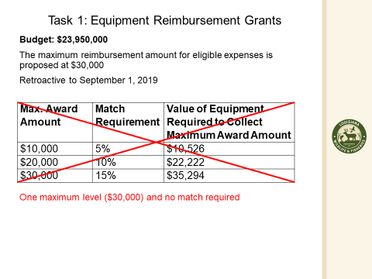
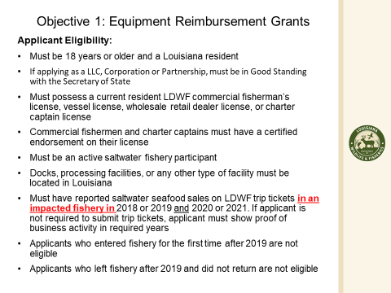
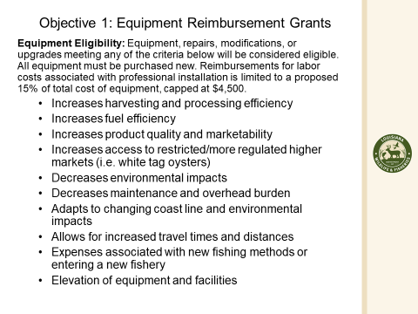
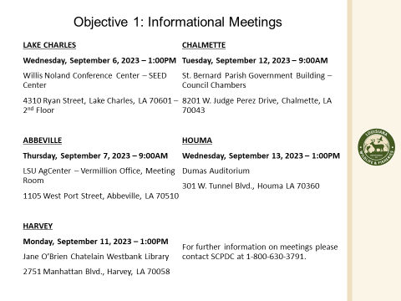
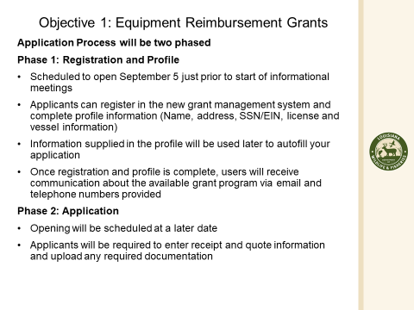
Jason Froeba stated that that LDWF has sent requests to NOAA for fisheries disasters for hurricanes in years 2020-21. Waiting on decision from the Secretary of Commerce, new timelines. Once disaster is declared LDWF will have 120 days to submit a spend plan, will need input from the task forces and the industry, NOAA will also only have 120 days to respond
- Andrew Blanchard motioned to approve funding for STF board members to travel to Washington, D.C. to walk the hill and participate in the LA Alive event, 2nd by Lance Nacio. Motion carries.
- Rodney Olander motioned to approve $2,750 to purchase 10 tickets for the LA Alive event , 2nd by Andrew Blanchard. Motion carries.

- David Williams provided a presentation on shrimp industry data
Plan to have regional areas for testing so testing can be done locally. Looking to get funding from NOAA or another entity to support a shrimp testing program
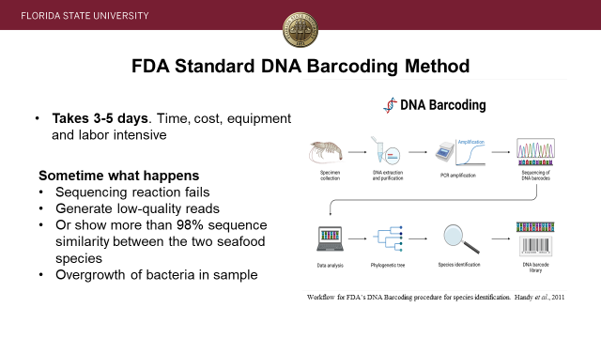
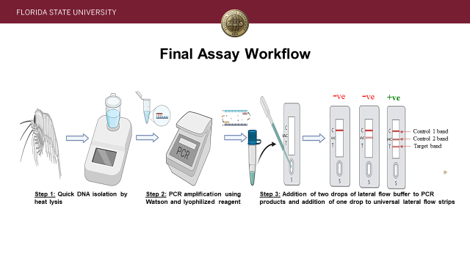
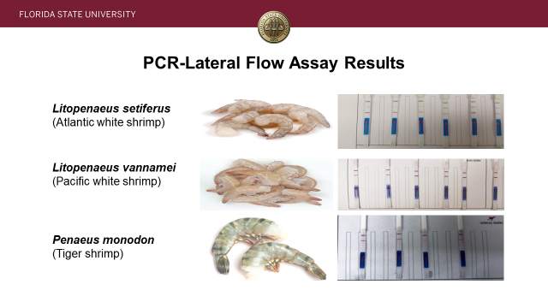
Andrew Blanchard motioned for the task force to work with David Williams on this project and research to try and find funding for this program to start rapid shrimp testing, 2nd by Randy Pearce. Motion carries.
- Andrew Blanchard motioned to nominate Acy Cooper as the Shrimp Task Force representative on the Imported Seafood Safety Task Force , 2nd by Alan Gibson. Motion carries.
- Andrew Blanchard motioned to fund travel to send STF board members, Acy Cooper and Jeff Drury to attend the NOAA GOM Shrimp Listening Session in Tampa, FL, 2nd by Alan Gibson. Motion carries.
- The task force discussed sending a letter to the Governor to request a declaration of emergency for the shrimp industry
Acy Cooper stated that a letter was written and submitted through LA Shrimp Alliance and think the task force should send a letter to the Governor to request that he submits a declaration of disaster for the industry
Andrew Blanchard motioned to write a letter to the Governor to request that a disaster declaration is made for the shrimp industry due to the ‘effects of market fluctuations and U.S. shrimp import tariff policies’, 2nd by Lance Nacio. Motion carries.
Acy Cooper stated that the Governor is putting something together waiting to hear an update on this
- Jason Bergeron provided a presentation to the task force on Catch to Marketing Program
The program helps take product from the vessel to the market, working with Nicholls and Sea Grant, promotes made in America products
V. Public Comment:
Eliska Branch stated that a petition has been started to raise the price of shrimp, the petition has over 3,000 signatures and need more trying to get it to the Governor, state legislators, white house, something needs to be done, will be on the news and on Facebook
Kim Chauvin, processor from Chauvin, requested a list from task force on all bills that they are going forth on, need to look at the labeling bill, has anyone requested what the EU criteria is for testing so that going into the seafood safety task force we will have this in front of us, request that STF writes a letter to NOAA about allocation to mega importers that this is unacceptable, TX has a bill that bans all imported bait, requesting that LA also have a bill banning imported bait
Lucy Pennel stated that the World Bank is still funding imported seafood projects, why can’t the money come back into the industry
Jennifer Armentor provided an update from LA Department of Health- collecting monthly imported shrimp samples from distributers, expecting August results in the next few days, testing for trio of four amphenicols, LDH is heading out two separate Seafood Safety Task Forces, one is for Senator Mills-Senate Resolution 159, and the other is from Representative Kerner which is HCR 134, trying to pick a date in September for a meeting (HCR 134); now a critical violation for restaurants in violation of labeling bill, now $150 fine for restaurants in violation of labeling violations
VI. The next STF meeting set for November 15, 2023 at the Terrebonne Parish Council Room in Houma, LA
VII. Andrew Blanchard motioned to adjourn, 2nd by Randy Pearce. Motion carries.

