Shrimp Task Force Meeting Minutes
Wednesday, July 31, 2024, 10:00am
Terrebonne Parish Government Tower
Council Chambers
8026 Main Street, Houma, LA

I. Pledge of Allegiance
II. Call to Order
III. Roll Call

Voting Members Present:
Rodney Olander
Andrew Blanchard
Alan Gibson
Lance Nacio
Phillip Tran

Voting Members Absent:
Acy Cooper, Jr.
Jeff Drury, III
Randy Pearce
Kristen Baumer
Chalin Delaune

Non-Voting Members Present:
Peyton Cagle
Gene Cavalier

Non-Voting Members Absent:
Edward Skena
Jack Isaacs
Neal McMillian

IV. Rodney Olander motioned to approve the July 10, 2024 meeting minutes, 2nd by Lance Nacio. Motion carries.

V. Rodney Olander motioned to approve the July 31, 2024 meeting agenda, 2nd by Alan Gibson. Motion carries.

VI. Financial Report
Remaining Fund Balance- $685,808
Remaining Budget Balance- $146,564

Rodney Olander motioned to approve the financial report as presented, 2nd by Alan Gibson. Motion carries.

VII. New Business:

- The task force discussed the application and enforcement of new seafood safety laws
Gene Cavalier with LDAF discussed SB166 and SB62, SB166 deals with proper labeling; will be utilizing the LDAF’s Weights and Measures, Ag Consumer Services, section inspectors to work on labeling, right now, the Weights and Measures director is working on regulations that are to implemented, also will be sending out a letter to distributers explaining the packaging and labeling regulations, messaging will need to be in 30pt black Ariel Font on packaging, spoke to the Director and they will be finding and creating a labeling system, inspectors go in a check at the retail level and if packaging and labelling is not in compliance have the ability to stop order the product so the product cannot be moved, that packaging has the ability to be corrected on site, use a random sample system, if there is a violation, the business who packages the product will be responsible for the misrepresentation; 1st offense would be not more than $15,000, second, not more than $25,000, and 3rd not more than $50,000
Regarding SB62, we will have a true random sampling process, CRT will provide the funding, and LDAF will be contracted through that process and that funding. The number and frequency of samples will based off the funding received from CRT. Once samples are collected, LDAF’s Ag Chemistry Lab will be used on LSU’s campus for processing. Once the sampling results are in the information is provided to CRT and they will do the enforcement action going forward from this point of the process. LDAF will be utilized to collect and process samples and CRT would be in charge of the enforcement. These regulations will be implemented on January 1, 2025.
Samantha Carroll with Culture, Recreation and Tourism (CRT), SPMB stated that CRT will be in charge of the fines, 1st fine is up to $1,000, 2nd is up to $2,000 and 3rd offense is up to $3,000. Recently formed a legislative team in their office to see through new seafood legislation. Representative Domangue’s Bill increased Act 667 was passed, which increased the Seafood Safety licensing by $1000 by year 4. Fesi’s bill would keep the license at $100, but since Domangue’s bill was the last Act signed is the one you go off of, have upcoming meetings with LDAF and LDH, collecting the currently license holder information from LDH, working on an MOU to work with the Department of AG to do the sampling, also setting up a hotline or text alert so people can call in and they can track incidences to report illnesses, etc., ACT 756 brought back the Seafood Safety Task Force, meeting set for September 18 at 10:00am at the state Capitol, will call for a rep from the STF replacing member from the DEA will be charged with making recommendations for SPMB and AG for testing

Alan Gibson stated that the labeling issue needs to be addressed

Samantha Carroll stated that LDH is not testing and very few people out in the field, once we get the packet from them and see if this needs to be contracted out, would like to do it for the first month or at least ride along with the contractor to be sure, need to iron out how many we should be doing per month and goals

Peyton Cagle recommended making sure that the language in those bills would allow for genetic testing, do not believe the genetic testing would be allowed based on what is currently written, but may want to see if this can be incorporated- Sam Carroll stated that the Seafood Safety Task Force is supposed to take recommendations and move forward so if this is something being recommended by the task force it could be done

Gene Cavalier stated that the Weights and Measures team should have enough personnel to preform samples

Lance Nacio suggested utilizing David Williams’ seafood sampling test since the cost is so much cheaper

Alan Gibson motioned to nominate Andrew Blanchard as the STF representative on the Seafood Safety Task Force, if allowable nominated Alan Gibson as the alternate, 2nd by Rodney Olander. Motion carries.

B. Peyton Cagle provided a review on the fall inshore shrimp season and the setting of the opening date

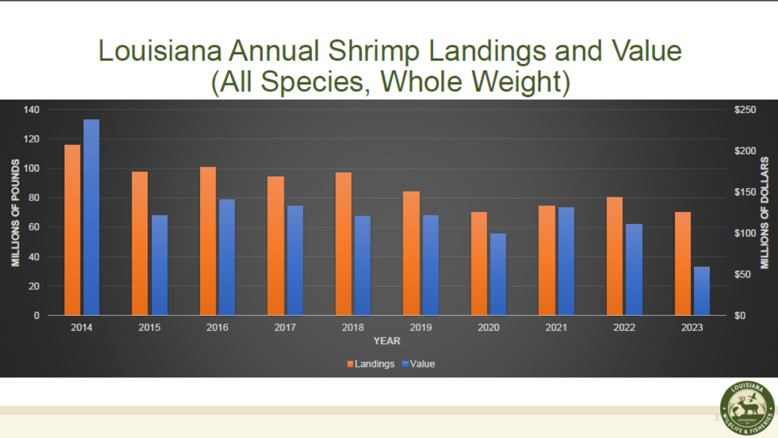
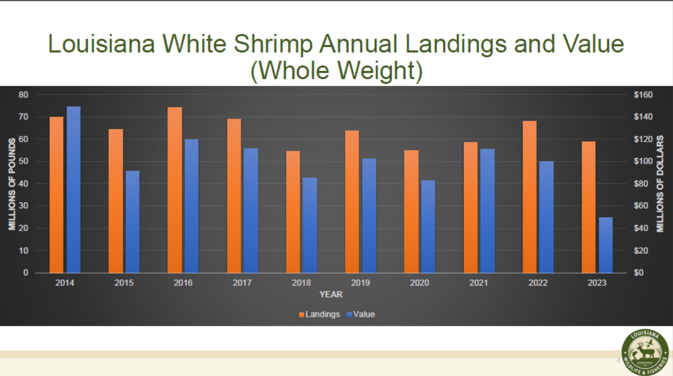
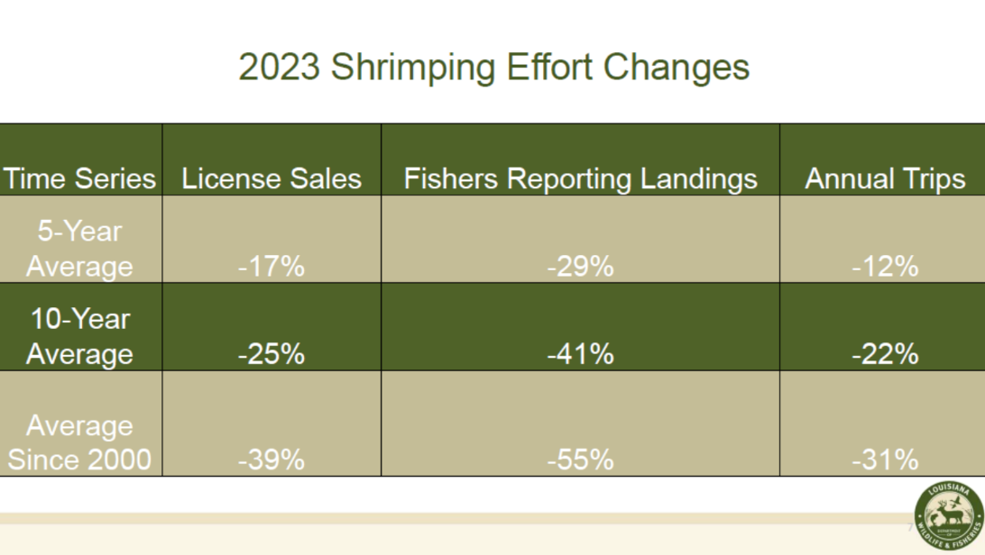
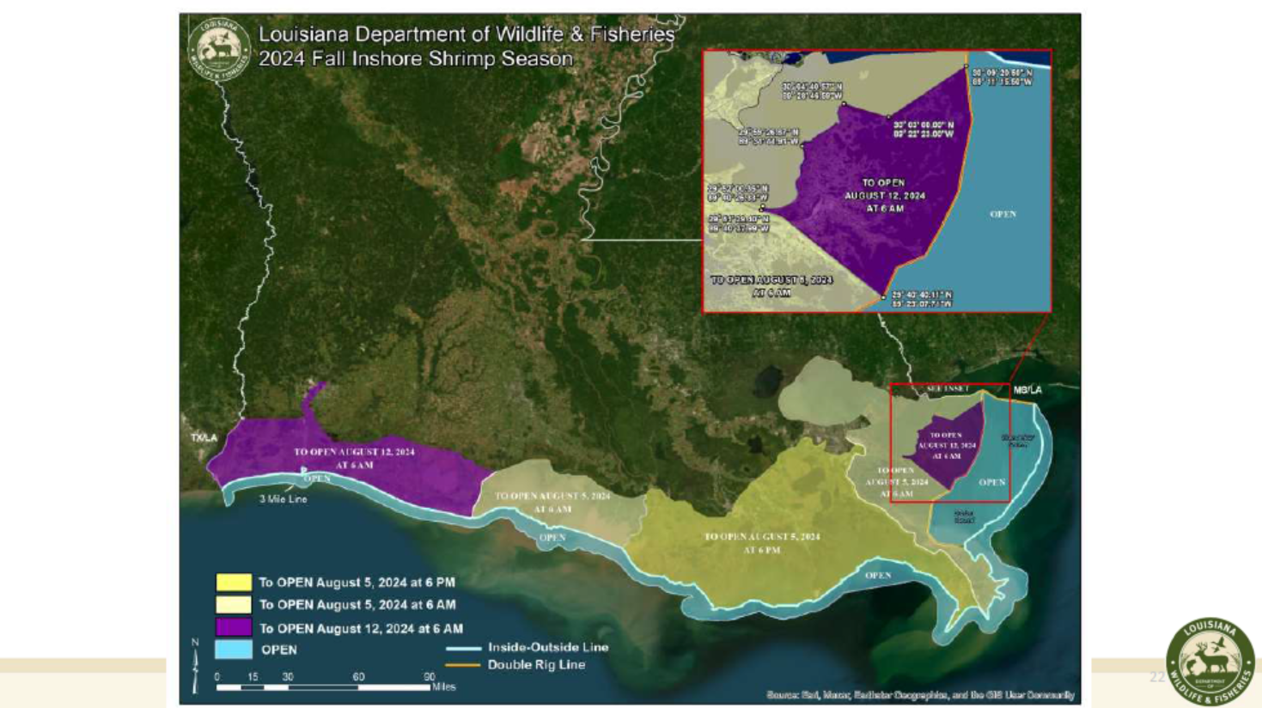

David Chauvin stated that brown shrimp opening and very little smaller sizes so need for that; every size shrimp would be good right now, issues with price and freezer storage

Alan Gibson stated that Zone 2 shrimpers want to go to work recommend opening it up, inside guys if something happens they will lose out, would like to follow the recommendation for zone 2 and possibly the entire recommendation

Alan Gibson motioned to go with biological data and take LDWF recommendation as presented, 2nd by Rodney Olander. Motion carries.

C. The task force was provided with an update on the equipment modernization program

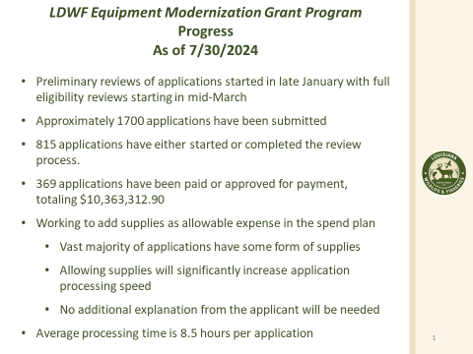

Patrick Banks stated that the new program is under review by NOAA at this time, still waiting to hear back

VIII. Public Comment:

Looking for EEZ permitted shrimpers to test devices, call 985-856-2477 if interested, volunteers are compensated

Lance Nacio went to a meeting on July 12 with Federal Trade Commission, looking for restaurants who are using deceptive marketing practices

- Next Shrimp Task Force meeting date set for Wednesday, October 9 for 10:00am at the Terrebonne Parish Council Chambers

IX. Rodney Olander motioned to adjourn, 2nd by Lance Nacio. Motion Carries.

